UNITED STATES
SECURITIES AND EXCHANGE COMMISSION
Washington, D.C. 20549

FORM 8-K

CURRENT REPORT
Pursuant to Section 13 OR 15(d)
of The Securities Exchange Act of 1934
Date of Report (Date of earliest event reported): July 30, 2024

TECTONIC THERAPEUTIC, INC.
(Exact name of registrant as specified in its charter)

Delaware |  | 001-38537 |  | 81-0710585
(State or other jurisdiction  of incorporation) |  | (Commission  File Number) |  | (IRS Employer  Identification No.)
490 Arsenal Way, Suite 210  Watertown, MA |  |  |  | 02472
(Address of principal executive offices) |  |  |  | (Zip Code)
(339) 666-3320
(Registrant’s telephone number, including area code)

Check the appropriate box below if the Form 8-K filing is intended to simultaneously satisfy the filing obligation of the registrant under any of the following provisions (see General Instruction A.2.):

☐ | Written communications pursuant to Rule 425 under the Securities Act (17 CFR 230.425)

☐ | Soliciting material pursuant to Rule 14a-12 under the Exchange Act (17 CFR 240.14a-12)

☐ | Pre-commencement communications pursuant to Rule 14d-2(b) under the Exchange Act (17 CFR 240.14d-2(b))

☐ | Pre-commencement communications pursuant to Rule 13e-4(c) under the Exchange Act (17 CFR 240.13e-4(c))
Securities registered pursuant to Section 12(b) of the Act:

Title of each class |  | Trading  Symbol |  | Name of each exchange  on which registered
Common Stock, par value $0.0001 per share |  | TECX |  | Nasdaq Global Market
Indicate by check mark whether the registrant is an emerging growth company as defined in Rule 405 of the Securities Act of 1933 (§230.405 of this chapter) or Rule 12b-2 of the Securities Exchange Act of 1934 (§240.12b-2 of this chapter).
Emerging growth company ☐
If an emerging growth company, indicate by check mark if the registrant has elected not to use the extended transition period for complying with any new or revised financial accounting standards provided pursuant to Section 13(a) of the Exchange Act. ☐

Item 7.01. | Regulation FD Disclosure.
On July 30, 2024, Tectonic Therapeutic, Inc. (the “Company”) issued a press release titled “Tectonic Therapeutic Announces U.S. FDA Clearance of IND Application of TX45 for Subjects with Group 2 PH Due to Heart Failure with Preserved Ejection Fraction.” A copy of the press release is furnished as Exhibit 99.1 to this Current Report on Form 8-K.
The Company has updated its corporate presentation for use in meetings with investors, analysts and others. A copy of the updated corporate presentation is furnished as Exhibit 99.2 to this Current Report on Form 8-K. Investors may access the presentation by visiting the “Events & Presentations” section of the Company’s investor website at https://investors.tectonictx.com.
The information furnished under this Item 7.01, including Exhibits 99.1 and 99.2, shall not be deemed “filed” for purposes of Section 18 of the Securities Exchange Act of 1934 (the “Exchange Act”) or subject to the liabilities of that section, nor shall it be deemed to be incorporated by reference into any of the Company’s filings with the Securities and Exchange Commission, regardless of any general incorporation language in such a filing.

Item 8.01. | Other Events.
The Company announced today that the U.S. Food and Drug Administration (the “FDA”) has cleared its Investigational New Drug (“IND”) application for TX45, an Fc-relaxin fusion protein being evaluated for the treatment of patients with Group 2 Pulmonary Hypertension (“PH”) due to Heart Failure with Preserved Ejection Fraction (“HFpEF”).
The Company is also updating its guidance in regard to the TX45 program as follows:

• |  | Topline trial results of the Phase 1a clinical trial of TX45 in healthy volunteers is expected to be released in September 2024.

• |  | Phase 1b hemodynamic trial evaluating single doses of TX45 in subjects with Group 2 PH due to HFpEF continues to enroll as planned, with topline trial results expected in mid-2025.

• |  | The Company expects to initiate a global, 24-week Phase 2 clinical trial to evaluate TX45 administered subcutaneously in subjects with Group 2 PH due to HFpEF in the third quarter of 2024.
Forward-Looking Statements
Statements contained in this Current Report on Form 8-K regarding matters that are not historical facts are “forward looking statements” within the meaning of the Private Securities Litigation Reform Act of 1995. The Company may, in some cases, use terms such as “aims”, “anticipates”, “believes”, “could”, “estimates”, “expects”, “forecasts”, “goal”, “intends”, “may”, “plans”, “possible”, “potential”, “seeks”, “will” and variations of these words or similar expressions that are intended to identify forward-looking statements, although not all forward-looking statements contain these words. Forward-looking statements include, but are not limited to, statements regarding: the design, objectives, initiation, timing, progress and results of current and future clinical trials of the Company’s product candidate, TX45, including the ongoing Phase 1a and Phase 1b clinical trials of TX45 and initiation of the Phase 2 clinical trial of TX45. These forward-looking statements are based on the Company’s expectations and assumptions as of the date of this filing. Each of these forward-looking statements involves risks and uncertainties that could cause the Company’s clinical development programs, future results or performance to differ materially from those expressed or implied by the forward-looking statements. Many factors may cause differences between current expectations and actual results, including: the potential that success in preclinical testing and earlier clinical trials does not ensure that later clinical trials will generate the same results or otherwise provide adequate data to demonstrate the efficacy and safety of a product candidate; the impacts of macroeconomic conditions, including the conflict in Ukraine and the conflict between Israel and Hamas, heightened inflation and uncertain credit and financial markets, on the Company’s business, clinical trials and financial position; unexpected safety or efficacy data observed during preclinical studies or clinical trials; clinical trial site activation or enrollment rates that are lower than expected; the Company’s ability to realize the benefits of its collaborations and license agreements; changes in expected or existing competition; changes in the regulatory environment; the uncertainties and timing of the regulatory approval process; and unexpected litigation or other disputes. Other factors that may cause the Company’s actual results to differ from those expressed or implied in the forward-looking statements are identified in the section titled “Risk Factors” in the final prospectus on Form 424(b)(3) filed by AVROBIO with the Securities and Exchange Commission on May 3, 2024, and in other filings that the Company makes and will make with the Securities and Exchange Commission in the future. The Company expressly disclaims any obligation to update any forward-looking statements contained herein, whether as a result of any new information, future events, changed circumstances or otherwise, except as otherwise required by law.

Item 9.01. | Financial Statements and Exhibits.
(d) Exhibits

Exhibit  No. |  | Description
99.1 |  | Press release dated July 30, 2024.
99.2 |  | Corporate Presentation dated July 2024.
104 |  | Cover Page Interactive Data File (formatted as Inline XBRL).

SIGNATURES
Pursuant to the requirements of the Securities Exchange Act of 1934, the registrant has duly caused this report to be signed on its behalf by the undersigned hereunto duly authorized.

 |  |  |  |  |  | TECTONIC THERAPEUTIC, INC.
Date: July 30, 2024 |  |  |  | By: |  | /s/ Daniel Lochner
 |  |  |  |  |  | Daniel Lochner
 |  |  |  |  |  | Chief Financial Officer
Exhibit 99.1
Tectonic Therapeutic Announces US IND Clearance for Lead Program, TX45

 |  |  | TX45 is an Fc-relaxin fusion protein being evaluated in patients with Group 2 Pulmonary Hypertension (PH) due to Heart Failure with Preserved Ejection Fraction (HFpEF), a serious condition estimated to affect over 600,000 people in the U.S. alone, currently with no approved therapies

 |  |  | Planned initiation of global, 24-week Phase 2 clinical trial to evaluate TX45 administered subcutaneously in subjects with Group 2 PH due to HFpEF (PH-HFpEF) in the third quarter of 2024, with topline trial results expected in 2026

 |  |  | Phase 1a topline trial results of TX45 in healthy volunteers are expected to be released this September, with detailed data to be subsequently presented at a scientific meeting

 |  |  | Phase 1b hemodynamic trial evaluating single doses of TX45 in subjects with Group 2 PH-HFpEF continues to enroll as planned, with topline study results expected in mid-2025
WATERTOWN, MA (GLOBENEWSWIRE)  July 30, 2024  Tectonic Therapeutic, Inc. (NASDAQ: TECX) (Tectonic), a clinical stage biotechnology company focused on the discovery and development of therapeutic proteins and antibodies that modulate the activity of G-protein coupled receptors (GPCRs), today announced that the U.S. Food and Drug Administration (FDA) has cleared its Investigational New Drug (IND) application for TX45, an Fc-relaxin fusion protein being evaluated for the treatment of patients with Group 2 PH-HFpEF. TX45 aims to address the physiological abnormalities of PH-HFpEF through its effects on both pulmonary and systemic vasodilation, cardiac diastolic dysfunction and potential remodeling in both the pulmonary vessels and cardiac muscle, which could translate into a clinically meaningful improvement in exercise capacity in these patients.
We believe our novel Fc-relaxin fusion protein has been engineered to optimize the pharmacology of TX45, commented Alise Reicin, M.D., President and CEO of Tectonic. The safety, pharmacokinetic and pharmacodynamic data we have received to date supports the initiation of our Phase 2 clinical trial in our target patient population. We expect to report topline results from our Phase 1a single dose healthy volunteer trial this September and topline results from our Phase 1b single dose patient trial in mid-2025. We remain enthusiastic about the potential of TX45 to address the unmet needs of patients living with PH-HFpEF for whom there is no approved therapy.
Tectonic expects to initiate the global Phase 2 clinical trial of TX45 in PH-HFpEF in the third quarter of 2024, with topline results anticipated in 2026. The trial is designed to evaluate efficacy in the broad PH-HFpEF population and enrich for the subset of Group 2 PH patients with a more severe form of disease known as combined post and precapillary pulmonary hypertension (CpcPH) defined by baseline pulmonary vascular resistance (PVR) of greater than 3 Wood units. The trial plans to enroll up to 180 subjects who will be randomized to one of two dose regimens of TX45 or placebo. TX45 will be administered by subcutaneous (SC) injection for 24-weeks followed by an 8-week follow-up period. The primary and secondary endpoints of the trial include change from baseline in PVR as well as other relevant hemodynamic changes. It will also explore TX45s effect on change in six-minute walk distance.

About TX45, a long-acting Fc-relaxin fusion protein
Tectonics lead program, TX000045 (TX45), is an Fc-relaxin fusion protein with optimized pharmacokinetics and biophysical properties that activates the RXFP1 receptor, the GPCR target of the hormone relaxin. Relaxin is an endogenous protein, expressed at low levels in both men and women. In normal human physiology, relaxin is upregulated during pregnancy where it exerts vasodilative effects, reduces systemic and pulmonary vascular resistance and increases cardiac output to accommodate the increased demand for oxygen and nutrients from the developing fetus. Relaxin also exerts anti-fibrotic effects on pelvic ligaments to facilitate delivery of the baby.
TX45s pharmacological profile, with an extended half-life compared with native relaxin, is a direct result of applying Tectonics protein engineering capabilities. It has the potential to address patients with Group 2 PH-HFpEF as the initial disease setting. Treatment with TX45 could potentially improve hemodynamics through effects on pulmonary and systemic vasodilation, cardiac diastolic dysfunction and potential remodeling in both the pulmonary vessels and the heart, which could translate into a clinically meaningful improvement in exercise capacity in these patients.
The Phase 1a clinical trial of TX45 in healthy volunteers was designed as a single ascending dose trial evaluating the safety, tolerability, pharmacokinetics and pharmacodynamics (including renal blood flow) of TX45 administered intravenously (IV) (four doses ranging from 0.3 mg/kg to 10 mg/kg) and SC (three doses, 150 mg, 300 mg and 600 mg). Topline results are expected to be reported from this trial this September, followed by more detailed data at a later scientific meeting.
The Phase 1b clinical trial of TX45 in patients with Group 2 PH-HFpEF is a single dose, open-label trial to evaluate safety, tolerability and acute hemodynamic effects of IV administration of TX45, with study results expected in mid-2025. The trial will evaluate the change from baseline in PVR as determined by right heart catheterization, as well as improvement in mean pulmonary artery pressure (mPAP), pulmonary capillary wedge pressure (PCWP), cardiac output, and systemic vascular resistance (SVR).
About Group 2 Pulmonary Hypertension in HFpEF
The World Health Organization has defined 5 groups of PH. Tectonic is focused on the Group 2 subtype, a condition that develops as a consequence of left-sided heart disease, specifically pulmonary hypertension secondary to left heart failure with preserved ejection fraction (PH-HFpEF). There are an estimated 6 million patients with heart failure in the United States, with HFpEF representing up to ~50% of heart failure cases. Tectonic estimates the combined Group 2 PH population with HFpEF at over 600,000.
In patients with PH-HFpEF, chronic heart failure leads to increased blood pressure in the pulmonary arteries, exerting severe strain on the right side of the heart, which adapts poorly to the increased pressure. This increased pulmonary pressure gradually causes worsening exercise capacity, shortness of breath and right-sided heart failure which can lead to death. Although several Group 1 PH (Pulmonary Arterial Hypertension, PAH) medications have been explored in Group 2 PH, to date, no medications have been approved for its treatment.

About Tectonic
Tectonic Therapeutic is a biotechnology company focused on the discovery and development of therapeutic proteins and antibodies that modulate the activity of G-protein coupled receptors (GPCRs). Leveraging its proprietary technology platform called GEODe (GPCRs Engineered for Optimal Discovery), Tectonic is focused on developing biologic medicines that overcome the existing challenges of GPCR-targeted drug discovery and harness the human body to modify the course of disease. Tectonic focuses on areas of significant unmet medical need, where therapeutic options are poor or nonexistent, and new medicines have the potential to improve patient quality of life. Tectonic is headquartered in Watertown, Massachusetts. For more information, please visit www.tectonictx.com and follow @TectonicTx on X (formerly Twitter) and LinkedIn.
Forward-Looking Statements
This press release contains forward-looking statements within the meaning of the safe harbor provisions of the Private Securities Litigation Reform Act of 1995. All statements in this press release other than statements of historical facts are forward-looking statements. These statements may be identified by words such as aims, anticipates, believes, could, estimates, expects, forecasts, goal, intends, may, plans, possible, potential, seeks, will and variations of these words or similar expressions that are intended to identify forward-looking statements, although not all forward-looking statements contain these words. Forward-looking statements in this press release include, but are not limited to, statements regarding: the design, objectives, initiation, timing, progress and results of current and future clinical trials of Tectonics product candidate, TX45, including the ongoing Phase 1a and Phase 1b clinical trial in Group 2 PH-HFpEF; the proposed initiation of the Phase 2 clinical trial of TX45 in Group 2 PH-HFpEF including anticipated clinical trial design and study endpoints; and anticipated market opportunity of TX45 to address the unmet needs of patients living with PH-HFpEF. These forward-looking statements are based on Tectonics expectations and assumptions as of the date of this press release. Each of these forward-looking statements involves risks and uncertainties that could cause Tectonics clinical development programs, future results or performance to differ materially from those expressed or implied by the forward-looking statements. Many factors may cause differences between current expectations and actual results, including: the potential that success in preclinical testing and earlier clinical trials does not ensure that later clinical trials will generate the same results or otherwise provide adequate data to demonstrate the efficacy and safety of a product candidate; the impacts of macroeconomic conditions, including the conflict in Ukraine and the conflict between Israel and Hamas, heightened inflation and uncertain credit and financial markets, on Tectonics business, clinical trials and financial position; unexpected safety or efficacy data observed during preclinical studies or clinical trials; clinical trial site activation or enrollment rates that are lower than expected; Tectonics ability to realize the benefits of its collaborations and license agreements; changes in expected or existing competition; changes in the regulatory environment; the uncertainties and timing of the regulatory approval process; and unexpected litigation or other disputes. Other factors that may cause Tectonics actual results to differ from those expressed or implied in the forward-looking statements in this press release are identified in the section titled Risk Factors in the final prospectus on Form 424(b)(3) filed by AVROBIO with the SEC on May 3, 2024, and in other filings that Tectonic makes and will make with the SEC in the future. Tectonic expressly disclaims any obligation to update any forward-looking statements contained herein, whether as a result of any new information, future events, changed circumstances or otherwise, except as otherwise required by law. For more information, please visit www.tectonictx.com and follow @TectonicTx on X (formerly Twitter) and LinkedIn.

Contacts:
Investors:
Dan Ferry
LifeSci Advisors
daniel@lifesciadvisors.com
(617) 430-7576
Media:
Karen Sharma
CG Life
ksharma@cglife.com
(617) 571-2733

Exhibit 99.2 Transforming and Innovating the Discovery and Development of Novel, Class Leading GPCR-Targeted Therapies J u l y 2 0 2 4

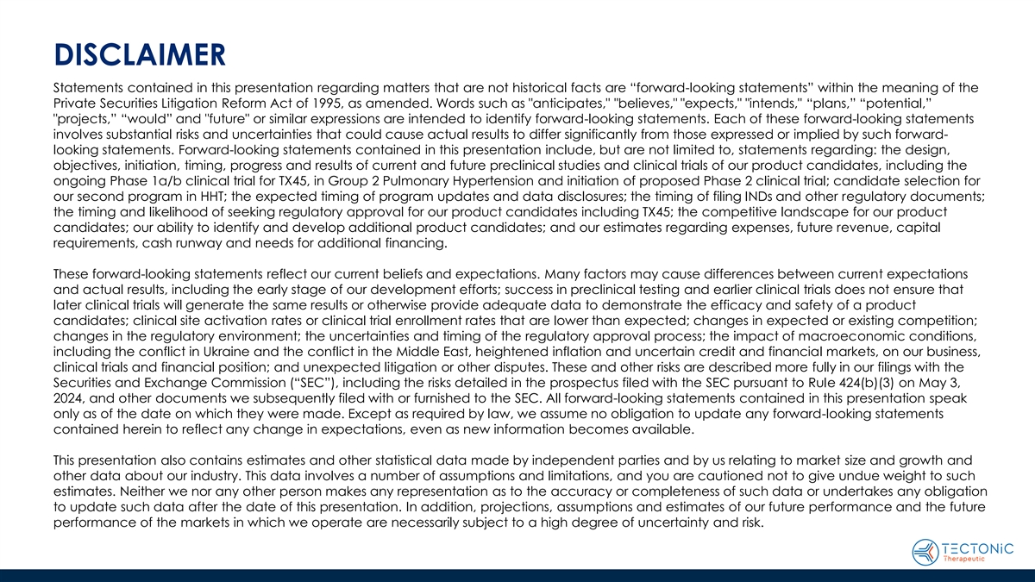
DISCLAIMER Statements contained in this presentation regarding matters that are not historical facts are “forward-looking statements” within the meaning of the Private Securities Litigation Reform Act of 1995, as amended. Words such as anticipates, believes, expects, intends, “plans,” “potential,” projects,” “would” and future or similar expressions are intended to identify forward-looking statements. Each of these forward-looking statements involves substantial risks and uncertainties that could cause actual results to differ significantly from those expressed or implied by such forward- looking statements. Forward-looking statements contained in this presentation include, but are not limited to, statements regarding: the design, objectives, initiation, timing, progress and results of current and future preclinical studies and clinical trials of our product candidates, including the ongoing Phase 1a/b clinical trial for TX45, in Group 2 Pulmonary Hypertension and initiation of proposed Phase 2 clinical trial; candidate selection for our second program in HHT; the expected timing of program updates and data disclosures; the timing of filing INDs and other regulatory documents; the timing and likelihood of seeking regulatory approval for our product candidates including TX45; the competitive landscape for our product candidates; our ability to identify and develop additional product candidates; and our estimates regarding expenses, future revenue, capital requirements, cash runway and needs for additional financing. These forward-looking statements reflect our current beliefs and expectations. Many factors may cause differences between current expectations and actual results, including the early stage of our development efforts; success in preclinical testing and earlier clinical trials does not ensure that later clinical trials will generate the same results or otherwise provide adequate data to demonstrate the efficacy and safety of a product candidates; clinical site activation rates or clinical trial enrollment rates that are lower than expected; changes in expected or existing competition; changes in the regulatory environment; the uncertainties and timing of the regulatory approval process; the impact of macroeconomic conditions, including the conflict in Ukraine and the conflict in the Middle East, heightened inflation and uncertain credit and financial markets, on our business, clinical trials and financial position; and unexpected litigation or other disputes. These and other risks are described more fully in our filings with the Securities and Exchange Commission (“SEC”), including the risks detailed in the prospectus filed with the SEC pursuant to Rule 424(b)(3) on May 3, 2024, and other documents we subsequently filed with or furnished to the SEC. All forward-looking statements contained in this presentation speak only as of the date on which they were made. Except as required by law, we assume no obligation to update any forward-looking statements contained herein to reflect any change in expectations, even as new information becomes available. This presentation also contains estimates and other statistical data made by independent parties and by us relating to market size and growth and other data about our industry. This data involves a number of assumptions and limitations, and you are cautioned not to give undue weight to such estimates. Neither we nor any other person makes any representation as to the accuracy or completeness of such data or undertakes any obligation to update such data after the date of this presentation. In addition, projections, assumptions and estimates of our future performance and the future performance of the markets in which we operate are necessarily subject to a high degree of uncertainty and risk.

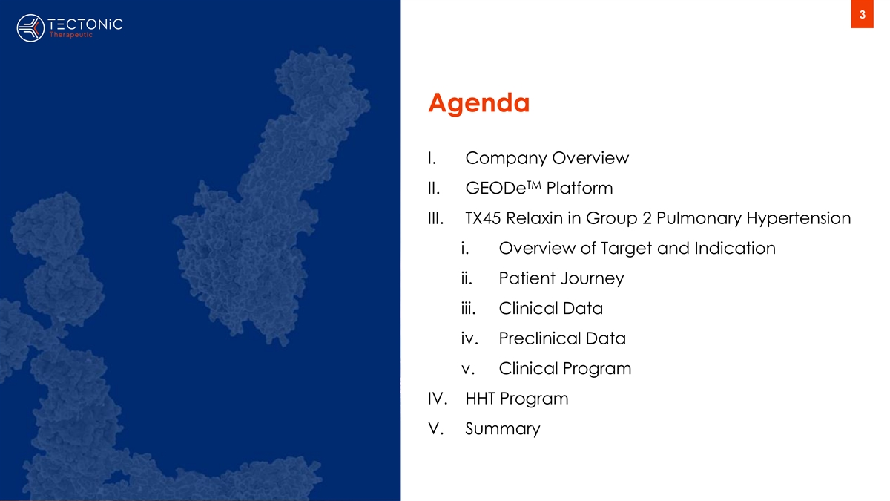
3 Agenda I. Company Overview TM II. GEODe Platform III. TX45 Relaxin in Group 2 Pulmonary Hypertension i. Overview of Target and Indication ii. Patient Journey iii. Clinical Data iv. Preclinical Data v. Clinical Program IV. HHT Program V. Summary

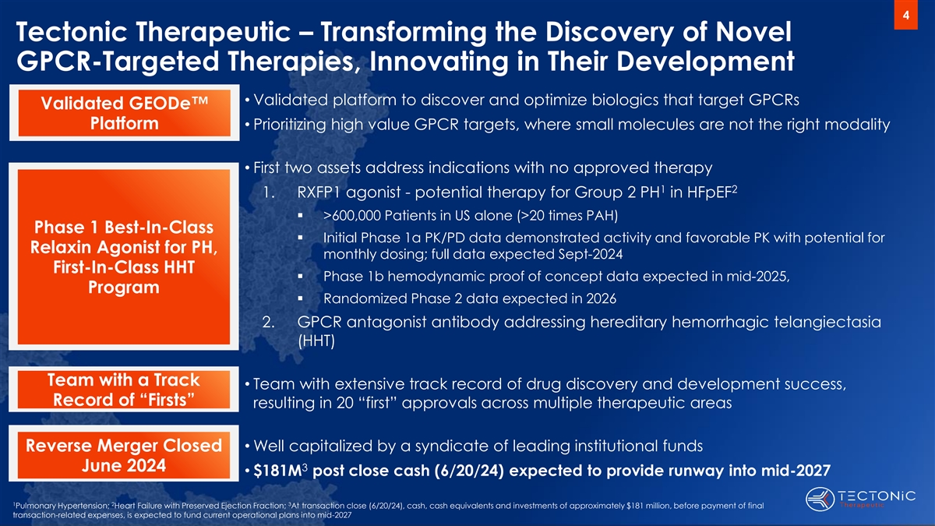
4 Tectonic Therapeutic – Transforming the Discovery of Novel GPCR-Targeted Therapies, Innovating in Their Development • Validated platform to discover and optimize biologics that target GPCRs Validated GEODe Platform• Prioritizing high value GPCR targets, where small molecules are not the right modality • First two assets address indications with no approved therapy 1 2 1. RXFP1 agonist - potential therapy for Group 2 PH in HFpEF ▪ >600,000 Patients in US alone (>20 times PAH) Phase 1 Best-In-Class ▪ Initial Phase 1a PK/PD data demonstrated activity and favorable PK with potential for Relaxin Agonist for PH, monthly dosing; full data expected Sept-2024 First-In-Class HHT ▪ Phase 1b hemodynamic proof of concept data expected in mid-2025, Program ▪ Randomized Phase 2 data expected in 2026 2. GPCR antagonist antibody addressing hereditary hemorrhagic telangiectasia (HHT) Team with a Track • Team with extensive track record of drug discovery and development success, Record of “Firsts” resulting in 20 “first” approvals across multiple therapeutic areas • Well capitalized by a syndicate of leading institutional funds Reverse Merger Closed June 2024 3 • $181M post close cash (6/20/24) expected to provide runway into mid-2027 1 2 3 Pulmonary Hypertension; Heart Failure with Preserved Ejection Fraction; At transaction close (6/20/24), cash, cash equivalents and investments of approximately $181 million, before payment of final transaction-related expenses, is expected to fund current operational plans into mid-2027

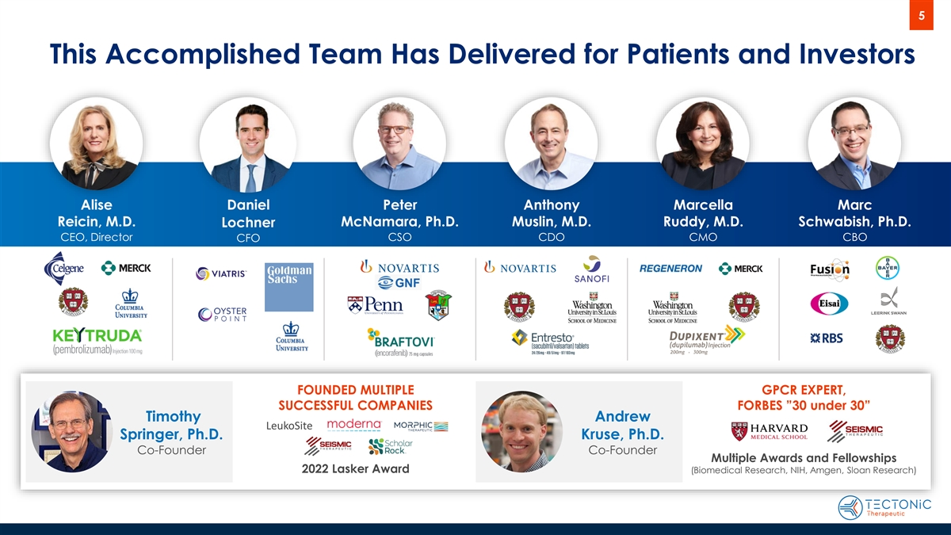
5 This Accomplished Team Has Delivered for Patients and Investors Alise Daniel Peter Anthony Marcella Marc Reicin, M.D. McNamara, Ph.D. Muslin, M.D. Ruddy, M.D. Schwabish, Ph.D. Lochner CEO, Director CSO CDO CMO CBO CFO FOUNDED MULTIPLE GPCR EXPERT, SUCCESSFUL COMPANIES FORBES ”30 under 30” Timothy Andrew LeukoSite Springer, Ph.D. Kruse, Ph.D. Co-Founder Co-Founder Multiple Awards and Fellowships 2022 Lasker Award (Biomedical Research, NIH, Amgen, Sloan Research)

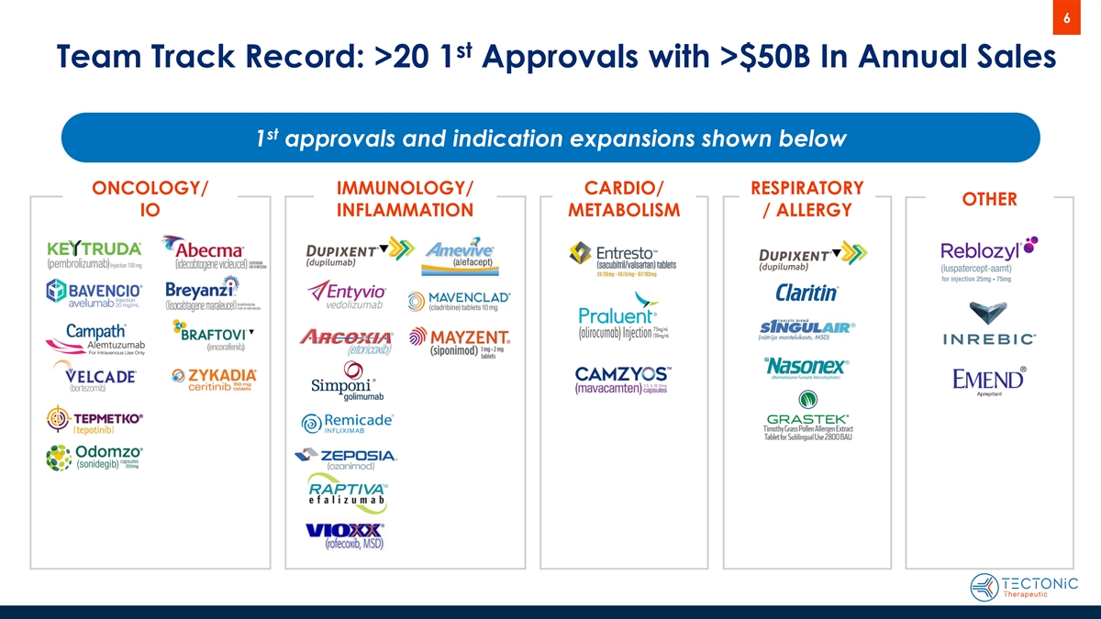
6 st Team Track Record: >20 1 Approvals with >$50B In Annual Sales st 1 approvals and indication expansions shown below ONCOLOGY/ IMMUNOLOGY/ CARDIO/ RESPIRATORY OTHER IO INFLAMMATION METABOLISM / ALLERGY

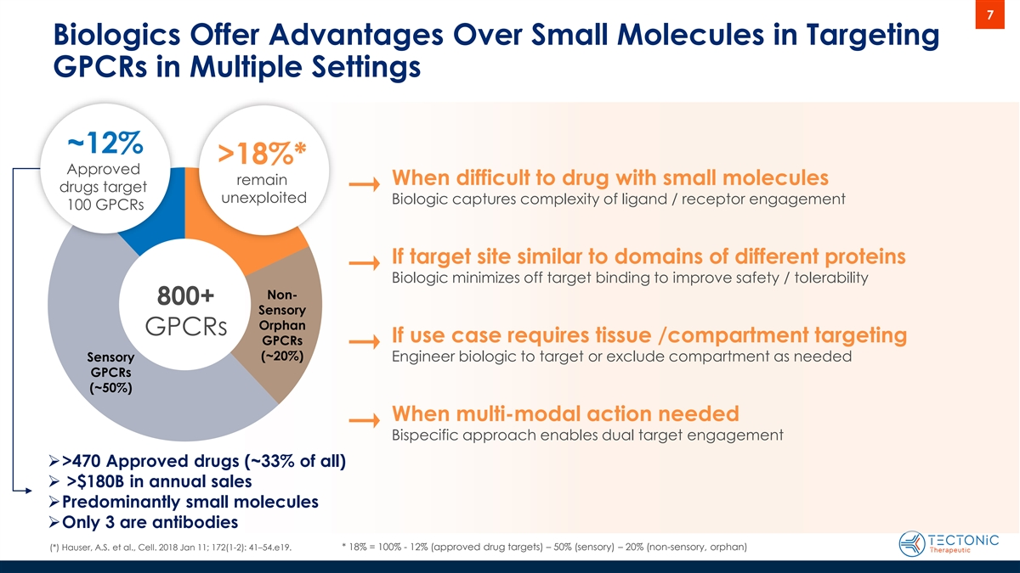
7 Biologics Offer Advantages Over Small Molecules in Targeting GPCRs in Multiple Settings ~12% >18%* Approved remain When difficult to drug with small molecules drugs target unexploited Biologic captures complexity of ligand / receptor engagement 100 GPCRs If target site similar to domains of different proteins Biologic minimizes off target binding to improve safety / tolerability Non- 800+ Sensory Orphan GPCRs If use case requires tissue /compartment targeting GPCRs (~20%) Sensory Engineer biologic to target or exclude compartment as needed GPCRs (~50%) When multi-modal action needed Bispecific approach enables dual target engagement ➢>470 Approved drugs (~33% of all) ➢ >$180B in annual sales ➢Predominantly small molecules ➢Only 3 are antibodies (*) Hauser, A.S. et al., Cell. 2018 Jan 11; 172(1-2): 41–54.e19. * 18% = 100% - 12% (approved drug targets) – 50% (sensory) – 20% (non-sensory, orphan)

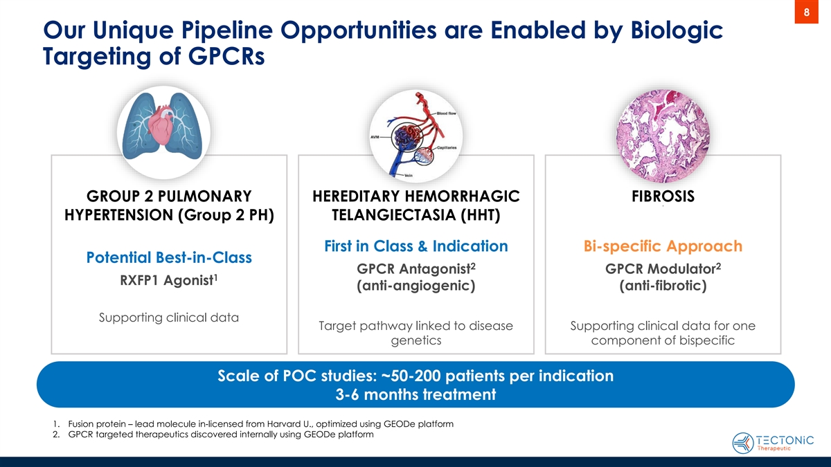
8 Our Unique Pipeline Opportunities are Enabled by Biologic Targeting of GPCRs GROUP 2 PULMONARY HEREDITARY HEMORRHAGIC FIBROSIS f HYPERTENSION (Group 2 PH) TELANGIECTASIA (HHT) First in Class & Indication Bi-specific Approach Potential Best-in-Class 2 2 GPCR Antagonist GPCR Modulator 1 RXFP1 Agonist (anti-angiogenic) (anti-fibrotic) Supporting clinical data Target pathway linked to disease Supporting clinical data for one genetics component of bispecific Scale of POC studies: ~50-200 patients per indication 3-6 months treatment 1. Fusion protein – lead molecule in-licensed from Harvard U., optimized using GEODe platform 2. GPCR targeted therapeutics discovered internally using GEODe platform

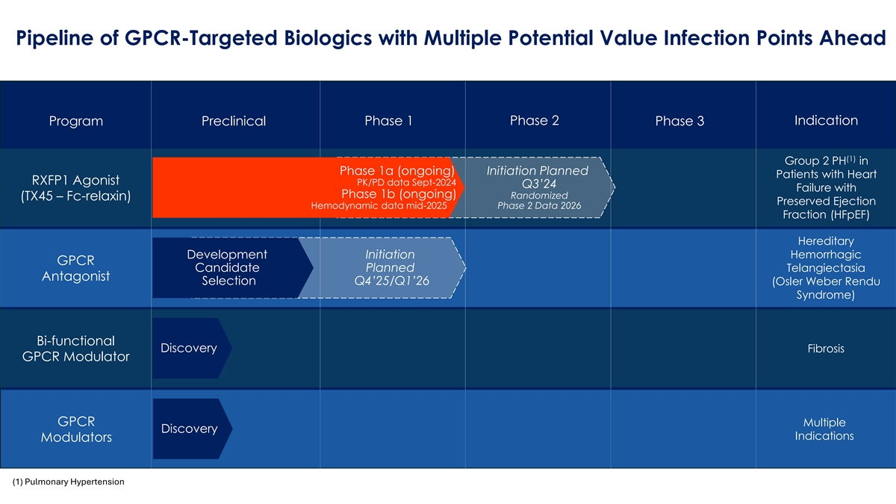
9 Pipeline of GPCR-Targeted Biologics with Multiple Potential Value Infection Points Ahead Phase 1 Phase 2 Indication Program Preclinical Phase 3 (1) Group 2 PH in Phase 1a (ongo ing) Initiation Planned Patients with Heart RXFP1 Agonist PK/PD data Sept-2024 Q3’24 Failure with Phase 1b (ongoing) Randomized (TX45 – Fc-relaxin) Preserved Ejection Hemodynami c data mid-2025 Phase 2 Data 2026 Fraction (HFpEF) Hereditary Development Initiation Hemorrhagic GPCR Candidat e Planned Telangiectasia Antagonist Select ion Q4’25/Q1’26 (Osler Weber Rendu Syndrome) Bi-functional Discovery Fibrosis GPCR Modulator GPCR Multiple Discovery Indications Modulators (1) Pulmonary Hypertension


10 GEODe PLATFORM Proprietary, validated platform, enables reproducible discovery and optimization of GPCR targeted biologics

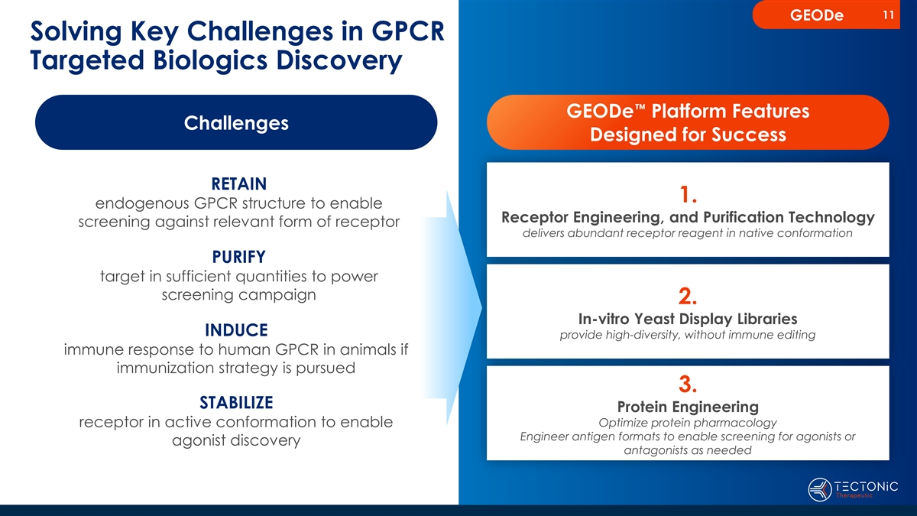
11 GEODe Solving Key Challenges in GPCR Targeted Biologics Discovery GEODe Platform Features Challenges Designed for Success RETAIN 1. endogenous GPCR structure to enable Receptor Engineering, and Purification Technology screening against relevant form of receptor delivers abundant receptor reagent in native conformation PURIFY target in sufficient quantities to power screening campaign 2. In-vitro Yeast Display Libraries INDUCE provide high-diversity, without immune editing immune response to human GPCR in animals if immunization strategy is pursued 3. STABILIZE Protein Engineering receptor in active conformation to enable Optimize protein pharmacology Engineer antigen formats to enable screening for agonists or agonist discovery antagonists as needed

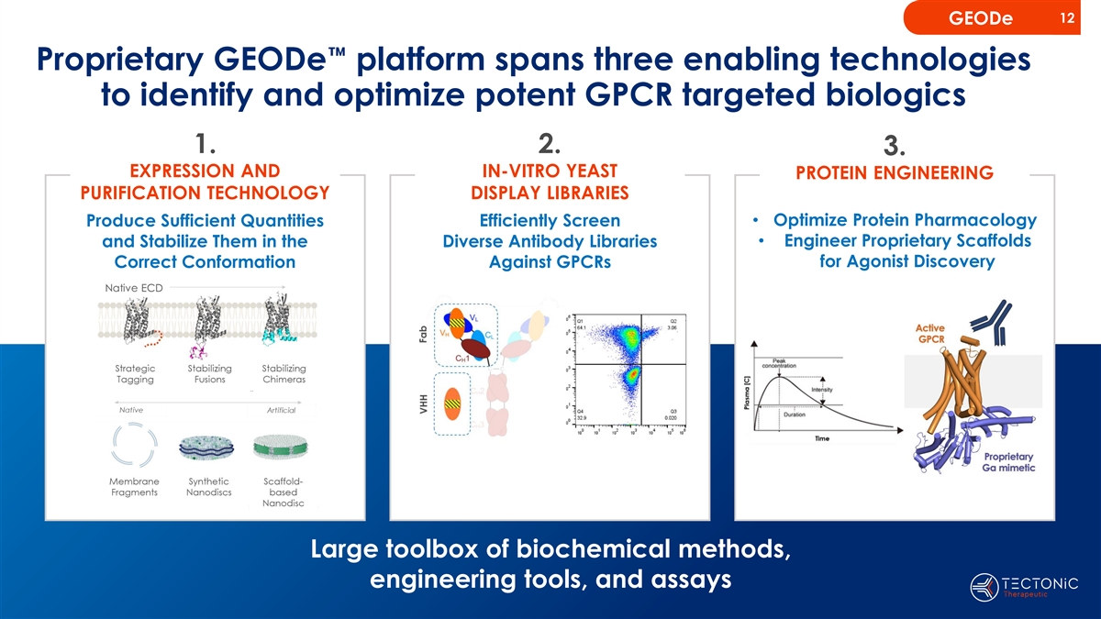
12 GEODe Proprietary GEODe platform spans three enabling technologies to identify and optimize potent GPCR targeted biologics 1. 2. 3. EXPRESSION AND IN-VITRO YEAST PROTEIN ENGINEERING PURIFICATION TECHNOLOGY DISPLAY LIBRARIES • Optimize Protein Pharmacology Produce Sufficient Quantities Efficiently Screen • Engineer Proprietary Scaffolds and Stabilize Them in the Diverse Antibody Libraries for Agonist Discovery Correct Conformation Against GPCRs Large toolbox of biochemical methods, engineering tools, and assays

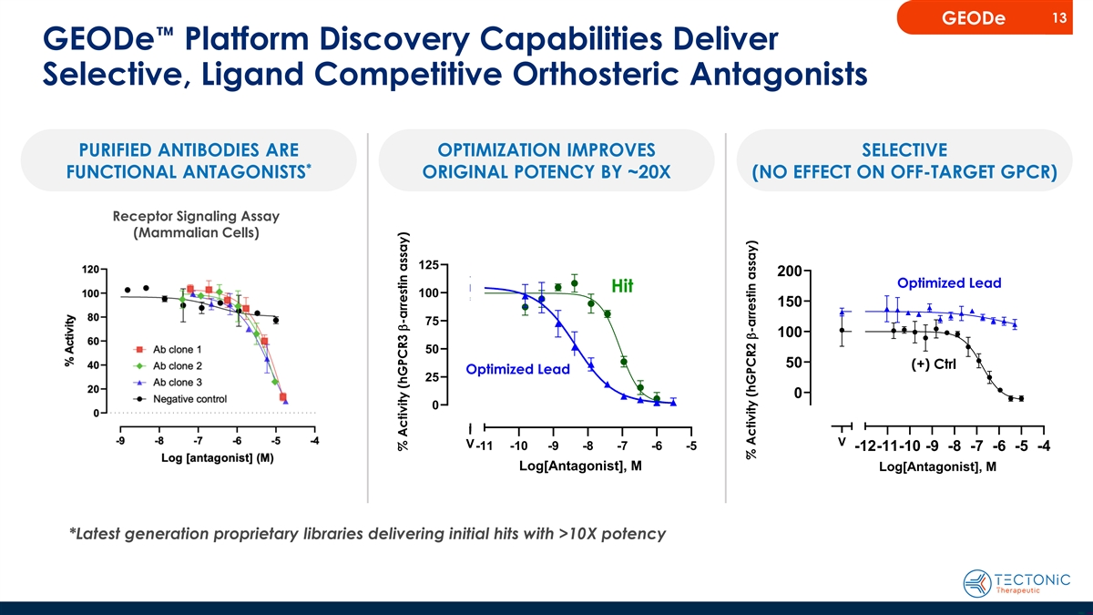
13 GEODe GEODe Platform Discovery Capabilities Deliver Selective, Ligand Competitive Orthosteric Antagonists PURIFIED ANTIBODIES ARE OPTIMIZATION IMPROVES SELECTIVE * FUNCTIONAL ANTAGONISTS ORIGINAL POTENCY BY ~20X (NO EFFECT ON OFF-TARGET GPCR) Receptor Signaling Assay (Mammalian Cells) 125 200 TX786 TX786 Optimized Lead Hit 100 TX774 150 (+) control 75 100 50 50 (+) Ctrl Optimized Lead 25 0 0 V V -11 -10 -9 -8 -7 -6 -5 -12-11-10 -9 -8 -7 -6 -5 -4 Log[Antagonist], M Log[Antagonist], M *Latest generation proprietary libraries delivering initial hits with >10X potency % Activity (hGPCR3 b-arrestin assay) % Activity % Activity (hGPCR2 b-arrestin assay) %Actvity

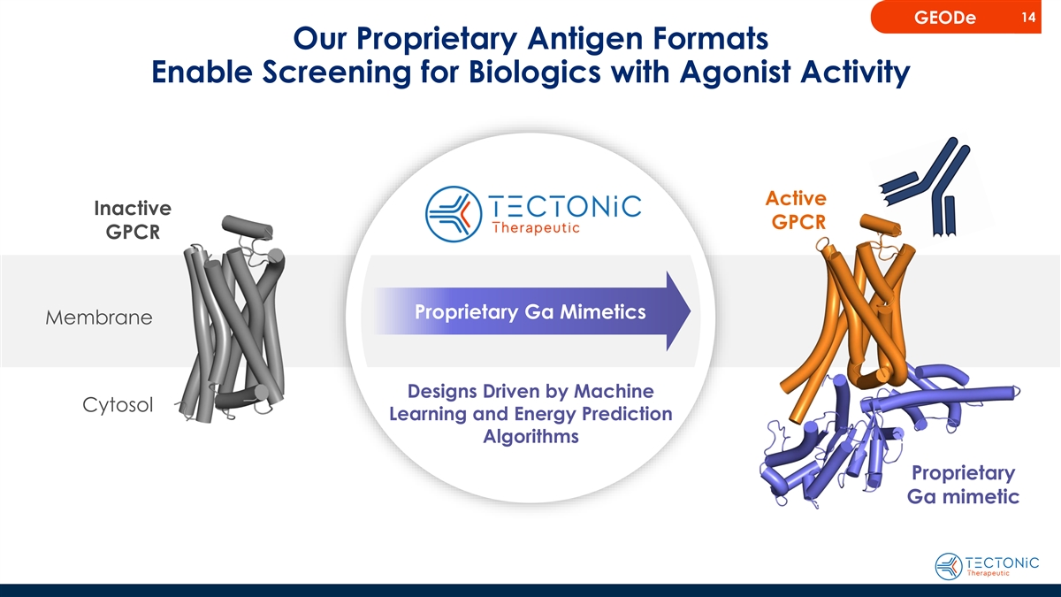
14 GEODe Our Proprietary Antigen Formats Enable Screening for Biologics with Agonist Activity Active Inactive GPCR GPCR Proprietary Ga Mimetics Membrane Designs Driven by Machine Cytosol Learning and Energy Prediction Algorithms Proprietary Gα mimetic

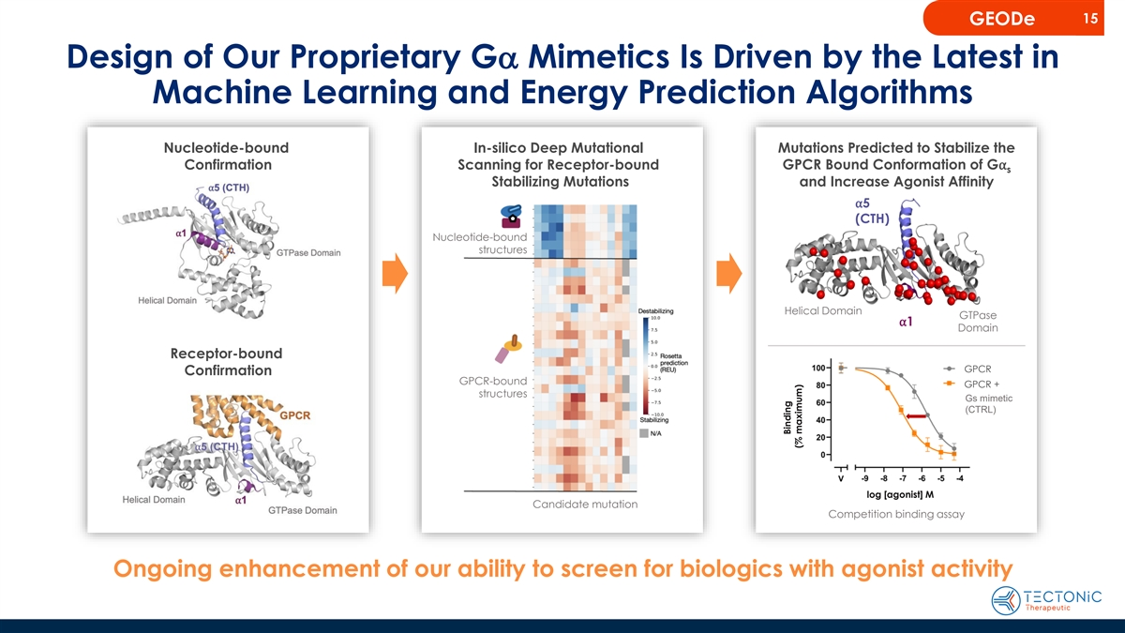
15 GEODe Design of Our Proprietary Ga Mimetics Is Driven by the Latest in Machine Learning and Energy Prediction Algorithms Nucleotide-bound In-silico Deep Mutational Mutations Predicted to Stabilize the Confirmation Scanning for Receptor-bound GPCR Bound Conformation of G⍺ s Stabilizing Mutations and Increase Agonist Affinity ⍺5 (CTH) Nucleotide-bound structures Helical Domain GTPase ⍺1 Domain Receptor-bound A2 G A PCR Confirmation GPCR-bound GPCR + A2A + structures Gs mimetic (CTRL) log [agonist] M Candidate mutation Competition binding assay Ongoing enhancement of our ability to screen for biologics with agonist activity Binding (% maximum)

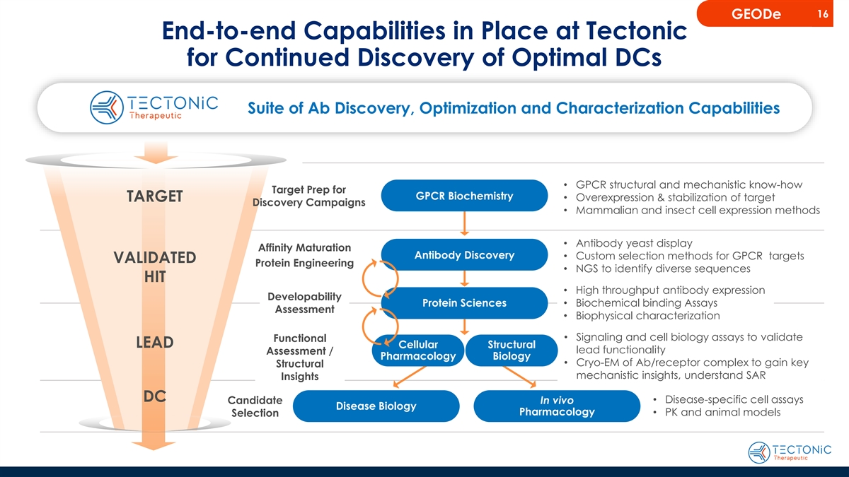
16 GEODe End-to-end Capabilities in Place at Tectonic for Continued Discovery of Optimal DCs Suite of Ab Discovery, Optimization and Characterization Capabilities • GPCR structural and mechanistic know-how Target Prep for GPCR Biochemistry • Overexpression & stabilization of target TARGET Discovery Campaigns • Mammalian and insect cell expression methods • Antibody yeast display Affinity Maturation Antibody Discovery • Custom selection methods for GPCR targets VALIDATED Protein Engineering • NGS to identify diverse sequences HIT • High throughput antibody expression Developability Protein Sciences• Biochemical binding Assays Assessment • Biophysical characterization • Signaling and cell biology assays to validate Functional LEAD Cellular Structural lead functionality Assessment / Pharmacology Biology • Cryo-EM of Ab/receptor complex to gain key Structural mechanistic insights, understand SAR Insights DC Candidate In vivo• Disease-specific cell assays Disease Biology Pharmacology • PK and animal models Selection

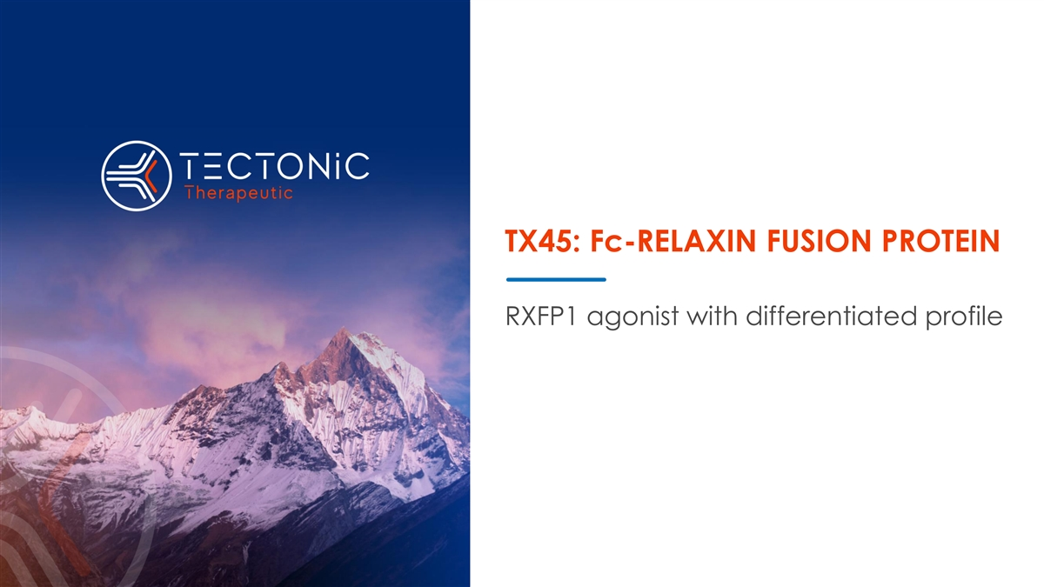
TX45: Fc-RELAXIN FUSION PROTEIN RXFP1 agonist with differentiated profile

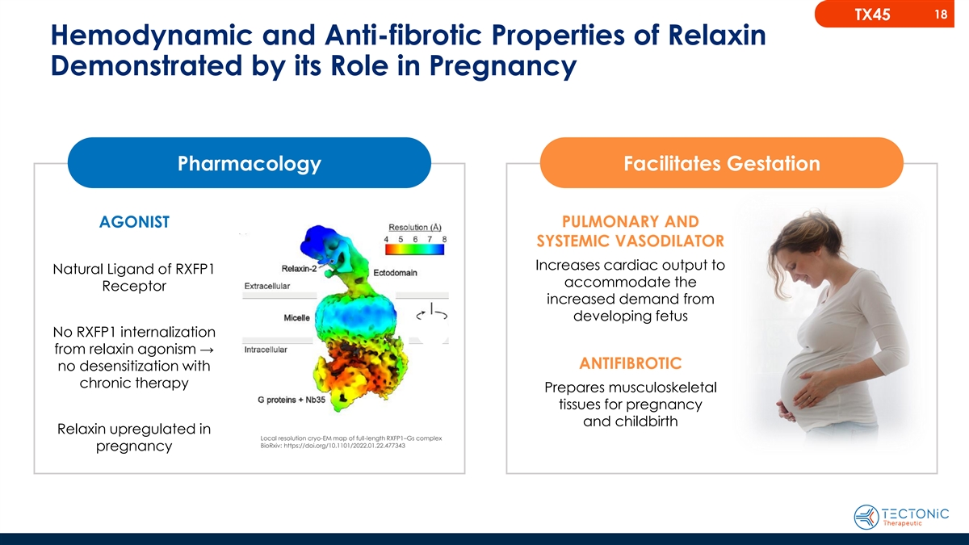
18 TX45 Hemodynamic and Anti-fibrotic Properties of Relaxin Demonstrated by its Role in Pregnancy Pharmacology Facilitates Gestation PULMONARY AND AGONIST SYSTEMIC VASODILATOR Increases cardiac output to Natural Ligand of RXFP1 accommodate the Receptor increased demand from developing fetus No RXFP1 internalization from relaxin agonism → ANTIFIBROTIC no desensitization with chronic therapy Prepares musculoskeletal tissues for pregnancy and childbirth Relaxin upregulated in Local resolution cryo-EM map of full-length RXFP1–Gs complex BioRxiv: https://doi.org/10.1101/2022.01.22.477343 pregnancy

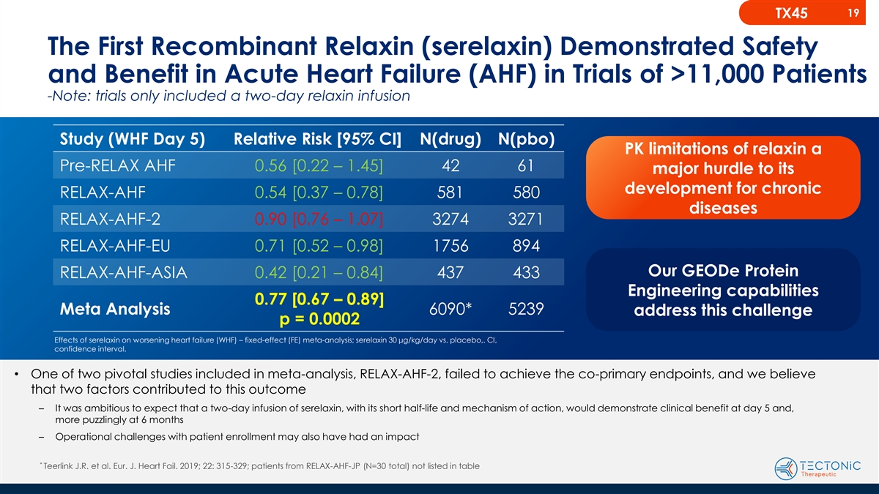
19 TX45 The First Recombinant Relaxin (serelaxin) Demonstrated Safety and Benefit in Acute Heart Failure (AHF) in Trials of >11,000 Patients -Note: trials only included a two-day relaxin infusion Study (WHF Day 5) Relative Risk [95% CI] N(drug) N(pbo) PK limitations of relaxin a Pre-RELAX AHF 0.56 [0.22 – 1.45] 42 61 major hurdle to its development for chronic RELAX-AHF 0.54 [0.37 – 0.78] 581 580 diseases RELAX-AHF-2 0.90 [0.76 – 1.07] 3274 3271 RELAX-AHF-EU 0.71 [0.52 – 0.98] 1756 894 Our GEODe Protein RELAX-AHF-ASIA 0.42 [0.21 – 0.84] 437 433 Engineering capabilities 0.77 [0.67 – 0.89] Meta Analysis 6090* 5239 address this challenge p = 0.0002 Effects of serelaxin on worsening heart failure (WHF) – fixed-effect (FE) meta-analysis; serelaxin 30 μg/kg/day vs. placebo,. CI, confidence interval. • One of two pivotal studies included in meta-analysis, RELAX-AHF-2, failed to achieve the co-primary endpoints, and we believe that two factors contributed to this outcome – It was ambitious to expect that a two-day infusion of serelaxin, with its short half-life and mechanism of action, would demonstrate clinical benefit at day 5 and, more puzzlingly at 6 months – Operational challenges with patient enrollment may also have had an impact * Teerlink J.R. et al. Eur. J. Heart Fail. 2019; 22: 315-329; patients from RELAX-AHF-JP (N=30 total) not listed in table

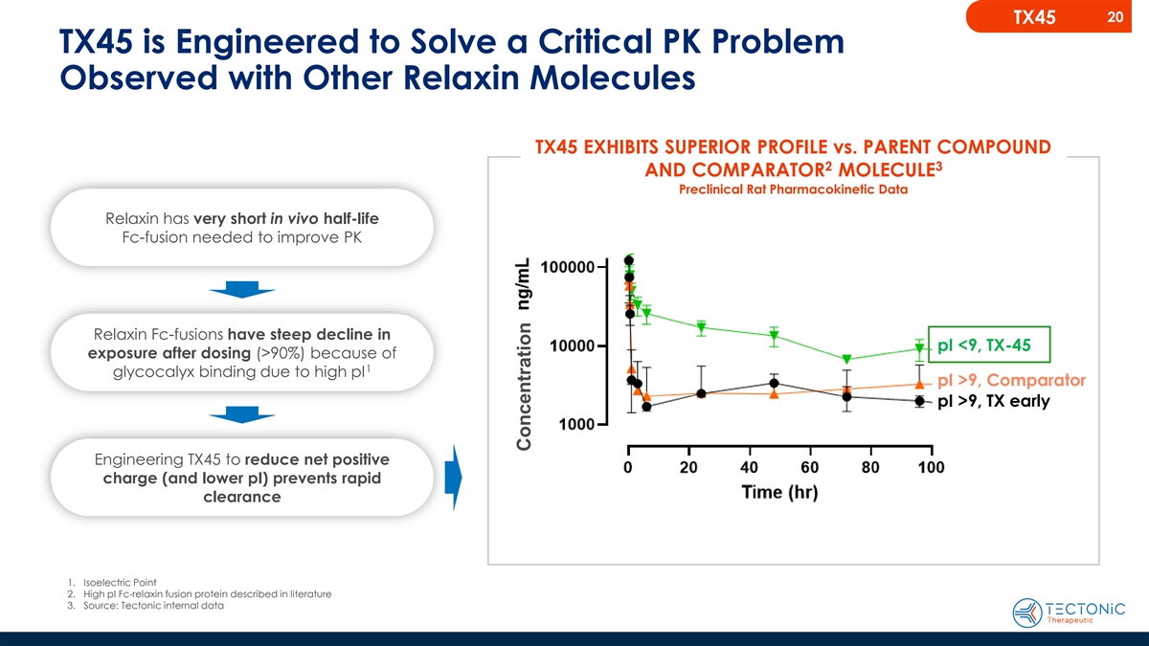
20 TX45 TX45 is Engineered to Solve a Critical PK Problem Observed with Other Relaxin Molecules TX45 EXHIBITS SUPERIOR PROFILE vs. PARENT COMPOUND 2 3 AND COMPARATOR MOLECULE Preclinical Rat Pharmacokinetic Data Relaxin has very short in vivo half-life Fc-fusion needed to improve PK Relaxin Fc-fusions have steep decline in pI <9, TX-45 exposure after dosing (>90%) because of 1 glycocalyx binding due to high pI pI >9, Comparator pI >9, TX early Engineering TX45 to reduce net positive charge (and lower pI) prevents rapid clearance 1. Isoelectric Point 2. High pI Fc-relaxin fusion protein described in literature 3. Source: Tectonic internal data Concentration

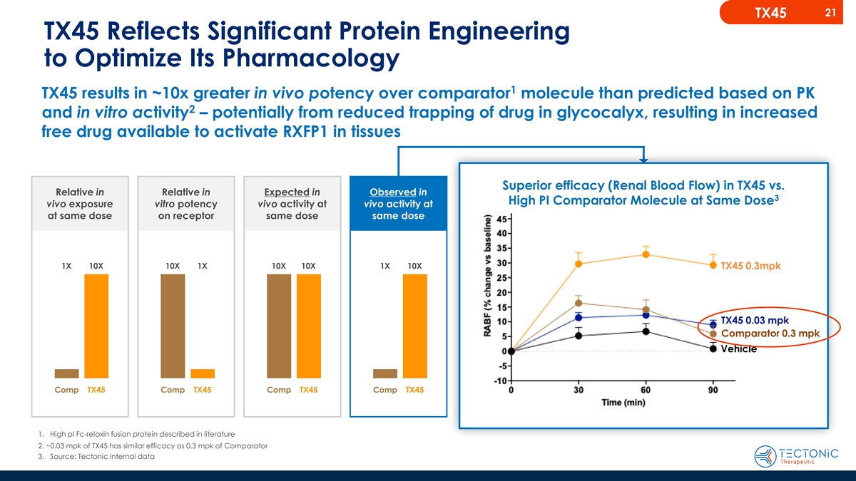
21 TX45 TX45 Reflects Significant Protein Engineering to Optimize Its Pharmacology 1 TX45 results in ~10x greater in vivo potency over comparator molecule than predicted based on PK 2 and in vitro activity – potentially from reduced trapping of drug in glycocalyx, resulting in increased free drug available to activate RXFP1 in tissues Superior efficacy (Renal Blood Flow) in TX45 vs. Relative in Relative in Expected in Observed in 3 High PI Comparator Molecule at Same Dose vivo exposure vitro potency vivo activity at vivo activity at at same dose on receptor same dose same dose 1X 10X 10X 1X 10X 10X 1X 10X TX45 0.3mpk TX45 0.03 mpk Comparator 0.3 mpk Vehicle Comp TX45 Comp TX45 Comp TX45 Comp TX45 1. High pI Fc-relaxin fusion protein described in literature 2. ~0.03 mpk of TX45 has similar efficacy as 0.3 mpk of Comparator 3. Source: Tectonic internal data

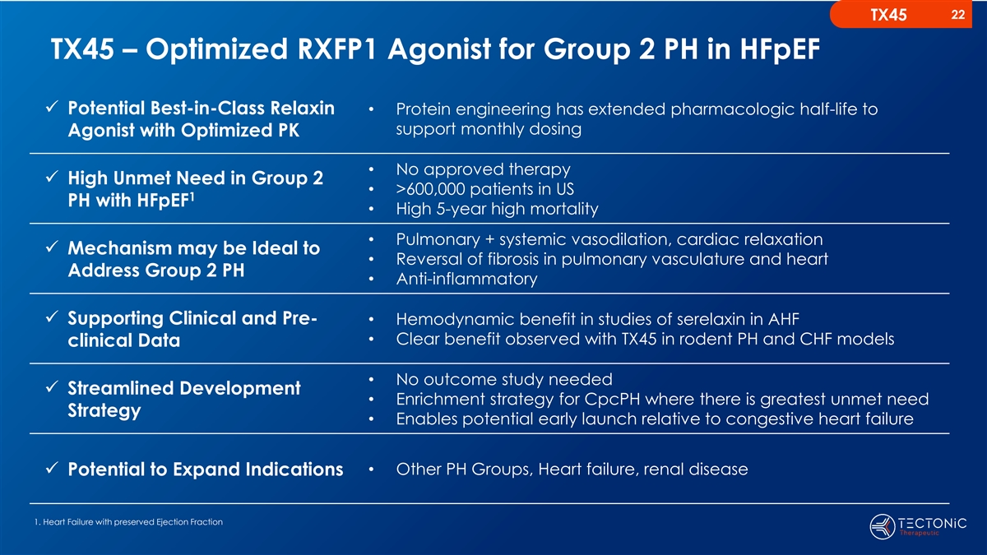
22 TX45 TX45 – Optimized RXFP1 Agonist for Group 2 PH in HFpEF ✓ Potential Best-in-Class Relaxin • Protein engineering has extended pharmacologic half-life to support monthly dosing Agonist with Optimized PK • No approved therapy ✓ High Unmet Need in Group 2 • >600,000 patients in US 1 PH with HFpEF • High 5-year high mortality • Pulmonary + systemic vasodilation, cardiac relaxation ✓ Mechanism may be Ideal to • Reversal of fibrosis in pulmonary vasculature and heart Address Group 2 PH • Anti-inflammatory ✓ Supporting Clinical and Pre-• Hemodynamic benefit in studies of serelaxin in AHF • Clear benefit observed with TX45 in rodent PH and CHF models clinical Data • No outcome study needed ✓ Streamlined Development • Enrichment strategy for CpcPH where there is greatest unmet need Strategy • Enables potential early launch relative to congestive heart failure • Other PH Groups, Heart failure, renal disease ✓ Potential to Expand Indications 1. Heart Failure with preserved Ejection Fraction

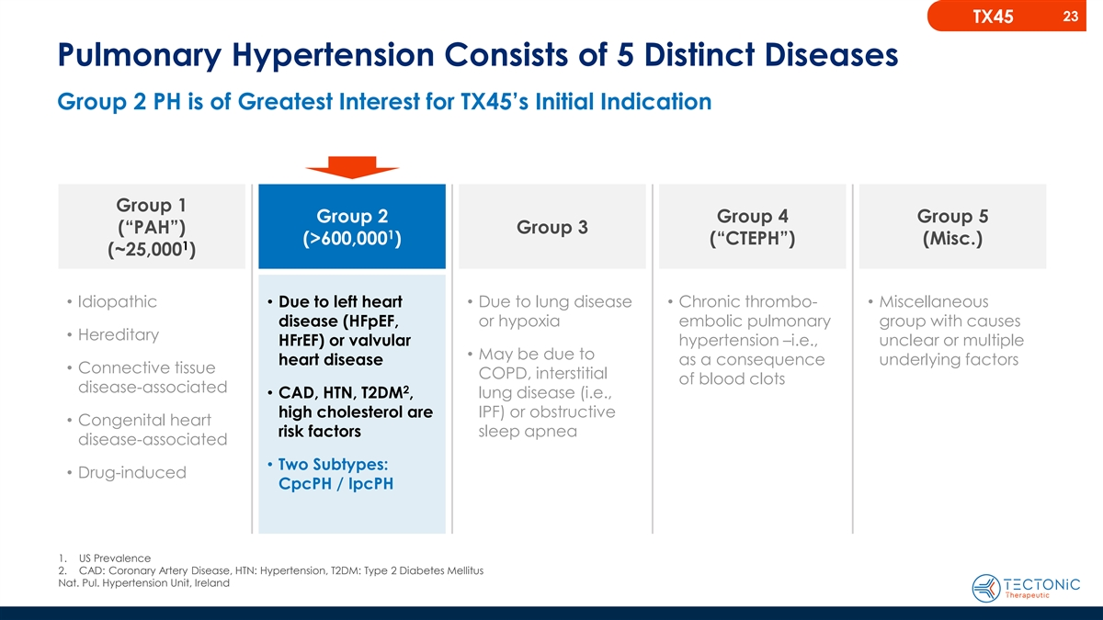
23 TX45 Pulmonary Hypertension Consists of 5 Distinct Diseases Group 2 PH is of Greatest Interest for TX45’s Initial Indication Group 1 Group 2 Group 4 Group 5 (“PAH”) Group 3 1 (>600,000 ) (“CTEPH”) (Misc.) 1 (~25,000 ) • Idiopathic• Due to left heart • Due to lung disease • Chronic thrombo-• Miscellaneous or hypoxia embolic pulmonary group with causes disease (HFpEF, • Hereditary HFrEF) or valvular hypertension –i.e., unclear or multiple • May be due to heart disease as a consequence underlying factors • Connective tissue COPD, interstitial of blood clots disease-associated 2 • CAD, HTN, T2DM , lung disease (i.e., high cholesterol are IPF) or obstructive • Congenital heart sleep apnea risk factors disease-associated • Two Subtypes: • Drug-induced CpcPH / IpcPH 1. US Prevalence 2. CAD: Coronary Artery Disease, HTN: Hypertension, T2DM: Type 2 Diabetes Mellitus Nat. Pul. Hypertension Unit, Ireland

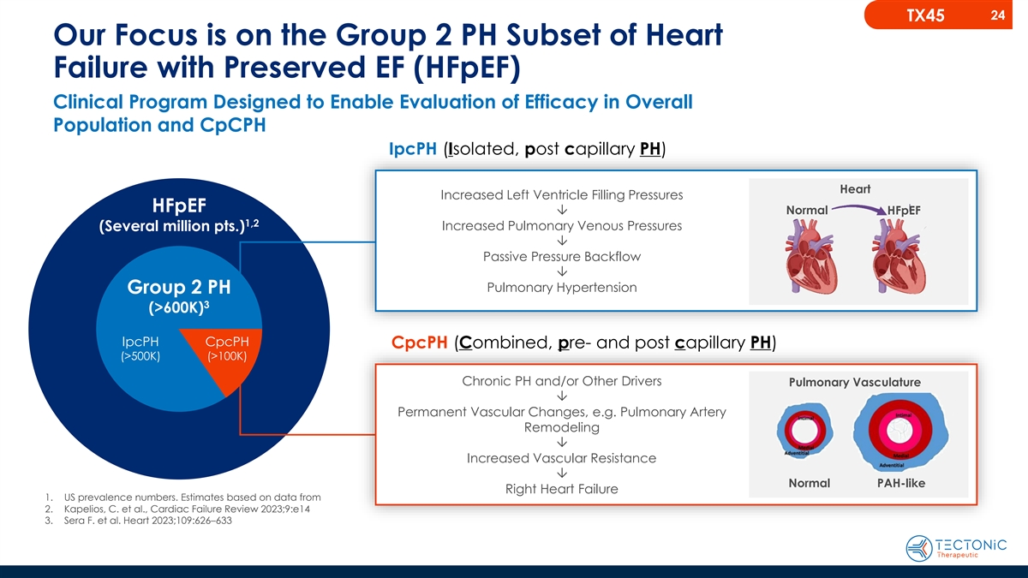
24 TX45 Our Focus is on the Group 2 PH Subset of Heart Failure with Preserved EF (HFpEF) Clinical Program Designed to Enable Evaluation of Efficacy in Overall Population and CpCPH IpcPH (Isolated, post capillary PH) Heart Increased Left Ventricle Filling Pressures HFpEF Normal Ô HFpEF 1,2 Increased Pulmonary Venous Pressures (Several million pts.) Ô Passive Pressure Backflow Ô Pulmonary Hypertension Group 2 PH 3 (>600K) IpcPH CpcPH CpcPH (Combined, pre- and post capillary PH) (>500K) (>100K) Chronic PH and/or Other Drivers Pulmonary Vasculature Ô Permanent Vascular Changes, e.g. Pulmonary Artery Remodeling Ô Increased Vascular Resistance Ô Normal PAH-like Right Heart Failure 1. US prevalence numbers. Estimates based on data from 2. Kapelios, C. et al., Cardiac Failure Review 2023;9:e14 3. Sera F. et al. Heart 2023;109:626–633


25 Group 2 PH: Patient Journey

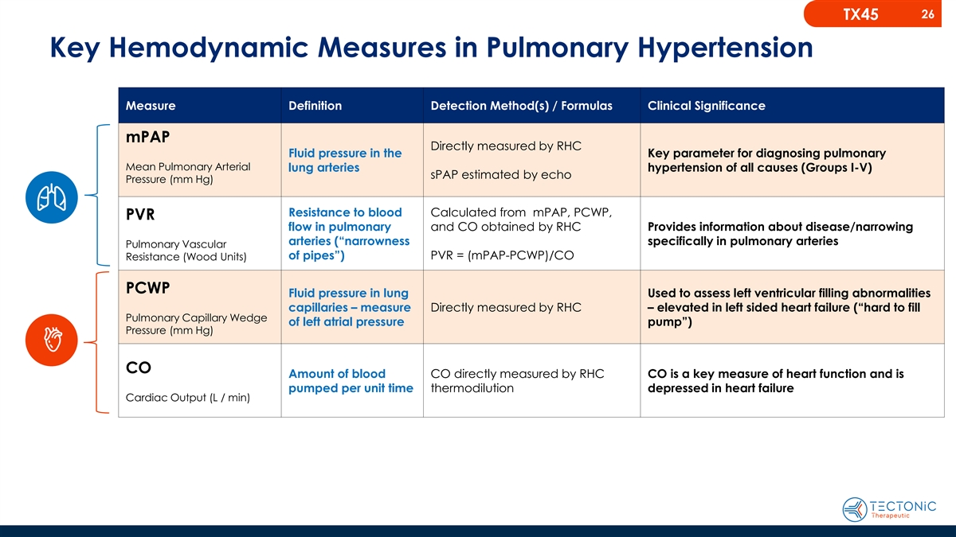
26 TX45 Key Hemodynamic Measures in Pulmonary Hypertension Measure Definition Detection Method(s) / Formulas Clinical Significance mPAP Directly measured by RHC Fluid pressure in the Key parameter for diagnosing pulmonary Mean Pulmonary Arterial lung arteries hypertension of all causes (Groups I-V) sPAP estimated by echo Pressure (mm Hg) Resistance to blood Calculated from mPAP, PCWP, PVR flow in pulmonary and CO obtained by RHC Provides information about disease/narrowing arteries (“narrowness specifically in pulmonary arteries Pulmonary Vascular of pipes”) PVR = (mPAP-PCWP)/CO Resistance (Wood Units) PCWP Fluid pressure in lung Used to assess left ventricular filling abnormalities capillaries – measure Directly measured by RHC – elevated in left sided heart failure (“hard to fill Pulmonary Capillary Wedge of left atrial pressure pump”) Pressure (mm Hg) CO Amount of blood CO directly measured by RHC CO is a key measure of heart function and is pumped per unit time thermodilution depressed in heart failure Cardiac Output (L / min)

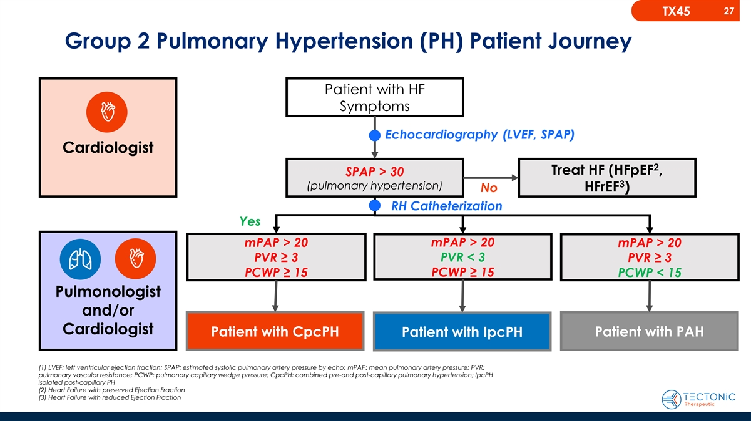
27 TX45 Group 2 Pulmonary Hypertension (PH) Patient Journey Patient with HF Symptoms Echocardiography (LVEF, SPAP) Cardiologist 2 Treat HF (HFpEF , SPAP > 30 3 (pulmonary hypertension) HFrEF ) No RH Catheterization Yes mPAP > 20 mPAP > 20 mPAP > 20 PVR ≥ 3 PVR < 3 PVR ≥ 3 PCWP ≥ 15 PCWP ≥ 15 PCWP < 15 Pulmonologist and/or Cardiologist Patient with CpcPH Patient with IpcPH Patient with PAH (1) LVEF: left ventricular ejection fraction; SPAP: estimated systolic pulmonary artery pressure by echo; mPAP: mean pulmonary artery pressure; PVR: pulmonary vascular resistance; PCWP: pulmonary capillary wedge pressure; CpcPH: combined pre-and post-capillary pulmonary hypertension; IpcPH isolated post-capillary PH (2) Heart Failure with preserved Ejection Fraction (3) Heart Failure with reduced Ejection Fraction

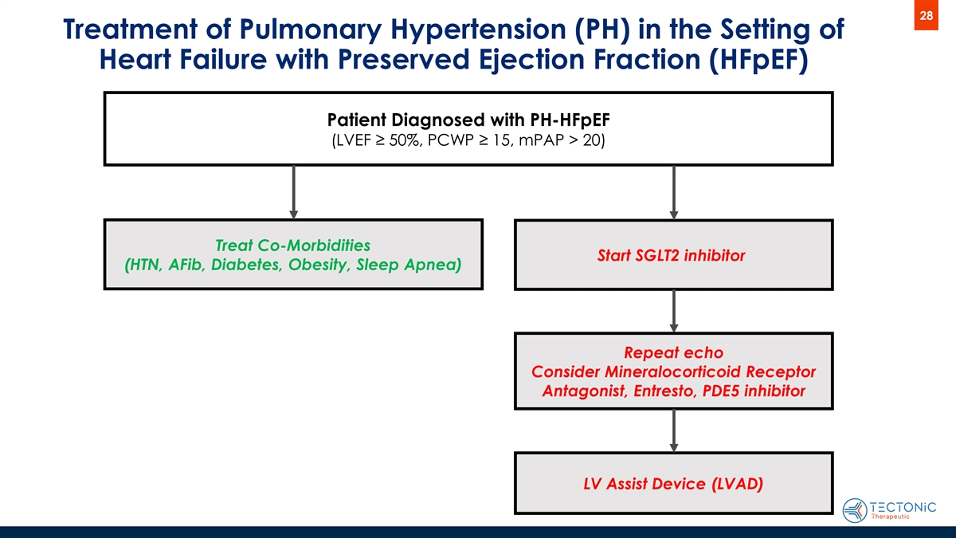
28 Treatment of Pulmonary Hypertension (PH) in the Setting of Heart Failure with Preserved Ejection Fraction (HFpEF) Patient Diagnosed with PH-HFpEF (LVEF ≥ 50%, PCWP ≥ 15, mPAP > 20) Treat Co-Morbidities Start SGLT2 inhibitor (HTN, AFib, Diabetes, Obesity, Sleep Apnea) Repeat echo Consider Mineralocorticoid Receptor Antagonist, Entresto, PDE5 inhibitor LV Assist Device (LVAD)

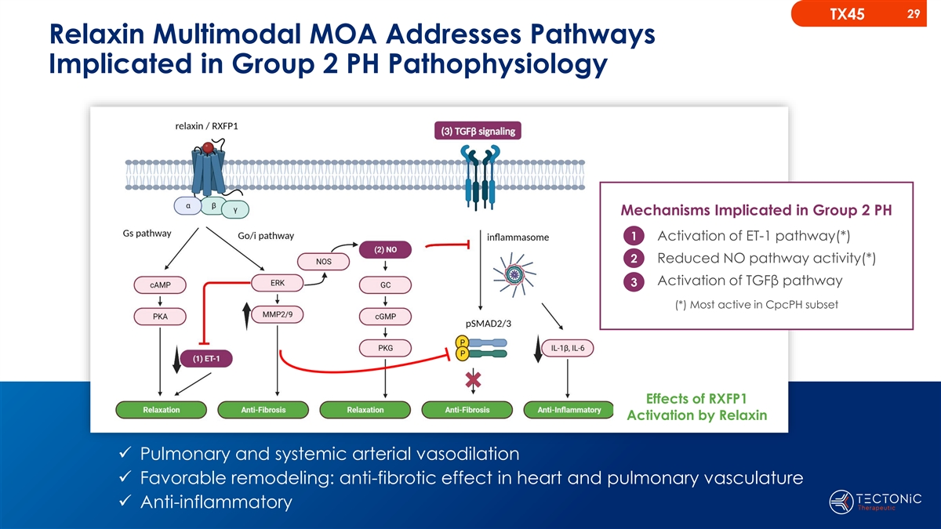
29 TX45 Relaxin Multimodal MOA Addresses Pathways Implicated in Group 2 PH Pathophysiology Mechanisms Implicated in Group 2 PH 1 Activation of ET-1 pathway(*) 2 Reduced NO pathway activity(*) Activation of TGFβ pathway 3 (*) Most active in CpcPH subset Effects of RXFP1 Activation by Relaxin ✓ Pulmonary and systemic arterial vasodilation ✓ Favorable remodeling: anti-fibrotic effect in heart and pulmonary vasculature ✓ Anti-inflammatory

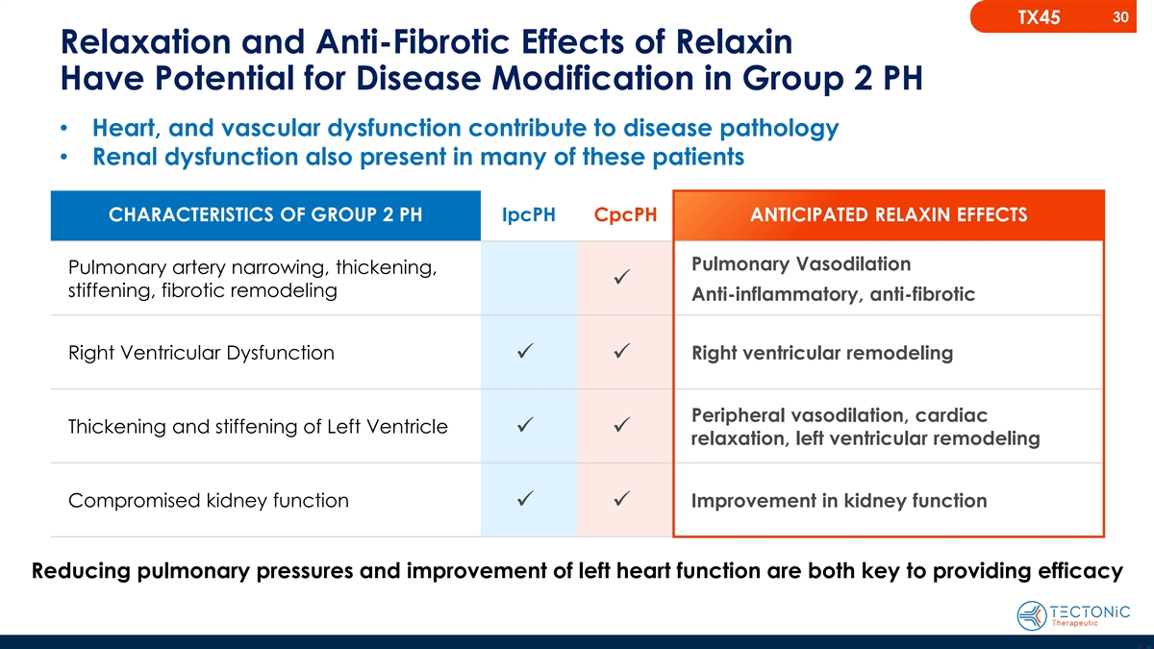
30 TX45 Relaxation and Anti-Fibrotic Effects of Relaxin Have Potential for Disease Modification in Group 2 PH • Heart, and vascular dysfunction contribute to disease pathology • Renal dysfunction also present in many of these patients CHARACTERISTICS OF GROUP 2 PH IpcPH CpcPH ANTICIPATED RELAXIN EFFECTS Pulmonary Vasodilation Pulmonary artery narrowing, thickening, ✓ stiffening, fibrotic remodeling Anti-inflammatory, anti-fibrotic Right Ventricular Dysfunction Right ventricular remodeling ✓ ✓ Peripheral vasodilation, cardiac Thickening and stiffening of Left Ventricle ✓ ✓ relaxation, left ventricular remodeling Compromised kidney function Improvement in kidney function ✓ ✓ Reducing pulmonary pressures and improvement of left heart function are both key to providing efficacy

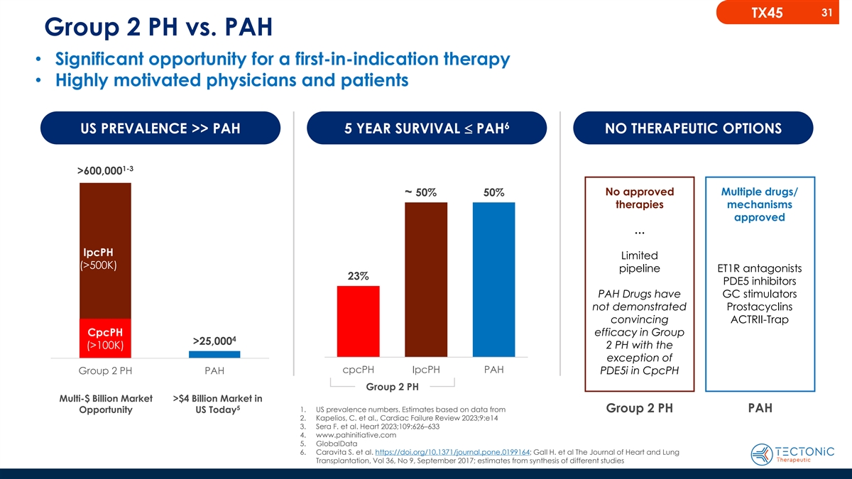
31 TX45 Group 2 PH vs. PAH • Significant opportunity for a first-in-indication therapy • Highly motivated physicians and patients 6 US PREVALENCE >> PAH 5 YEAR SURVIVAL £ PAH NO THERAPEUTIC OPTIONS 1-3 >600,000 No approved Multiple drugs/ ~ 50% 50% therapies mechanisms approved … IpcPH Limited (>500K) pipeline ET1R antagonists 23% PDE5 inhibitors PAH Drugs have GC stimulators not demonstrated Prostacyclins convincing ACTRII-Trap CpcPH efficacy in Group 4 >25,000 (>100K) 2 PH with the exception of cpcPH IpcPH PAH Group 2 PH PAH PDE5i in CpcPH Group 2 PH Multi-$ Billion Market >$4 Billion Market in 5 1. US prevalence numbers. Estimates based on data from Group 2 PH PAH Opportunity US Today 2. Kapelios, C. et al., Cardiac Failure Review 2023;9:e14 3. Sera F. et al. Heart 2023;109:626–633 4. www.pahinitiative.com 5. GlobalData 6. Caravita S. et al. https://doi.org/10.1371/journal.pone.0199164; Gall H. et al The Journal of Heart and Lung Transplantation, Vol 36, No 9, September 2017; estimates from synthesis of different studies

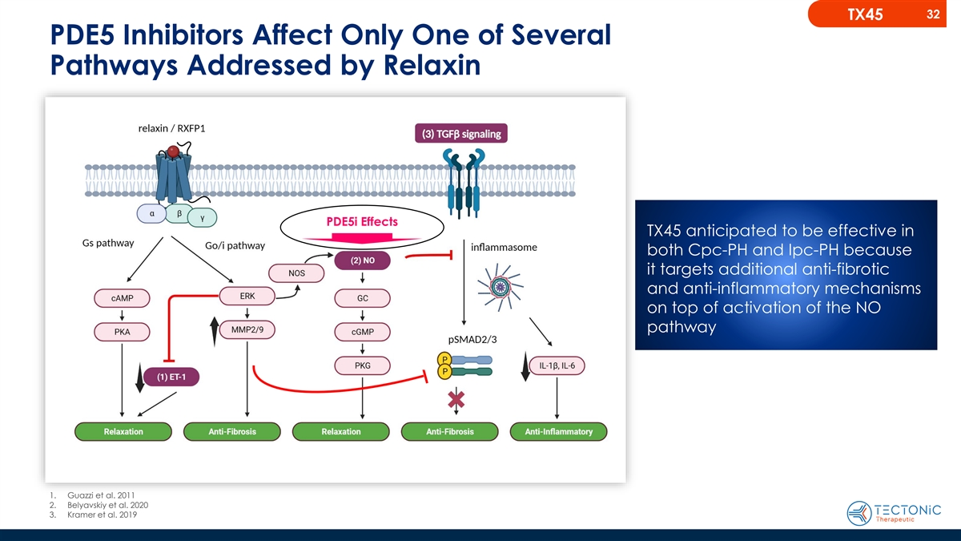
32 TX45 PDE5 Inhibitors Affect Only One of Several Pathways Addressed by Relaxin PDE5i Effects TX45 anticipated to be effective in both Cpc-PH and Ipc-PH because it targets additional anti-fibrotic and anti-inflammatory mechanisms on top of activation of the NO pathway 1. Guazzi et al. 2011 2. Belyavskiy et al. 2020 3. Kramer et al. 2019

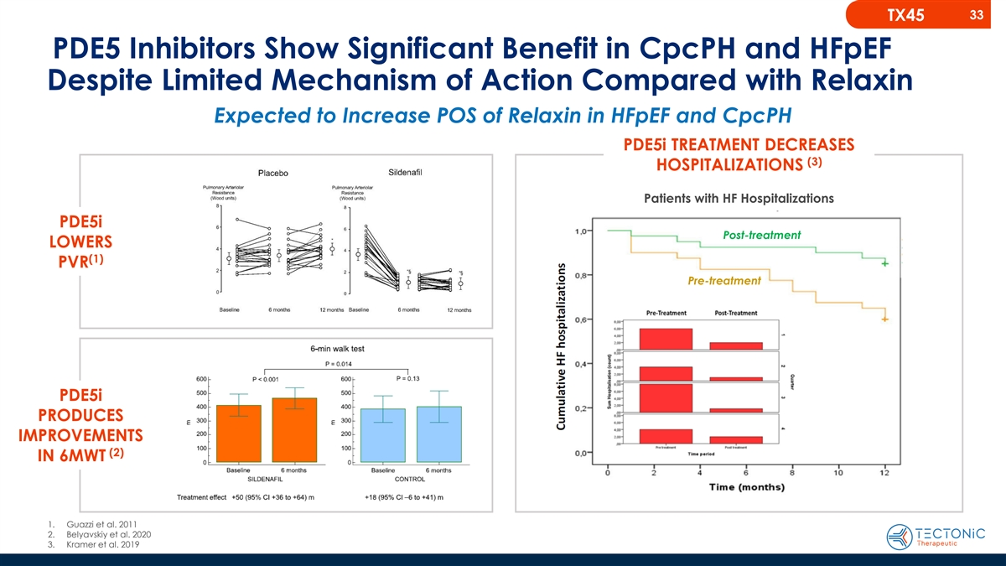
33 TX45 PDE5 Inhibitors Show Significant Benefit in CpcPH and HFpEF Despite Limited Mechanism of Action Compared with Relaxin Expected to Increase POS of Relaxin in HFpEF and CpcPH PDE5i TREATMENT DECREASES (3) HOSPITALIZATIONS Patients with HF Hospitalizations PDE5i Post-treatment LOWERS (1) PVR Pre-treatment PDE5i PRODUCES IMPROVEMENTS (2) IN 6MWT 1. Guazzi et al. 2011 2. Belyavskiy et al. 2020 3. Kramer et al. 2019

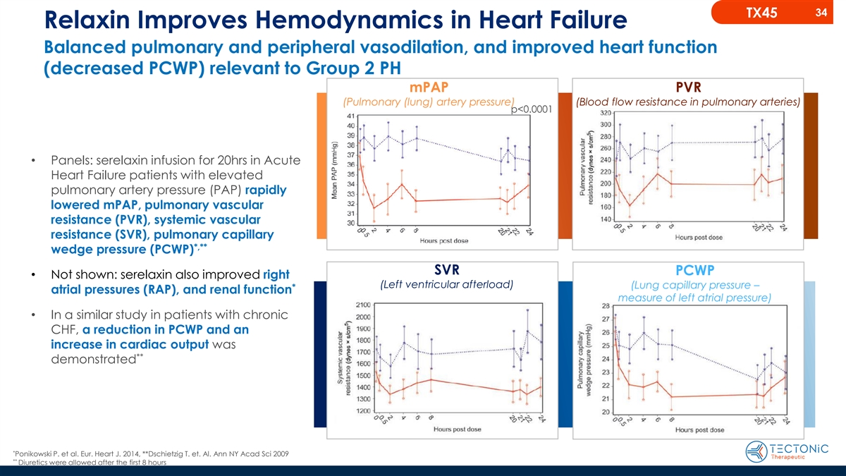
34 TX45 Relaxin Improves Hemodynamics in Heart Failure Balanced pulmonary and peripheral vasodilation, and improved heart function (decreased PCWP) relevant to Group 2 PH mPAP PVR (Pulmonary (lung) artery pressure) (Blood flow resistance in pulmonary arteries) p<0.0001 • Panels: serelaxin infusion for 20hrs in Acute Heart Failure patients with elevated pulmonary artery pressure (PAP) rapidly lowered mPAP, pulmonary vascular resistance (PVR), systemic vascular resistance (SVR), pulmonary capillary *,** wedge pressure (PCWP) SVR PCWP • Not shown: serelaxin also improved right (Left ventricular afterload) (Lung capillary pressure – * atrial pressures (RAP), and renal function measure of left atrial pressure) • In a similar study in patients with chronic CHF, a reduction in PCWP and an increase in cardiac output was ** demonstrated * Ponikowski P. et al. Eur. Heart J. 2014, **Dschietzig T. et. Al. Ann NY Acad Sci 2009 ** Diuretics were allowed after the first 8 hours

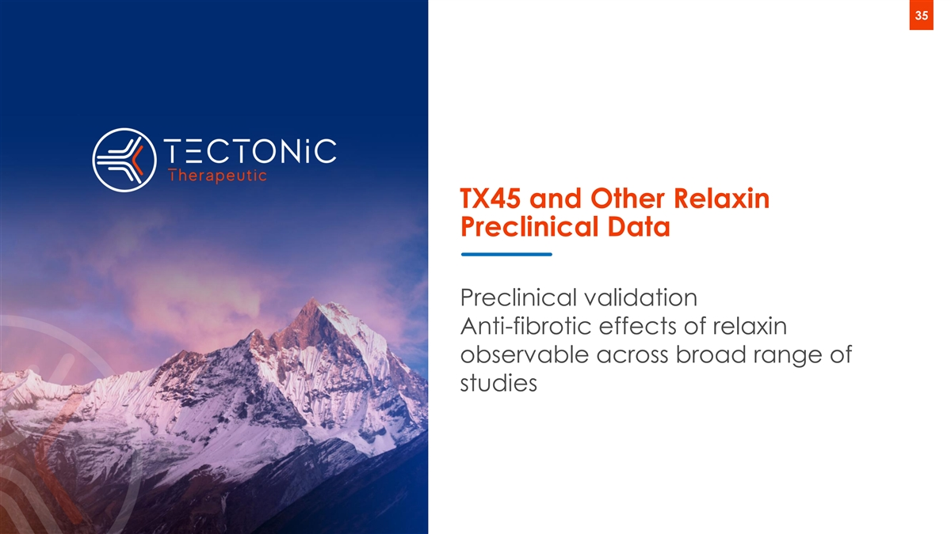
35 TX45 and Other Relaxin Preclinical Data Preclinical validation Anti-fibrotic effects of relaxin observable across broad range of studies

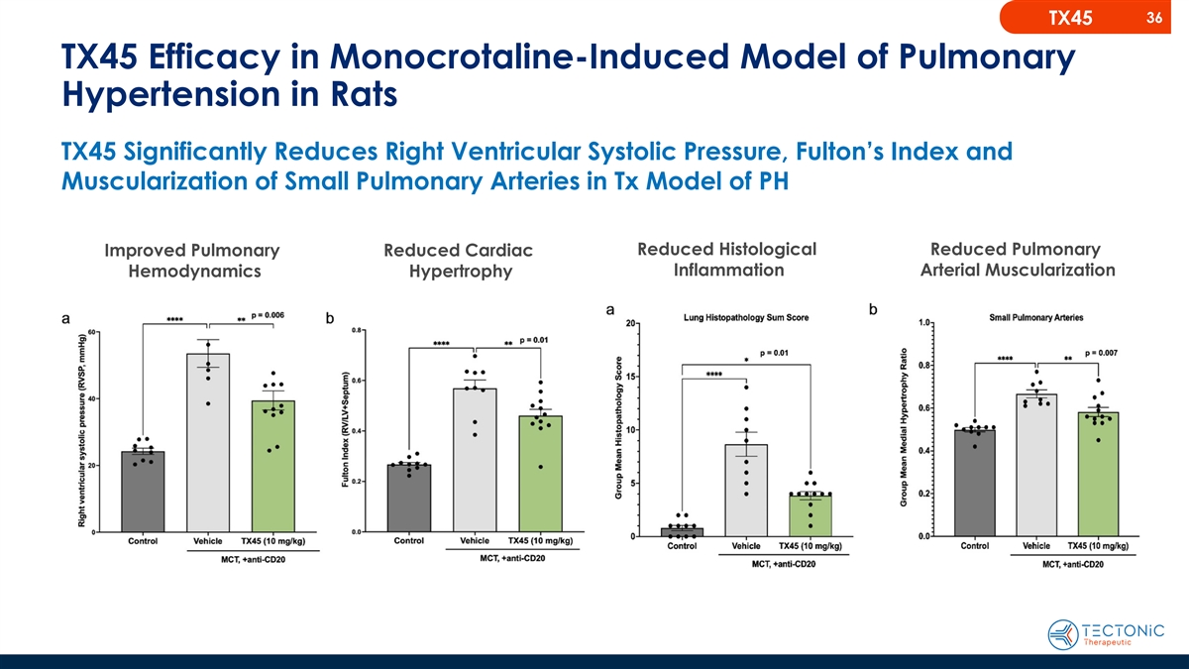
36 TX45 TX45 Efficacy in Monocrotaline-Induced Model of Pulmonary Hypertension in Rats TX45 Significantly Reduces Right Ventricular Systolic Pressure, Fulton’s Index and Muscularization of Small Pulmonary Arteries in Tx Model of PH Reduced Histological Reduced Pulmonary Improved Pulmonary Reduced Cardiac Inflammation Arterial Muscularization Hemodynamics Hypertrophy

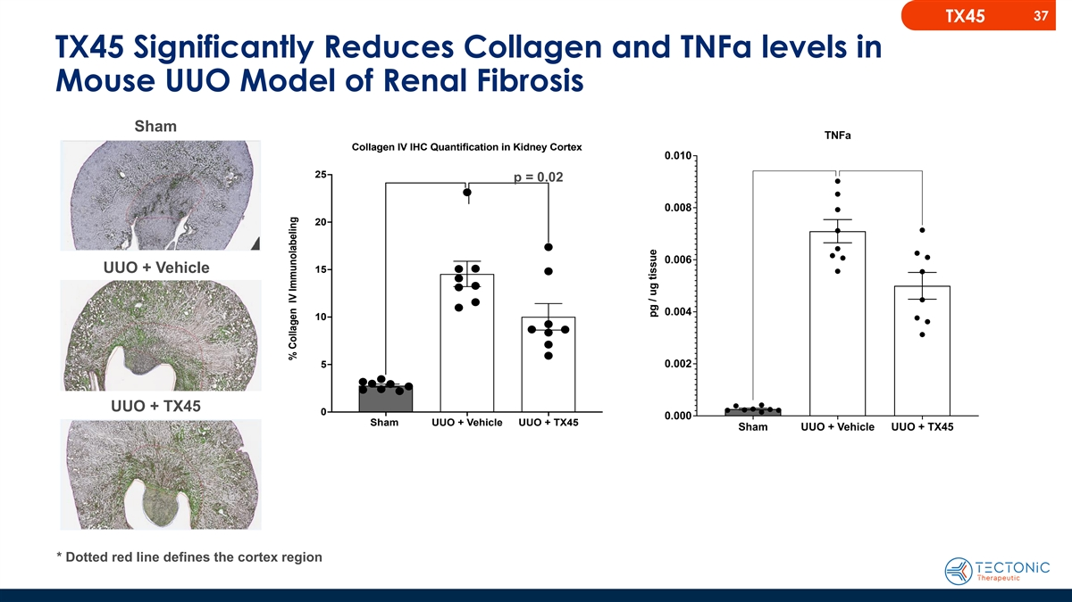
37 TX45 TX45 Significantly Reduces Collagen and TNFa levels in Mouse UUO Model of Renal Fibrosis Sham TNFa Collagen IV IHC Quantification in Kidney Cortex 0.010 25 p = 0.02 0.008 20 0.006 UUO + Vehicle 15 0.004 10 5 0.002 UUO + TX45 0 0.000 Sham UUO + Vehicle UUO + TX45 Sham UUO + Vehicle UUO + TX45 * Dotted red line defines the cortex region % Collagen IV Immunolabeling pg / ug tissue

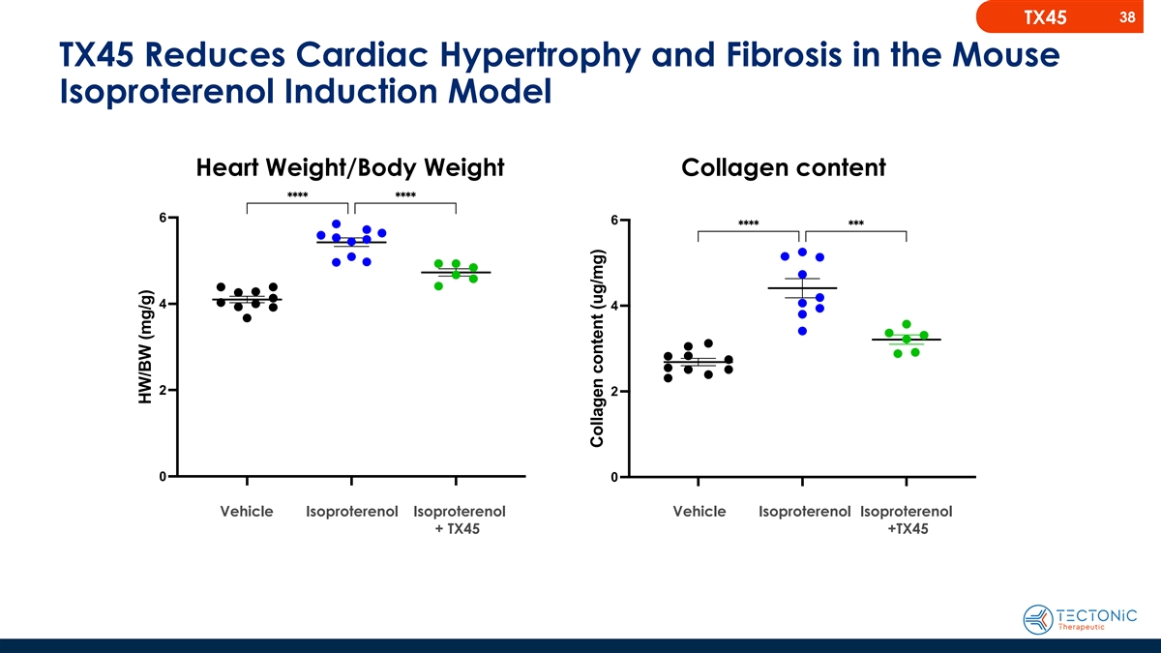
38 TX45 TX45 Reduces Cardiac Hypertrophy and Fibrosis in the Mouse Isoproterenol Induction Model Heart Weight/Body Weight Collagen content Vehicle Isoproterenol Isoproterenol Vehicle Isoproterenol Isoproterenol + TX45 +TX45

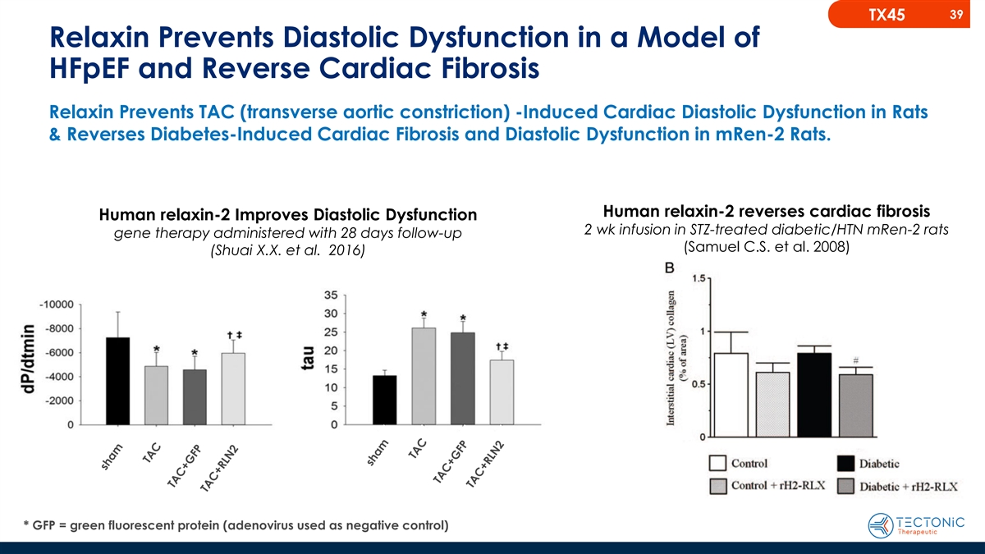
39 TX45 Relaxin Prevents Diastolic Dysfunction in a Model of HFpEF and Reverse Cardiac Fibrosis Relaxin Prevents TAC (transverse aortic constriction) -Induced Cardiac Diastolic Dysfunction in Rats & Reverses Diabetes-Induced Cardiac Fibrosis and Diastolic Dysfunction in mRen-2 Rats. Human relaxin-2 reverses cardiac fibrosis Human relaxin-2 Improves Diastolic Dysfunction 2 wk infusion in STZ-treated diabetic/HTN mRen-2 rats gene therapy administered with 28 days follow-up (Samuel C.S. et al. 2008) (Shuai X.X. et al. 2016) * GFP = green fluorescent protein (adenovirus used as negative control)

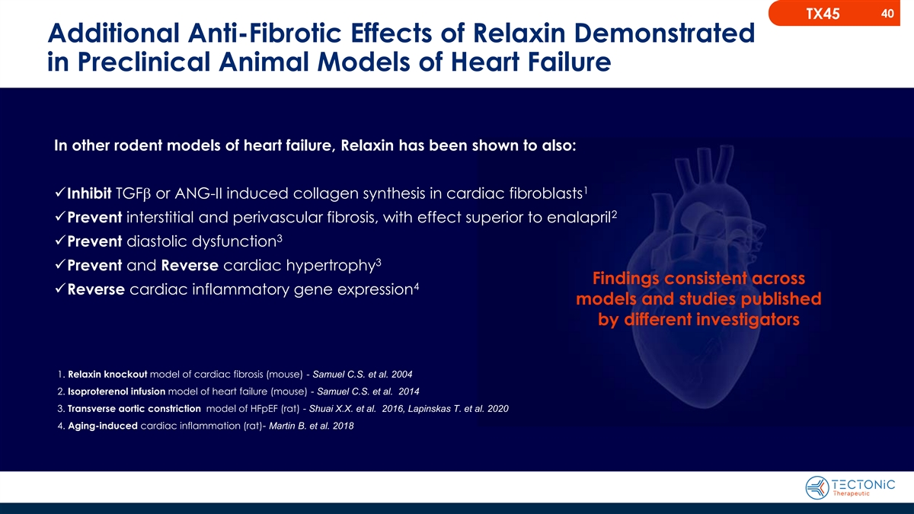
40 TX45 Additional Anti-Fibrotic Effects of Relaxin Demonstrated in Preclinical Animal Models of Heart Failure In other rodent models of heart failure, Relaxin has been shown to also: 1 ✓Inhibit TGFb or ANG-II induced collagen synthesis in cardiac fibroblasts 2 ✓Prevent interstitial and perivascular fibrosis, with effect superior to enalapril 3 ✓Prevent diastolic dysfunction 3 ✓Prevent and Reverse cardiac hypertrophy Findings consistent across 4 ✓Reverse cardiac inflammatory gene expression models and studies published by different investigators 1. Relaxin knockout model of cardiac fibrosis (mouse) - Samuel C.S. et al. 2004 2. Isoproterenol infusion model of heart failure (mouse) - Samuel C.S. et al. 2014 3. Transverse aortic constriction model of HFpEF (rat) - Shuai X.X. et al. 2016, Lapinskas T. et al. 2020 4. Aging-induced cardiac inflammation (rat)- Martin B. et al. 2018

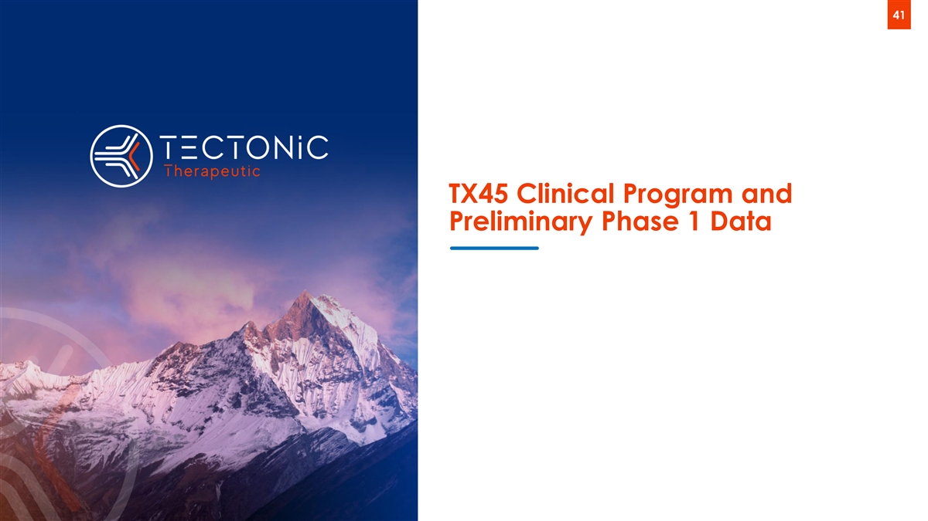
41 TX45 Clinical Program and Preliminary Phase 1 Data

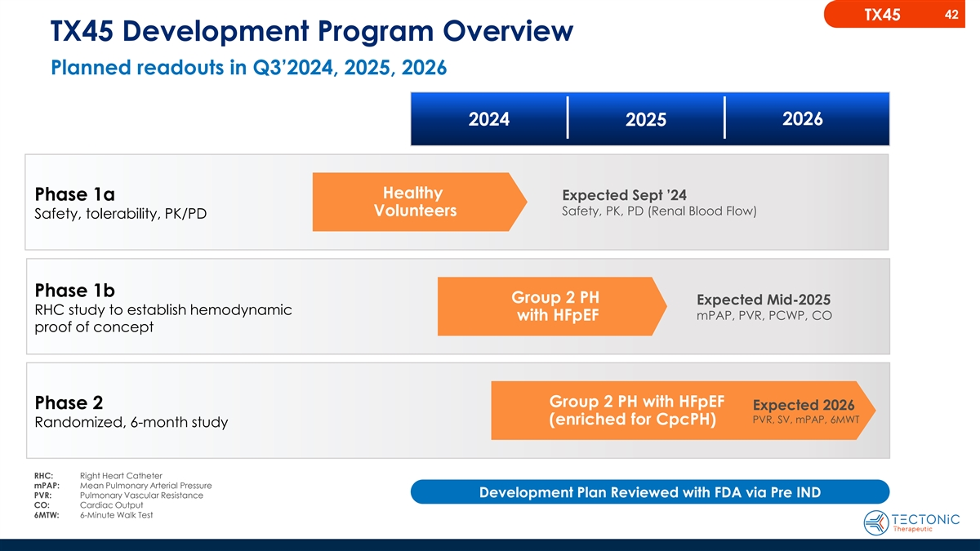
42 TX45 TX45 Development Program Overview Planned readouts in Q3’2024, 2025, 2026 2024 2026 2025 Healthy Expected Sept ’24 Phase 1a Safety, PK, PD (Renal Blood Flow) Volunteers Safety, tolerability, PK/PD Phase 1b Group 2 PH Expected Mid-2025 RHC study to establish hemodynamic with HFpEF mPAP, PVR, PCWP, CO proof of concept Group 2 PH with HFpEF Phase 2 Expected 2026 PVR, SV, mPAP, 6MWT (enriched for CpcPH) Randomized, 6-month study RHC: Right Heart Catheter mPAP: Mean Pulmonary Arterial Pressure PVR: Pulmonary Vascular Resistance Development Plan Reviewed with FDA via Pre IND CO: Cardiac Output 6MTW: 6-Minute Walk Test

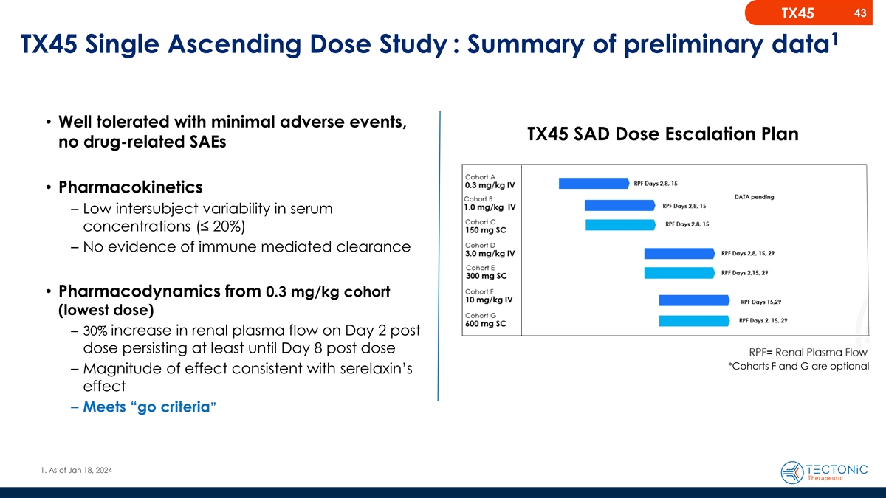
43 TX45 1 TX45 Single Ascending Dose Study : Summary of preliminary data • Well tolerated with minimal adverse events, TX45 SAD Dose Escalation Plan no drug-related SAEs • Pharmacokinetics – Low intersubject variability in serum concentrations (≤ 20%) – No evidence of immune mediated clearance • Pharmacodynamics from 0.3 mg/kg cohort (lowest dose) – 30% increase in renal plasma flow on Day 2 post dose persisting at least until Day 8 post dose *Cohorts F and G are optional – Magnitude of effect consistent with serelaxin’s effect – Meets “go criteria” 1. As of Jan 18, 2024

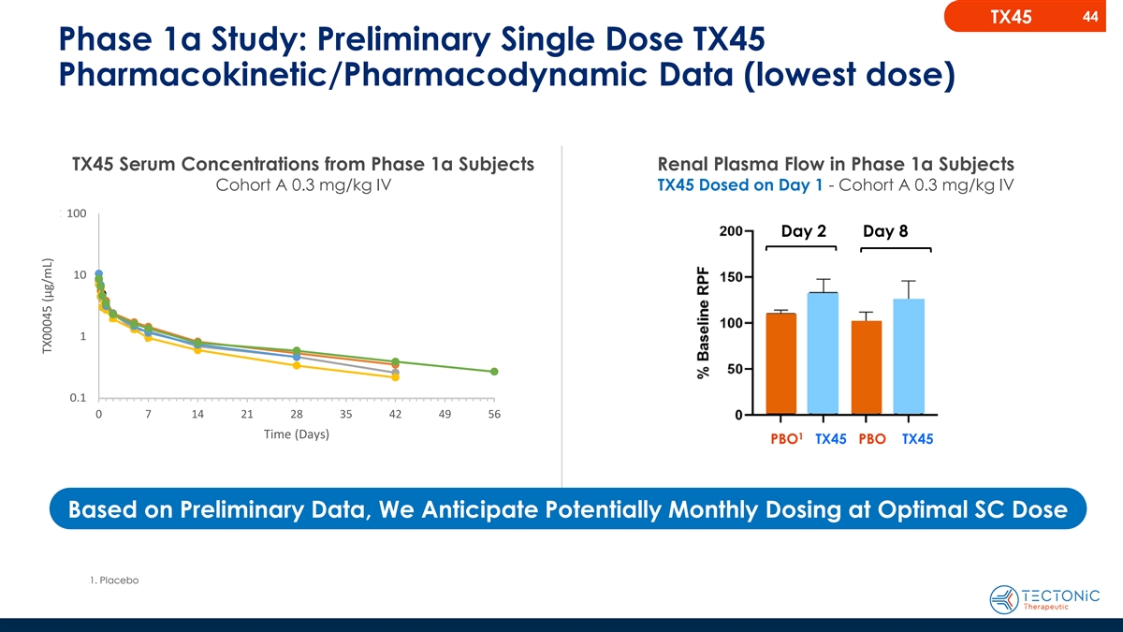
44 TX45 Phase 1a Study: Preliminary Single Dose TX45 Pharmacokinetic/Pharmacodynamic Data (lowest dose) TX45 Serum Concentrations from Phase 1a Subjects Renal Plasma Flow in Phase 1a Subjects Cohort 0.3 mg /k A g 0.I3 mg/k V g IV TX45 Dosed on Day 1 - Cohort A 0.3 mg/kg IV 150 mg SC PK in humans 100.0 100 Predicted predicted from NHP data Day 2 Day 8 10.0 10 1.0 1 0.1 0.1 0 0 7 14 21 28 7 35 42 49 56 14 Time (Days) Time (Days) 1 PBO TX45 PBO TX45 Based on Preliminary Data, We Anticipate Potentially Monthly Dosing at Optimal SC Dose 1. Placebo TX00045 (µg/mL) TX00045 (µg/mL)

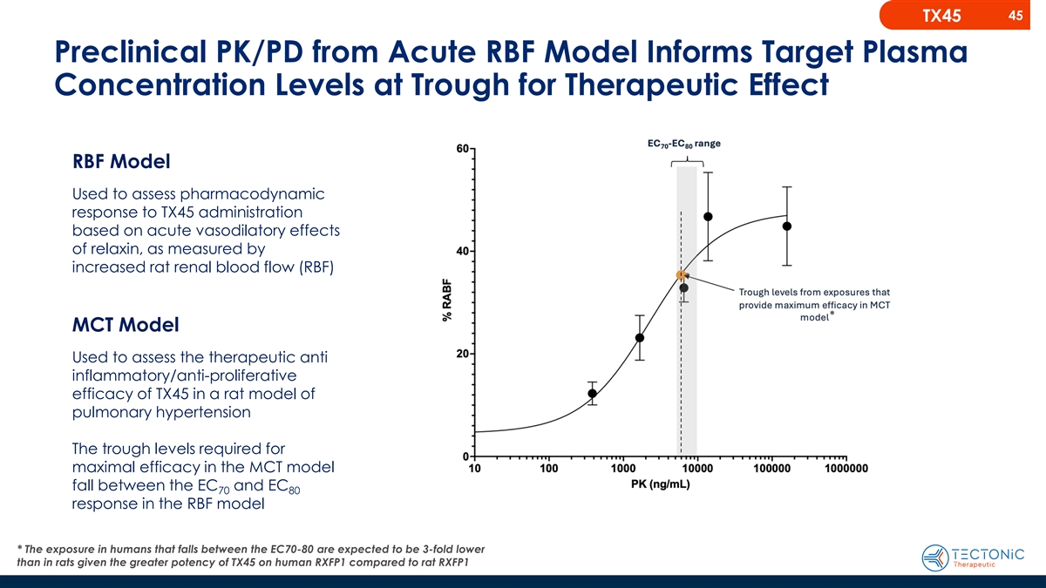
45 TX45 Preclinical PK/PD from Acute RBF Model Informs Target Plasma Concentration Levels at Trough for Therapeutic Effect RBF Model Used to assess pharmacodynamic response to TX45 administration based on acute vasodilatory effects of relaxin, as measured by increased rat renal blood flow (RBF) * MCT Model Used to assess the therapeutic anti inflammatory/anti-proliferative efficacy of TX45 in a rat model of pulmonary hypertension The trough levels required for maximal efficacy in the MCT model fall between the EC and EC 70 80 response in the RBF model * The exposure in humans that falls between the EC70-80 are expected to be 3-fold lower than in rats given the greater potency of TX45 on human RXFP1 compared to rat RXFP1

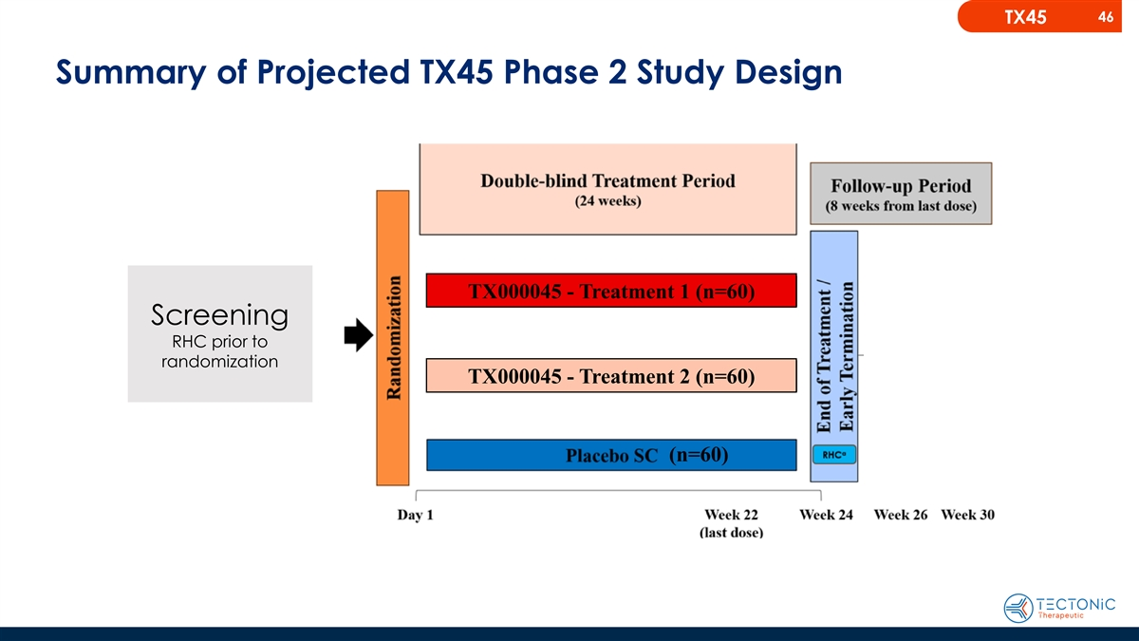
46 TX45 Summary of Projected TX45 Phase 2 Study Design TX000045 - Treatment 1 (n=60) Screening RHC prior to randomization TX000045 - Treatment 2 (n=60) (n=60)

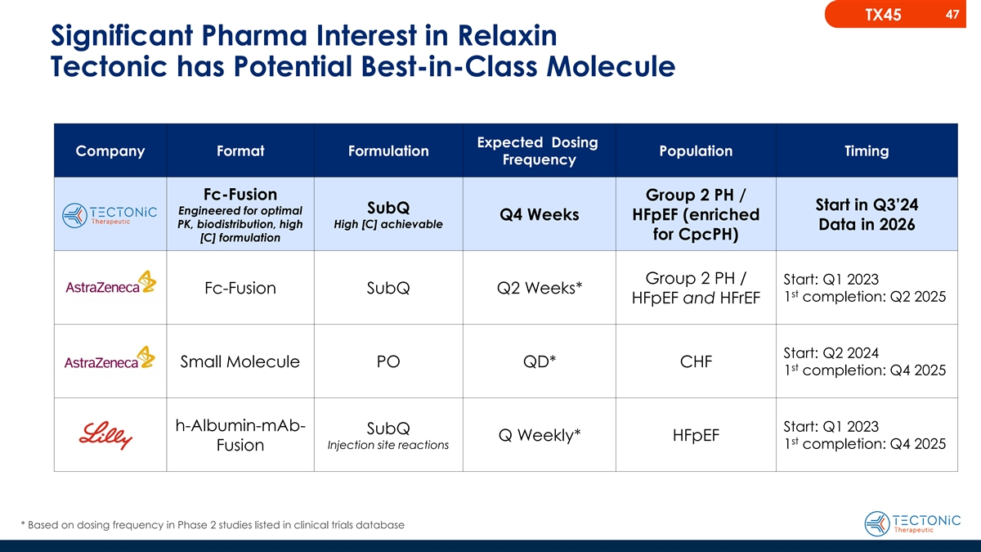
47 TX45 Significant Pharma Interest in Relaxin Tectonic has Potential Best-in-Class Molecule Expected Dosing Company Format Formulation Population Timing Frequency Fc-Fusion Group 2 PH / Start in Q3’24 SubQ Engineered for optimal Q4 Weeks HFpEF (enriched PK, biodistribution, high High [C] achievable Data in 2026 for CpcPH) [C] formulation Group 2 PH / Start: Q1 2023 Fc-Fusion SubQ Q2 Weeks* st 1 completion: Q2 2025 HFpEF and HFrEF Start: Q2 2024 Small Molecule PO QD* CHF st 1 completion: Q4 2025 h-Albumin-mAb- Start: Q1 2023 SubQ Q Weekly* HFpEF st Injection site reactions 1 completion: Q4 2025 Fusion * Based on dosing frequency in Phase 2 studies listed in clinical trials database

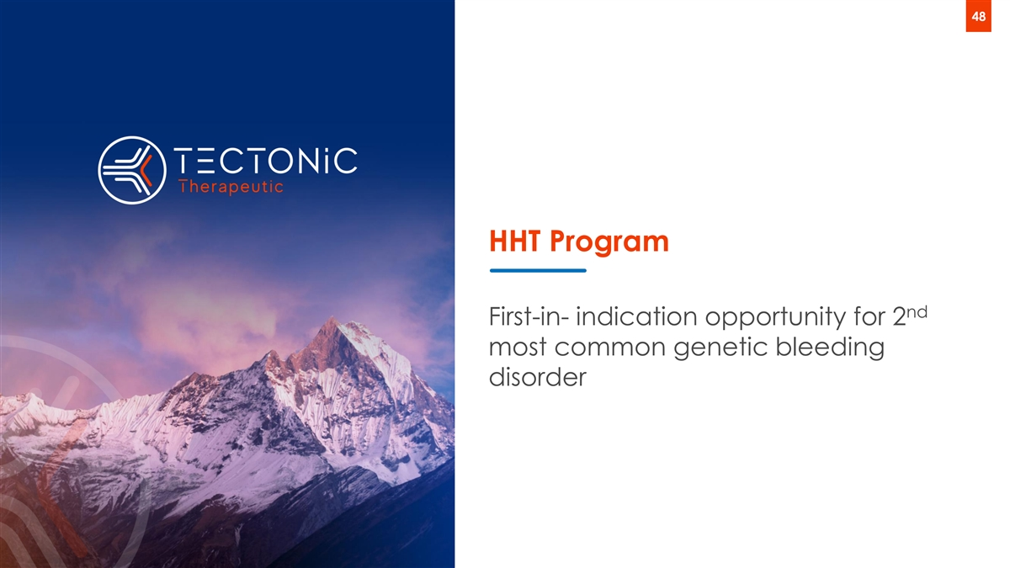
48 HHT Program nd First-in- indication opportunity for 2 most common genetic bleeding disorder

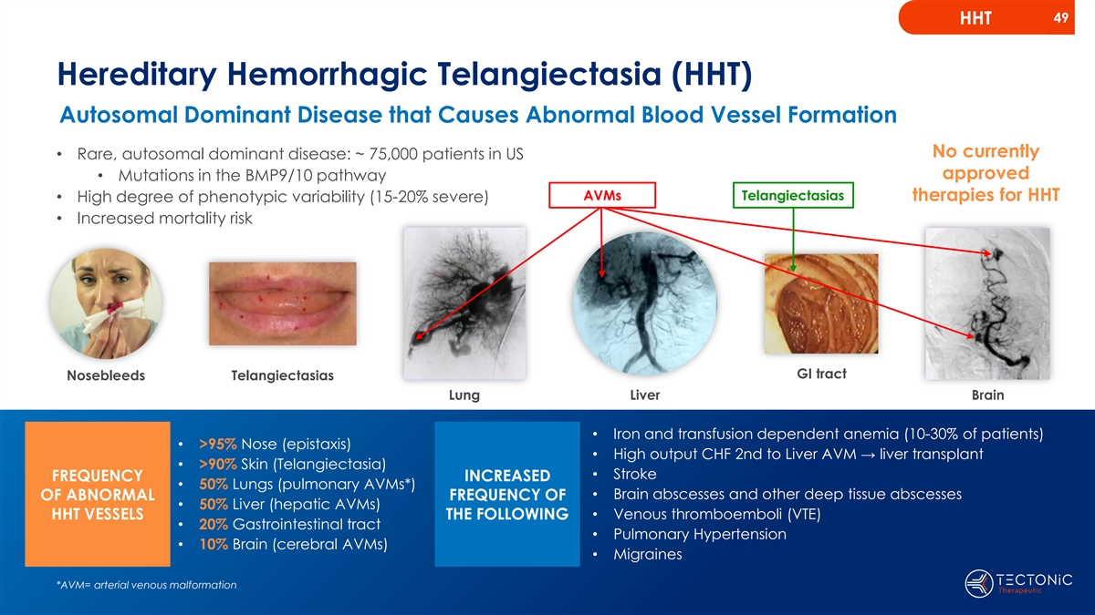
49 HHT Hereditary Hemorrhagic Telangiectasia (HHT) Autosomal Dominant Disease that Causes Abnormal Blood Vessel Formation No currently • Rare, autosomal dominant disease: ~ 75,000 patients in US approved • Mutations in the BMP9/10 pathway AVMs Telangiectasias therapies for HHT • High degree of phenotypic variability (15-20% severe) • Increased mortality risk GI tract Nosebleeds Telangiectasias Lung Liver Brain • Iron and transfusion dependent anemia (10-30% of patients) • >95% Nose (epistaxis) • High output CHF 2nd to Liver AVM → liver transplant • >90% Skin (Telangiectasia) • Stroke FREQUENCY INCREASED • 50% Lungs (pulmonary AVMs*) • Brain abscesses and other deep tissue abscesses OF ABNORMAL FREQUENCY OF • 50% Liver (hepatic AVMs) HHT VESSELS THE FOLLOWING• Venous thromboemboli (VTE) • 20% Gastrointestinal tract • Pulmonary Hypertension • 10% Brain (cerebral AVMs) • Migraines *AVM= arterial venous malformation

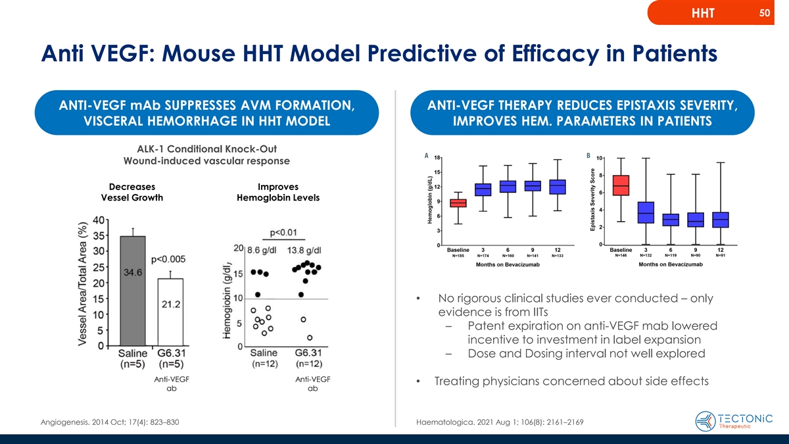
50 HHT Anti VEGF: Mouse HHT Model Predictive of Efficacy in Patients ANTI-VEGF mAb SUPPRESSES AVM FORMATION, ANTI-VEGF THERAPY REDUCES EPISTAXIS SEVERITY, VISCERAL HEMORRHAGE IN HHT MODEL IMPROVES HEM. PARAMETERS IN PATIENTS ALK-1 Conditional Knock-Out Wound-induced vascular response Decreases Improves Vessel Growth Hemoglobin Levels Incisional wounds • No rigorous clinical studies ever conducted – only evidence is from IITs – Patent expiration on anti-VEGF mab lowered incentive to investment in label expansion – Dose and Dosing interval not well explored Anti-VEGF Anti-VEGF • Treating physicians concerned about side effects ab ab Angiogenesis. 2014 Oct; 17(4): 823–830 Haematologica. 2021 Aug 1; 106(8): 2161–2169

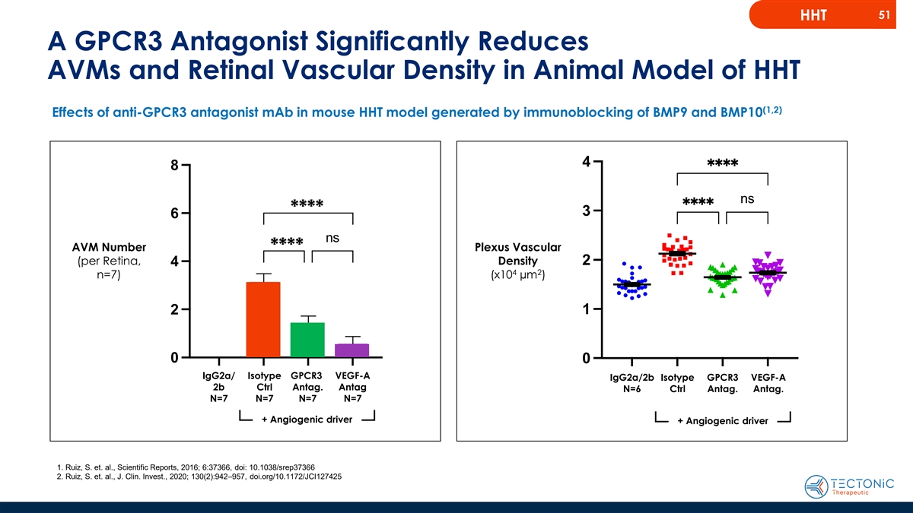
51 HHT A GPCR3 Antagonist Significantly Reduces AVMs and Retinal Vascular Density in Animal Model of HHT (1,2) Effects of anti-GPCR3 antagonist mAb in mouse HHT model generated by immunoblocking of BMP9 and BMP10 8 **** 6 ns AVM Number **** Plexus Vascular (per Retina, Density 4 4 2 n=7) (x10 µm ) 2 0 IgG2a/ Isotype GPCR3 VEGF-A IgG2a/2b Isotype GPCR3 VEGF-A 2b Ctrl Antag. Antag N=6 Ctrl Antag. Antag. N=7 N=7 N=7 N=7 + Angiogenic driver + Angiogenic driver 1. Ruiz, S. et. al., Scientific Reports, 2016; 6:37366, doi: 10.1038/srep37366 2. Ruiz, S. et. al., J. Clin. Invest., 2020; 130(2):942–957, doi.org/10.1172/JCI127425 IgG2a/2b TX942 TX1351 G6.31 AVM number (per retina, n=7)

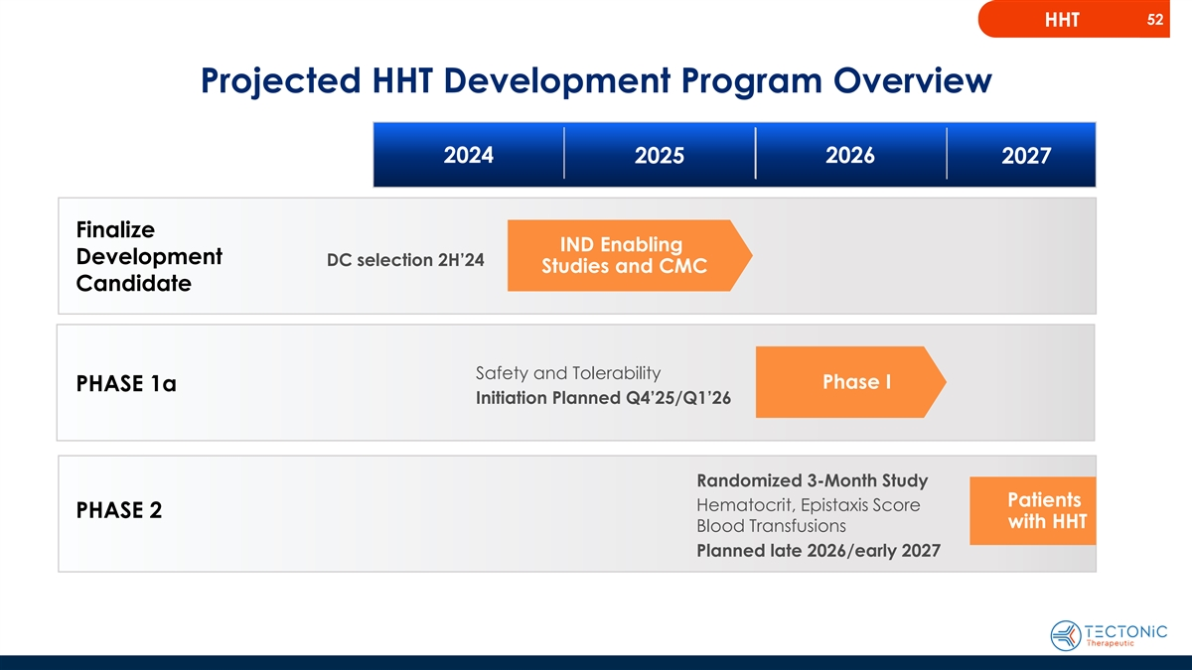
52 HHT Projected HHT Development Program Overview 2024 2026 2025 2027 Finalize IND Enabling Development DC selection 2H’24 Studies and CMC Candidate Safety and Tolerability Phase I PHASE 1a Initiation Planned Q4’25/Q1’26 Randomized 3-Month Study Patients Hematocrit, Epistaxis Score PHASE 2 with HHT Blood Transfusions Planned late 2026/early 2027


53 Summary

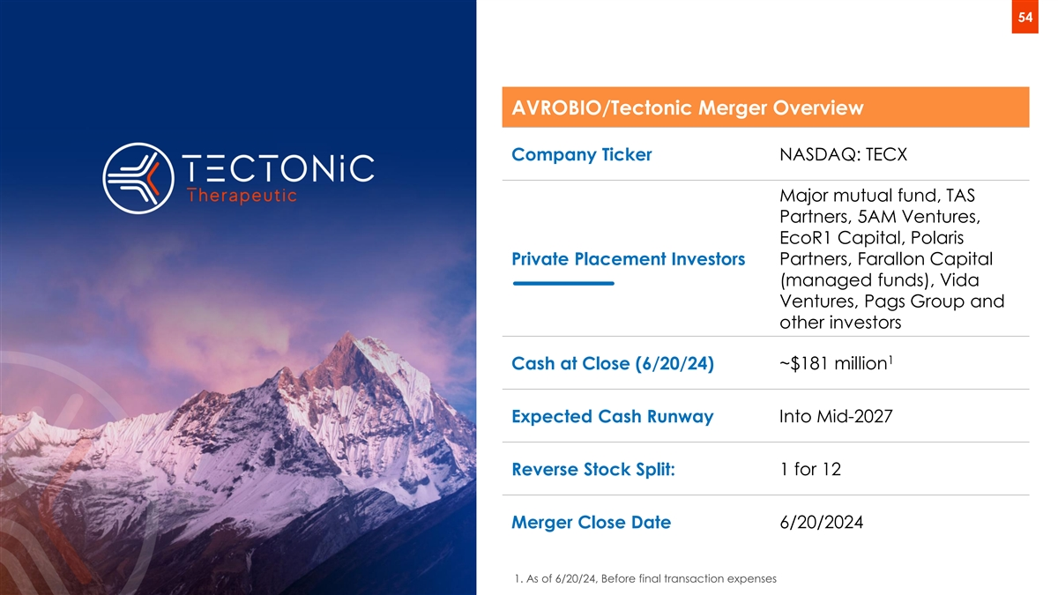
54 AVROBIO/Tectonic Merger Overview Company Ticker NASDAQ: TECX Major mutual fund, TAS Partners, 5AM Ventures, EcoR1 Capital, Polaris Private Placement Investors Partners, Farallon Capital (managed funds), Vida Ventures, Pags Group and other investors 1 ~$181 million Cash at Close (6/20/24) Into Mid-2027 Expected Cash Runway Reverse Stock Split: 1 for 12 Merger Close Date 6/20/2024 1. As of 6/20/24, Before final transaction expenses

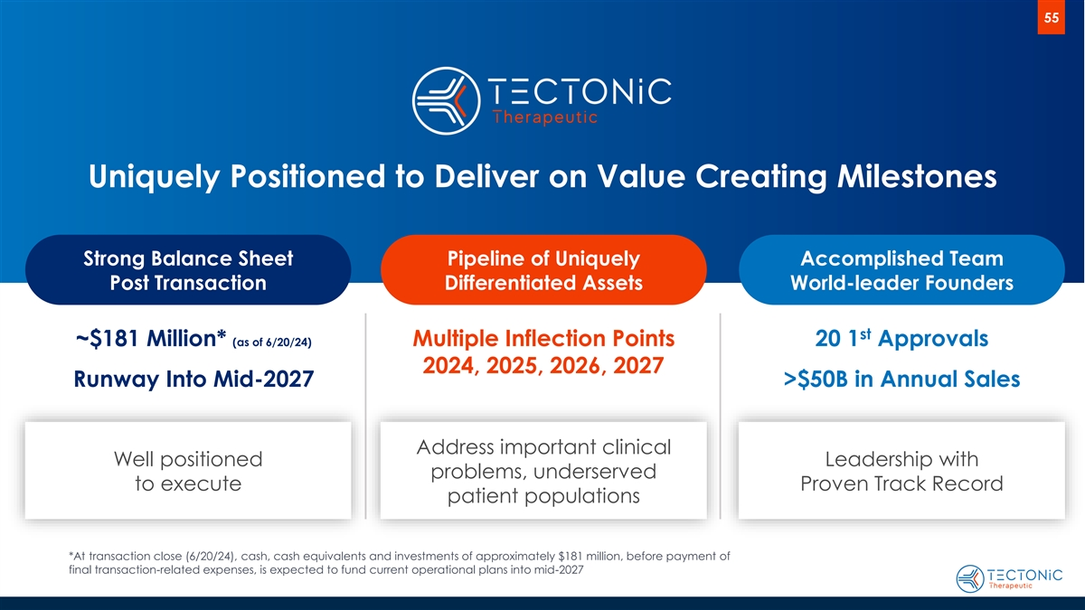
55 Uniquely Positioned to Deliver on Value Creating Milestones Strong Balance Sheet Pipeline of Uniquely Accomplished Team Post Transaction Differentiated Assets World-leader Founders st ~$181 Million* (as of 6/20/24) Multiple Inflection Points 20 1 Approvals 2024, 2025, 2026, 2027 Runway Into Mid-2027 >$50B in Annual Sales Address important clinical Well positioned Leadership with problems, underserved to execute Proven Track Record patient populations *At transaction close (6/20/24), cash, cash equivalents and investments of approximately $181 million, before payment of final transaction-related expenses, is expected to fund current operational plans into mid-2027


56 Thank you info@tectonictx.com www.tectonictx.com LinkedIn: TectonicTx

