UNITED STATES

SECURITIES AND EXCHANGE COMMISSION
Washington, D.C. 20549

FORM 8-K

CURRENT REPORT

Pursuant to Section 13 or 15(d)

of the Securities Exchange Act of 1934

Date of Report (Date of earliest event reported): May 13, 2020

AVROBIO, INC.

(Exact name of registrant as specified in its charter)

Delaware

001-38537

81-0710585

(State or other jurisdiction

of incorporation)

(Commission

File Number)

(I.R.S. Employer

Identification No.)

One Kendall Square

Building 300, Suite 201

Cambridge, MA 02139

(Address of principal executive offices, including zip code)

(617) 914-8420

(Registrant’s telephone number, including area code)

Not Applicable

(Former Name or Former Address, if Changed Since Last Report)

Check the appropriate box below if the Form 8-K filing is intended to simultaneously satisfy the filing obligation of the registrant under any of the following provisions:

- Written communications pursuant to Rule 425 under the Securities Act (17 CFR 230.425)

- Soliciting material pursuant to Rule 14a-12 under the Exchange Act (17 CFR 240.14a-12)

- Pre-commencement communications pursuant to Rule 14d-2(b) under the Exchange Act (17 CFR 240.14d-2(b))

- Pre-commencement communications pursuant to Rule 13e-4(c) under the Exchange Act (17 CFR 240.13e-4(c))

Securities registered pursuant to Section 12(b) of the Act:
 |  |  | Trading |  | Name of each exchange
Title of each class |  |  | symbol(s) |  | on which registered
Common Stock, $0.0001 par value per share |  |  | AVRO |  | Nasdaq Global Select Market

Indicate by check mark whether the registrant is an emerging growth company as defined in Rule 405 of the Securities Act of 1933 (§ 230.405 of this chapter) or Rule 12b-2 of the Securities Exchange Act of 1934 (§ 240.12b-2 of this chapter).

Emerging growth company ☒

If an emerging growth company, indicate by check mark if the registrant has elected not to use the extended transition period for complying with any new or revised financial accounting standards provided pursuant to Section 13(a) of the Exchange Act. ☐

Item 7.01 Regulation FD Disclosure.

On May 13, 2020, AVROBIO, Inc. (the “Company”) updated its corporate presentation for use in meetings with investors, analysts and others. A copy of the slide presentation is furnished as Exhibit 99.1 to this Current Report on Form 8-K.

The information in this Item 7.01 and Exhibit 99.1 attached hereto shall not be deemed “filed” for purposes of the Securities Exchange Act of 1934, as amended (the “Exchange Act”), or otherwise subject to the liabilities of that section, nor shall it be deemed incorporated by reference in any filing under the Securities Act of 1933, as amended, or the Exchange Act, except as expressly set forth by specific reference in such a filing.

Item 8.01 Other Events.

On May 13, 2020, the Company issued a press release titled “AVROBIO Reports Updated Clinical Data from Investigational Gene Therapy Programs for Fabry Disease and Cystinosis.” A copy of the press release is filed as Exhibit 99.2 to this Current Report on Form 8-K and incorporated into this Item 8.01 by reference.

Item 9.01. Financial Statements and Exhibits.

(d) Exhibits

99.1 AVROBIO, Inc. slide presentation, dated May 13, 2020.

99.2 Press release issued by AVROBIO, Inc., dated May 13, 2020.

SIGNATURES

Pursuant to the requirements of the Securities Exchange Act of 1934, the registrant has duly caused this report to be signed on its behalf by the undersigned hereunto duly authorized.

 | AVROBIO, INC.
Date: May 13, 2020 | By: /s/ Geoff MacKay
 |  | Geoff MacKay
 |  | President and Chief Executive Officer

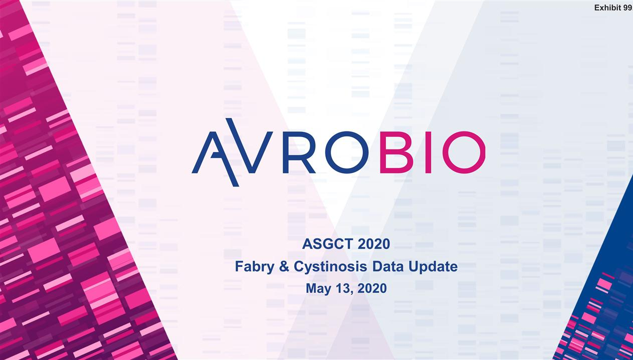

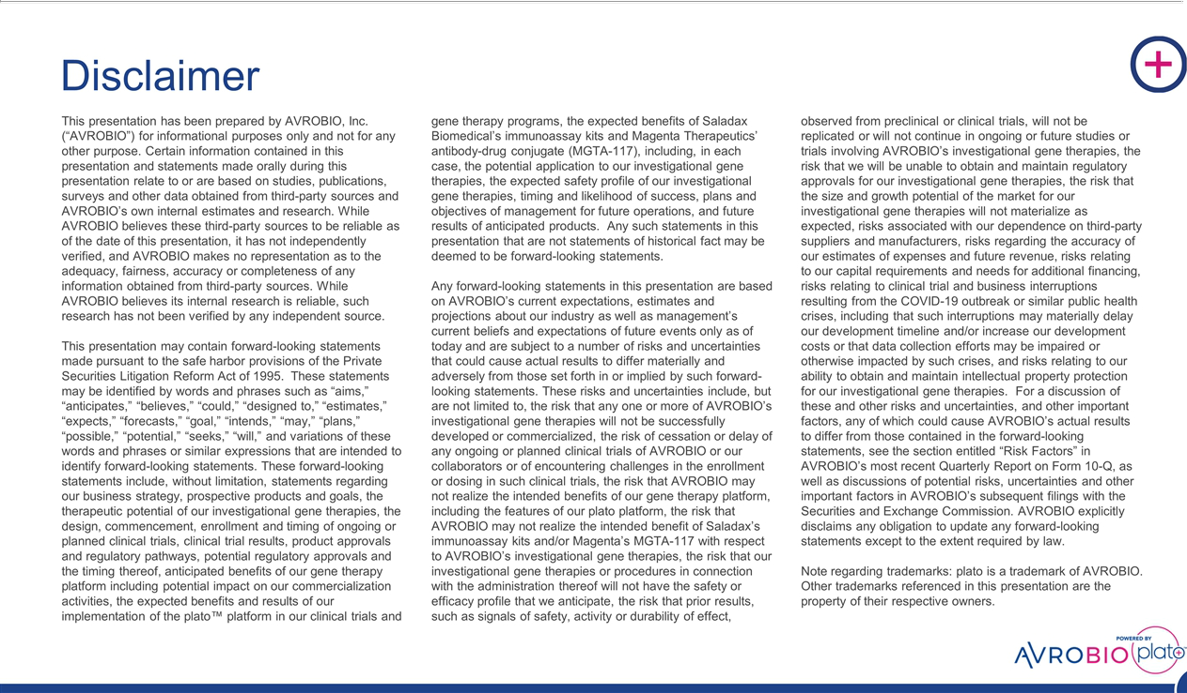

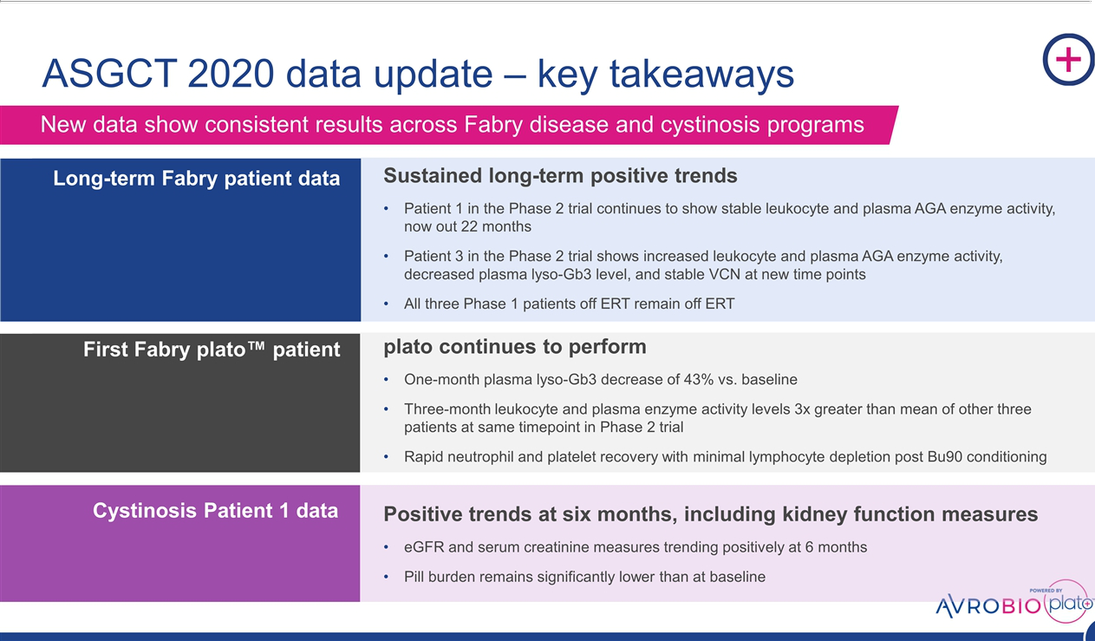

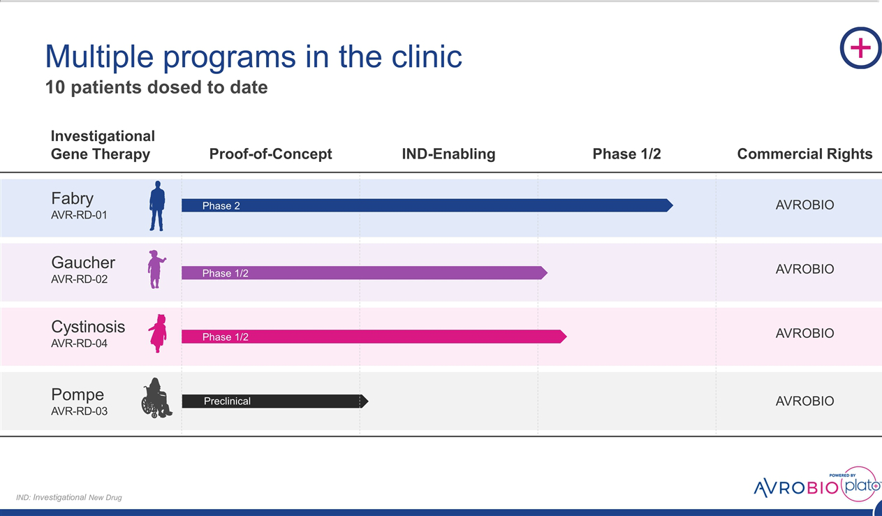

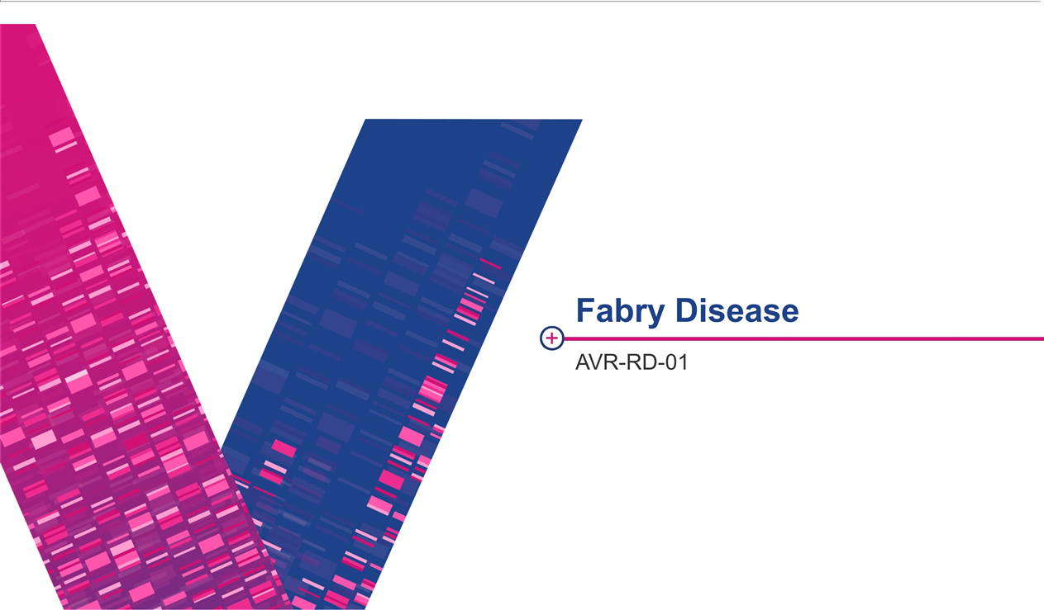

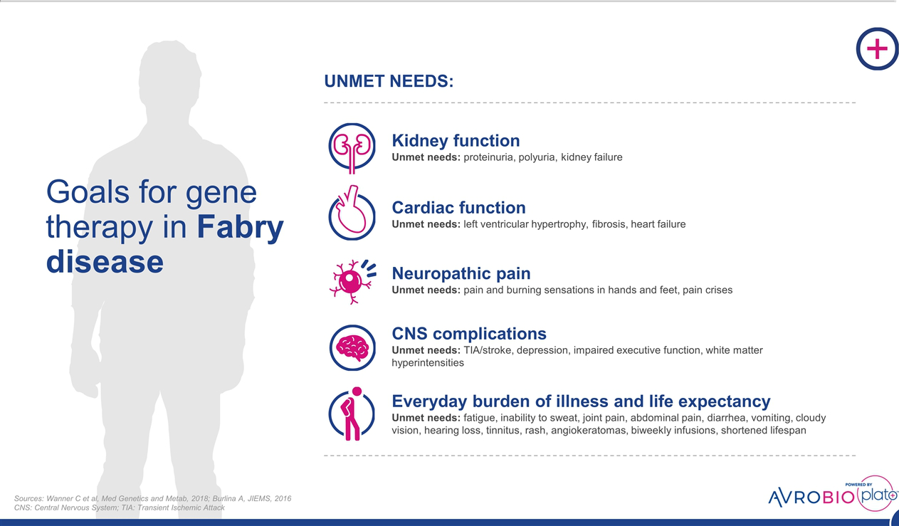

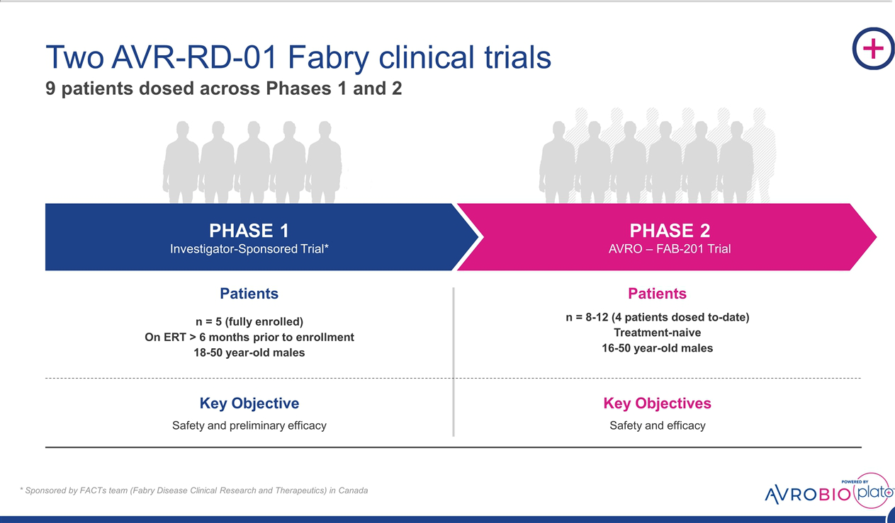

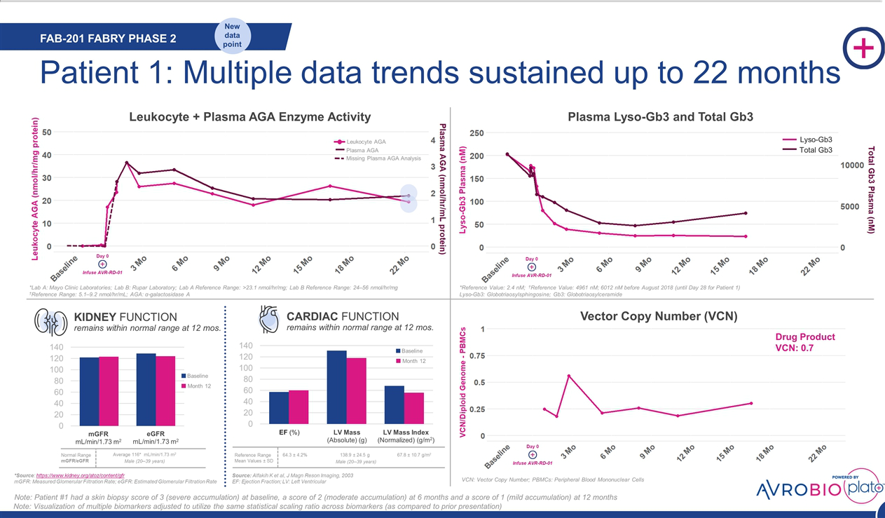

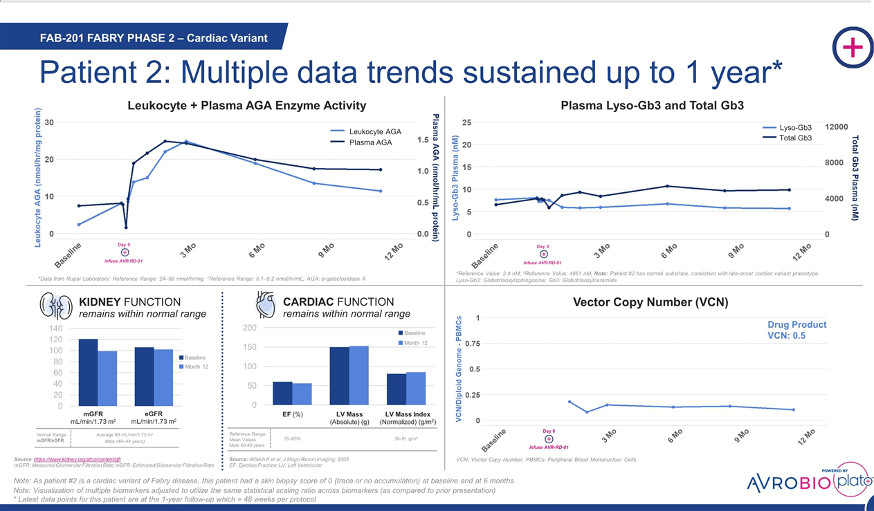

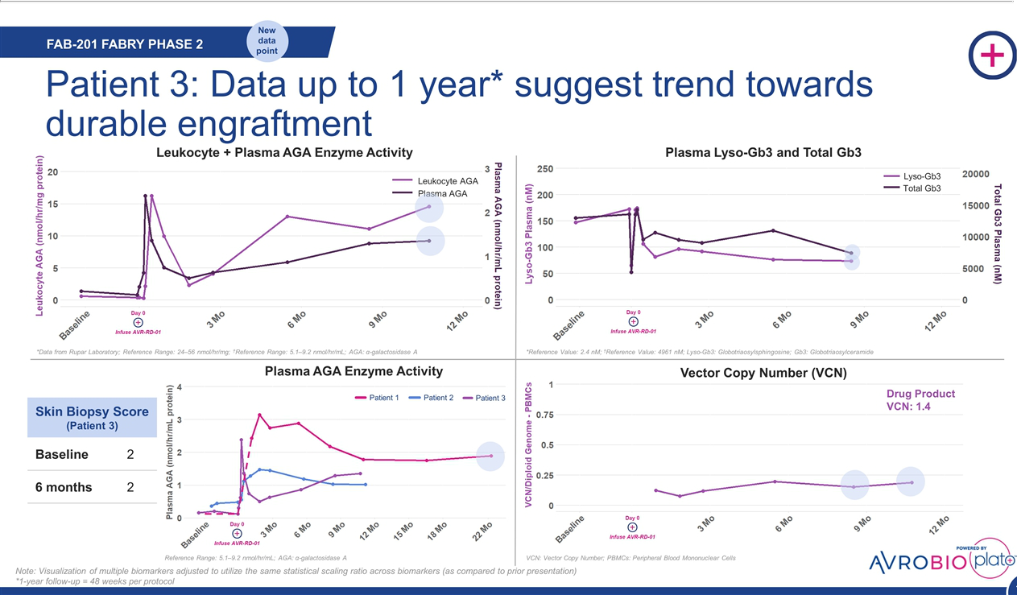

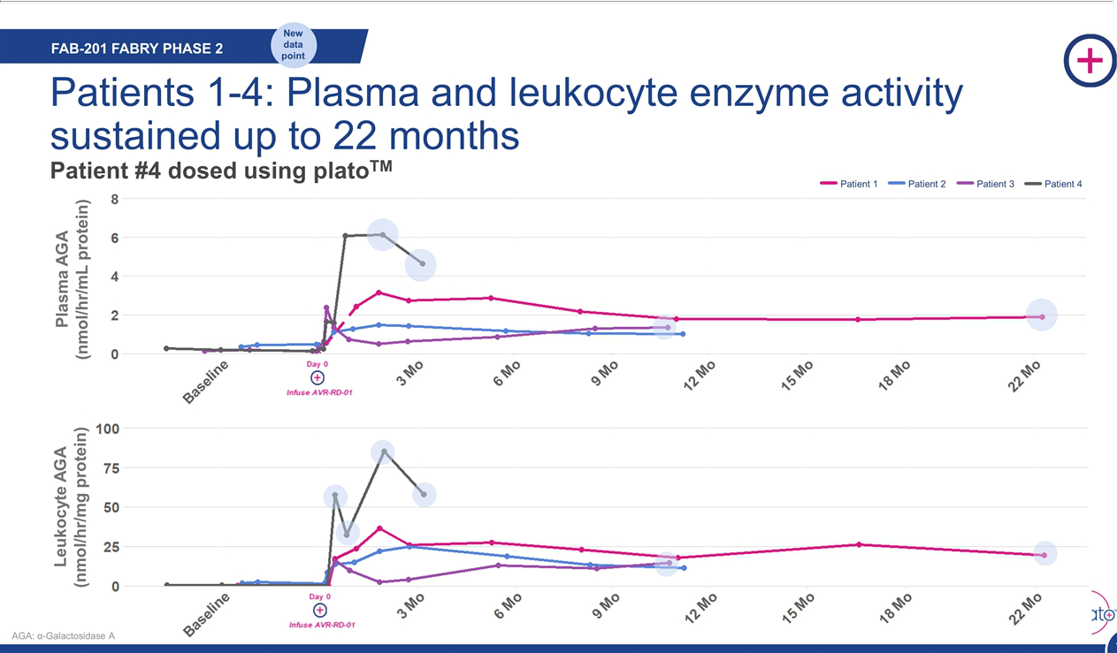

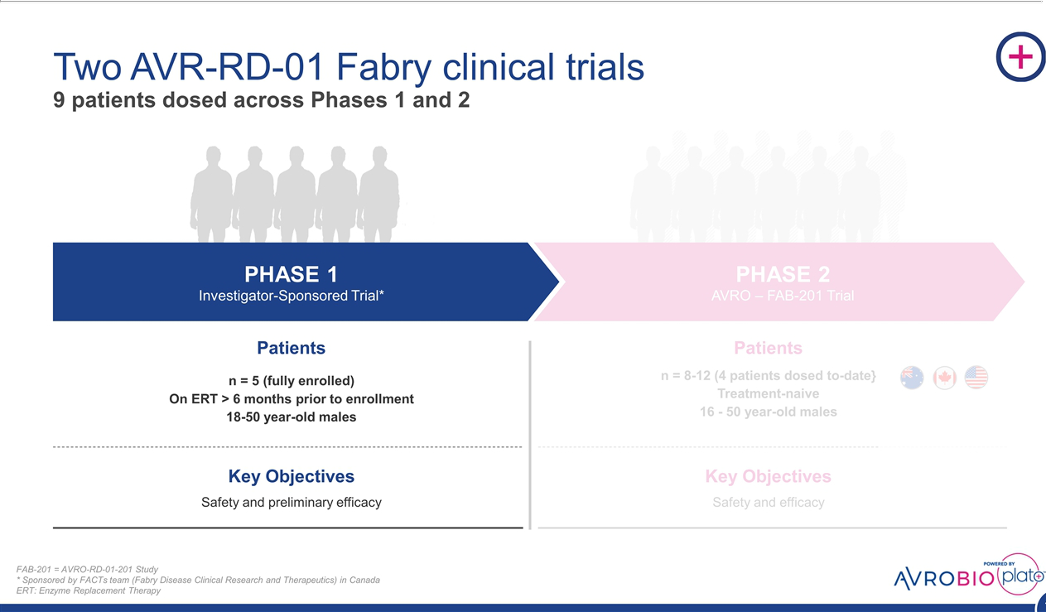

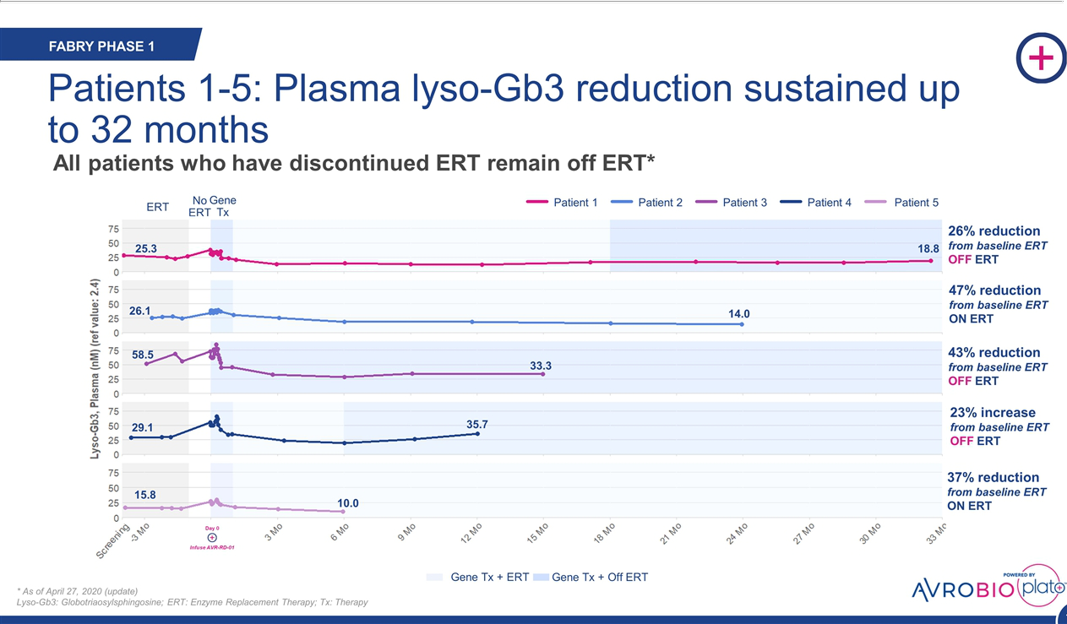

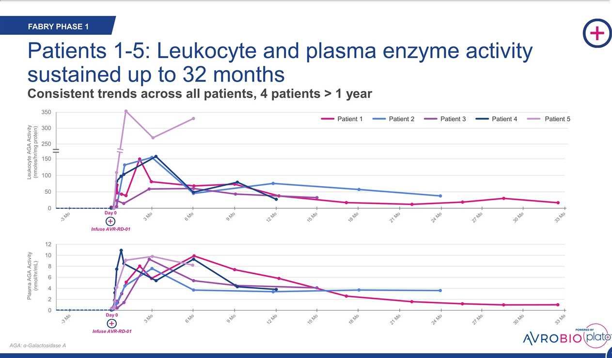

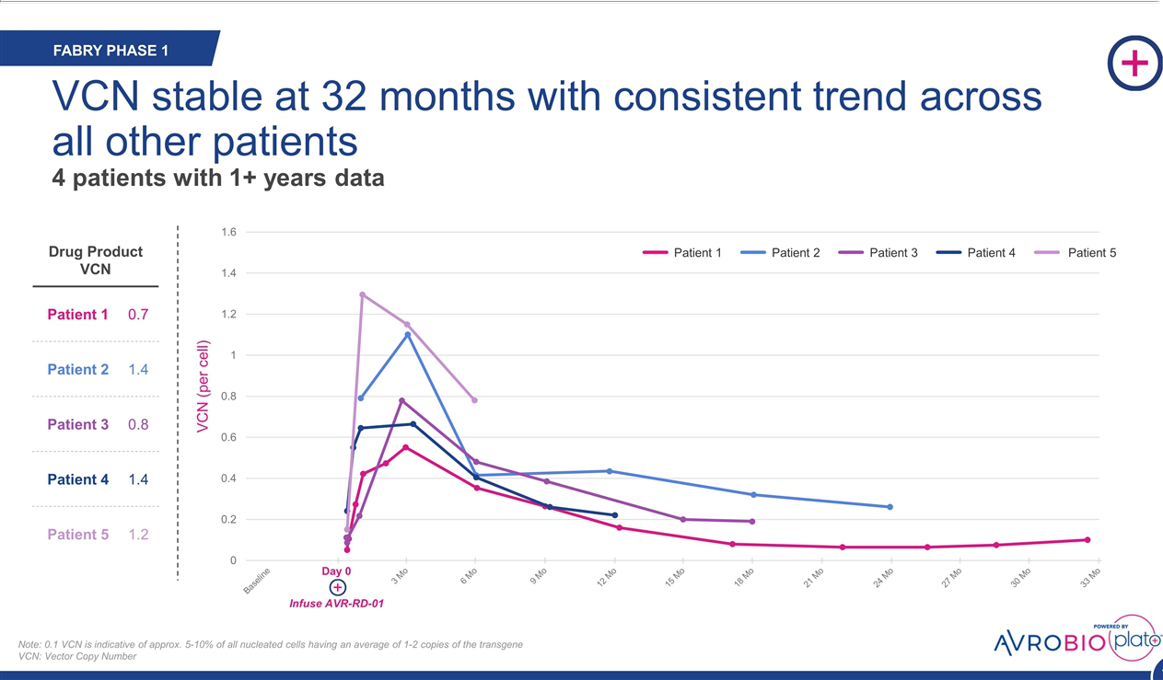

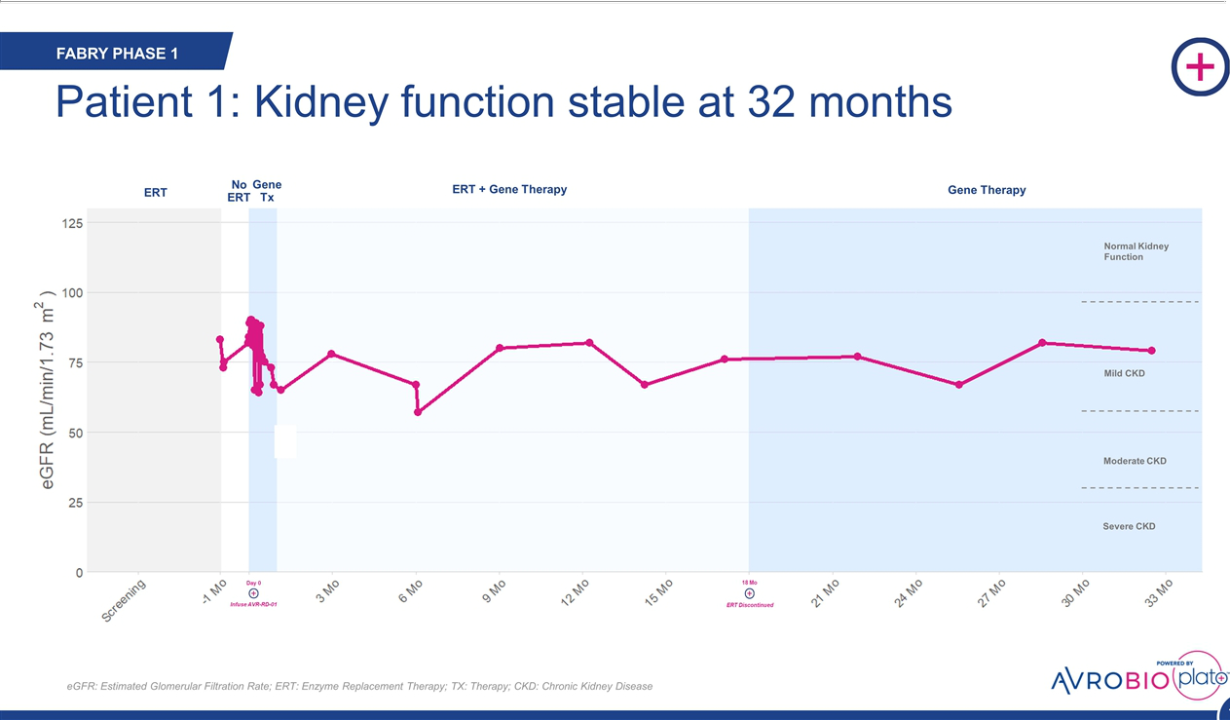

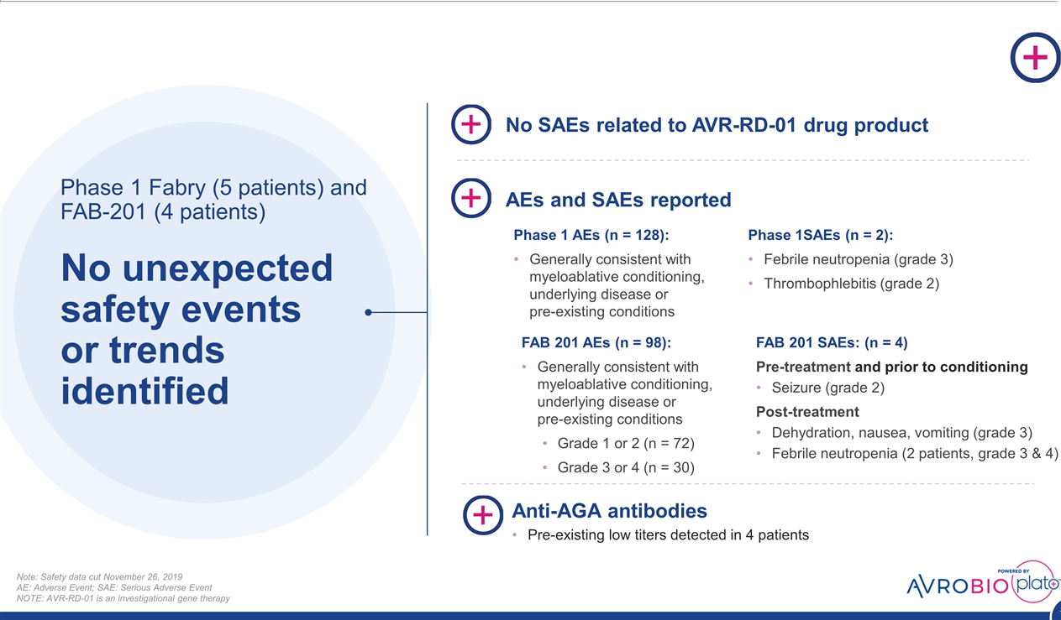

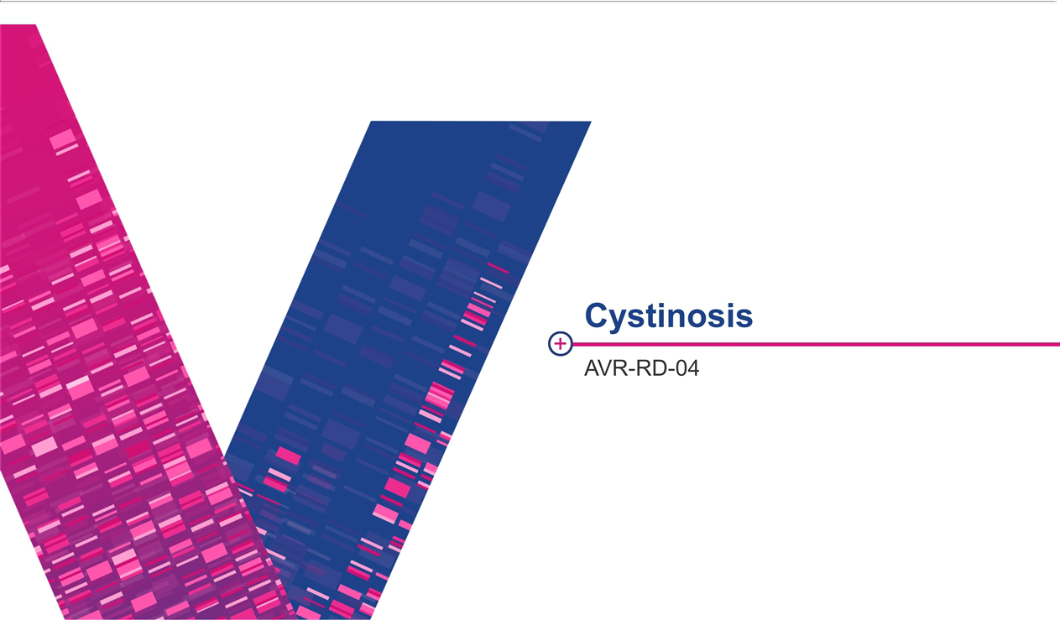

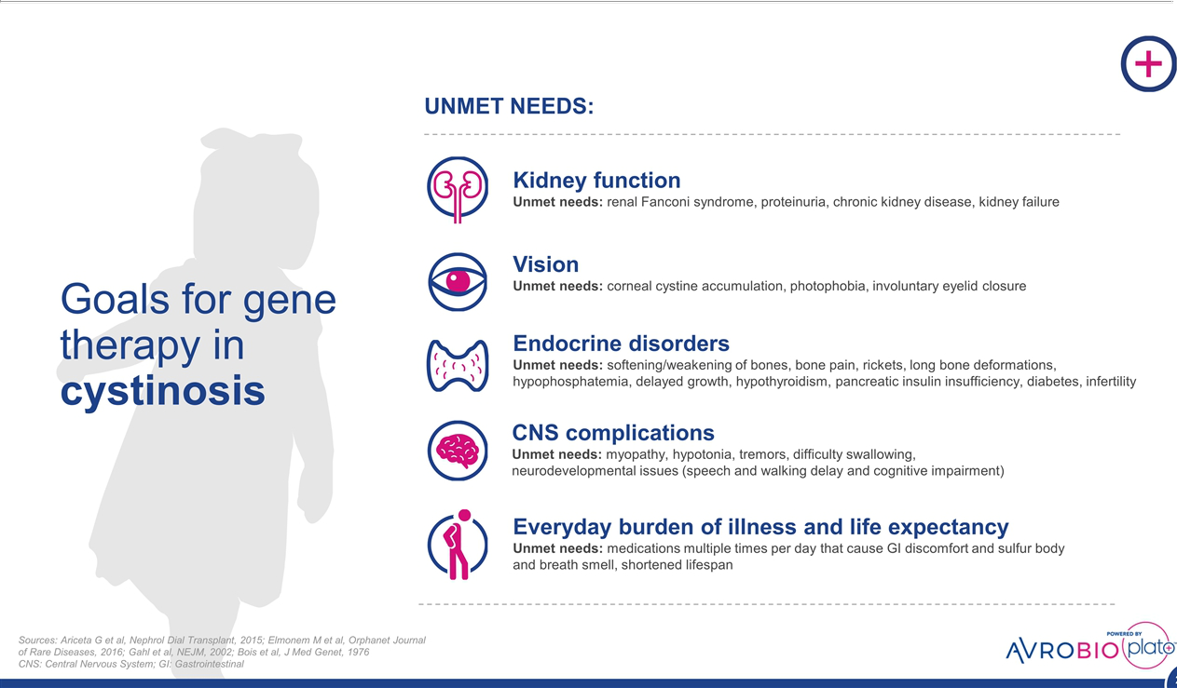

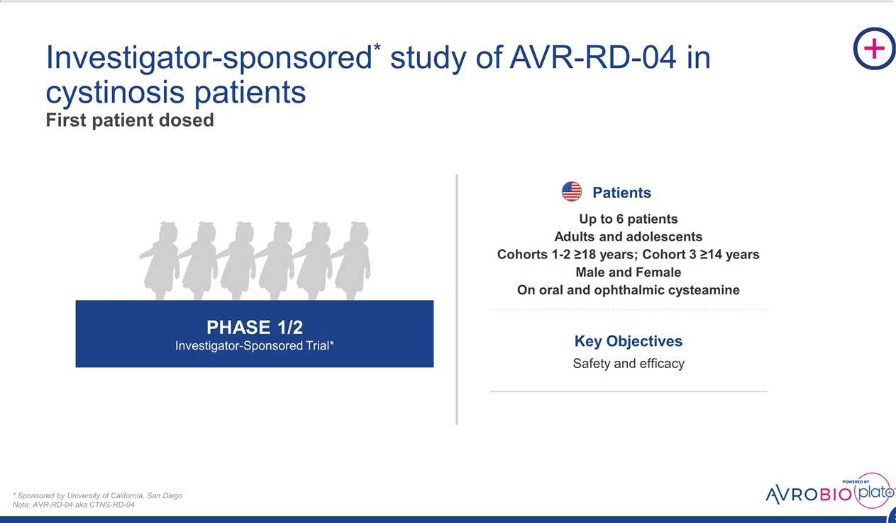

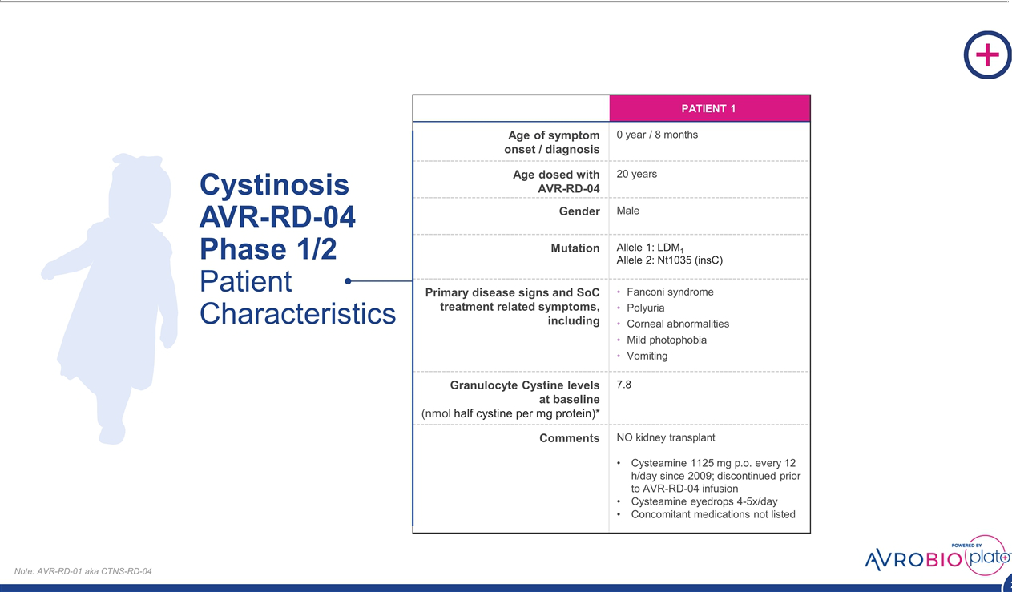

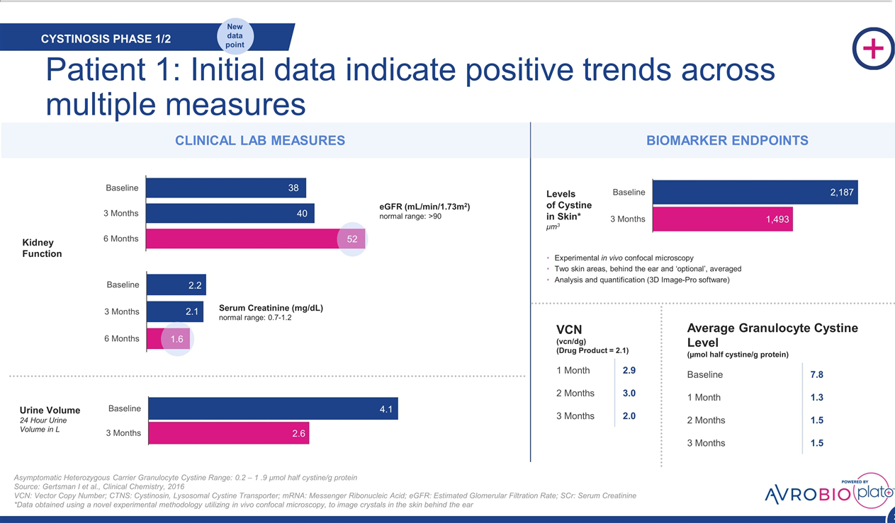

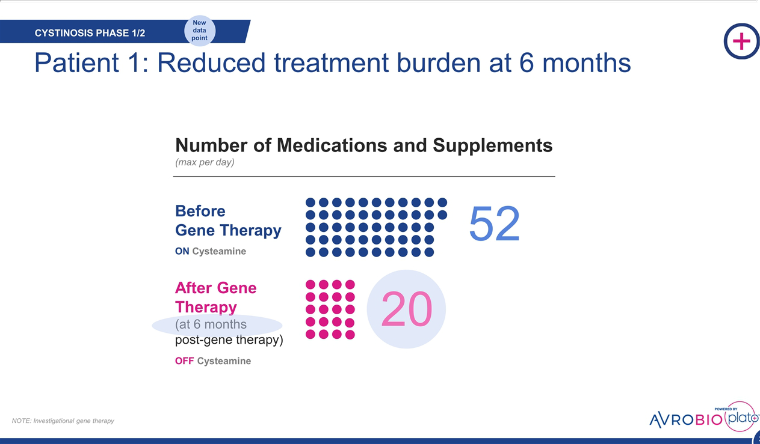

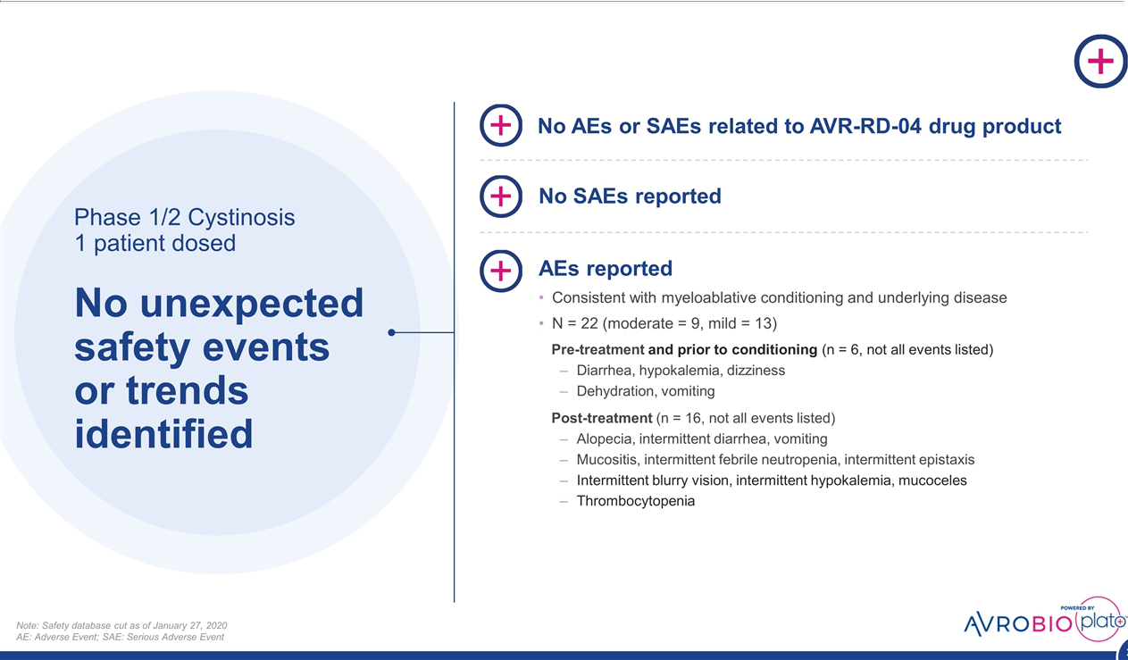

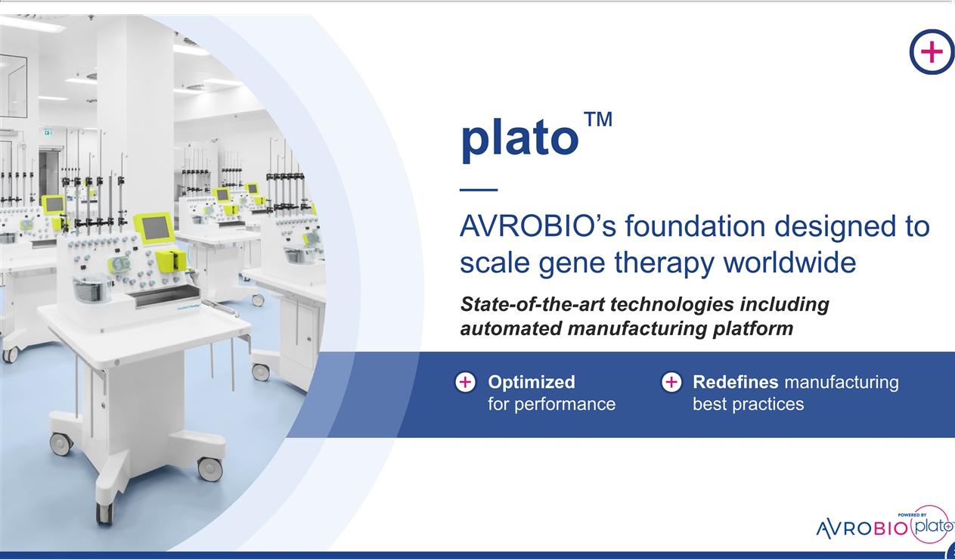

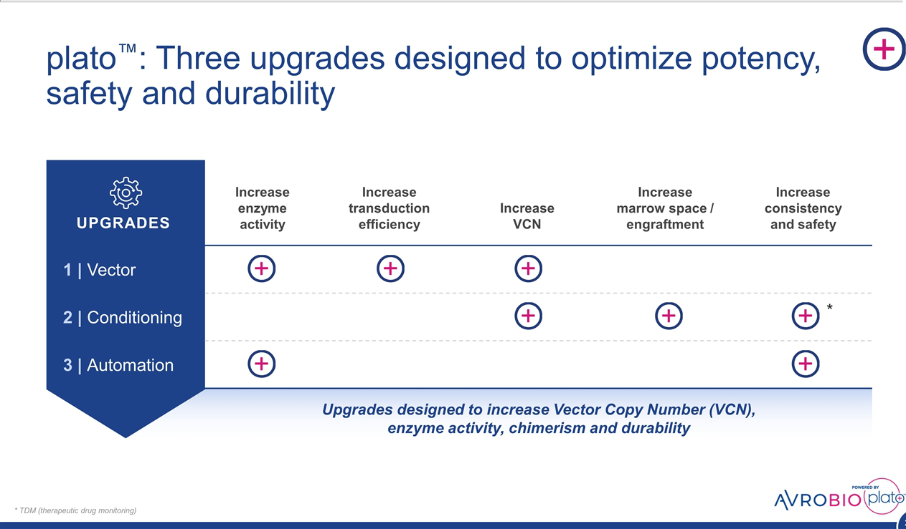

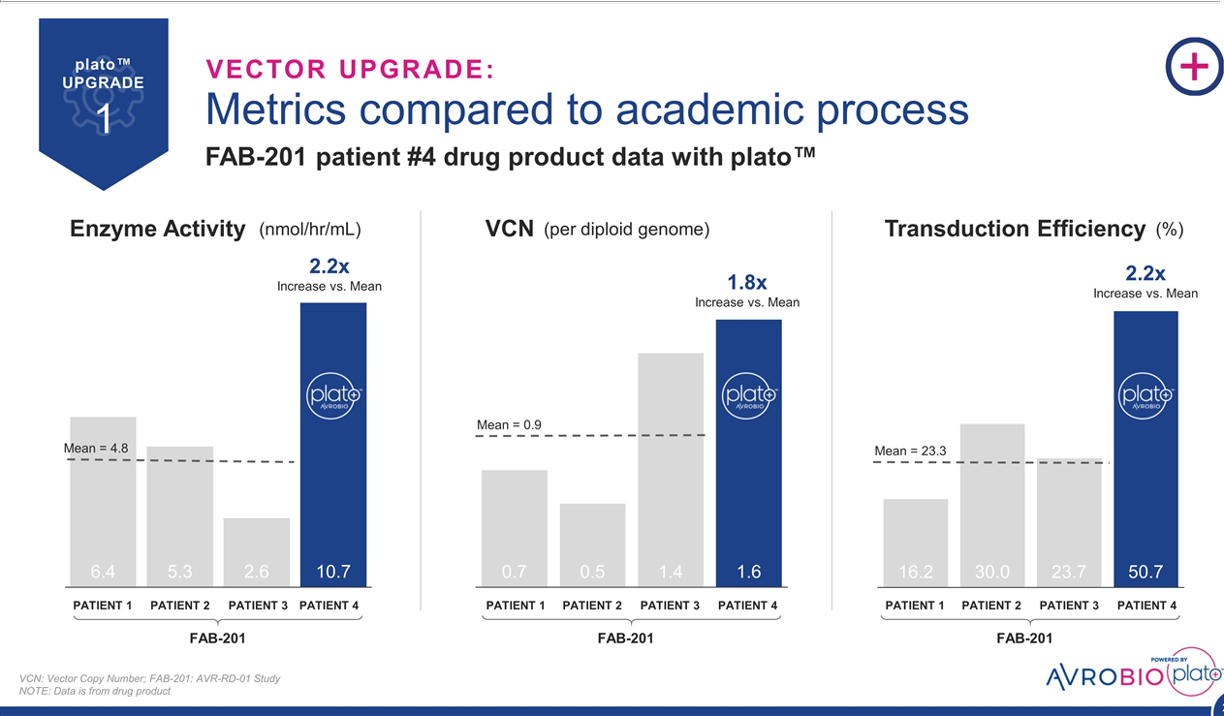

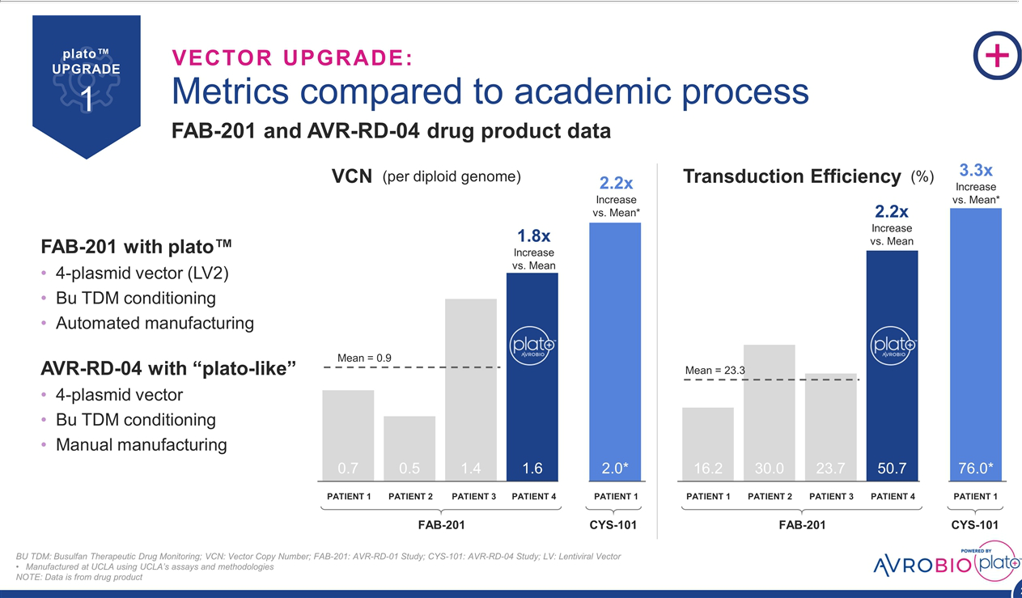

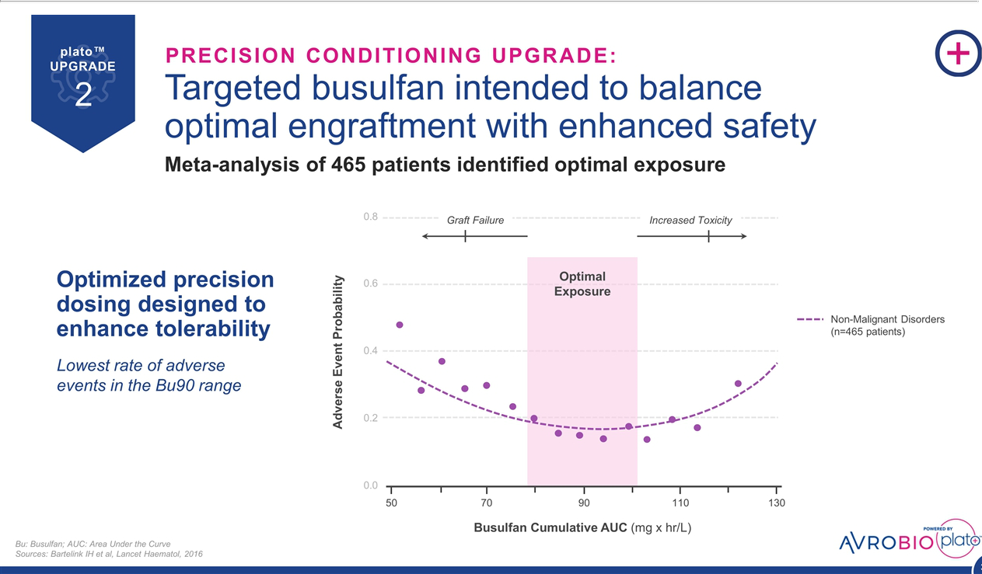

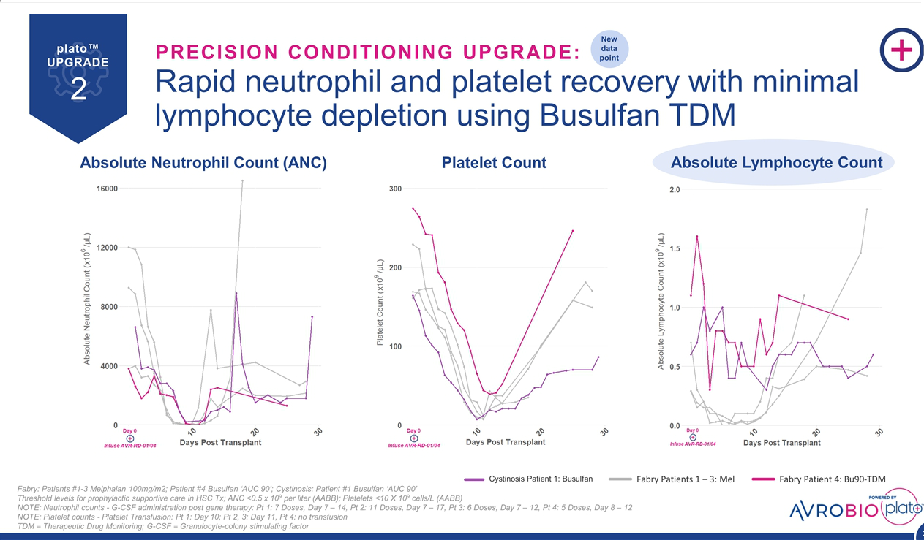

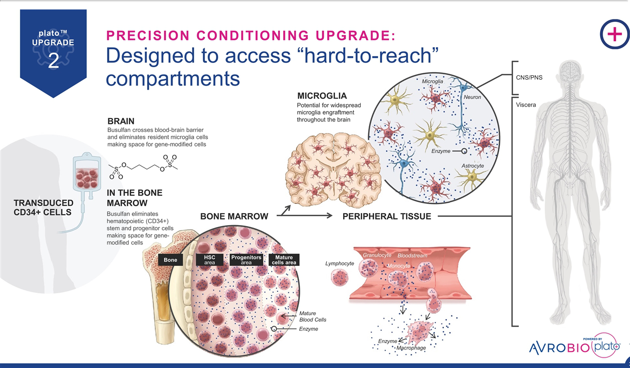

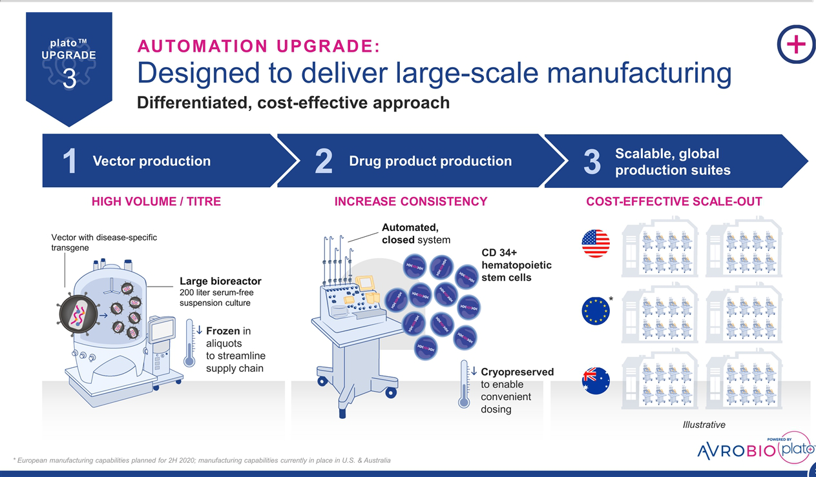

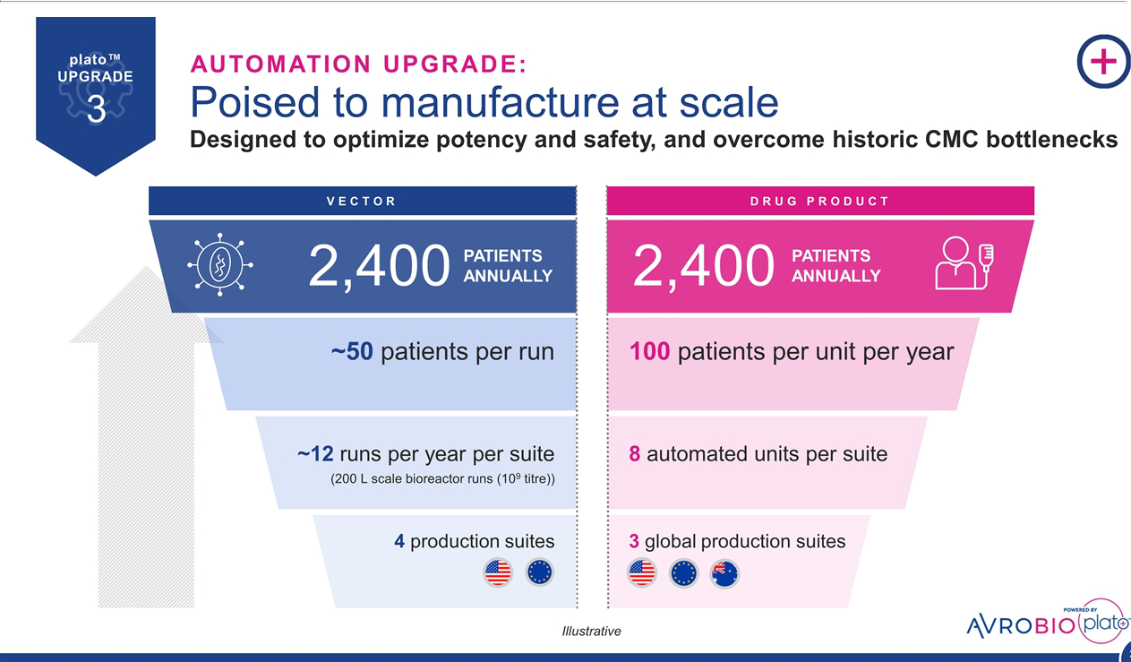

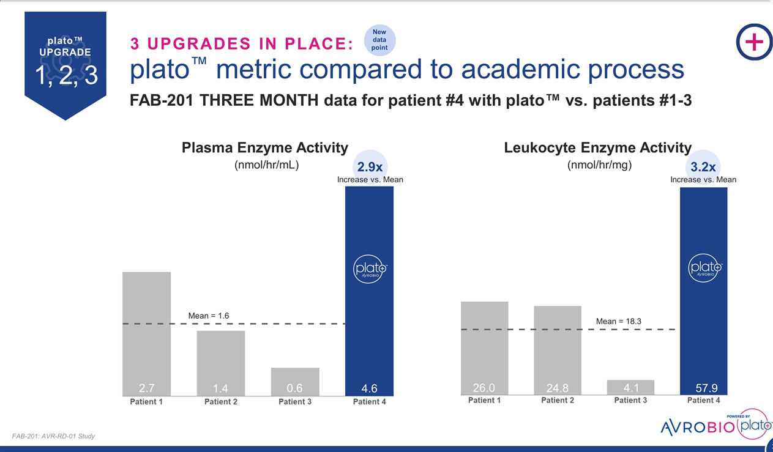

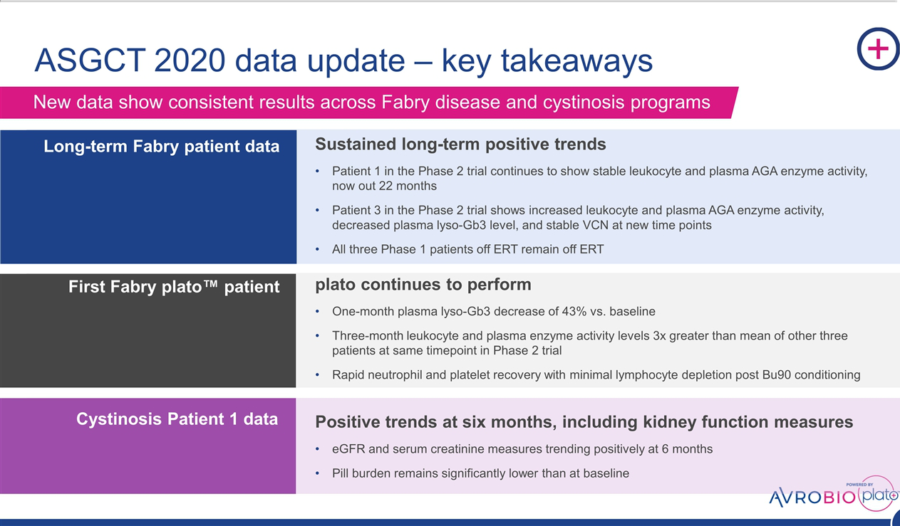

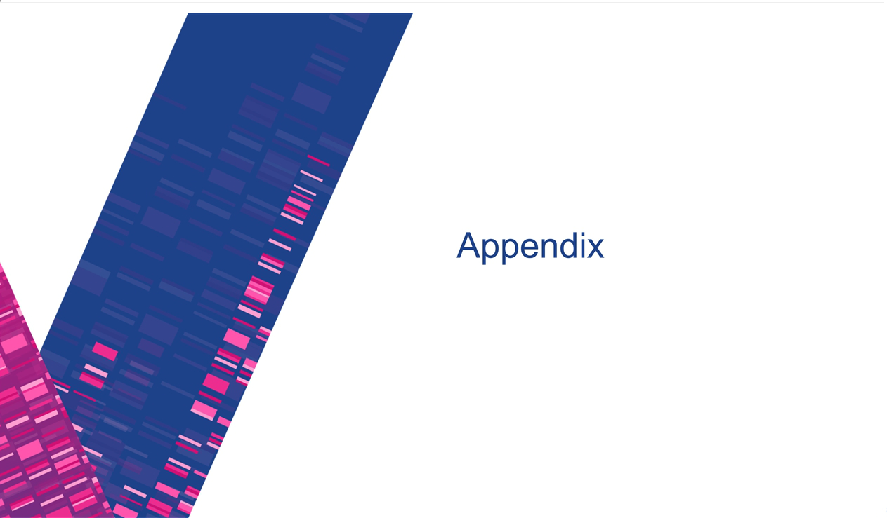

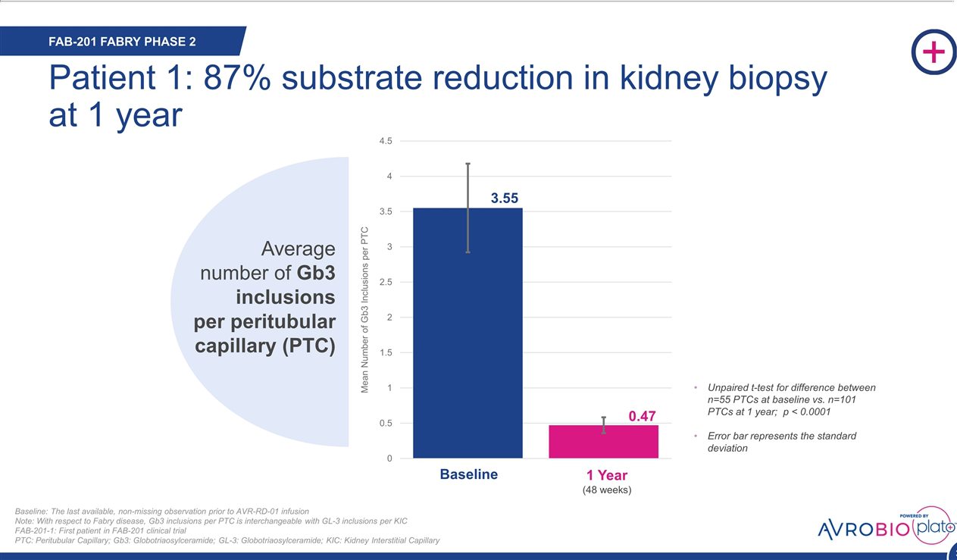

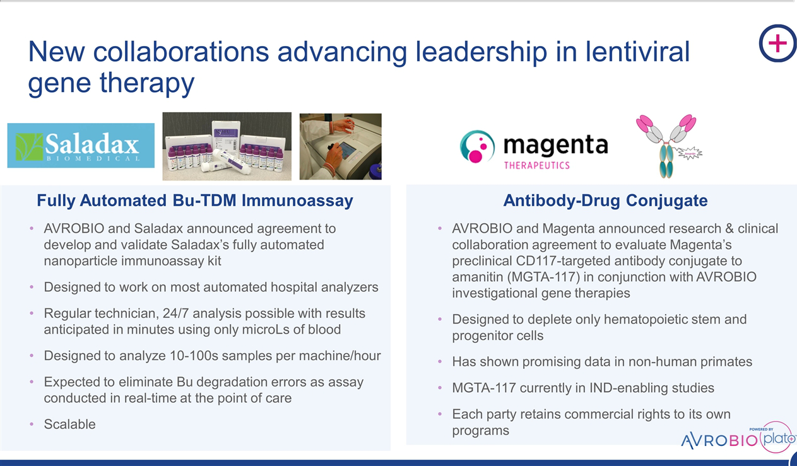

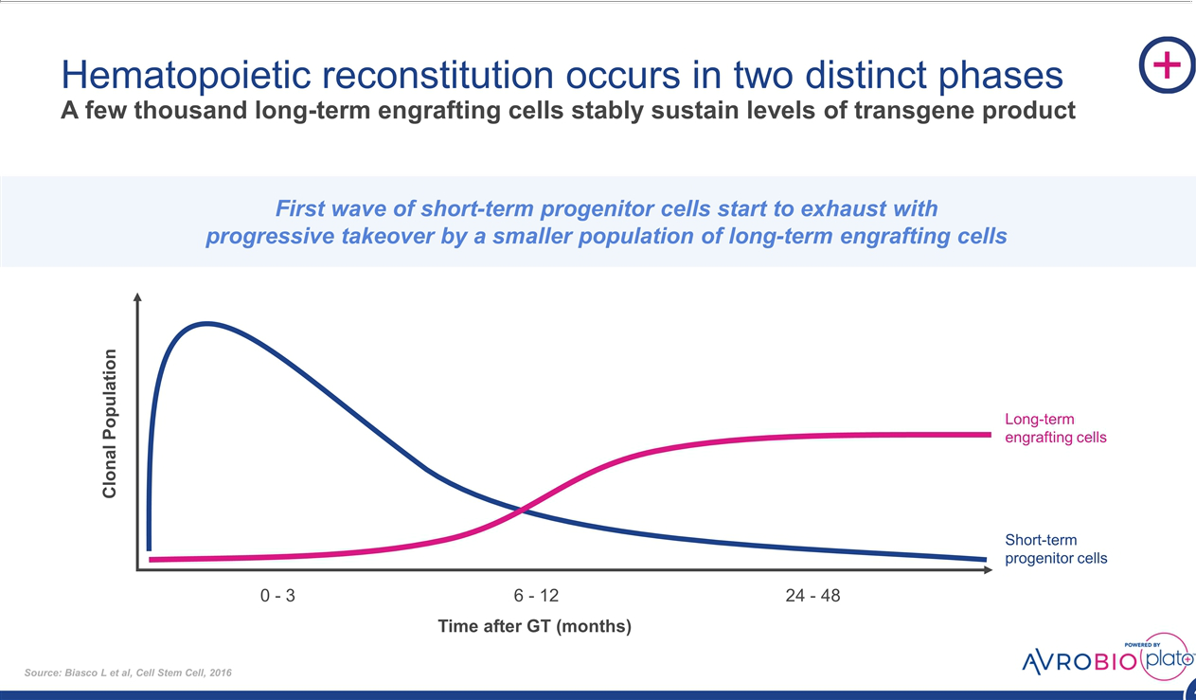

Exhibit 99.2

AVROBIO Reports Updated Clinical Data from Investigational Gene Therapy

Programs for Fabry Disease and Cystinosis

Sustained enzyme activity up to 22 months and consistent trends demonstrated across multiple

other measures in first patient in Fabry disease Phase 2 clinical trial

Data from first patient treated using plato TM gene therapy platform in Fabry disease trial show:

- 43-percent reduction in toxic metabolite plasma lyso-Gb3 one month post-treatment

- Significantly higher leukocyte and plasma enzyme activity three months post-treatment than other Phase 2 patients treated using academic platform at same timepoint

Data from first cystinosis patient in Phase 1/2 trial show positive trends at six months, including in kidney function measures

CAMBRIDGE, Mass., May 13, 2020 — AVROBIO, Inc. (Nasdaq: AVRO), a leading clinical-stage gene therapy company with a mission to free people from a lifetime of genetic disease, today announced new clinical data from its investigational programs for Fabry disease and cystinosis. The data will be presented today at the American Society of Gene & Cell Therapy (ASGCT) 23rd Annual Meeting.

“We’re excited to see continued strong results across our clinical programs for Fabry disease and cystinosis. The general consistency across our Phase 2 Fabry disease patients treated so far suggests that a one-time dose of our investigational gene therapy may enable patients to durably produce the functional enzyme they need to clear toxic substrates and metabolites. Additionally, six months post-treatment, the first patient in our investigator-sponsored Phase 1/2 trial for cystinosis continues to show positive trends for important measures of kidney function,” said Geoff MacKay, AVROBIO’s president and CEO. “We’re gratified to see platoTM continuing to perform, with the first patient treated using plato’s personalized conditioning regimen of busulfan with therapeutic drug monitoring (TDM) reporting a significant reduction in plasma lyso-Gb3 one month post-treatment. At three months, this patient’s leukocyte and plasma enzyme activity were triple the levels seen at the same timepoint in the other Phase 2 patients, who were treated using our academic platform rather than plato.”

New interim data continue to support potential first-line use of AVR-RD-01 for Fabry disease

Four patients have been dosed in the Phase 2 trial (FAB-201) of AVR-RD-01, AVROBIO’s investigational lentiviral gene therapy for Fabry disease. The following new data will be presented today at ASGCT:

- The first patient continued to show increased leukocyte and plasma AGA enzyme activity, now up to 22 months post-treatment. These data suggest the patient is producing an

endogenous supply of functional alpha-galactosidase (AGA) enzyme, which is essential to prevent the accumulation of a toxic metabolite, lyso-Gb3, in tissues including the heart and kidneys. A sustained decrease in plasma lyso-Gb3 and total Gb3 levels has previously been reported for this patient out to 18 months.

- The third patient had a sustained decrease in plasma lyso-Gb3 and total Gb3 levels nine months after dosing. This patient also had a stable vector copy number (VCN) out approximately one year post-treatment, suggesting successful engraftment.

- The fourth patient, who is also the first to be dosed with AVROBIO’s plato gene therapy platform, had a 43-percent reduction in the toxic metabolite plasma lyso-Gb3 at one month. At three months, he also had leukocyte enzyme and plasma enzyme activity levels approximately three times higher than the mean activity level of the first three patients in the same trial at the same timepoint.

While the presentation today will focus on data updates for its Phase 2 trial, the company also reports that all three Phase 1 patients who discontinued enzyme replacement therapy (ERT) after receiving AVR-RD-01 gene therapy, remain off ERT as of April 27, 2020.

As of the safety data cut-off date of Nov. 26, 2019, there have been no safety events attributed to AVR-RD-01 drug product in either the Phase 1 or Phase 2 trial. Through the safety data cut-off date, four serious adverse events (SAEs) have been reported in the FAB-201 trial and two SAEs in the Phase 1 trial. The fourth Phase 2 patient, who was dosed after the safety data cut-off date, has reported an SAE, which was not attributed to AVR-RD-01 and which subsequently resolved. Across both studies, each of the SAEs has been consistent with the conditioning regimen, stem cell mobilization, underlying disease or pre-existing conditions. Pre-existing low anti-AGA antibody titers have been detected in four patients in the Phase 1 trial and a transient low titer was observed but not detectable in subsequent measures in one patient in the Phase 2 trial.

AVROBIO continues to actively identify participants for the Phase 2 Fabry disease trial in Australia, Canada and the U.S. The FAB-201 trial is an ongoing open-label, single-arm Phase 2 clinical trial evaluating the efficacy and safety of AVR-RD-01 in eight to 12 treatment-naïve Fabry disease patients.

New six-month data for cystinosis program indicate positive trends in key kidney function measures

New data will also be presented from the first patient dosed in the investigator-sponsored Phase 1/2 trial of AVR-RD-04 for cystinosis, a progressive disease marked by the accumulation

of cystine in cellular organelles known as lysosomes. This buildup can cause debilitating symptoms including kidney failure, corneal damage and thyroid dysfunction, often leading to a shortened lifespan. Currently, more than 90 percent of treated cystinosis patients require a kidney transplant in the second or third decade of life. The current standard of care for cystinosis is cysteamine, a burdensome treatment regimen that can require dozens of pills per day and may not prevent overall progression of the disease.

Six months following administration of AVR-RD-04, the patient’s estimated glomerular filtration rate (eGFR), which is a measure of kidney function, improved from 38 mL/mi/1.73m2 at baseline to 52 mL/mi/1.73m2. The patient’s serum creatinine, another measure of kidney function, also improved, falling from 2.2 mg/dL at baseline to 1.6 mg/dL at six months. The patient stopped cysteamine treatment before administration of AVR-RD-04 and remains off cysteamine.

As of the safety data cut-off date of Jan. 27, 2020, which was approximately three months following administration of the investigational gene therapy to the first patient in the AVR-RD-04 program, there have been no reports of safety events attributed to the investigational drug product. In addition, no SAEs have been reported as of the safety data cut-off date. Adverse events did not suggest any unexpected safety signals or trends.

The cystinosis data will be presented today at ASGCT by Stephanie Cherqui, Ph.D., an associate professor at the University of California, San Diego (UCSD), the principal investigator of the trial and an AVROBIO collaborator and consultant. The Phase 1/2 trial of AVR-RD-04 is funded by grants to UCSD from the California Institute for Regenerative Medicine, Cystinosis Research Foundation and the National Institutes of Health (NIH). The trial is actively identifying up to six participants.

About AVROBIO’s personalized gene therapy approach

Our investigational lentiviral gene therapies start with the patient’s own stem cells. We use a lentiviral vector to transduce those cells in order to insert a therapeutic gene designed to enable the patient to produce a functional supply of the protein they lack. These cells are then infused back into the patient, where they are expected to engraft in the bone marrow and produce generations of daughter cells, each containing a copy or copies of the therapeutic gene. To optimize engraftment, we use a personalized conditioning regimen of busulfan with therapeutic drug monitoring (TDM) to clear space in the patient’s bone marrow. Our approach is designed to drive durable production of the functional protein throughout the patient’s body, thereby potentially addressing symptoms from “head to toe,” including those originating in the central nervous system.

About lentiviral gene therapy

Lentiviral vectors are differentiated from other delivery mechanisms because of their large cargo capacity and their ability to integrate the therapeutic gene directly into the patient’s chromosomes. This integration is designed to maintain the therapeutic gene’s presence as the patient’s cells divide, which potentially enables dosing of pediatric patients, whose cells divide rapidly as they grow. Because the therapeutic gene is integrated using the vector into patients’ stem cells ex vivo, patients are not excluded from receiving the investigational therapy due to pre-existing antibodies to the viral vector.

About AVROBIO

Our mission is to free people from a lifetime of genetic disease with a single dose of gene therapy. We aim to halt or reverse disease throughout the body by driving durable expression of functional protein, even in hard-to-reach tissues and organs including the brain, muscle and bone. Our clinical-stage programs include Fabry disease, Gaucher disease and cystinosis and we also are advancing a program in Pompe disease. AVROBIO is powered by the plato™ gene therapy platform, our foundation designed to scale gene therapy worldwide. We are headquartered in Cambridge, Mass., with an office in Toronto, Ontario. For additional information, visit avrobio.com, and follow us on Twitter and LinkedIn.

Forward-Looking Statement

This press release contains forward-looking statements, including statements made pursuant to the safe harbor provisions of the Private Securities Litigation Reform Act of 1995. These statements may be identified by words and phrases such as “aims,” “anticipates,” “believes,” “could,” “designed to,” “estimates,” “expects,” “forecasts,” “goal,” “intends,” “may,” “plans,” “possible,” “potential,” “seeks,” “will,” and variations of these words and phrases or similar expressions that are intended to identify forward-looking statements. These forward-looking statements include, without limitation, statements regarding our business strategy for and the potential therapeutic benefits of our prospective product candidates, the design, commencement, enrollment and timing of ongoing or planned clinical trials, clinical trial results, product approvals and regulatory pathways, anticipated benefits of our gene therapy platform including potential impact on our commercialization activities, timing and likelihood of success, the expected benefits and results of our implementation of the plato platform in our clinical trials and gene therapy programs, and the expected safety profile of our investigational gene therapies. Any such statements in this press release that are not statements of historical fact may be deemed to be forward-looking statements. Results in preclinical or early-stage clinical trials may not be indicative of results from later stage or larger scale clinical trials and do not ensure regulatory approval. You should not place undue reliance on these statements, or the scientific data presented.

Any forward-looking statements in this press release are based on AVROBIO’s current expectations, estimates and projections about our industry as well as management’s current beliefs and expectations of future events only as of today and are subject to a number of risks and uncertainties that could cause actual results to differ materially and adversely from those set forth in or implied by such forward-looking statements. These risks and uncertainties include, but are not limited to, the risk that any one or more of AVROBIO’s product candidates will not be successfully developed or commercialized, the risk of cessation or delay of any ongoing or planned clinical trials of AVROBIO or our collaborators, the risk that AVROBIO may not successfully recruit or enroll a sufficient number of patients for our clinical trials, the risk that AVROBIO may not realize the intended benefits of our gene therapy platform, including the features of our plato platform, the risk that our product candidates or procedures in connection with the administration thereof will not have the safety or efficacy profile that we anticipate, the risk that prior results, such as signals of safety, activity or durability of effect, observed from preclinical or clinical trials, will not be replicated or will not continue in ongoing or future studies or trials involving AVROBIO’s product candidates, the risk that we will be unable to obtain and maintain regulatory approval for our product candidates, the risk that the size and growth potential of the market for our product candidates will not materialize as expected, risks associated with our dependence on third-party suppliers and manufacturers, risks regarding the accuracy of our estimates of expenses and future revenue, risks relating to our capital requirements and needs for additional financing, risks relating to clinical trial and business interruptions resulting from the COVID-19 outbreak or similar public health crises, including that such interruptions may materially delay our development timeline and/or increase our development costs or that data collection efforts may be impaired or otherwise impacted by such crises, and risks relating to our ability to obtain and maintain intellectual property protection for our product candidates. For a discussion of these and other risks and uncertainties, and other important factors, any of which could cause AVROBIO’s actual results to differ materially and adversely from those contained in the forward-looking statements, see the section entitled “Risk Factors” in AVROBIO’s most recent Quarterly Report, as well as discussions of potential risks, uncertainties and other important factors in AVROBIO’s subsequent filings with the Securities and Exchange Commission. AVROBIO explicitly disclaims any obligation to update any forward-looking statements except to the extent required by law.

Investor Contact:

Christopher F. Brinzey

Westwicke, an ICR Company

339-970-2843

chris.brinzey@westwicke.com

Media Contact:

Tom Donovan

Ten Bridge Communications

857-559-3397

tom@tenbridgecommunications.com

