Table of Contents

Filed pursuant to Rule 424(b)(5)

Registration No. 333-235641

PROSPECTUS SUPPLEMENT

(to Prospectus dated January 14, 2020)

5,000,000 Shares


Common Stock

We are offering 5,000,000 shares of our common stock, par value $0.0001 per share. Our common stock is listed on The Nasdaq Global Select Market under the symbol “AVRO.” On November 19, 2020, the last reported sale price of our common stock was $16.98 per share.

We are an “emerging growth company” under applicable Securities and Exchange Commission rules and will be subject to reduced public company reporting requirements for this prospectus supplement and future filings.

Our business and an investment in our common stock involve significant risks. These risks are described under the caption “Risk Factors” beginning on page S-32 of this prospectus supplement.

Neither the Securities and Exchange Commission nor any state securities commission has approved or disapproved of these securities or determined whether this prospectus supplement or the accompanying prospectus is truthful or complete. Any representation to the contrary is a criminal offense.

Public offering price |  | Per Share |  |  | $ |  | Total
Public offering price |  | $ | 15.00 |  | $ |  | 75,000,000
Underwriting discounts and commissions (1) | $ |  | 0.90 |  | $ | 4,500,000
Proceeds to us before expenses | $ |  | 14.10 |  | $ | 70,500,000

- We have agreed to reimburse the underwriters for certain expenses. See “Underwriting.”

We have granted the underwriters an option for a period of 30 days from the date of this prospectus supplement to purchase up to 750,000 additional shares of our common stock (15% of the shares sold). If the underwriters exercise their option in full, the total underwriting discounts and commissions payable by us will be $5,175,000, and the total proceeds to us, before expenses, will be $81,075,000.

Delivery of the shares of common stock is expected to be made on or about November 24, 2020.

The date of this prospectus supplement is November 19, 2020

MORGAN STANLEY

COWEN

WELLS FARGO SECURITIES

WEDBUSH PACGROW

BARCLAYS

Table of Contents

TABLE OF CONTENTS

PROSPECTUS SUPPLEMENT

 | Page
ABOUT THIS PROSPECTUS SUPPLEMENT | S-1
CAUTIONARY STATEMENT REGARDING FORWARD-LOOKING STATEMENTS | S-2
PROSPECTUS SUPPLEMENT SUMMARY | S-4
COMPANY OVERVIEW | S-4
RECENT DEVELOPMENTS | S-4
COMPANY INFORMATION | S-27
IMPLICATIONS OF BEING AN EMERGING GROWTH COMPANY | S-29
THE OFFERING | S-30
RISK FACTORS | S-32
USE OF PROCEEDS | S-38
MARKET FOR COMMON STOCK | S-39
DIVIDEND POLICY | S-40
CAPITALIZATION | S-41
DILUTION | S-43
UNDERWRITING | S-45
MATERIAL U.S. FEDERAL INCOME TAX CONSIDERATIONS FOR NON-U.S. HOLDERS | S-52
LEGAL MATTERS | S-56
EXPERTS | S-56
WHERE YOU CAN FIND MORE INFORMATION | S-56
INCORPORATION BY REFERENCE | S-56
PROSPECTUS
 | Page
ABOUT THIS PROSPECTUS | 1
RISK FACTORS | 2
CAUTIONARY STATEMENT REGARDING FORWARD-LOOKING STATEMENTS | 3
THE COMPANY | 5
USE OF PROCEEDS | 8
SECURITIES WE MAY OFFER | 9
DESCRIPTION OF CAPITAL STOCK | 10
DESCRIPTION OF DEBT SECURITIES | 16
DESCRIPTION OF WARRANTS | 24
DESCRIPTION OF UNITS | 25
PLAN OF DISTRIBUTION | 28
LEGAL MATTERS | 31
EXPERTS | 31
WHERE YOU CAN FIND MORE INFORMATION | 31
INCORPORATION BY REFERENCE | 32

AVROBIO, Inc. and other trademarks or service marks of AVROBIO, Inc. appearing in this prospectus supplement and the accompanying prospectus are the property of AVROBIO, Inc. This prospectus supplement and the accompanying prospectus may refer to brand names, trademarks, service marks or trade names of other companies and organizations, and those brand names, trademarks, service marks and trade names are the property of their respective holders.

i

Table of Contents

ABOUT THIS PROSPECTUS SUPPLEMENT

This document is in two parts. The first part is this prospectus supplement, which describes the specific terms of this offering of common stock. The second part is the accompanying prospectus, which provides more general information, some of which may not apply to this offering. The information included or incorporated by reference in this prospectus supplement also adds to, updates and changes information contained or incorporated by reference in the accompanying prospectus. If information included or incorporated by reference in this prospectus supplement is inconsistent with the accompanying prospectus or the information incorporated by reference therein, then this prospectus supplement or the information incorporated by reference in this prospectus supplement will apply and will supersede the information in the accompanying prospectus and the documents incorporated by reference therein.

This prospectus supplement is part of a registration statement that we filed with the Securities and Exchange Commission, or SEC, using a “shelf” registration process. Under the shelf registration process, we may from time to time offer and sell any combination of the securities described in the accompanying prospectus up to a total dollar amount of $250.0 million, of which this offering is a part.

You should rely only on the information contained or incorporated by reference in this prospectus supplement, the accompanying prospectus and any free writing prospectus prepared by us or on our behalf. We have not, and the underwriters have not, authorized any other person to provide you with information different from that contained in this prospectus supplement and the accompanying prospectus or incorporated by reference in this prospectus supplement and the accompanying prospectus. If anyone provides you with different or inconsistent information, you should not rely on it. We are not, and the underwriters are not, making an offer to sell or soliciting an offer to buy these securities under any circumstance in any jurisdiction where the offer or solicitation is not permitted. You should assume that the information contained in this prospectus supplement, the accompanying prospectus and any free writing prospectus prepared by us or on our behalf is accurate only as of the date of the respective document in which the information appears, and that any information in documents that we have incorporated by reference is accurate only as of the date of the document incorporated by reference, regardless of the time of delivery of this prospectus supplement or any sale of a security. Our business, financial condition, results of operations and prospects may have changed since those dates.

It is important for you to read and consider all of the information contained in this prospectus supplement and the accompanying prospectus in making your investment decision. We include cross-references in this prospectus supplement and the accompanying prospectus to captions in these materials where you can find additional related discussions. The table of contents in this prospectus supplement provides the pages on which these captions are located. You should read both this prospectus supplement and the accompanying prospectus, together with the additional information described in the sections entitled “Where You Can Find More Information” and “Incorporation by Reference” of this prospectus supplement, before investing in our common stock.

We are offering to sell, and seeking offers to buy, shares of common stock only in jurisdictions where offers and sales are permitted. The distribution of this prospectus supplement and the accompanying prospectus and the offering of the common stock in certain jurisdictions may be restricted by law. Persons outside the United States who come into possession of this prospectus supplement and the accompanying prospectus must inform themselves about, and observe any restrictions relating to, the offering of the common stock and the distribution of this prospectus supplement and the accompanying prospectus outside the United States. This prospectus supplement and the accompanying prospectus do not constitute, and may not be used in connection with, an offer to sell, or a solicitation of an offer to buy, any securities offered by this prospectus supplement and the accompanying prospectus by any person in any jurisdiction in which it is unlawful for such person to make such an offer or solicitation.

S-1

Table of Contents

CAUTIONARY STATEMENT REGARDING FORWARD-LOOKING STATEMENTS

This prospectus supplement and the accompanying prospectus, including the documents that we incorporate by reference, contain forward-looking statements which are made pursuant to the safe harbor provisions of Section 27A of the Securities Act of 1933, as amended, or the Securities Act, and Section 21E of the Securities Exchange Act of 1934, as amended, or the Exchange Act. Any statements about our expectations, beliefs, plans, objectives, assumptions or future events or performance are not historical facts and may be forward-looking. These statements are often, but are not always, made through the use of words or phrases such as “may,” “will,” “could,” “should,” “expects,” “intends,” “target,” “contemplates,” “plans,” “anticipates,” “believes,” “estimates,” “predicts,” “projects,” “potential,” “designed to,” or “continue,” and similar expressions, or the negative of these terms, or similar expressions. Accordingly, these statements involve estimates, assumptions and uncertainties which could cause actual results to differ materially from those expressed in them. Any forward-looking statements are qualified in their entirety by reference to the factors discussed throughout this report, and in particular those factors referenced in the section “Risk Factors.”

This prospectus supplement and the accompanying prospectus contain forward-looking statements that are based on our management’s belief and assumptions and on information currently available to our management. These statements relate to future events or our future financial performance, and involve known and unknown risks, uncertainties and other factors that may cause our actual results, levels of activity, performance or achievements to be materially different from any future results, levels of activity, performance or achievements expressed or implied by these forward-looking statements.

Forward-looking statements include, but are not limited to, statements about:

- the impact of the COVID-19 pandemic on our clinical trial programs, clinical supply and business generally, as well as our plans and expectations with respect to the timing and resumption of any development activities that were or may be temporarily paused as a result of the COVID-19 pandemic;

- the timing, progress and results of preclinical studies and clinical trials for our programs and product candidates, including statements regarding the timing of initiation and completion of studies or trials and related preparatory work, the period during which the results of the trials will become available and our research and development programs;

- the existence or absence of side effects or other properties relating to our product candidates which could delay or prevent their regulatory approval, limit their commercial potential, or result in significant negative consequences following any potential marketing approval;

- the durability of effects from our product candidates;

- the timing, scope or likelihood of regulatory filings, approvals or anticipated regulatory interactions, including our ability to secure a meeting with the U.S. Food and Drug Administration (“FDA”) and submit a briefing book for a potential accelerated approval strategy for our investigational gene therapy AVR-RD-01 in Fabry disease;

- our ability to develop and advance product candidates into, and successfully complete, clinical studies;

- our expectations regarding the size of the patient populations for our product candidates, if approved for commercial use;

- the implementation of our business model and our strategic plans for our business, product candidates, technology and plato® platform;

- our commercialization, marketing and manufacturing capabilities and strategy;

- the pricing and reimbursement of our product candidates, if approved;

- the scalability and commercial viability of our manufacturing methods and processes, including our move to a closed, automated system;

- the rate and degree of market acceptance and clinical utility of our product candidates, in particular, and gene therapy, in general;

- our ability to establish or maintain collaborations or strategic relationships or obtain additional funding;

S-2

Table of Contents

- our competitive position;

- the scope of protection we and/or our licensors are able to establish and maintain for intellectual property rights covering our current and future product candidates, as well as any statements as to whether we do or do not infringe, misappropriate or otherwise violate any third-party intellectual property rights;

- our financial performance;

- our ability to retain the continued service of our key professionals and to identify, hire and retain additional qualified professionals;

- developments and projections relating to our competitors and our industry;

- our expectations related to the use of our cash reserves;

- our expectations related to the use of proceeds from this offering;

- our estimates regarding expenses, future revenue, capital requirements and needs for additional financing;

- our ability to remediate the material weaknesses that we and our independent registered public accounting firm previously identified and avoid any findings of material weaknesses or significant deficiencies in the future;

- the impact of laws and regulations, including without limitation recently enacted tax reform legislation;

- our expectations regarding the time during which we are an emerging growth company under the Jumpstart Our Business Startups Act of 2012, as amended, or the JOBS Act; and

- other risks and uncertainties, including those listed under the caption “Risk Factors”.

This prospectus supplement, the accompanying prospectus and the documents incorporated by reference herein and therein also contain estimates, projections and other information concerning our industry, our business, and the markets for certain diseases, including data regarding the estimated size of those markets, and the incidence and prevalence of certain medical conditions. Information that is based on estimates, forecasts, projections, market research or similar methodologies is inherently subject to uncertainties and actual events or circumstances may differ materially from events and circumstances reflected in this information. Unless otherwise expressly stated, we obtained this industry, business, market and other data from reports, research surveys, studies and similar data prepared by market research firms and other third parties, industry, medical and general publications, government data and similar sources.

You should read this prospectus supplement, the accompanying prospectus and the documents that we incorporate by reference herein or therein completely and with the understanding that our actual future results may be materially different from what we expect. The forward-looking statements in this prospectus supplement, the accompanying prospectus and the documents we incorporate by reference herein represent our views as of their respective dates. We anticipate that subsequent events and developments will cause our views to change. However, while we may elect to update these forward-looking statements at some point in the future, we have no current intention of doing so except to the extent required by applicable law. You should, therefore, not rely on these forward-looking statements as representing our views as of any date subsequent to the date of this prospectus supplement.

S-3

Table of Contents


PROSPECTUS SUPPLEMENT SUMMARY

This summary provides an overview of selected information contained elsewhere in this prospectus supplement and the accompanying prospectus and does not contain all of the information you should consider before making your investment decision. Before investing in our common stock, you should carefully read this entire prospectus supplement and the accompanying prospectus and the information incorporated herein and therein by reference, including our financial statements and the related notes included or incorporated by reference into this prospectus supplement and the accompanying prospectus. You should also consider, among other things, the matters described under “Risk Factors” beginning on page S-32 and “Management’s Discussion and Analysis of Financial Condition and Results of Operations” in each case included or incorporated by reference in this prospectus supplement and the accompanying prospectus and the information incorporated herein and therein by reference. As used in this prospectus supplement and the accompanying prospectus, the terms “AVROBIO,” “we,” “our,” “us,” or “the Company” refer to AVROBIO, Inc. and its subsidiaries on a consolidated basis, unless the context otherwise indicates.

COMPANY OVERVIEW

We are a leading clinical-stage gene therapy company with a mission to free people from a lifetime of genetic disease. Our Company is focused on developing potentially curative ex vivo lentiviral-based gene therapies to treat patients with rare diseases following a single dose treatment regimen. Our investigational gene therapies employ hematopoietic stem cells that are harvested from the patient and then modified with a lentiviral vector to insert the equivalent of a functional copy of the gene that is defective in the target disease. We believe that our approach, which is designed to transform stem cells from patients into therapeutic products, has the potential to provide curative benefit for a range of diseases. Our initial focus is on a group of rare genetic diseases referred to as lysosomal diseases, some of which today are primarily managed with enzyme replacement therapies, or ERTs. These lysosomal diseases have well-understood biologies, identified patient populations, established standards of care yet with significant unmet needs, and represent large market opportunities with approximately $4.6 billion in worldwide net sales in 2019.

RECENT DEVELOPMENTS

AVR-RD-01 for Fabry disease

In November 2020, we announced data from clinical trials of our investigational gene therapy AVR-RD-01 in Fabry disease. AVR-RD-01 is currently being studied in two ongoing clinical trials. A Phase 1 investigator-sponsored clinical trial of AVR-RD-01 is being conducted by the University Health Network, or UHN, and sponsored by Fabry Disease Clinical Research and Therapeutics, or FACTs, at three centers in Canada. A total of five male patients with Fabry disease who have been previously treated with ERT for at least six months have been enrolled and enrollment is complete. In addition, we are sponsoring a Phase 2 open-label, multinational clinical trial of AVR-RD-01, with expected enrollment of eight to 12 male patients with classic Fabry disease, 16 to 50 years old, who have not been treated with ERT within 10 years prior to enrollment or chaperone therapy at any time. Four patients in Australia have enrolled in this Phase 2 clinical trial, and we currently have the necessary regulatory clearances to expand enrollment to sites in Canada and the United States. We are actively recruiting potential patients for our sites in Australia, Canada and the United States. The Phase 1 and Phase 2 clinical trials of AVR-RD-01 remain ongoing and the results presented below are preliminary and may not be representative of later results. The data cut-off date for the results below was November 3, 2020, unless otherwise specified.

The primary efficacy endpoint of our Phase 2 clinical trial is the change from baseline in the average number of globotriaosylceramide, or Gb3, inclusions per peritubular capillary, or PTC, as measured in a patient

S-4

Table of Contents


kidney biopsy one year (48 weeks) after treatment with AVR-RD-01. In addition to safety, the Phase 2 and Phase 1 clinical trials are also examining additional secondary efficacy endpoints including biomarkers such as plasma lyso-globotriaosylsphingosine, or lyso-Gb3, alpha-galactosidase A, or AGA, enzyme levels measured in plasma and leukocytes, as well as certain parameters of organ function. In addition, vector copy number, or VCN, is being measured in these trials to assess the potential durability of the gene therapy. Safety and tolerability parameters are also being assessed in these trials.

- Kidney biopsy / Gb3 PTC reductions. Gb3, also referred to as GL-3, is a type of fatty substrate that builds in the cells of Fabry patients, resulting in damage to organs such as kidneys and heart. PTCs, also referred to as kidney interstitial capillaries, or KICs, in Fabry clinical trials, convey blood after filtration in the glomeruli, enabling the blood to eventually exit the kidney and return to the circulatory system.

In July 2019, we announced that the first patient in our Phase 2 clinical trial exhibited a reduction from an average of 3.55 Gb3 inclusions per PTC at baseline to an average of 0.47 inclusions per PTC one year after administration of AVR-RD-01, representing an 87% reduction and a numerical decrease of 3.08. The second patient in the Phase 2 clinical trial has an N215S genotype, which is associated with a late-onset cardiac variant phenotype. This patient’s cardiac variant phenotype does not typically result in Gb3 accumulation in the kidney, and accordingly this patient’s kidney biopsy had low levels of Gb3 and lyso-Gb3 at all measurements, including at baseline. Although we expect that data obtained from this patient will not provide meaningful insight on the primary efficacy endpoint in our Phase 2 clinical trial, including kidney biopsies, other important efficacy and safety measures continue to be derived from data collected from this patient. A kidney biopsy was conducted on the third patient in the Phase 2 clinical trial, but due to human error in processing the biopsy sample at the external laboratory vendor, the kidney Gb3 inclusions could not be evaluated and will not be available. Our quality assurance personnel have worked closely with the external vendor to identify the cause of the vendor error and to identify additional protocols for implementation by the vendor that are designed to prevent similar errors in the future.

We expect to receive kidney biopsy data for the fourth patient in the Phase 2 clinical trial, who was dosed using our plato platform, as early as late November 2020. We currently expect to disclose such kidney biopsy data at the upcoming WORLDSymposium in February 2021.

- Plasma lyso-Gb3 reductions. The substrate, Gb3, and its toxic metabolite, known as lyso-Gb3, are considered surrogate markers for disease activity and treatment response for Fabry disease. In the case of ERT-naïve patients and patients who have discontinued ERT, we believe that reductions in Gb3 levels following treatment with gene therapy are likely driven by the therapeutic effect of gene therapy.

The first patient in our Phase 2 trial had an 86% reduction in plasma lyso-Gb3 as of 22 months post-treatment with AVR-RD-01, the third patient had a plasma lyso-Gb3 reduction of 49% as of 12 months post-treatment with AVR-RD-01 and the fourth patient had a plasma lyso-Gb3 reduction of 59% as of six months post-treatment with AVR-RD-01. Plasma lyso-Gb3 data are also available for the second patient in the Phase 2 trial, up to 18 months post-treatment with AVR-RD-01. However, the patient’s cardiac variant phenotype does not typically result in Gb3 accumulation in the kidney and skin, and accordingly this patient’s skin and kidney biopsy had low levels of Gb3 and lyso-Gb3 at all measurements, including at baseline. Although we expect that data obtained from this patient will not provide meaningful insight on the efficacy endpoints in our Phase 2 clinical trial, including kidney and skin biopsies, there may be other important insights derived from data collected from this patient in the Phase 2 clinical trial.

S-5

Table of Contents
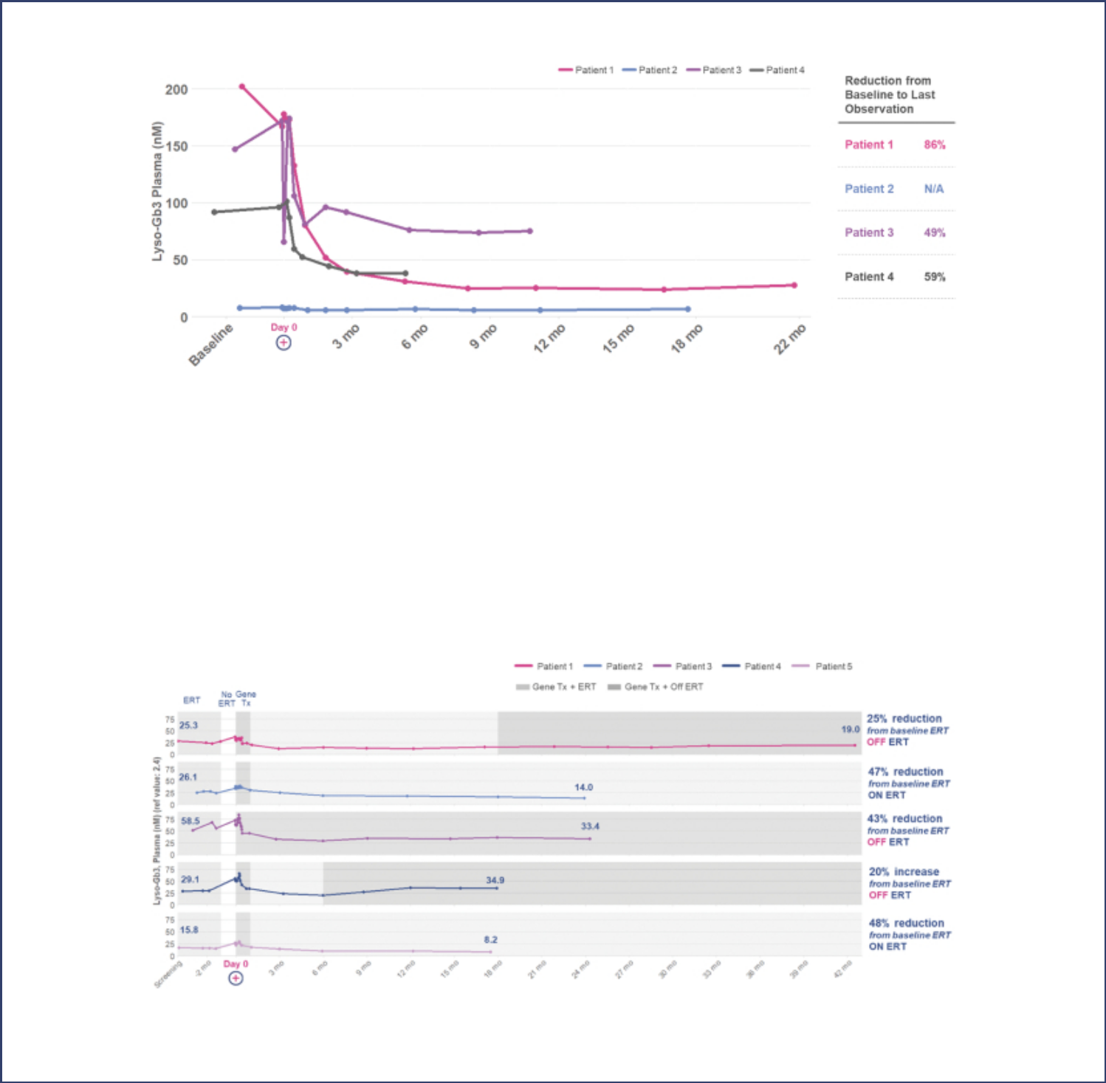

The figure below summarizes the plasma lyso-Gb3 data observed in the four dosed patients in our ongoing Phase 2 clinical trial of AVR-RD-01.

Reference Value: 2.4 nM

In four of the five patients in the Phase 1 clinical trial of AVR-RD-01, we have observed plasma lyso-Gb3 at levels post-treatment that are lower than the levels observed when the patient received only ERT prior to administration of AVR-RD-01, which we refer to as baseline ERT levels. We define baseline ERT for these Phase 1 patients as the mean of the plasma lyso-Gb3 values reported prior to initiating mobilization. Based on the latest available efficacy data, these four Phase 1 patients exhibited reductions in plasma lyso-Gb3 levels ranging between 25% and 48% compared to their baseline ERT levels. With respect to patient 4, who discontinued ERT six months following administration of AVR-RD-01, we observed an initial decline in plasma lyso-Gb3 levels through six months post-treatment compared to baseline ERT, and a 20% increase in plasma lyso-Gb3 levels at 18 months post-treatment compared to baseline ERT. This patient’s plasma lyso-Gb3 levels remain within the range for the Fabry disease patients on ERT observed in this Phase 1 clinical trial.

The following figure summarizes the plasma lyso-Gb3 data observed in all five patients from the ongoing Phase 1 clinical trial of AVR-RD-01.

- AGA enzyme activity as measured in plasma and leukocytes. We believe, based on years of observations of Fabry patients prescribed ERT, that even partial plasma AGA activity is associated

S-6

Table of Contents
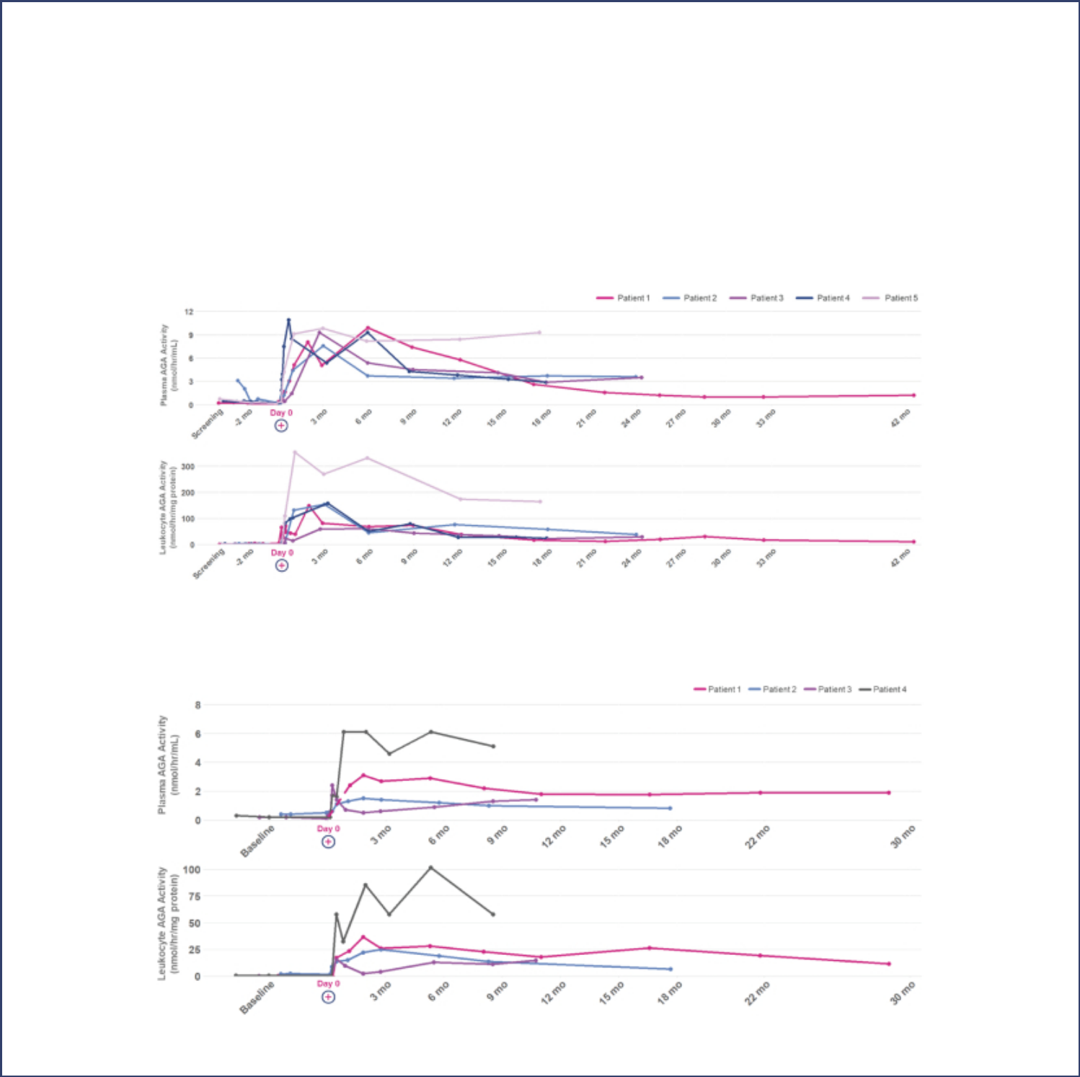

with improved outcomes in Fabry patients. AGA enzyme activity is able to reduce Gb3 levels in multiple cells and tissues. For our gene therapy, functional AGA is in part produced by the pool of circulating leukocytes derived from genetically-modified CD34+ hematopoietic stem cells, which may directly contribute to clearance of accumulated Gb3 in cells. Functional plasma AGA enters cells and travels to the lysosomes, where it can degrade Gb3. This process is referred to as cross-correction. Genetically-modified leukocytes are the progeny of transduced cells from the gene therapy. As a result, we believe that assessing leukocyte AGA activity provides a potentially improved measure to assess the durability of the gene therapy than plasma AGA enzyme activity alone.

All nine patients in our Phase 2 and Phase 1 clinical trials of AVR-RD-01 have exhibited sustained AGA enzyme activity in both the plasma and leukocytes. The following figures summarize the plasma and leukocyte AGA enzyme activity reported from the ongoing Phase 2 and Phase 1 clinical trials of AVR-RD-01.

Phase 1: AGA Enzyme Activity

AGA Activity Reference Range: 24–56 nmol/hr/mg protein; plasma AGA Activity Reference Range: 5.1–9.2 nmol/hr/mL

Phase 2: AGA Enzyme Activity

AGA Activity Reference Range: 24–56 nmol/hr/mg protein; plasma AGA Activity Reference Range: 5.1–9.2 nmol/hr/mL

S-7

Table of Contents
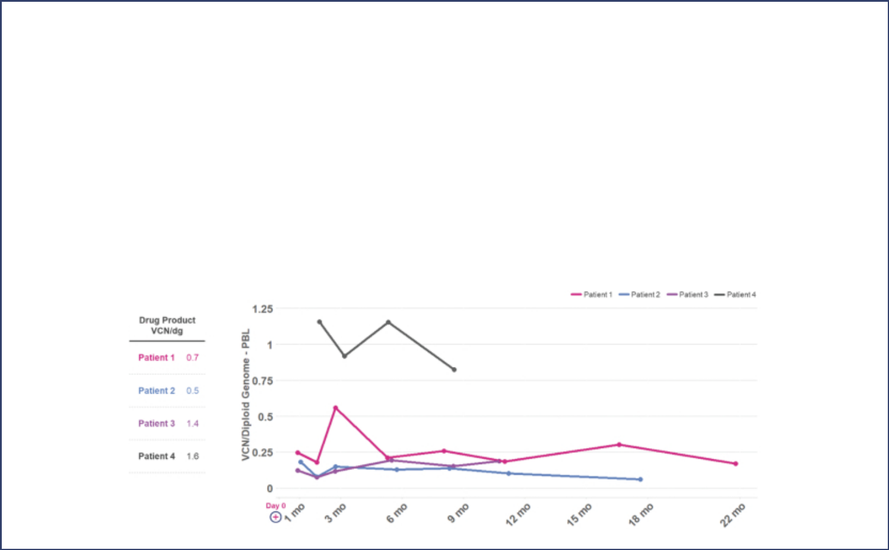

- Vector Copy Number. Vector Copy Number, or VCN, which is expressed as VCN per diploid genome, refers to the average number of copies of the lentiviral-vector inserted transgene that are integrated into the genome of a cell, and is another measure that can be used to help assess the durability of a gene therapy. We believe that different diseases may require varying levels of VCN based on the underlying condition, and therefore VCN measurements across different diseases should be assessed separately. For example, a VCN of 0.1 may represent 5% to 10% of all nucleated circulating blood cells carrying one to two copies of the inserted gene, which we believe may be sufficient to result in clinically meaningful AGA enzyme activity in the case of Fabry disease, as suggested by our interim data from our ongoing clinical trials of our investigational gene therapy, AVR-RD-01, in Fabry disease.

All nine patients in our Phase 2 and Phase 1 clinical trials of AVR-RD-01 have exhibited consistent VCN trends, with VCN levels for the first Phase 1 patient stable at 32 months post-treatment. The following figures summarize the VCN observations from the ongoing Phase 2 and Phase 1 clinical trials of AVR-RD-01, including the VCN of the drug product with which each patient was dosed. The fourth patient in the Phase 2 clinical trial, for whom data is available out to nine months post-treatment, was dosed using our plato platform.

Phase 2: VCN

S-8

Table of Contents
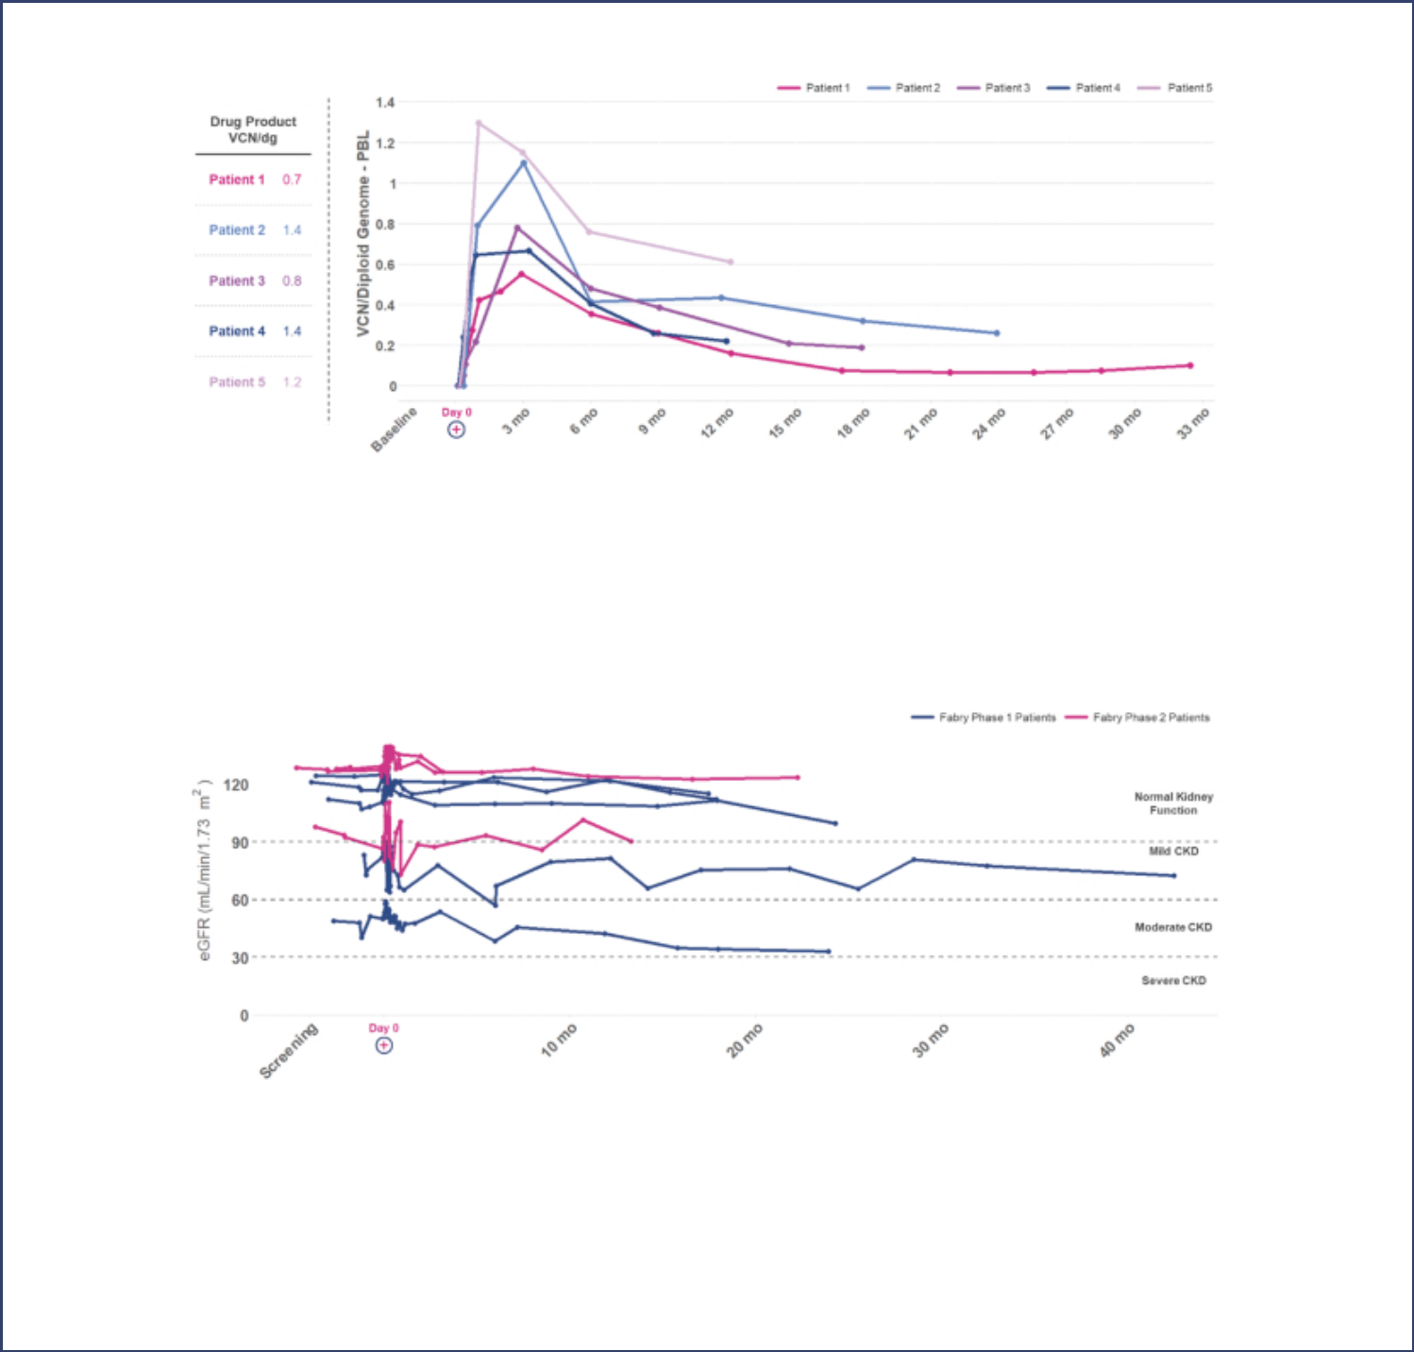

Phase 1: VCN

- Kidney and cardiac function stability. Secondary endpoints of our Phase 2 trial include measurements of kidney function, as measured by estimated glomerular filtration rate, or eGFR, and measured glomerular filtration rate, or mGFR, as well as measures of cardiac function, as assessed by Left Ventricular Mass Index, or LVMI. eGFR is determined using the Chronic Kidney Disease Epidemiology Collaboration, or CKD-EPI, formula and mGFR is determined using plasma clearance of iohexol.

The following figure summarizes eGFR data for all patients in our Phase 2 and Phase 1 clinical trials of AVR-RD-01, other than Patient 2 in the Phase 2 clinical trial whose cardiac variant phenotype does not typically result in Gb3 accumulation in the kidney.

- ERT discontinuation by Phase 1 patients. Three patients in the Phase 1 clinical trial who have been treated with AVR-RD-01, our investigational gene therapy, have discontinued ERT and, as of October 26, 2020, have remained off ERT since such discontinuations. Patient 1 received his last ERT dose in July 2018, Patient 3 received his last ERT dose in May 2018, and Patient 4 received his last ERT dose in June 2019.

- Safety update. Preliminary clinical data for all nine patients dosed to date in the Phase 2 and Phase 1 clinical trials appear to indicate that our AVR-RD-01 investigational gene therapy has been generally well tolerated with no unexpected trends or safety events identified. No serious adverse events, or

S-9

Table of Contents


SAEs, related to the AVR-RD-01 drug product were reported as of the safety data cut-off date of October 8, 2020, for both the Phase 2 trial and the Phase 1 trial. As of the safety data cut-off date, six SAEs were reported in the Phase 2 trial and two SAEs were reported in the Phase 1 trial and were consistent with expectations for the myeloablative conditioning regimen, underlying Fabry disease, or pre-existing conditions.

In the Phase 2 trial, the six SAEs that were reported through the safety data cut-off date of October 8, 2020 included one report of a Grade 2 pre-treatment seizure experienced after commencing stem cell mobilization but prior to undergoing the conditioning regimen and treatment with AVR-RD-01; one report of Grade 3 dehydration, nausea and vomiting following the conditioning regimen and treatment with AVR-RD-01; two reports of febrile neutropenia (Grades 3 and 4, respectively) in separate patients following the conditioning regimen and treatment with AVR-RD-01; one report of Grade 2 culture-negative fevers following the conditioning regimen and treatment with AVR-RD-01; and one report of Grade 2 mucositis following the conditioning regimen and treatment with AVR-RD-01. All six SAEs have subsequently resolved.

In the Phase 1 trial, the two SAEs that were reported through the safety data cut-off date of October 8, 2020 included one report of Grade 3 febrile neutropenia and one report of Grade 2 thrombophlebitis, each occurring following the conditioning regimen and treatment with AVR-RD-01. Both SAEs have subsequently resolved.

Anti-AGA antibody titers have been observed in four patients in the Phase 1 trial and two patients in the Phase 2 trial. We believe none of these are of clinical significance.

- Regulatory update. We intend to submit a briefing book to the FDA in the fourth quarter of 2020 outlining our proposal for a potential accelerated approval strategy for AVR-RD-01. We expect our proposal to include an expansion of our ongoing Phase 2 clinical trial to include female patients, as well as a confirmatory ERT-switch trial that would enroll mutation-independent patients with Fabry disease who have been previously treated with ERT.

AVR-RD-04 for cystinosis

In November 2020, we announced clinical data for the first and second patients dosed in the clinical trial of the investigational gene

therapy CTNS-RD-04 for cystinosis, which we refer to as AVR-RD-04. We also announced in November 2020 that a third patient has been dosed in

this clinical trial. AVR-RD-04 is currently being studied by our collaborators at the University of California, San Diego, or UCSD, in a Phase 1/2

investigator-sponsored clinical trial. The single-arm trial is expected to enroll four adults and a potential follow-on cohort of two adults or adolescents

at least 14 years of age who are currently being treated with cysteamine, the standard of care for cystinosis. The clinical trial’s primary endpoints are

safety and tolerability, assessed for up to two years after treatment. Secondary endpoints to assess preliminary efficacy include change from baseline

in renal function, cystine levels in rectal mucosa as well as cystine crystal counts in the cornea and skin, muscle strength, pulmonary function, bone

density and muscle mass, endocrine function, neurologic and psychometric function, and quality of life measures. These secondary efficacy endpoints

will also be evaluated through assessments of kidney function, ophthalmologic measures, grip strength, pulmonary function, neurological and

psychometric function, dual x-ray absorptiometry, as well as through patient-reported outcomes and assessments of health-related quality of life. This

clinical trial remains ongoing and the results presented below are preliminary and may not be representative of later results. The data cut-off date for

the results below was November 3, 2020, unless otherwise specified.

- Granulocyte cystine levels. One of the original primary endpoints of the Phase 1/2 clinical trial was the change in the average level of cystine in granulocytes from baseline to up to two years post-treatment with AVR-RD-04. Mixed leukocyte and granulocyte cystine concentration measures have

S-10

Table of Contents
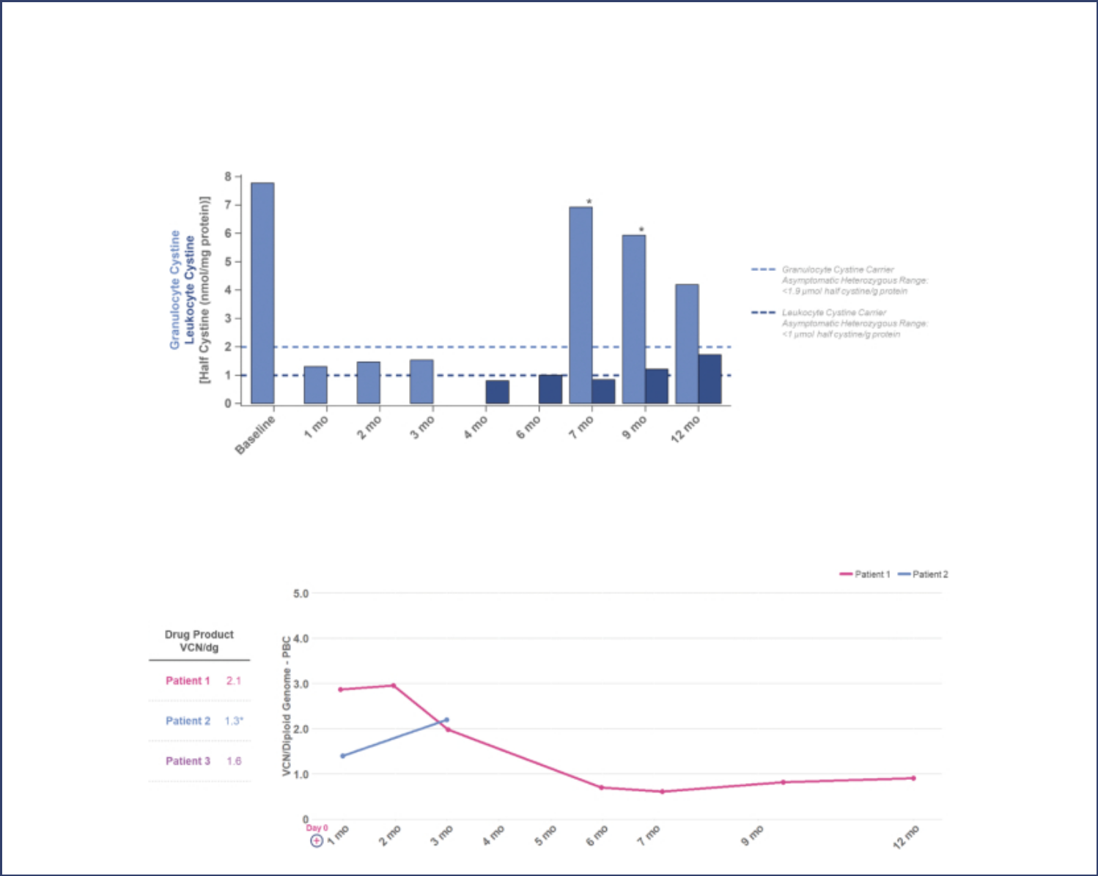

been part of cystinosis standard of care treatment for the past two decades. However, we and our collaborators at UCSD have determined that cystine concentration in leukocytes and granulocytes, which is used to monitor small molecule therapies, is not appropriate to represent the mechanism of action of a gene therapy. As a result, the protocol for this investigator-sponsored clinical trial has been amended to retain safety and tolerability as the primary endpoint, as is appropriate for this stage of development, and shift measurement of cystine in granulocytes to a secondary endpoint. The following figure summarizes data on the average granulocyte and leukocyte cystine levels from the first patient in the ongoing clinical trial of AVR-RD-04.

- Vector copy number. In November 2020, we presented VCN data for the first two patients dosed in the clinical trial, as well as the VCN of the drug product manufactured for these first two patients and a third patient who was dosed in November 2020, as shown in the graph below.

S-11

Table of Contents
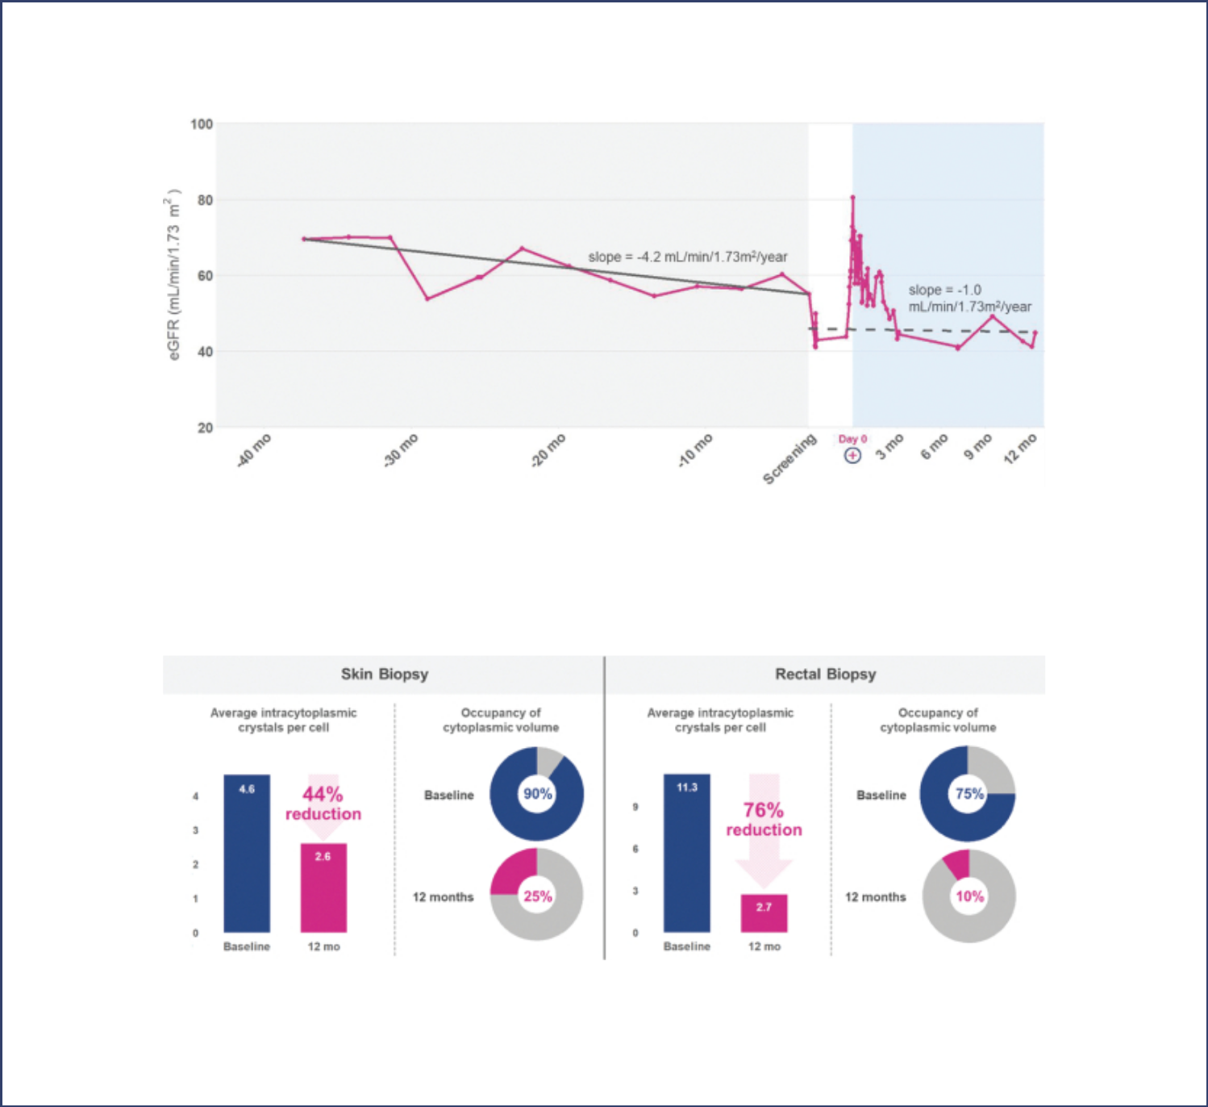

- Kidney function. Assessment of kidney function includes measurements of eGFR and serum creatinine, or SCr. eGFR is determined using the CKD-EPI formula and SCr is measured as part of the comprehensive metabolic panel. In November 2020, we presented the following eGFR data for the first patient in the clinical trial.

- Cystine crystals in skin and rectal biopsy tissue. Skin and rectal biopsies were performed on the first patient at baseline and

12-months post-treatment with AVR-RD-04. The data from the biopsies are intended to show the average skin intracytoplasmic crystals per cell, which is a measurement of the number of toxic crystals in each cell, as well as the occupancy of cytoplasmic volume with crystals. In November 2020, we presented the data below, which we believe suggest that the patient is now producing an endogenous supply of functional cystinosin that is reducing the accumulation of toxic cystine crystals.

- Levels of cystine in skin. Levels of cystine in the skin are measured with in vivo confocal microscopy, or IVCM, on two separate areas of the skin: behind the ear and in a location determined by the treating physician. The two measurements are analyzed and quantified with 3D Image-Pro software and averaged. The first patient in the Phase 1/2 clinical trial exhibited a 56% reduction from baseline in skin cystine levels measured 12 months post-treatment with AVR-RD-04. The baseline measurement

S-12

Table of Contents
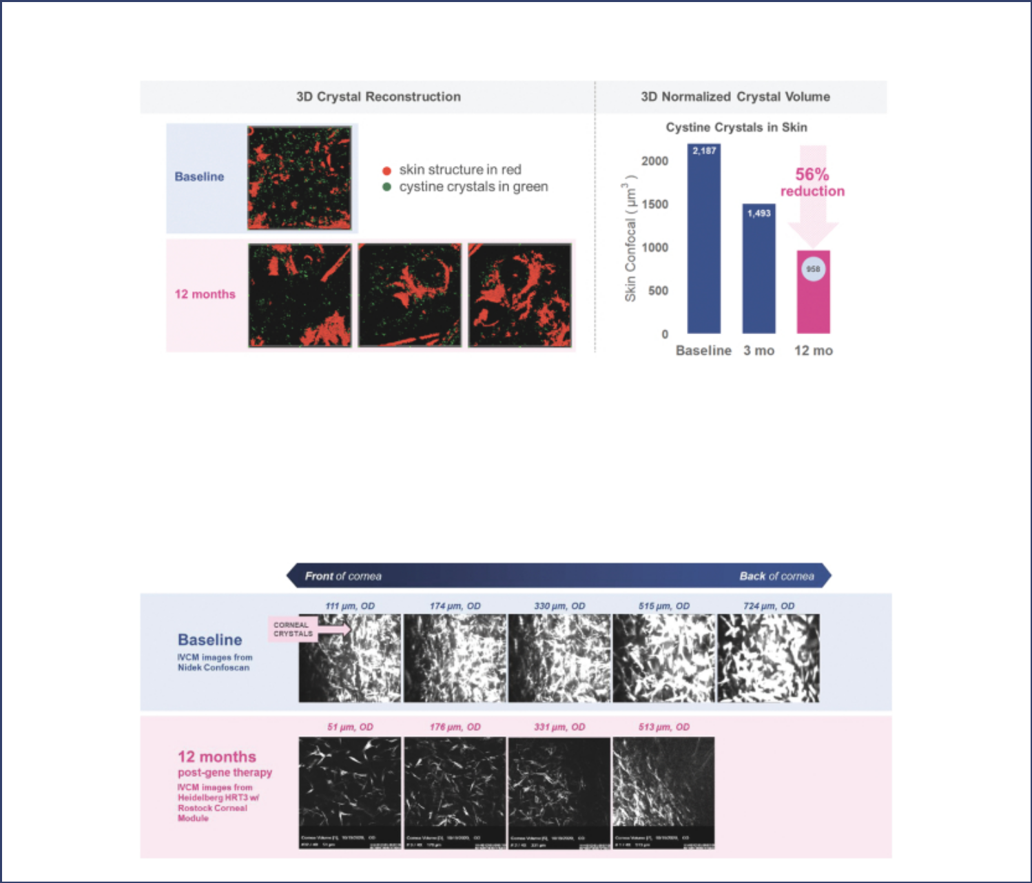

and 12-month data was obtained using IVCM. These measurements, analysis and 3D depiction are generated using early, experimental methodologies and will require additional study to determine their validity and significance.

- Levels of cystine in cornea. Levels of corneal cystine crystals are being assessed in this study using IVCM. In November 2020, we presented one set of images of the first patient’s cornea measured at baseline and 12-months post-administration of AVR-RD-04, and another set of images measured at baseline, seven-, nine- and 12-months post-administration. In the first set, the baseline IVCM images were taken using a Nidek ConfoScan microscope and the 12-month IVCM images were taken using a Heidelberg (HRT3) with Rostock Cornea Module microscope, or Rostock microscope. In the second set of images, the baseline IVCM images were taken using a Nidek ConfoScan microscope, and the seven-, nine- and 12-month IVCM images were taken using a Rostock microscope. The patient discontinued oral and eye drop cysteamine prior to the administration of AVR-RD-04 and, as of November 3, 2020, has remained off such therapies.

S-13

Table of Contents
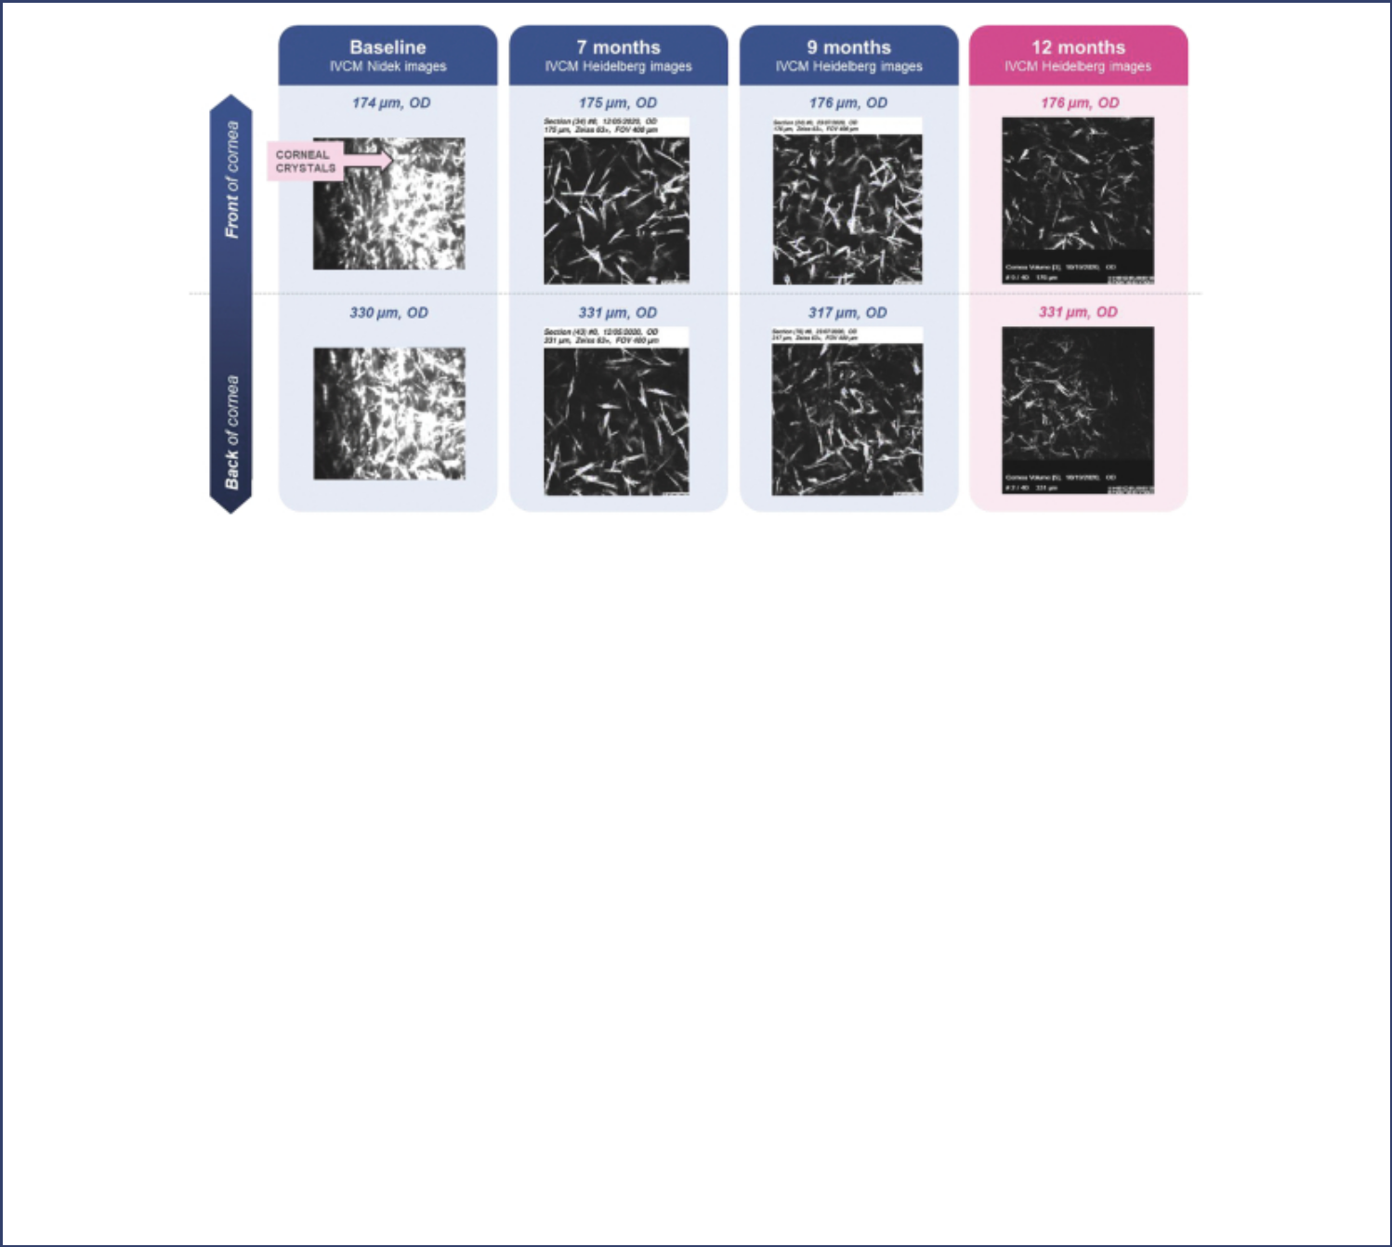

- Exploratory measurement – skin and hair melanin. Photographs of the first patient in this clinical trial taken at four-, six- and nine-months post-treatment suggest that the patient’s complexion, eyebrows and hair color have darkened following administration of AVR-RD-04. As is typical of many people with cystinosis, this patient had fair hair color and skin tone prior to dosing. Cystinosin has been demonstrated to impact the regulation of melanin synthesis, and the protocol for this trial has been amended to prospectively assess changes in melanin.

Safety update. As of the safety cut-off date of November 2, 2020, preliminary clinical data for the first two patients dosed in the Phase 1/2 clinical trial appear to indicate that the AVR-RD-04 investigational gene therapy has been generally well-tolerated with no unexpected safety events identified. As of the safety data cut-off date of November 2, 2020, there have been no reported SAEs or safety events attributed to the AVR-RD-04 drug product. For the first patient, as of the safety cut-off date, a total of 29 AEs were reported over a 12-month observation period, one of which was Grade 3. All remaining AEs were Grade 1 or Grade 2. For the second patient, as of the safety cut-off date of November 2, 2020 a total of 16 AEs were reported, 13 of which were Grade 1 or Grade 2 and three of which had not yet been graded. Reported AEs were generally consistent with expectations for the underlying disease and the conditioning regimen prescribed by the study protocol.

AVR-RD-02 for Gaucher disease type 1

In November 2020, we announced clinical data for the first patient dosed in the clinical trial of our investigational gene therapy AVR-RD-02 for Gaucher disease type 1. AVR-RD-02 is currently being studied in a Company-sponsored Phase 1/2 clinical trial in patients with Gaucher disease type 1, which we refer to as the Guard1 trial. The clinical trial is an adaptive trial that will include both patients that are currently stable on ERT and treatment-naïve patients. We intend to enroll eight to 16 patients, between the ages of 18 and 45, with Gaucher disease type 1. Patients currently prescribed ERT will cease treatment prior to infusion of AVR-RD-02. All enrolled patients will receive a single treatment with AVR-RD-02 and will be followed for 52 weeks to measure safety and efficacy. We intend to utilize our plato platform for all patients enrolling in the Guard1 clinical trial. Efficacy endpoints for this clinical trial will include measures of liver and spleen volumes, hemoglobin, platelet counts, bone pain and bone density measures along with other blood markers used in Gaucher disease. The Guard1 clinical trial is actively recruiting in Australia and Canada, with additional sites

S-14

Table of Contents
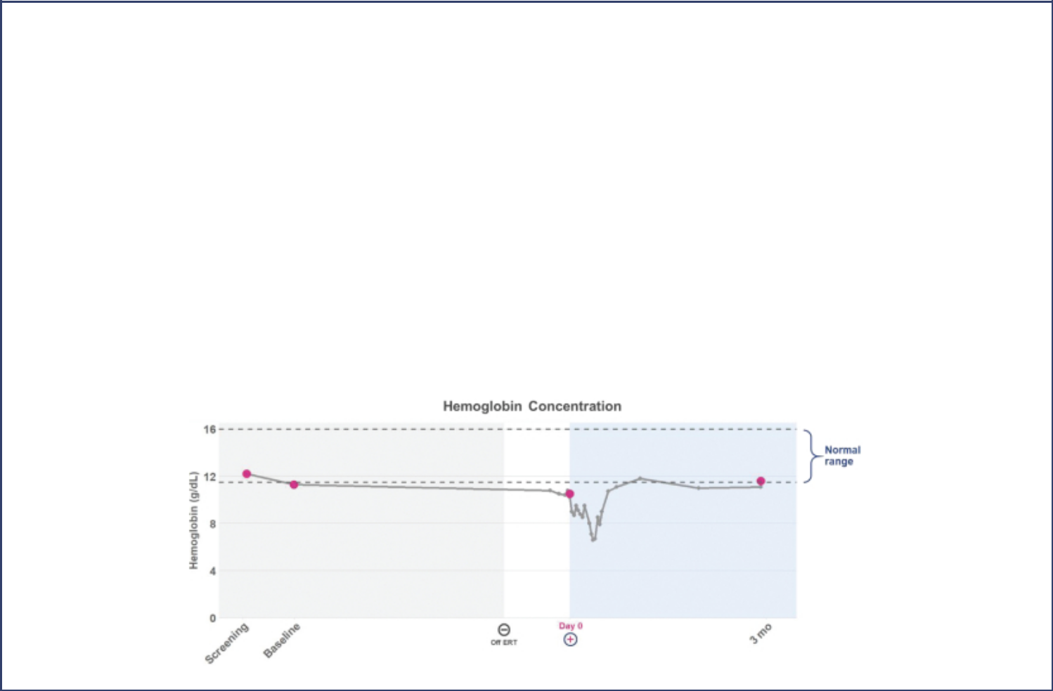

planned to be opened in the United States and Israel in the fourth quarter of 2020. This clinical trial remains ongoing and the results presented below are preliminary and may not be representative of later results. The data cut-off date for the results below was November 3, 2020.

- Plasma Lyso-Gb1 reductions. Glucosylsphingosine, or lyso-Gb1, is considered a surrogate marker for disease activity and treatment response for Gaucher disease. In the case of ERT-naïve patients and patients who have discontinued ERT, we believe that reductions in lyso-Gb1 levels following treatment with gene therapy are likely driven by the therapeutic effect of gene therapy. In November 2020, we announced that the first patient in our Guard1 clinical trial exhibited a 22% reduction in plasma lyso-Gb1 levels three months post-administration of AVR-RD-02 as compared to baseline while on ERT. We define baseline ERT for this patient as the mean of the plasma lyso-Gb1 values reported prior to initiating mobilization. This patient discontinued ERT one month prior to dosing of AVR-RD-02 and remains off ERT as of November 3, 2020.

- Plasma chitotriosidase reductions. Chitotriosidase is a biomarker of macrophage activation that is found in high levels in Gaucher patients where the macrophages have accumulated an excess lipid burden. In November 2020, we announced that at three months post-treatment with AVR-RD-02 the first patient in the Guard1 clinical trial exhibited a 17% reduction in chitotriosidase levels as compared to baseline while on ERT.

- Red blood cells and platelet counts. Gaucher disease typically causes patients to have low levels of hemoglobin and platelets. In November 2020, we presented the following data, which highlights the hemoglobin and platelet levels of the first patient dosed in the Guard1 clinical trial at baseline and three months post-administration of AVR-RD-02.

S-15

Table of Contents
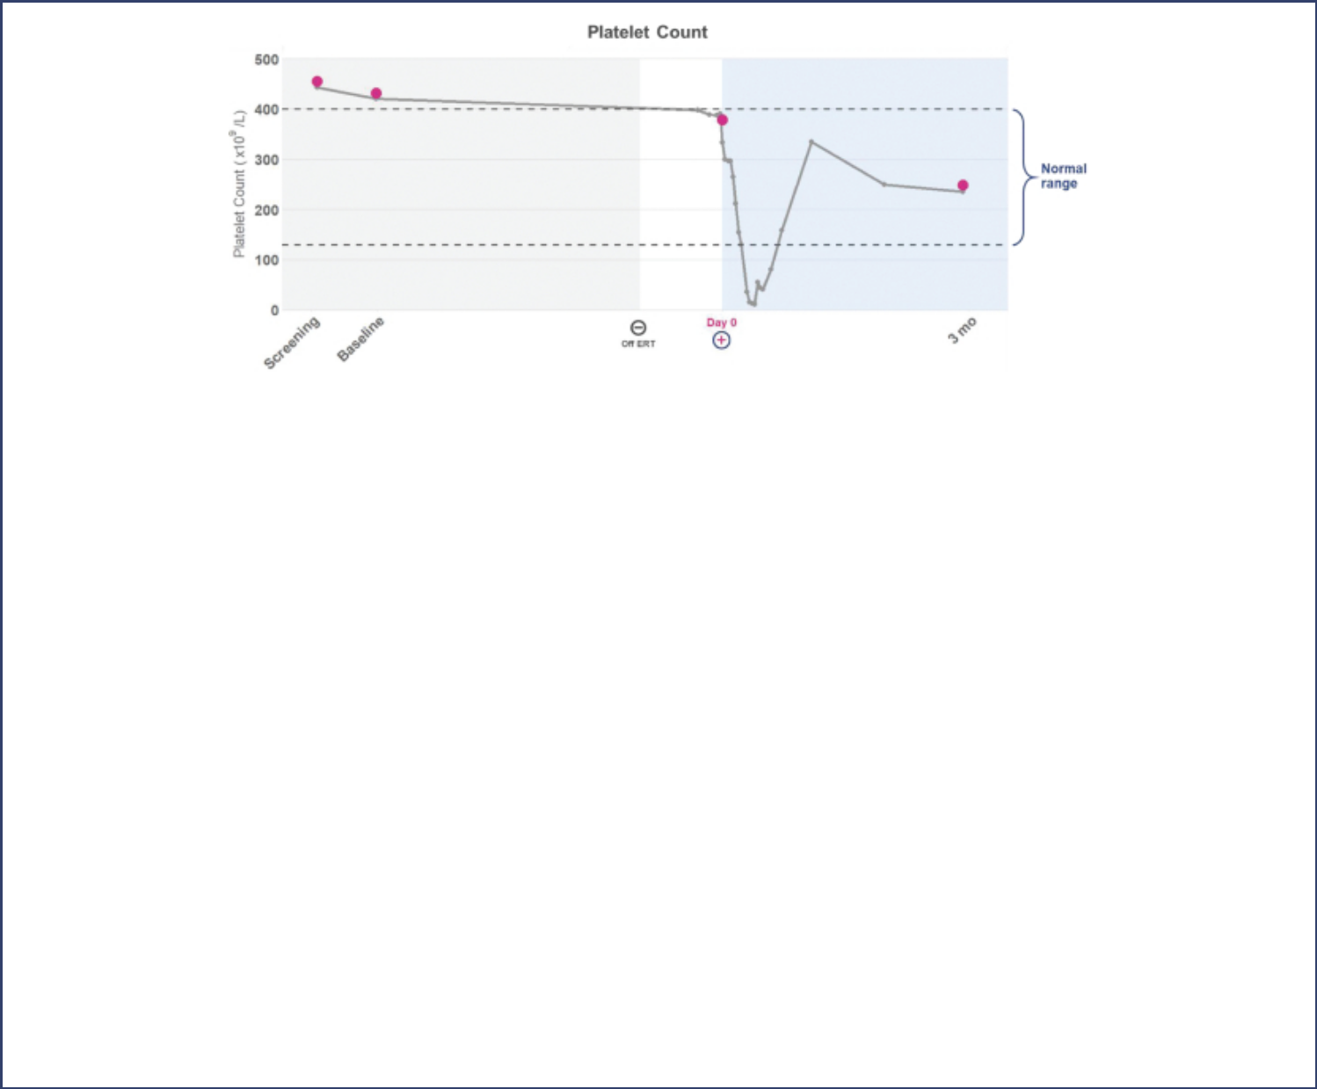

- Vector copy number. In November 2020, we announced that the first patient in the Guard1 clinical trial exhibited a VCN of 0.6 three months post-treatment with AVR-RD-02. In addition, an exploratory assessment of VCN in specific cell populations showed a VCN ³

0.7 in the myeloid cell lines, which we believe could be indicative of transgene presence in the macrophages, the essential cell impacted in Gaucher patients.

Safety update. As of the safety cut-off date of November 3, 2020, clinical data for the first patient dosed in the Guard1 clinical trial appear to indicate that the AVR-RD-02 investigational gene therapy has been generally well tolerated with no unexpected safety events identified. No SAEs were reported as of the safety data cut-off date of November 3, 2020. A total of 26 AEs were reported as of the safety cut-off date, one of which was Grade 4 and eight of which were Grade 3. The remainder of the AEs were Grade 2 or Grade 1. All reported AEs were consistent with expectations for the underlying disease and conditioning regimen prescribed by the study protocol and have resolved. There have been no reports of safety events attributed to the AVR-RD-02 drug product.

AVR-RD-03 for Pompe disease

AVR-RD-03 is our preclinical product candidate for the treatment of Pompe disease. AVR-RD-03 is expected to be manufactured from hematopoietic stem cells that are first harvested from the patient, modified to add the gene that encodes for acid alpha glucosidase A, or GAA, attached to a peptide sequence known as a glycosylation-independent lysosomal targeting, or GILT, tag and then infused into the patient. AVR-RD-03 will incorporate a GILT tag because the GILT tag has been found to increase the uptake of GAA into cells, especially in muscle cells, by a multiple of 25, which is a particularly important target tissue for patients with Pompe disease and a target tissue that is considered difficult to access for ERT. AVR-RD-03 is designed to incorporate a potent promoter to increase volume of system enzyme in circulation.

In November 2020, we presented data from a study in which mice with the equivalent of classic infantile-onset Pompe disease were treated with AVR-RD-03.

- GAA enzyme production. The following graphs summarize the levels of GAA observed in normal mice, mice with the equivalent of infantile-onset Pompe disease, mice treated with AVR-RD-03 modified to not incorporate our proprietary GILT tag, and mice treated with AVR-RD-03 including our GILT tag, in each case measured 16 weeks post-treatment.

S-16

Table of Contents
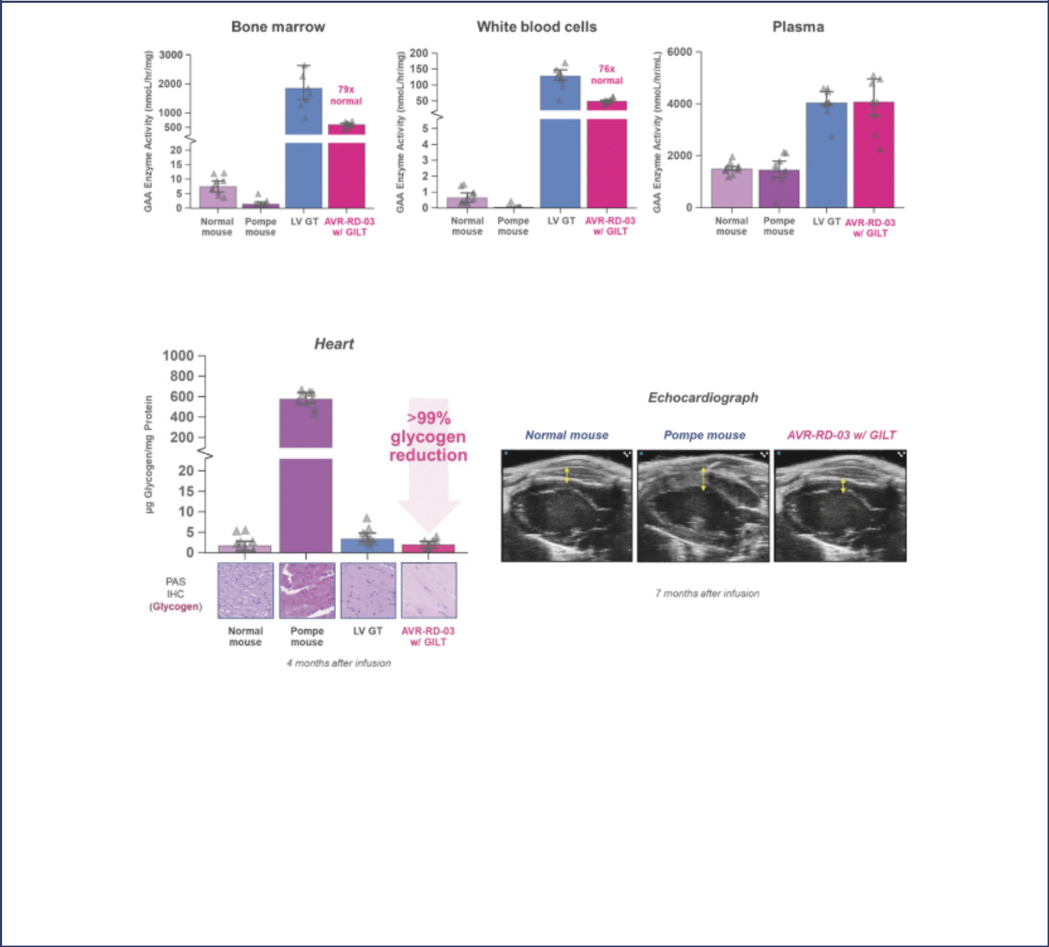

- Reduction in glycogen. The following graphs summarize the reduction in levels of glycogen observed in the hearts of study mice at four months post-treatment. In addition, we presented an echocardiograph image of the heart of a study mouse taken seven months post-treatment with our GILT-tagged version of AVR-RD-03.

Our study measured glycogen levels in the brain at four months post-treatment with our GILT-tagged version of AVR-RD-03, which showed a 100% reduction in glycogen levels. In addition, our study measured glycogen levels in various organs of the study mice at eight months post-treatment. The data showed an average of greater than 99% reduction in glycogen levels in the heart, greater than 97% reduction in the diaphragm, greater than 85% reduction in skeletal muscle, greater than 95% reduction in the brain, and greater than 99% reduction in the spinal cord.

AVR-RD-05 for Hunter syndrome

AVR-RD-05 is our preclinical product candidate for the treatment of Hunter syndrome, or mucopolysaccharidosis type II (MPSII). On

October 5, 2020, we announced that we entered into an agreement with The University of Manchester, England, or UoM, whereby UoM granted to us

an exclusive worldwide license under certain patent and other intellectual property rights, subject to certain retained rights, to develop, commercialize

and sell an ex vivo lentiviral gene therapy for use in the treatment of Hunter syndrome.

S-17

Table of Contents
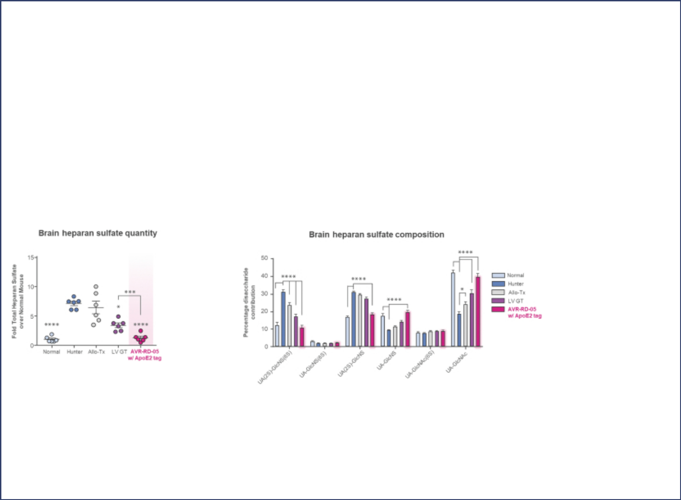

AVR-RD-05 will be studied by our collaborators at UoM and a Phase 1/2 investigator-sponsored clinical trial of AVR-RD-05 is expected to commence in the second half of 2021.

AVR-RD-05 involves ex vivo transduction of the patient’s own hematopoietic stem cells with a therapeutic transgene, in-licensed from the University of Manchester, designed to express functional iduronate 2-sulfatase, or IDS, which is the enzyme the patient needs to maintain cellular health, coupled to a proprietary ApoE2 protein tag that is designed to improve stability of the enzyme in the bloodstream and facilitate uptake by tissues.

In November 2020, we presented previously published preclinical data on AVR-RD-05. The study presented data from normal study mice, mice affected with the equivalent of Hunter syndrome, mice treated with AVR-RD-05 modified to not incorporate the ApoE2 protein tag, and mice treated with AVR-RD-05 incorporating the proprietary ApoE2 tag.

- Brain heparan sulfate. IDS insufficiency affects the catabolism of heparan sulfate, leading to its toxic accumulation in all cells. The graph on the left below summarizes levels of heparan sulfate and the graph on the right summarizes the composition of heparan sulfates, in each case in the brains of study mice. Heparan sulfate comes in a variety of forms, and it is the differences in their composition that determines their specific function. Changes in composition may play a role in pathogenesis.

- Neuro-inflammation. The images below summarize the effect of AVR-RD-05 with the ApoE2 tag on neuro-inflammatory pathologies in the brains of mice affected with Hunter syndrome. We believe the ApoE2 tag may increase the cells’ secretion of IDS to potentially restore healthy cellular function, may stabilize the secreted IDS so it has a longer half-life, and may facilitate uptake of IDS into the brain. The images on the left illustrate a series of histology sections of the cortex and striatum, where the dark specks indicate microglia that have been inappropriately activated in the brain due to the accumulation of heparan sulfate. The images on the right illustrate the effect on astrogliosis, another marker of pathological brain inflammation in Hunter. The green specks indicate astrocytes, the red speck are lysosomes and the blue specks are cell nuclei.

S-18

Table of Contents
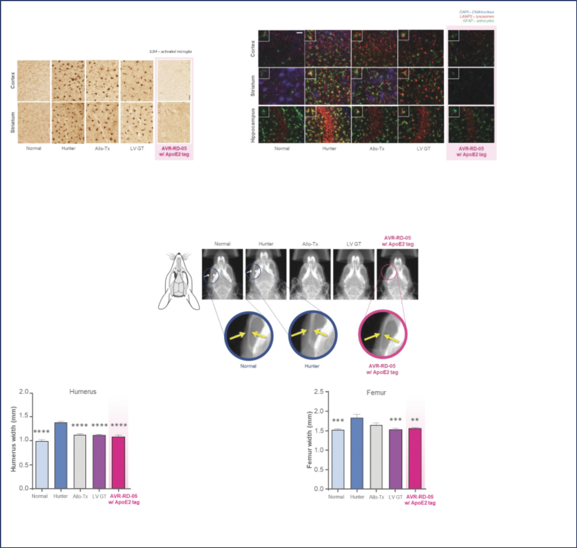

- Facial and skeletal abnormalities. Hunter syndrome affects not only the brain, the heart, and respiratory function, but also skeletal muscles and facial features. The images on the left below show x-rays of a mouse face, including an image of a mouse affected with the equivalent of Hunter syndrome exhibiting significant thickening of the zygomatic arch, or cheek bones. The graphs on the right present data measuring the width of the humerus and femur. In mice affected with Hunter syndrome, these bones are notably wider, an abnormality that is believed to contribute to the overall reduced stature and physical deformity.

- Cognition and performance. Patients with neuronopathic Hunter syndrome typically experience rapid cognitive decline. The images on the left below summarize mouse performance data on a Y

S-19

Table of Contents
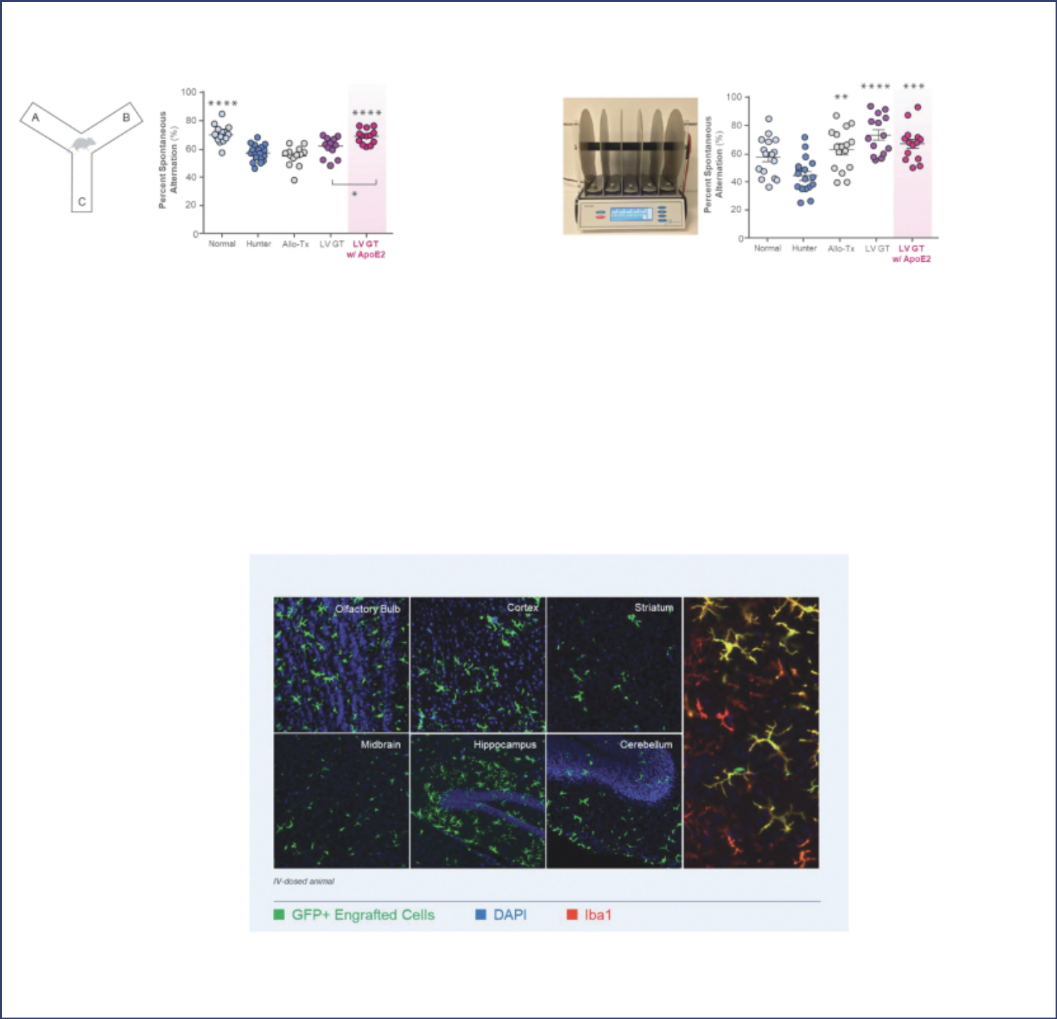

maze test, which evaluates working memory, and the images on the right below summarize mouse performance on an accelerating rotarod, which evaluates sensorimotor coordination and balance.

AVR-RD-06 for Gaucher disease type 3

In November 2020, we announced an expansion of our lysosomal disorder pipeline with a new preclinical product candidate, AVR-RD-06, our investigational gene therapy for Gaucher disease type 3. Gaucher disease type 3 is the subacute neurological form of Gaucher disease characterized by progressive encephalopathy and associated with the systemic manifestations of Gaucher type 1. As with Gaucher type 1, Gaucher type 3 disease is caused by a gene that codes for the enzyme glucocerebrosidase. The deficiency in glucocerebrosidase leads to the accumulation of Gb1 and its toxic metabolite, lyso-Gb1. AVR-RD-06 is expected to use the same vector that we use in AVR-RD-02, our investigational gene therapy for Gaucher disease type 1.

In November 2020, we presented preclinical data from a green fluorescent protein transgenic mouse study which we believe demonstrate the ability of lentiviral gene therapy to repopulate the microglia compartment of the brain with microglia cells carrying the therapeutic gene. The green specks in the images below reflect engrafted, genetically modified cells.

We also presented preclinical data demonstrating a technique that potentially allows us to examine individual cells in the brain to determine which cell types contain the therapeutic gene. The image on the left

S-20

Table of Contents
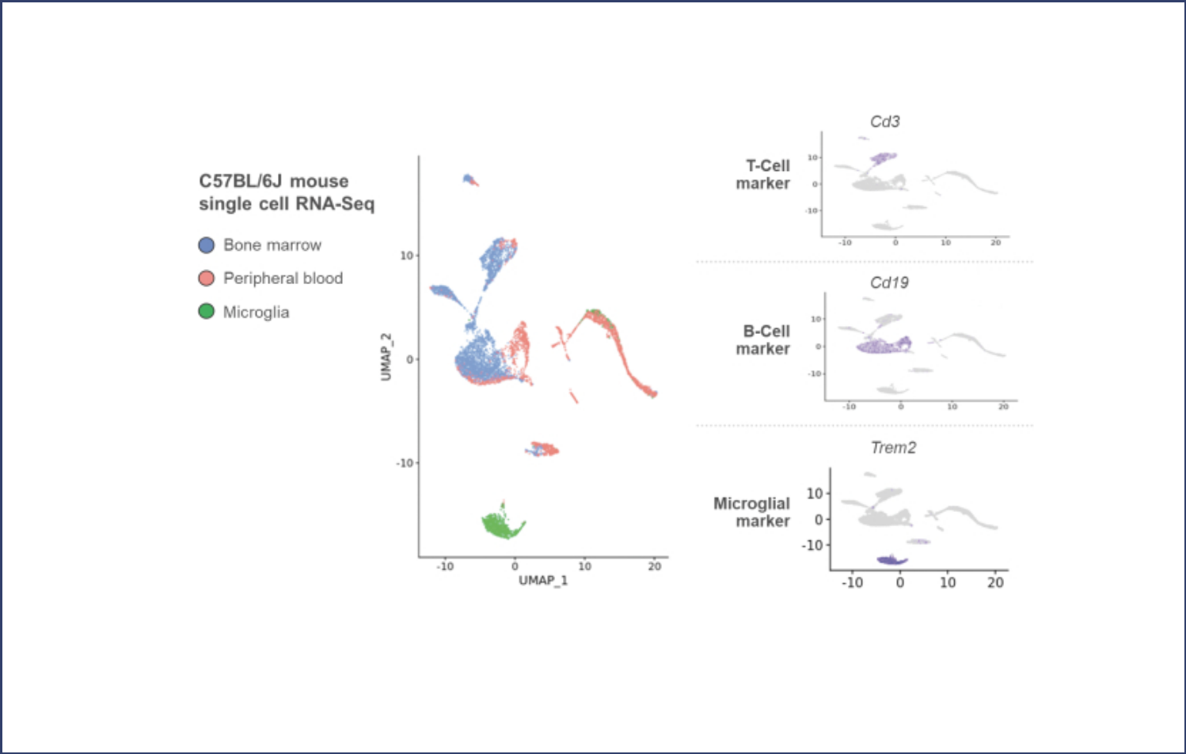

suggests that by using RNA sequencing technology we can identify cells by their transcriptome, allowing us to distinguish the bone marrow, peripheral blood and microglia. The graphs on the right suggest that we can also distinguish the cells by their “signature” marker, such as the presence of TREM2 in microglia cells.

In addition, we conducted a preclinical experiment to assess how genetically modified microglia carry out their physiological role in the brain compared to endogenous microglia. The image on the left shows the engrafted microglia in green, dispersed in a physiological pattern in the central nervous system, and the chart on the right plots the transcriptional differences between the two sets of cells. We believe the dense scatter plot suggests that the engrafted cells have similar transcriptional signatures to endogenous cells and could therefore be expected to carry out the physiological role of endogenous microglia.

S-21

Table of Contents
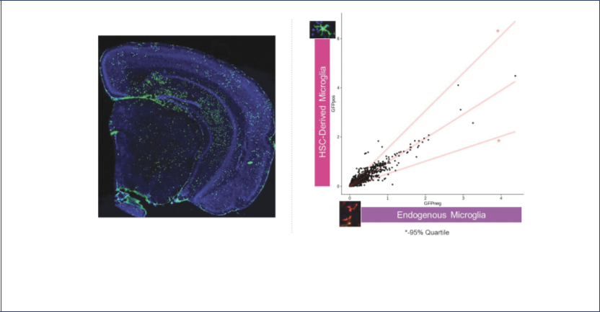

Finally, we presented another dataset comparing the genetically modified microglia and endogenous microglia. The top half of the image below shows markers that are typical of invading macrophages, which enter the brain in response to injury. The data suggest that even though the modified cells are not native to the brain, they do not act as “invaders” and thus could be expected to carry out normal physiological functions. The bottom half of the image shows markers of canonical microglia activity, and again the signatures in both the modified and endogenous cells are similar.

S-22

Table of Contents
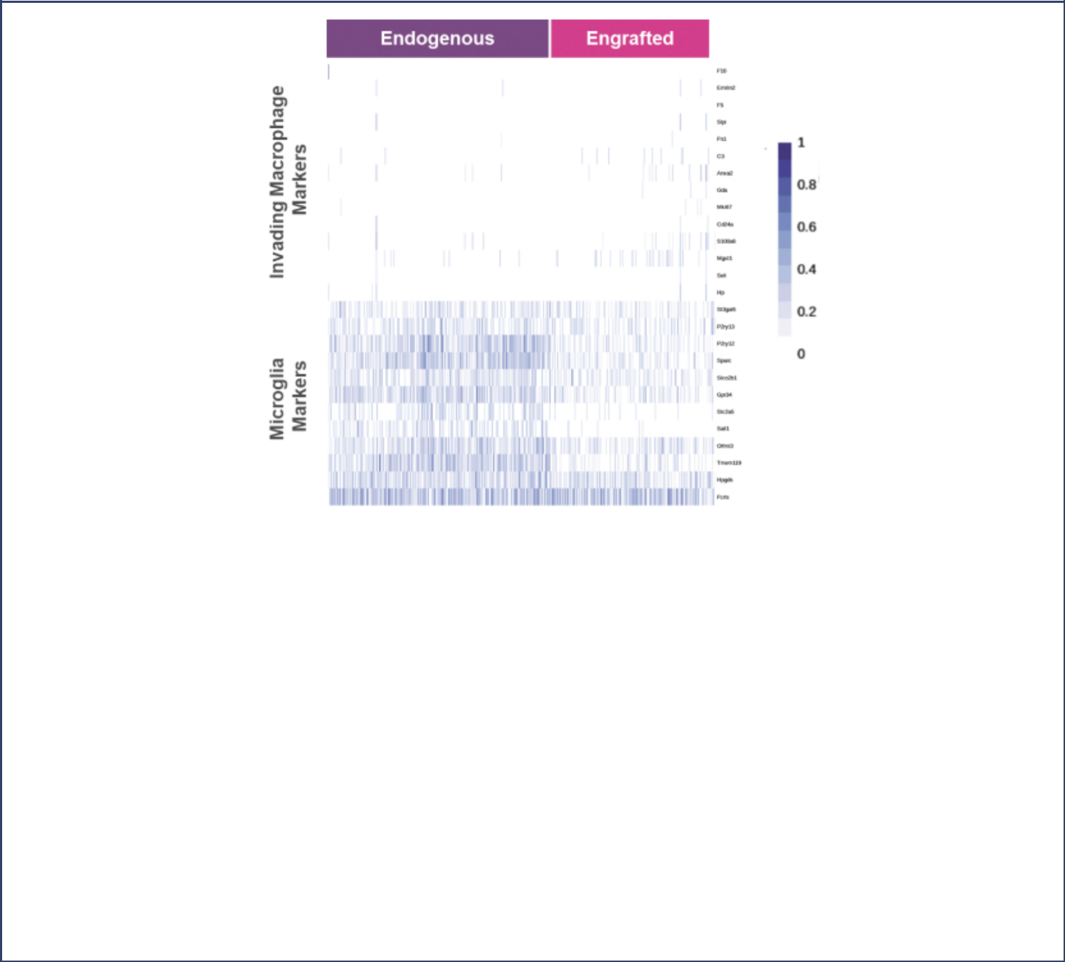

Plato platform

Plato is our gene therapy platform designed to provide the foundation for the potential worldwide commercialization of our gene therapies, if approved. It is an ex vivo gene therapy platform incorporating multiple upgrades including a four-plasmid lentiviral vector designed to optimize vector copy number, transduction efficiency and resulting enzyme activity, a closed, automated manufacturing system designed to improve manufacturing consistency and predictability of the drug product, and a personalized approach to conditioning using busulfan with targeted concentration intervention, or TCI, which is designed to optimize safety and the potential reach of our ex vivo investigational lentiviral gene therapies. TCI builds on therapeutic drug monitoring, or TDM. While TDM was designed to aim for the right dose range of busulfan, TCI aims for the right target dose. By targeting busulfan exposure to an area under the curve of 90 mg x hr/L over four days, TCI is designed to maximize the likelihood of engraftment while minimizing the risk of out-of-range side effects.

The three upgrades described above were cleared by applicable regulatory bodies in the United States, Canada and Australia for use in the Phase 2 clinical trial of AVR-RD-01 for Fabry disease and the Phase 1/2 Guard1 clinical trial of AVR-RD-02 for Gaucher disease type 1. We intend to utilize the plato platform for all future patients enrolling in our Phase 2 clinical trial of AVR-RD-01 for Fabry disease and our Guard1 clinical trial for Gaucher disease type 1. To date, two patients have been dosed with our plato platform – the fourth patient in our ongoing Phase 2 clinical trial of AVR-RD-01 and the first patient in our Phase 1/2 Guard1 clinical trial of AVR-RD-02.

In addition, we are developing a universal VCN assay that is designed to be transferred to multiple regulatory jurisdictions and may be leveraged across our portfolio. We have also focused on advancing next-generation analytics and whole transcriptome profiling, such as characterization of tens of thousands of single cells in our apheresis starting material.

S-23

Table of Contents
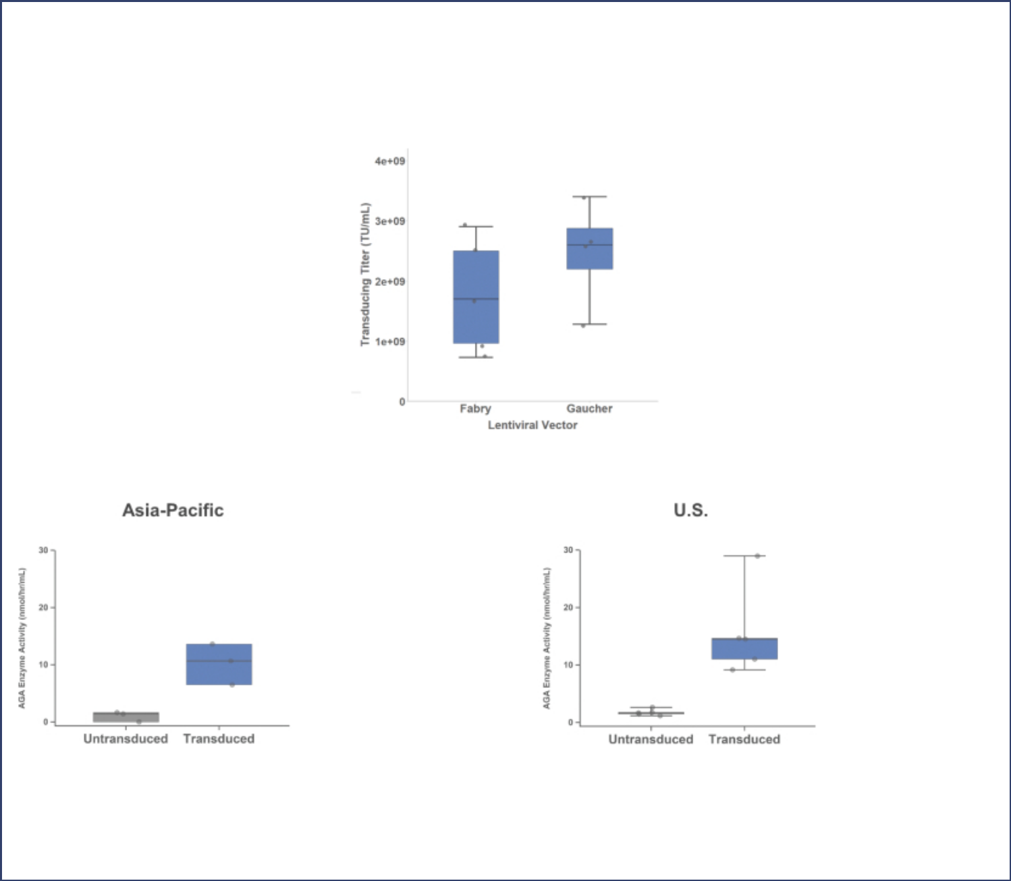

In November 2020, we presented data on our plato platform highlighting potential advances in chemistry, manufacturing and controls (CMC).

- High titers. The graph below summarizes vector titer results from multiple 50L and 200L serum-free suspension batches across our AVR-RD-01 program for Fabry disease and our AVR-RD-02 program for Gaucher disease type 1. The titers from both production processes are above the industry standard of 100,000,000 to 500,000,000 transducing titers per ml. We believe that a high titer vector batch may translate into a higher yield and subsequently fewer vector batches required to fulfill patient demand.

- Potency assay candidate. The graphs below summarize AGA enzyme activity, a potency assay candidate, before and after transduction. The data exhibit an increase in activity post-transduction, as expected.

- VCN consistency. The graphs below summarize VCN data across our AVR-RD-01 program for Fabry disease and AVR-RD-02 for Gaucher disease type 1, as measured by several different contract manufacturing sites around the world. VCN refers to the average number of copies of the lentiviral-vector inserted gene that are integrated into the genome of a cell, and is another measure that can be used to help assess potency. The data suggest comparable results for the assay, as shown by the overlapping box plots across the charts, for both disease indications at our global contract manufacturing organization sites.

S-24

Table of Contents
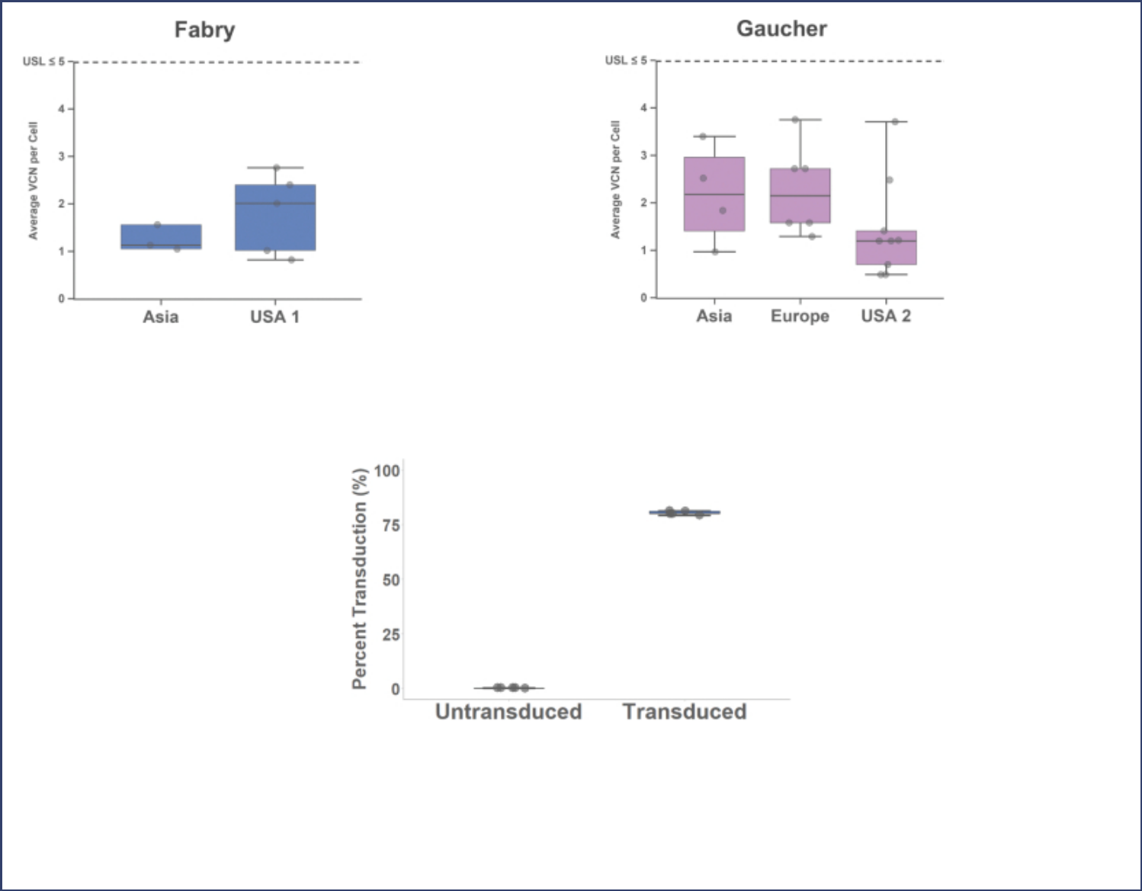

- Rapid transduction. The plots below summarize data from our transduction assay which is designed to deliver results in days rather than months. The plots show two samples – untransduced and transduced – and five assessments for each sample. We analyzed more than 30 thousand cells per sample in less than one week, which we believe would take months and potentially generate more variable data using traditional transduction methods.

- Product characterization. The charts and graphs below summarize product characterization and quality data. The illustrations on the left demonstrate how VCN from the same sample can be assessed at two different levels – the top panel shows the distribution of VCN across the cell population and the bottom panel shows the average VCN. With respect to the images on the right, the smaller pie chart provides data first showing the untransduced and transduced cell proportion, and the larger pie chart represents a view of the transduced population, enabling us to evaluate proportion of cells with different VCN. We expect this level of resolution may help us with process optimization and control over manufacturing consistency.

S-25

Table of Contents
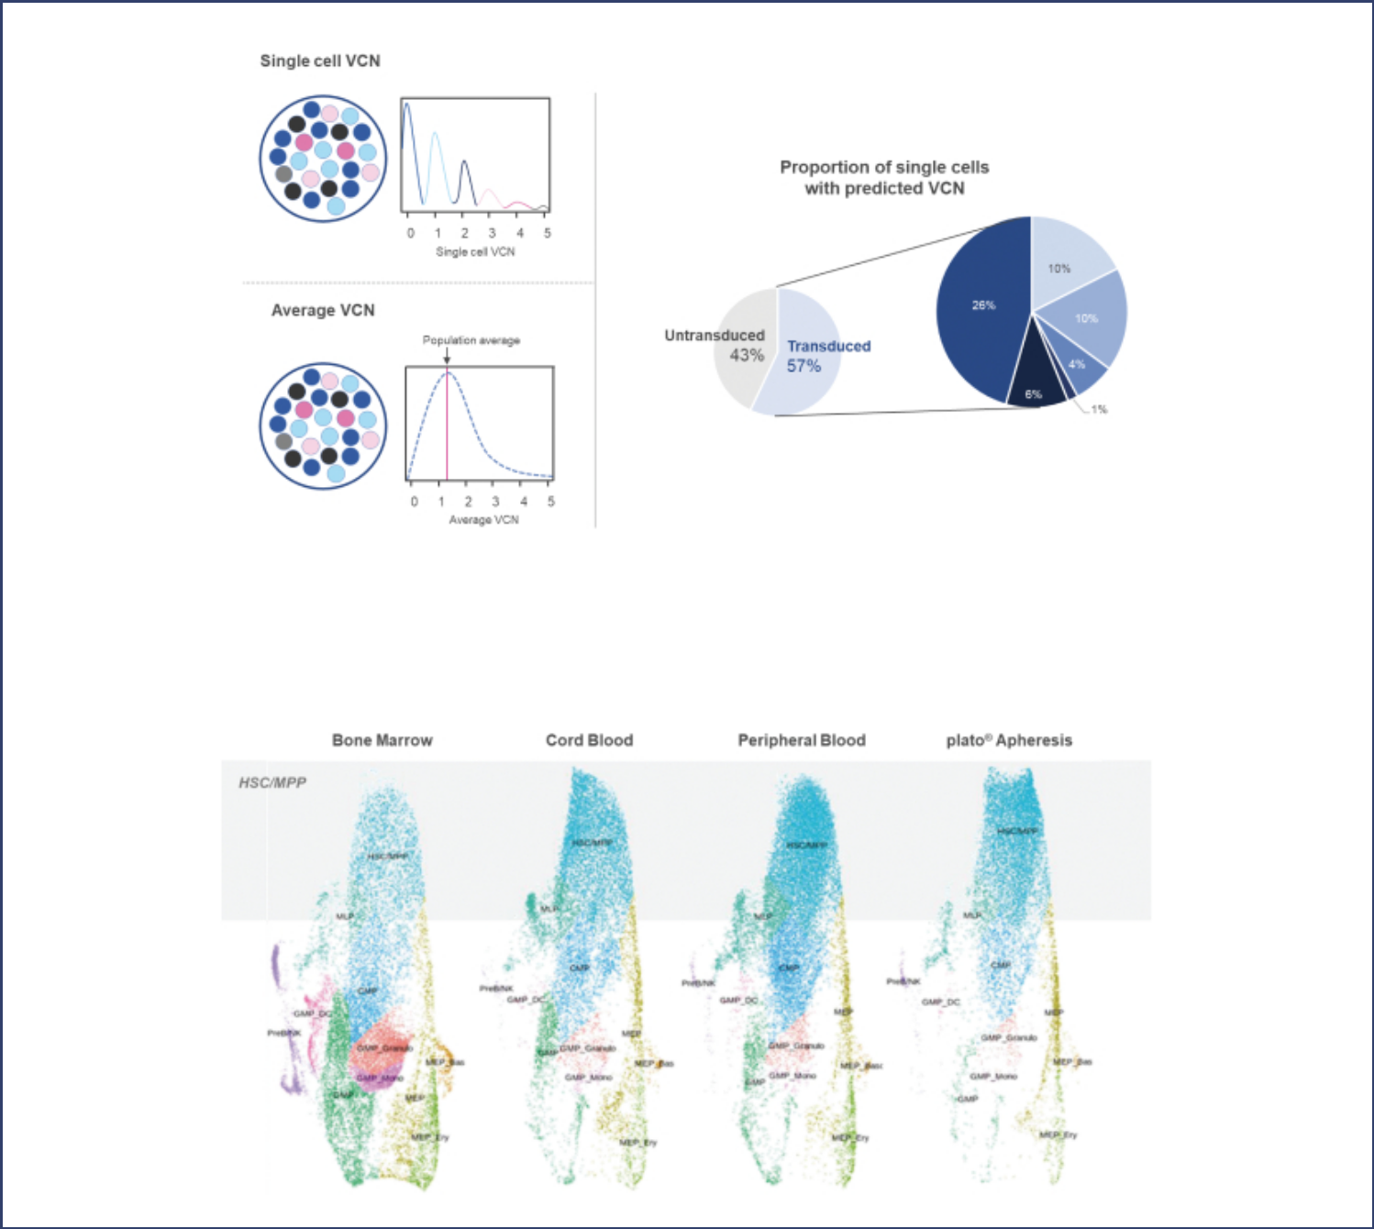

Tracking long-term engrafting cells. We have developed a method that potentially enables us to assess attributes predictive of durability by measuring levels of hematopoietic stem cells in the apheresis as well as manufactured drug product. The phenotypic maps shown below are generated from samples of 35,000 cells from the bone marrow, cord blood, peripheral blood, and plato apheresis. The blue color represents hematopoietic stem cells and shows that the plato apheresis sample has a similar proportion of hematopoietic stem cells when compared to all other samples. We believe this method could enable us to run experiments to confirm the cellular composition of our starting material – and, in the future, drug product.

S-26

Table of Contents


COMPANY INFORMATION

We were formed as a corporation under the laws of the State of Delaware in November 2015 under the name AvroBio, Inc. Our corporate name was changed to AVROBIO, Inc. in June 2017. We completed our initial public offering in June 2018. Our executive offices are located at One Kendall Square, Building 300, Suite 201, Cambridge, Massachusetts 02139 and our telephone number is (617) 914-8420. Our website address is www.avrobio.com. We do not incorporate the information on or accessible through our website into this this prospectus supplement or the accompanying prospectus, and you should not consider any information on, or that can be accessed through, our website as part of this prospectus. Our common stock trades on The Nasdaq Global Select Market under the symbol “AVRO”.

SUMMARY OF THE MATERIAL RISKS ASSOCIATED WITH OUR BUSINESS

Our business is subject to a number of risks of which you should be aware before making an investment decision. These risks are discussed more fully in the “Risk Factors” section on page S-32 of this prospectus supplement or otherwise incorporated by reference in this prospectus supplement and the accompanying prospectus. These risks include, but are not limited to, the following:

- We have incurred net losses since inception. We expect to incur net losses for the foreseeable future and may never achieve or maintain profitability.

- We will need additional funding, which may not be available on acceptable terms, or at all. Failure to obtain this necessary capital when needed may force us to delay, limit or terminate our product development efforts or other operations.

- Business interruptions resulting from the coronavirus disease (COVID-19) pandemic or similar public health crises have caused and may continue to cause a disruption of the development of our product candidates and adversely impact our business.

- Our lentiviral-based gene therapy product candidates are based on a novel technology, which makes it difficult to predict the time and cost of product candidate development and of subsequently obtaining regulatory approval.

- Our product candidates and the process for administering our product candidates may cause undesirable side effects or have other properties that could delay or prevent their regulatory approval, limit their commercial potential or result in significant negative consequences following any potential marketing approval.

- Success in preclinical studies or early clinical trials may not be indicative of results obtained in later trials and preliminary results from studies and trials may not be indicative of final results from those studies and trials.

- We may find it difficult to enroll patients in our clinical trials, which could delay or prevent us from proceeding with clinical trials of our product candidates.

- We may encounter substantial delays in our clinical trials or we may fail to demonstrate safety and efficacy to the satisfaction of applicable regulatory authorities.

- Even if we complete the necessary preclinical and clinical studies, we cannot predict when or if we will obtain regulatory approval to commercialize a product candidate and the approval may be for a narrower indication than we seek.

- Certain of our clinical trials, including the ongoing investigator-sponsored clinical trial of AVR-RD-01, a portion of our Company-sponsored clinical trial of AVR-RD-01, and the investigator-sponsored

S-27

Table of Contents


clinical trial of AVR-RD-04, do not utilize our commercial-scale plato platform. In addition, the planned investigator-sponsored clinical trial of AVR-RD-05 will not utilize the plato platform. While we have submitted and intend to continue to submit comparability studies to the FDA and other regulatory agencies, as needed, with respect to our implementation of our commercial-scale plato platform, there can be no assurance that the FDA or other regulatory agencies will not in the future require us to conduct additional preclinical studies or clinical trials with respect to these programs or our other product candidates that could result in delays in our development or commercialization programs of our product candidates, if approved, and additional expenses and otherwise could adversely affect our business.

- We face significant competition in our industry and there can be no assurance that our product candidates, if approved, will achieve acceptance in the market over existing established therapies. In addition, our competitors may develop therapies that are more advanced or effective than ours, which may adversely affect our ability to successfully market or commercialize any of our product candidates.

- Gene therapies are novel, complex and difficult to manufacture. We could experience production problems that result in delays in our development or commercialization programs or otherwise adversely affect our business.

- We expect to rely on third parties to conduct some or all aspects of our vector production, product manufacturing, protocol development, research and preclinical and clinical testing, and these third parties may not perform satisfactorily.

- We are dependent on a limited number of suppliers for some of our components and materials used in our product candidates.

- Third-party claims of intellectual property infringement may prevent or delay our development and commercialization efforts.

- Our rights to develop and commercialize our product candidates are subject, in part, to the terms and conditions of licenses granted to us by others. In particular, we have in-licensed certain intellectual property rights and know-how relevant to AVR-RD-01 for our Fabry program and AVR-RD-02 for our Gaucher program, but do not own or license any patents or patent applications covering these product candidates.

- We and our independent registered public accounting firm have identified material weaknesses in our internal control over financial reporting. While we have taken numerous steps to address these material weaknesses and believe we have made progress toward remediating them, if we are unable to remedy these material weaknesses, or if we fail to establish and maintain effective internal controls, we may be unable to produce timely and accurate financial statements, and we may conclude that our internal control over financial reporting is not effective, which could adversely impact our investors’ confidence and our stock price.

The summary risk factors described above should be read together with the text of the full risk factors in the section entitled “Risk Factors” on page S-32 of this prospectus supplement or otherwise incorporated by reference in this prospectus supplement and the accompanying prospectus, and the other information set forth in this prospectus supplement or otherwise incorporated by reference in this prospectus supplement and the accompanying prospectus, including our consolidated financial statements and the related notes, as well as in other documents that we file with the Securities and Exchange Commission, or the SEC. The risks summarized above or described below or incorporated by reference herein are not the only risks that we face. Additional risks and uncertainties not precisely known to us, or that we currently deem to be immaterial may also materially adversely affect our business, financial condition, results of operations and future growth prospects.

S-28

Table of Contents


IMPLICATIONS OF BEING AN EMERGING GROWTH COMPANY

We qualify as an “emerging growth company” as defined in the JOBS Act. As an emerging growth company, we may take advantage of specified reduced disclosure and other requirements that are otherwise applicable generally to public companies. These provisions include:

- Only two years of audited financial statements in addition to any required unaudited interim financial statements with correspondingly reduced “Management’s Discussion and Analysis of Financial Condition and Results of Operations” disclosure;

- Reduced disclosure about our executive compensation arrangements;

- No advisory votes on executive compensation or golden parachute arrangements;

- Exemption from the auditor attestation requirement in the assessment of our internal control over financial reporting; and

- An exemption from new or revised financial accounting standards until they would apply to private companies and from compliance with any new requirements adopted by the Public Company Accounting Oversight Board requiring mandatory audit firm rotation.

We may take advantage of these exemptions for up to five years or such earlier time that we are no longer an emerging growth company. We would cease to be an emerging growth company on the date that is the earliest of (i) the last day of the fiscal year in which we have total annual gross revenues of $1.07 billion or more; (ii) the last day of our fiscal year following the fifth anniversary of our initial public offering in June 2018; (iii) the date on which we have issued more than $1.0 billion in nonconvertible debt during the previous three years; or (iv) the date on which we are deemed to be a large accelerated filer under the rules of the SEC. We may choose to take advantage of some but not all of these exemptions. We have taken advantage of reduced reporting requirements in this prospectus supplement. Accordingly, the information contained herein may be different from the information you receive from other public companies in which you hold stock. We have elected to avail ourselves of the exemption for the delayed adoption of certain accounting standards and, therefore, are not subject to the same new or revised accounting standards as other public companies that are not emerging growth companies.

Even after we no longer qualify as an emerging growth company, we may still qualify as a “smaller reporting company” if the market value of our common stock held by non-affiliates is below $250 million (or $700 million if our annual revenue is less than $100 million) as of June 30 in any given year, which would allow us to take advantage of many of the same exemptions from disclosure requirements.

S-29

Table of Contents


 | THE OFFERING
Common stock offered by us | 5,000,000 shares of common stock
Common stock to be outstanding immediately after this offering | 41,449,153 shares (or 42,199,153 shares if the underwriters exercise
 | their option to purchase additional shares in full).
Underwriters’ option to purchase additional shares | We have granted the underwriters an option for a period of 30 days to
 | purchase up to 750,000 additional shares of common stock.
Use of proceeds | We intend to use the proceeds from this offering, after deducting
 | underwriting discounts and commissions and estimated offering
 | expenses payable by us, to fund our current programs in Fabry disease,
 | cystinosis, Gaucher disease type 1, Hunter syndrome, Pompe disease
 | and Gaucher disease type 3, fund external and internal manufacturing
 | and process development activities and to fund research and
 | development activities that relate to our current and future clinical and
 | preclinical activities, including the cost of research and development
 | personnel. We intend to use the remainder for planned general and
 | administrative expenses, working capital and other general corporate
 | purposes. For a more complete description of our intended use of the
 | proceeds from this offering, see “Use of Proceeds” on page S-38.
Risk factors | This investment involves a high degree of risk. You should carefully
 | read “Risk Factors” on page S-32 of this prospectus supplement or
 | otherwise incorporated by reference in this prospectus supplement and
 | the accompanying prospectus for a discussion of factors that you should
 | consider before deciding to invest in our common stock.
Nasdaq Global Select Market symbol | “AVRO”

All information in this prospectus supplement related to the number of shares of our common stock to be outstanding immediately after this offering is based on 36,449,153 shares of our common stock outstanding as of September 30, 2020 and gives effect to the sale of 5,000,000 shares of common stock at the public offering price of $15.00 per share, and does not include:

- 4,088,676 shares of common stock issuable upon the exercise of stock options outstanding as of September 30, 2020 under our 2018 Stock Option and Incentive Plan, as amended by the First Amendment to the AVROBIO, Inc. 2018 Stock Option and Incentive Plan (the “2018 Plan”) and our Amended and Restated 2015 Stock Option and Grant Plan (the “2015 Plan”), at a weighted-average exercise price of $14.05 per share;

- 1,342 shares of common stock issuable upon the vesting of restricted stock units outstanding as of September 30, 2020;

S-30

Table of Contents


- 968,450 shares of common stock issuable upon the exercise of stock options outstanding as of September 30, 2020 under our 2019 Inducement Plan, at a weighted-average exercise price of $17.56 per share, which excludes 443,250 additional stock options that were issued after September 30, 2020;

- 601,764 shares of common stock issuable upon the exercise of stock options issued outside of our 2018 Plan and our 2015 Plan as of September 30, 2020, at a weighted-average exercise price of $19.70 per share;

- 3,541,042 shares of common stock reserved for future issuance under our 2018 Plan as of September 30, 2020;

- 774,088 shares of common stock reserved for future issuance under our 2018 Employee Stock Purchase Plan as of September 30, 2020; and

- 831,550 shares of common stock reserved for future issuance under our 2019 Inducement Plan.

Except as otherwise indicated, we have presented the information in this prospectus supplement assuming no exercise by the underwriters in this offering of their option to purchase additional shares of common stock and no exercise of outstanding options or settlement of the restricted stock units described above.

S-31

Table of Contents

RISK FACTORS

Investing in our common stock involves a high degree of risk. Before deciding whether to invest in our common stock, you should consider carefully the risks and uncertainties described below. You should also consider the risks, uncertainties and assumptions discussed under the heading “Risk Factors” included in our most recent annual report on Form 10-K and our subsequent quarterly reports on Form 10-Q, each of which is on file with the SEC and are incorporated herein by reference, and which may be amended, supplemented or superseded from time to time by other reports we file with the SEC in the future. There may be other unknown or unpredictable economic, business, competitive, regulatory or other factors that could have material adverse effects on our future results. If any of these risks actually occurs, our business, business prospects, financial condition or results of operations could be seriously harmed. This could cause the trading price of our common stock to decline, resulting in a loss of all or part of your investment. Please also read carefully the section above entitled “Cautionary Statement Regarding Forward-Looking Statements.”

Risks Related to This Offering and Our Common Stock

The market price of our common stock may be highly volatile, and you may not be able to resell your shares at or above the offering price.

Our stock price is likely to be volatile. Since our initial public offering in June 2018, or our IPO, the trading price of our common stock has ranged from $9.76 to $53.70. The stock market in general, and the market for biopharmaceutical companies in particular, has experienced extreme volatility that has often been unrelated to the operating performance of particular companies. As a result of this volatility, you may not be able to sell your common stock at or above the price at which you purchase shares. The market price for our common stock may be influenced by many factors, including:

- adverse results or delays in preclinical studies or clinical trials;

- reports of adverse events in other gene therapy products or clinical studies of such products;

- an inability to obtain additional funding;

- failure by us to successfully develop and commercialize our product candidates;

- failure by us to maintain our existing strategic collaborations or enter into new collaborations;

- failure by us or our licensors and strategic partners to prosecute, maintain or enforce our intellectual property rights;

- changes in laws or regulations applicable to future products;

- an inability to obtain adequate product supply for our product candidates or the inability to do so at acceptable prices;

- adverse regulatory decisions;

- the introduction of new products, services or technologies by our competitors;

- failure by us to meet or exceed financial projections we may provide to the public;

- failure by us to meet or exceed the financial projections of the investment community;

- the perception of the pharmaceutical industry by the public, legislatures, regulators and the investment community;

- announcements of significant acquisitions, strategic partnerships, joint ventures or capital commitments by us, our strategic partner or our competitors;

- disputes or other developments relating to proprietary rights, including patents, litigation matters and our ability to obtain patent protection for our technologies;

S-32

Table of Contents

- additions or departures of key scientific or management personnel;

- significant lawsuits, including patent or stockholder litigation;

- changes in the market valuations of similar companies;

- sales of our common stock by us or our stockholders in the future; and

- the trading volume of our common stock.

In addition, companies trading in the stock market in general, and The Nasdaq Global Select Market in particular, have experienced extreme price and volume fluctuations that have often been unrelated or disproportionate to the operating performance of these companies. Broad market and industry factors may negatively affect the market price of our common stock, regardless of our actual operating performance.

We could be subject to securities class action litigation.

In the past, securities class action litigation has often been brought against a company following a decline in the market price of its securities. This risk is especially relevant for us because pharmaceutical companies have experienced significant stock price volatility in recent years. If we face such litigation, it could result in substantial costs and a diversion of management’s attention and resources, which could harm our business.

An active trading market for our common stock may not be sustained.

Although our common stock is listed on The Nasdaq Global Select Market, an active trading market for our shares may never be sustained. If an active market for our common stock is not sustained, it may be difficult for you to sell shares you purchase in this offering without depressing the market price for the shares, or at all.

An inactive trading market may also impair our ability to raise capital to continue to fund operations by selling additional shares and may impair our ability to acquire other companies or technologies by using our shares as consideration.

If securities or industry analysts do not publish research or publish inaccurate or unfavorable research about our business, our share price and trading volume could decline.

The trading market for our common stock will likely depend in part on the research and reports that securities or industry analysts publish about us or our business. We do not have any control over these analysts. Although we have obtained research coverage from certain analysts, there can be no assurance that analysts will continue to cover us or provide favorable coverage. If one or more analysts downgrade our stock or change their opinion of our stock, our share price would likely decline. In addition, if one or more analysts cease coverage of our company or fail to regularly publish reports on us, we could lose visibility in the financial markets, which could cause our share price or trading volume to decline.

Concentration of ownership of our common stock among our existing executive officers, directors and principal stockholders may prevent new investors from influencing significant corporate decisions.

Based on shares outstanding as of September 30, 2020, our executive officers, directors, five percent stockholders and their affiliates beneficially owned approximately 28% of our outstanding voting stock. As a result, if these stockholders were to act together, they would be able to control all matters submitted to our stockholders for approval, as well as our management and affairs. For example, these stockholders, acting together, may be able to control elections of directors, amendments of our organizational documents, or approval of any merger, sale of assets, or other major corporate transaction. This may prevent or discourage unsolicited acquisition proposals or offers for our common stock that you may believe are in your best interest as one of our stockholders. Some of these persons or entities may have interests different than yours. For example, because

S-33

Table of Contents

many of these stockholders purchased their shares at prices substantially below the price at which you may purchase our shares and have held their shares for a longer period, they may be more interested in selling our company to an acquirer than other investors or they may want us to pursue strategies that deviate from the interests of other stockholders.

We are an “emerging growth company,” and the reduced disclosure requirements applicable to emerging growth companies may make our common stock less attractive to investors.

We are an “emerging growth company,” or EGC, as defined in the JOBS Act. We will remain an EGC until the earliest of: (i) the last day of the fiscal year in which we have total annual gross revenues of $1.07 billion or more; (ii) the last day of the fiscal year following the fifth anniversary of the date of the completion of our IPO; (iii) the date on which we have issued more than $1.0 billion in nonconvertible debt during the previous three years; or (iv) the date on which we are deemed to be a large accelerated filer under the rules of the SEC, which means the first day of the year following the first year in which the market value of our common stock that is held by non-affiliates exceeds $700 million as of June 30. For so long as we remain an EGC, we are permitted and intend to rely on exemptions from certain disclosure requirements that are applicable to other public companies that are not emerging growth companies. These exemptions include:

- not being required to comply with the auditor attestation requirements of Section 404 of the Sarbanes-Oxley Act, or Section 404;

- not being required to comply with any requirement that may be adopted by the Public Company Accounting Oversight Board regarding mandatory audit firm rotation or a supplement to the auditor’s report providing additional information about the audit and the financial statements;

- being permitted to provide only two years of audited financial statements, in addition to any required unaudited interim financial statements, with correspondingly reduced “Management’s discussion and analysis of financial condition and results of operations” disclosure;

- reduced disclosure obligations regarding executive compensation; and

- an exemption from the requirement to seek nonbinding advisory votes on executive compensation or golden parachute arrangements.

We may choose to take advantage of some, but not all, of the available exemptions. We have taken advantage of reduced reporting burdens. In particular, we have not included all of the executive compensation information that would be required if we were not an EGC. We cannot predict whether investors will find our common stock less attractive if we rely on certain or all of these exemptions. If some investors find our common stock less attractive as a result, there may be a less active trading market for our common stock and our stock price may be reduced or more volatile.

In addition, the JOBS Act provides that an EGC may take advantage of an extended transition period for complying with new or revised accounting standards. This allows an EGC to delay the adoption of certain accounting standards until those standards would otherwise apply to private companies. We have elected to avail ourselves of this exemption from new or revised accounting standards and, therefore, we will not be subject to the same new or revised accounting standards as other public companies that are not emerging growth companies.

Even after we no longer qualify as an emerging growth company, we may still qualify as a “smaller reporting company” if the market value of our common stock held by non-affiliates is below $250 million (or $700 million if our annual revenue is less than $100 million) as of June 30 in any given year, which would allow us to take advantage of many of the same exemptions from disclosure requirements.

S-34

Table of Contents

If you purchase our common stock in this offering, you will incur immediate and substantial dilution in the book value of your shares.

Investors purchasing shares of common stock in this offering will pay a price per share that substantially exceeds the as adjusted book value per share of our tangible assets after subtracting our liabilities. As a result, investors purchasing shares of common stock in this offering will incur immediate dilution of $8.29 per share, based on the public offering price of $15.00 per share, and our as adjusted net tangible book value as of September 30, 2020. Further, based on these assumptions, investors purchasing shares of common stock in this offering will contribute approximately 14.3% of the total amount invested by stockholders since our inception, but will own only approximately 12.1% of the shares of common stock outstanding. For information on how the foregoing amounts were calculated, see “Dilution.”

You may experience future dilution as a result of future equity offerings.

In order to raise additional capital, we may in the future offer additional shares of our common stock or other securities convertible into or exchangeable for our common stock at prices that may not be the same as the price per share in this offering. We may sell shares or other securities in any other offering at a price per share that is less than the price per share paid by investors in this offering, and investors purchasing shares or other securities in the future could have rights superior to those of existing stockholders. The price per share at which we sell additional shares of our common stock, or securities convertible or exchangeable into common stock, in future transactions may be higher or lower than the price per share paid by investors in this offering.

Sales of a substantial number of shares of our common stock in the public market could cause our stock price to fall.

Sales of a substantial number of shares of our common stock in the public market or the perception that these sales might occur could depress the market price of our common stock and could impair our ability to raise capital through the sale of additional equity securities. We are unable to predict the effect that such sales may have on the prevailing market price of our common stock. In addition, the sale of substantial amounts of our common stock could adversely impact its price. As of September 30, 2020, we had outstanding 36,449,153 shares of our common stock, options to purchase 5,658,890 shares of our common stock (of which 1,754,340 were exercisable as of that date) and 1,342 shares of common stock issuable upon the vesting of restricted stock units (none of which were vested as of that date). The sale or the availability for sale of a large number of shares of our common stock in the public market could cause the price of our common stock to decline. While our directors and officers and certain stockholders affiliated with one of our directors have entered into lock-up agreements in connection with this offering, these lock-up agreements include, among other exceptions, an exception for sales or other dispositions of shares of our common stock pursuant to 10b5-1 plans in place on the date of this prospectus, and as a result, a significant number of shares of our common stock currently held by such parties could be sold in the public market during the applicable restricted period under such agreements. See “Underwriting”.

We have broad discretion in the use of the net proceeds from this offering and may not use them effectively.

Our management will have broad discretion in the application of the net proceeds from this offering, including for any of the purposes described in the section entitled “Use of Proceeds,” and you will not have the opportunity as part of your investment decision to assess whether the net proceeds are being used appropriately. Because of the number and variability of factors that will determine our use of the net proceeds from this offering, their ultimate use may vary substantially from their currently intended use. The failure by our management to apply these funds effectively could harm our business. Pending their use, we may invest the net proceeds from this offering in short-term, investment-grade, interest-bearing securities. These investments may not yield a favorable return to our stockholders.

S-35

Table of Contents

We do not intend to pay dividends on our common stock so any returns will be limited to the value of our stock.

We have never declared or paid any cash dividends on our common stock. We currently anticipate that we will retain future earnings for the development, operation and expansion of our business and do not anticipate declaring or paying any cash dividends for the foreseeable future. Any return to stockholders will therefore be limited to the appreciation of their stock. For example, our prior loan facility with Silicon Valley Bank restricted our ability to pay any dividends or making any distributions on account of our capital stock, and we may enter into agreements in the future with similar restrictions. As a result, capital appreciation, if any, of our common stock will be your sole source of gain for the foreseeable future.

Changes in tax law could adversely affect our business and financial condition.

The rules dealing with U.S. federal, state, and local income taxation are constantly under review by persons involved in the legislative process and by the Internal Revenue Service and the U.S. Treasury Department. Changes to tax laws (which changes may have retroactive application) could adversely affect us or holders of our common stock. In recent years, many such changes have been made and changes are likely to continue to occur in the future. Future changes in tax laws could have a material adverse effect on our business, cash flow, financial condition or results of operations. We urge investors to consult with their legal and tax advisers regarding the implications of potential changes in tax laws on an investment in our common stock.

Our bylaws contain exclusive forum provisions, which may limit a stockholder’s ability to bring a claim in a judicial forum it finds favorable and may discourage lawsuits with respect to such claims.

Our amended and restated bylaws provide that, unless we consent in writing to an alternative forum, the Court of Chancery of the State of Delaware will be the sole and exclusive forum for any state law claim for (1) any derivative action or proceeding brought on our behalf; (2) any action asserting a claim of breach of or based on a fiduciary duty owed by any of our current or former directors, officers or other employees to us or our stockholders;

- any action asserting a claim against us or any of our current or former directors, officers, employees or stockholders arising pursuant to any provision of the Delaware General Corporation Law, our amended and restated certificate of incorporation or our amended and restated bylaws; or (4) any action asserting a claim governed by the internal affairs doctrine, or the Delaware Forum Provision. The Delaware Forum Provision will not apply to any causes of action arising under the Securities Act or the Exchange Act. Our amended and restated bylaws further provide that, unless we consent in writing to an alternative forum, the United States District Court for the District of Massachusetts will be the exclusive forum for resolving any complaint asserting a cause of action arising under the Securities Act, or the Federal Forum Provision, as our principal executive offices are located in Cambridge, Massachusetts. In addition, our amended and restated bylaws provide that any person or entity purchasing or otherwise acquiring any interest in shares of our capital stock is deemed to have notice of and consented to the foregoing Delaware Forum Provision and the Federal Forum Provision; provided, however, that stockholders cannot and will not be deemed to have waived our compliance with the U.S. federal securities laws and the rules and regulations thereunder.

We recognize that the Delaware Forum Provision and the Federal Forum Provision may impose additional litigation costs on stockholders who assert the provision is not enforceable and may impose more general additional litigation costs in pursuing any such claims, particularly if the stockholders do not reside in or near the State of Delaware or the Commonwealth of Massachusetts. Additionally, these forum selection clauses in our amended and restated bylaws may limit our stockholders’ ability to bring a claim in a judicial forum that they find favorable for disputes with us or our directors, officers or employees, which may discourage such lawsuits against us and our directors, officers and employees even though an action, if successful, might benefit our stockholders. While the Delaware Supreme Court ruled in March 2020 that federal forum selection provisions purporting to require claims under the Securities Act be brought in federal court are “facially valid” under Delaware law, there is uncertainty as to whether other courts will enforce our Federal Forum Provision. The

S-36

Table of Contents

Federal Forum Provision may also impose additional litigation costs on stockholders who assert the provision is unenforceable, and if the Federal Forum Provision is found to be unenforceable, we may incur additional costs with resolving such matters. The Court of Chancery of the State of Delaware and the United States District Court for the District of Massachusetts may also reach different judgments or results than would other courts, including courts where a stockholder considering an action may be located or would otherwise choose to bring the action, and such judgments may be more or less favorable to us than our stockholders.

S-37

Table of Contents

USE OF PROCEEDS

We estimate that the net proceeds from this offering, after deducting underwriting discounts and commissions and estimated offering expenses payable by us, will be approximately $70.2 million, based on the public offering price of $15.00 per share. If the underwriters exercise in full their option to purchase additional shares, we estimate that our net proceeds from this offering will be approximately $80.8 million.

The principal purpose of this offering is to obtain additional capital to support our operations. We expect to use the net proceeds of this offering, in addition to our existing cash resources, as follows:

- to fund our current programs in Fabry disease, cystinosis, Gaucher disease type 1, Hunter syndrome, Pompe disease and Gaucher disease type 3;

- to fund external and internal manufacturing and process development activities and to fund research and development activities that relate to our current and future clinical and preclinical activities, including the cost of research and development personnel; and

- the remainder for planned general and administrative expenses, working capital and other general corporate purposes.

Based on our current plans, we believe our existing cash and cash equivalents, together with the net proceeds from this offering, will be sufficient to fund our operations into the first quarter of 2023.

The amounts and timing of our use of the remaining net proceeds from this offering will depend on a number of factors, such as the timing and plans for initiation of our planned clinical trials, the progress of our research and development, the status of and results from non-clinical studies or clinical trials we may commence in the future, as well as any collaborations that we may enter into with third parties for our product candidates or strategic opportunities that become available to us, and any unforeseen cash needs. As of the date of this prospectus supplement, we cannot specify with certainty all of the particular uses for the net proceeds to us from this offering. Accordingly, our management will have broad discretion in the timing and application of these proceeds. Pending application of the net proceeds as described above, we intend to temporarily invest the proceeds in short-term, interest-bearing instruments.

S-38

Table of Contents

MARKET FOR COMMON STOCK

Our common stock has been listed on The Nasdaq Global Select Market under the symbol “AVRO” since June 21, 2018. Prior to that time, there was no public market for our common stock.

On November 19, 2020, the closing price of our common stock as reported on The Nasdaq Global Select Market was $16.98 per share. As of

November 19, 2020, we had approximately 8 record holders of our common stock (not including beneficial owners whose shares are held in street name).

S-39

Table of Contents

DIVIDEND POLICY

We have never declared or paid any cash dividends on our capital stock. We currently intend to retain all available funds and any future earnings to support our operations and finance the growth and development of our business. We do not intend to pay cash dividends on our common stock for the foreseeable future. Any future determination related to dividend policy will be made at the discretion of our board of directors and will depend on, among other factors, our results of operations, financial condition, capital requirements, contractual restrictions, business prospects and other factors our board of directors may deem relevant. Investors should not purchase our common stock with the expectation of receiving cash dividends.

S-40

Table of Contents

CAPITALIZATION

The following table sets forth our cash, cash equivalents and capitalization as of September 30, 2020:

- on an actual basis; and

- on an as adjusted basis, giving effect to the sale of 5,000,000 shares of common stock by us in this offering at the public offering price of $15.00 per share, and after deducting the underwriting discounts and commissions and estimated offering expenses payable by us.

You should read this table in conjunction with “Use of Proceeds” as well as our “Management’s Discussion and Analysis of Financial Condition and Results of Operations” and our consolidated financial statements, including the related notes, incorporated by reference into this prospectus supplement and the accompanying prospectus from our annual report on Form 10-K for the fiscal year ended December 31, 2019 and our subsequent quarterly reports on Form 10-Q, and incorporated by reference herein and therein.

 | As of September 30, 2020
 | Actual |  |  |  | As
 |  |  |  |  | Adjusted
 | (in thousands, except
 | per share data)
Cash and cash equivalents | $ 219,546 |  |  | $ 289,746
Stockholder’s equity
Preferred stock, $0.0001 par value, 10,000 shares authorized and no shares issued or outstanding, actual and as adjusted | — |  |  |  | —
Common stock, $0.0001 par value; 150,000 shares authorized; 36,449 issued and outstanding, actual; 150,000 shares
authorized; 41,449 issued and outstanding, adjusted | 4 |  |  | 4
Additional paid-in capital | 444,153 |  |  | 514,353
Accumulated deficit | (236,285) |  |  | (236,285)
Total stockholders’ equity | 207,872 |  |  |  | 278,072
Total capitalization | $ 207,872 |  |  |  | $ 278,072

The actual and adjusted information set forth in the table above excludes the following:

- 4,088,676 shares of common stock issuable upon the exercise of stock options outstanding as of September 30, 2020 under our 2018 Plan and our 2015 Plan, at a weighted-average exercise price of $14.05 per share;

- 1,342 shares of common stock issuable upon the vesting of restricted stock units outstanding as of September 30, 2020;

- 968,450 shares of common stock issuable upon the exercise of stock options outstanding as of September 30, 2020 under our 2019 Inducement Plan, at a weighted-average exercise price of $17.56 per share, which excludes 443,250 additional stock options that were issued after September 30, 2020;

- 601,764 shares of common stock issuable upon the exercise of stock options issued outside of our 2018 Plan and our 2015 Plan as of September 30, 2020, at a weighted-average exercise price of $19.70 per share;

- 3,541,042 shares of common stock reserved for future issuance under our 2018 Plan as of September 30, 2020;

S-41

Table of Contents

- 774,088 shares of common stock reserved for future issuance under our 2018 Employee Stock Purchase Plan as of September 30, 2020; and

- 831,550 shares of common stock reserved for future issuance under our 2019 Inducement Plan.

S-42

Table of Contents

DILUTION

If you purchase shares of our common stock in this offering, your interest will be diluted to the extent of the difference between the public offering price per share of our common stock and the net tangible book value per share of our common stock after this offering. Our net tangible book value as of September 30, 2020 was approximately $207.9 million, or approximately $5.70 per share of common stock. “Net tangible book value” is total assets minus the sum of liabilities and intangible assets. “Net tangible book value per share” is net tangible book value divided by the total number of shares of common stock outstanding.

After giving effect to the sale by us of 5,000,000 shares of our common stock in this offering at the public offering price of $15.00 per share, and

after deducting the underwriting discounts and commissions and estimated offering expenses payable by us, our net tangible book value as of

September 30, 2020 would have been approximately $278.1 million, or $6.71 per share of common stock. This amount represents an immediate increase in

net tangible book value of $1.01 per share to existing stockholders and an immediate dilution of $8.29 per share to purchasers in this offering.

The following table illustrates the dilution:
Public offering price per share of common stock | $ |  |  |  | 15.00
Net tangible book value per share as of September 30, 2020 | $5.70
Increase in net tangible book value per share attributable to this offering | $1.01
As adjusted net tangible book value per share after this offering |  |  | $ |  | 6.71
Dilution per share to new investors | $ |  |  |  | 8.29

If the underwriters exercise their option to purchase 750,000 additional shares, the as adjusted net tangible book value per share after this offering would be $6.84 per share, and the dilution in as adjusted net tangible book value per share to new investors purchasing common shares in this offering would be $8.16 per share, after deducting underwriting discounts and commissions and estimated offering expenses payable by us.

S-43

Table of Contents

The information above and in the foregoing table is based upon 36,449,153 shares of our common stock outstanding as of September 30, 2020. The information above and in the foregoing table excludes:

- 4,088,676 shares of common stock issuable upon the exercise of stock options outstanding as of September 30, 2020 under our 2018 Plan and our 2015 Plan, at a weighted-average exercise price of $14.05 per share;

- 1,342 shares of common stock issuable upon the vesting of restricted stock units outstanding as of September 30, 2020;

- 968,450 shares of common stock issuable upon the exercise of stock options outstanding as of September 30, 2020 under our 2019 Inducement Plan, at a weighted-average exercise price of $17.56 per share, which excludes 443,250 additional stock options that were issued after September 30, 2020;

- 601,764 shares of common stock issuable upon the exercise of stock options issued outside of our 2018 Plan and our 2015 Plan as of September 30, 2020, at a weighted-average exercise price of $19.70 per share;

- 3,541,042 shares of common stock reserved for future issuance under our 2018 Plan as of September 30, 2020;

- 774,088 shares of common stock reserved for future issuance under our 2018 Employee Stock Purchase Plan as of September 30, 2020; and

- 831,550 shares of common stock reserved for future issuance under our 2019 Inducement Plan.

S-44

Table of Contents

UNDERWRITING

Under the terms and subject to the conditions in an underwriting agreement dated the date of this prospectus supplement, the underwriters named below, for whom Morgan Stanley & Co. LLC and Cowen and Company, LLC are acting as representatives, have severally agreed to purchase, and we have agreed to sell to them, severally, the number of shares indicated below:

Name |  |  | Number of
 |  |  |  | Shares
Morgan Stanley & Co. LLC |  |  |  | 2,050,000
Cowen and Company, LLC |  | 1,350,000
Wells Fargo Securities, LLC |  | 650,000
Barclays Capital Inc. |  | 637,500
Wedbush Securities Inc. |  | 312,500
Total: |  |  | 5,000,000

The underwriters and the representatives are collectively referred to as the “underwriters” and the “representatives,” respectively. The underwriters are offering the shares of common stock subject to their acceptance of the shares from us and subject to prior sale. The underwriting agreement provides that the obligations of the several underwriters to pay for and accept delivery of the shares of common stock offered by this prospectus supplement are subject to the approval of certain legal matters by their counsel and to certain other conditions. The underwriters are obligated to take and pay for all of the shares of common stock offered by this prospectus supplement if any such shares are taken. However, the underwriters are not required to take or pay for the shares covered by the underwriters’ option to purchase additional shares described below.

After the initial offering of the shares of common stock, the offering price and other selling terms may from time to time be varied by the representatives.

We have granted to the underwriters an option, exercisable for 30 days from the date of this prospectus supplement, to purchase up to 750,000 additional shares of common stock at the public offering price listed on the cover page of this prospectus supplement, less underwriting discounts and commissions. To the extent the option is exercised, each underwriter will become obligated, subject to certain conditions, to purchase about the same percentage of the additional shares of common stock as the number listed next to the underwriter’s name in the preceding table bears to the total number of shares of common stock listed next to the names of all underwriters in the preceding table.

The following table shows the per share and total public offering price, underwriting discounts and commissions, and proceeds before expenses to us. These amounts are shown assuming both no exercise and full exercise of the underwriters’ option to purchase up to an additional 750,000 shares of common stock.

 |  | Per |  |  | Total
 |  | Share |  |  | No Exercise |  |  |  | Full Exercise
Public offering price | $ | 15.00 |  | $ | 75,000,000 |  |  | $ | 86,250,000
Underwriting discounts and commissions to be paid by us: | $ | 0.90 |  | $ | 4,500,000 |  | $ |  | 5,175,000
Proceeds, before expenses, to us | $ | 14.10 |  | $ | 70,500,000 |  | $ |  | 81,075,000

The estimated offering expenses payable by us, exclusive of the underwriting discounts and commissions, are approximately $0.3 million. We have agreed to reimburse the underwriters for expenses relating to clearance of this offering with the Financial Industry Regulatory Authority up to $30,000.

Our common stock is listed on The Nasdaq Global Select Market under the symbol “AVRO.”

We and all of our directors and officers and certain holders of our outstanding stock affiliated with one of our directors have agreed that, without the prior written consent of Morgan Stanley & Co. LLC and Cowen and

S-45

Table of Contents

Company, LLC, on behalf of the underwriters, we and they will not, during the period ending 90 days (with respect to us and our officers and directors) or 45 days (with respect to holders of our outstanding stock affiliated with one of our directors) after the date of this prospectus supplement (the “restricted period”):

- offer, pledge, sell, contract to sell, sell any option or contract to purchase, purchase any option or contract to sell, grant any option, right or warrant to purchase, lend or otherwise transfer or dispose of, directly or indirectly, any shares of common stock or any securities convertible into or exercisable or exchangeable for shares of common stock;

- with respect to us, file any registration statement with the SEC relating to the offering of any shares of common stock or any securities convertible into or exercisable or exchangeable for common stock, other than a registration statement relating to securities under our equity incentive plans; or

- enter into any swap or other arrangement that transfers to another, in whole or in part, any of the economic consequences of ownership of the common stock.

whether any such transaction described above is to be settled by delivery of common stock or such other securities, in cash or otherwise. In addition, we and each such person agrees that, without the prior written consent of Morgan Stanley & Co. LLC and Cowen and Company, LLC, on behalf of the underwriters, we or such other person will not, during the applicable restricted period, make any demand for, or exercise any right with respect to, the registration of any shares of common stock or any security convertible into or exercisable or exchangeable for common stock.

The restrictions described in the immediately preceding paragraph do not apply to our directors and officers and holders of our outstanding stock affiliated with one of our directors with respect to the following:

- transactions relating to shares of common stock or other securities acquired in this offering or acquired in open market transactions after this offering

- transfers of shares of common stock or any security convertible or exercisable or exchangeable into common stock as a bona fide gift;

- distributions of shares of common stock or any security convertible into common stock to limited partners or stockholders, members, general partners, managers, directors, officers or employees or trust beneficiaries of the signatory or of the signatory’s affiliates (as defined in Rule 405 promulgated under the Securities Act) or to any investment fund or other entity that is directly or indirectly controlling, controlled by, managing or managed by or under common control with the signatory or the signatory’s affiliates;

- the establishment of a trading plan pursuant to Rule 10b5-1 under the Exchange Act for the transfer of shares of common stock, provided that such plan does not provide for the transfer of shares of common stock during the applicable restricted period;

- transfers or dispositions of shares of common stock or other securities to any member of the immediate family of the signatory or any trust for the direct or indirect benefit of the signatory or the immediate family of the signatory in a transaction not involving a disposition for value;

- transfers or dispositions of shares of common stock or any security convertible into or exercisable or exchangeable for common stock or other securities to any corporation, partnership, limited liability company or other entity that is directly or indirectly controlling, controlled by, managing or managed by or under common control with the signatory, or the signatory’s affiliates; including, for the avoidance of doubt, transfers or distributions of shares of common stock or any securities convertible into or exercisable or exchangeable for common stock to a fund managed by the same manager or managing member or general partner or management company or by an entity controlling, controlled by, or under common control with such manager or managing member or general partner or management company as the signatory or who shares a common investment advisor with the signatory in a transaction not involving a disposition for value;

S-46

Table of Contents

- transfers or dispositions of shares for common stock or other securities (i) by will, other testamentary document or intestate succession to the legal representative, heir, beneficiary or a member of the immediate family of the signatory upon the death of the signatory, or (ii) by operation of law pursuant to a domestic order or negotiated divorce settlement;

- transfers or dispositions of common stock or any security convertible into or exercisable or exchangeable for common stock to us pursuant to any contractual arrangement in effect prior to the date of this prospectus supplement and disclosed to Morgan Stanley & Co. LLC and Cowen and Company, LLC, that provides for the repurchase of the signatory’s common stock or other securities by us or in connection with the termination of the signatory’s employment with or service to us, provided that the repurchase price for any such shares of common stock or other securities shall not exceed the original purchase price (subject to appropriate adjustment in the event of any stock dividend, stock split, combination or other similar recapitalization) paid by the signatory to us for such shares or securities, and, provided further that any public announcement or public filing under Section 16(a) of the Exchange Act required to be made during the applicable restricted period in connection with such transfer or disposition shall clearly indicate in the footnotes thereto or comments section thereof that such transfer or disposition was made solely to us pursuant to the circumstances described above;

- the exercise of any option or warrant described in the prospectus supplement and outstanding as of the date hereof for shares of common stock, provided that any such shares of common stock received by the signatory shall be subject to the terms of the lock-up agreement; provided, further, that any public filing or public announcement under Section 16(a) of the Exchange Act required during the applicable restricted period in connection with the exercise of such stock option or warrant shall clearly indicate in the footnotes thereto or comments section thereof that the filing relates to the exercise of a stock option or warrant, as the case may be, that no shares of common stock were sold by the reporting person and that the shares of common stock received upon exercise of the stock option or warrant are subject to a lock-up agreement with the underwriters of this offering;

- transfers or dispositions of title to (but not beneficial ownership of) shares of common stock or other securities to a nominee or custodian of a person or entity to whom a disposition or transfer would be permissible under any of the foregoing clauses; provided that any such shares of common stock or other securities shall remain subject to the terms of the lock-up agreement;

- transfers or dispositions of shares of common stock or such other securities pursuant to a bona fide tender offer for shares of our capital stock, merger, consolidation or other similar transaction made to all holders of our securities involving a change of control of us (including without limitation, the entering into of any lock-up, voting or similar agreement pursuant to which the undersigned may agree to transfer, sell, tender or otherwise dispose of shares of common stock or other securities in connection with such transaction) that has been approved by our board of directors, provided that, in the event that the change of control transaction is not consummated, this clause shall not be applicable to the lock-up signatory’s shares and other securities shall remain subject to the restrictions contained in the lock-up agreement; or

- for holders that have 10b5-1 plans in place on the date of this prospectus, sales or other dispositions under such plans;

provided that, in the case of any transfer or distribution as described in the second, third, fifth, sixth or seventh bullet point above, the transferee or distributee shall agree to be subject to the restrictions described in the immediately preceding paragraph and (ii) in the case of any transfer or distribution described in the first, second, third, fourth, fifth, sixth, seventh or tenth bullet point above, no public announcement or public filing under Section 16(a) of the Exchange Act relating to such transfer or distribution shall be required or shall be voluntarily made during the applicable restricted period.

In addition, the restrictions described in the paragraph above relating to us do not apply to:

- the shares to be sold in this offering;

S-47

Table of Contents

- our issuance of shares of common stock upon the exercise of an option or warrant or the conversion of a security outstanding on the date of this prospectus supplement pursuant to stock plans disclosed in this prospectus supplement;

- the establishment of a trading plan pursuant to Rule 10b5-1 under the Exchange Act for the transfer of shares of common stock, provided that such plan does not provide for the transfer of shares of common stock during the applicable restricted period and to the extent a public announcement or filing under the Exchange Act is required of or voluntarily made by the Company regarding the establishment of such plan, such

- announcement or filing shall include a statement to the effect that no transfer of shares of common stock may be made under such plan during the applicable restricted period; or

- the sale or issuance of or entry into an agreement to sell or issue shares of common stock or securities convertible into or exercisable for common stock in connection with any (i) merger, (ii) acquisition of securities, businesses, property or any other assets, (iii) joint ventures, (iv) strategic alliances, (v) equipment leasing arrangements or (vi) debt financing, provided that the aggregate number of shares of common stock or securities convertible into or exercisable for common stock (on an as converted or as exercised basis, as the case may be) that the Company may sell or issue or agree to sell or issue pursuant to this bullet shall not exceed 5% of the total number of shares of the Company’s common stock issued and outstanding immediately following the completion of this offering;

provided that, in the case of any transfer or distribution as described in the fourth bullet point above, we shall agree to be subject to the restrictions described in the paragraph preceding the immediately preceding paragraph.

Pursuant to the exceptions to the lock-up agreements described above, our directors and officers and holders of our outstanding stock affiliated with one of our directors have the ability to sell or dispose of shares of our common stock pursuant to 10b5-1 trading plans in place on the date of this prospectus, and as a result, a significant number of shares of our common stock currently held by such parties could be sold in the public market during the applicable restricted period. In addition, Morgan Stanley & Co. LLC and Cowen and Company, LLC, in their sole discretion, may release the common stock and other securities subject to the lock-up agreements described above in whole or in part at any time.

In order to facilitate the offering of the common stock, the underwriters may engage in transactions that stabilize, maintain or otherwise affect the price of the common stock. Specifically, the underwriters may sell more shares than they are obligated to purchase under the underwriting agreement, creating a short position. A short sale is covered if the short position is no greater than the number of shares available for purchase by the underwriters under their option to purchase additional shares. The underwriters can close out a covered short sale by exercising their option to purchase additional shares or purchasing shares in the open market. In determining the source of shares to close out a covered short sale, the underwriters will consider, among other things, the open market price of shares compared to the price available under their option to purchase additional shares. The underwriters may also sell shares in excess of their option to purchase additional shares, creating a naked short position. The underwriters must close out any naked short position by purchasing shares in the open market. A naked short position is more likely to be created if the underwriters are concerned that there may be downward pressure on the price of the common stock in the open market after pricing that could adversely affect investors who purchase in this offering. As an additional means of facilitating this offering, the underwriters may bid for, and purchase, shares of common stock in the open market to stabilize the price of the common stock. These activities may raise or maintain the market price of the common stock above independent market levels or prevent or retard a decline in the market price of the common stock. The underwriters are not required to engage in these activities and may end any of these activities at any time.

We and the underwriters have agreed to indemnify each other against certain liabilities, including liabilities under the Securities Act.

S-48

Table of Contents

A prospectus supplement in electronic format may be made available on websites maintained by one or more underwriters, or selling group members, if any, participating in this offering. The representatives may agree to allocate a number of shares of common stock to underwriters for sale to their online brokerage account holders. Internet distributions will be allocated by the representatives to underwriters that may make Internet distributions on the same basis as other allocations.

The underwriters and their respective affiliates are full service financial institutions engaged in various activities, which may include securities trading, commercial and investment banking, financial advisory, investment management, investment research, principal investment, hedging, financing and brokerage activities. Certain of the underwriters and their respective affiliates have, from time to time, performed, and may in the future perform, various financial advisory and investment banking services for us, for which they received or will receive customary fees and expenses.

In addition, in the ordinary course of their various business activities, the underwriters and their respective affiliates may make or hold a broad array of investments and actively trade debt and equity securities (or related derivative securities) and financial instruments (including bank loans) for their own account and for the accounts of their customers and may at any time hold long and short positions in such securities and instruments. Such investment and securities activities may involve our securities and instruments. The underwriters and their respective affiliates may also make investment recommendations or publish or express independent research views in respect of such securities or instruments and may at any time hold, or recommend to clients that they acquire, long or short positions in such securities and instruments.

Selling Restrictions

Canada

Shares of our common stock may be sold only to purchasers purchasing, or deemed to be purchasing, as principal that are accredited investors, as defined in National Instrument 45-106 Prospectus Exemptions or subsection 73.3(1) of the Securities Act (Ontario), and are permitted clients, as defined in National Instrument 31-103 Registration Requirements, Exemptions and Ongoing Registrant Obligations. Any resale of shares of our common stock must be made in accordance with an exemption from, or in a transaction not subject to, the prospectus requirements of applicable securities laws.

Securities legislation in certain provinces or territories of Canada may provide a purchaser with remedies for rescission or damages if this prospectus (including any amendment thereto) contains a misrepresentation, provided that the remedies for rescission or damages are exercised by the purchaser within the time limit prescribed by the securities legislation of the purchaser’s province or territory. The purchaser should refer to any applicable provisions of the securities legislation of the purchaser’s province or territory for particulars of these rights or consult with a legal advisor.

Pursuant to section 3A.3 (or, in the case of securities issued or guaranteed by the government of a non-Canadian jurisdiction, section 3A.4) of National Instrument 33-105 Underwriting Conflicts (NI 33-105), the underwriters are not required to comply with the disclosure requirements of NI 33-105 regarding underwriter conflicts of interest in connection with this offering.

European Economic Area and the United Kingdom

In relation to each Member State of the European Economic Area which has implemented the Prospectus Directive and the United Kingdom (each, a “Relevant State”), an offer to the public of any shares of our common stock may not be made in that Relevant State, except that an offer to the public in that Relevant State of any shares of our common stock may be made at any time under the following exemptions under the Prospectus Directive, if they have been implemented in that Relevant State:

- to any legal entity which is a qualified investor as defined in the Prospectus Directive; S-49

Table of Contents

- to fewer than 100 or, if the Relevant State has implemented the relevant provision of the 2010 PD Amending Directive, 150, natural or legal persons (other than qualified investors as defined in the Prospectus Directive), as permitted under the Prospectus Directive, subject to obtaining the prior consent of the representatives for any such offer; or

- in any other circumstances falling within Article 3(2) of the Prospectus Directive, provided that no such offer of shares of our common stock shall result in a requirement for the publication by us or any underwriter of a prospectus pursuant to Article 3 of the Prospectus Directive.

For the purposes of this provision, the expression an “offer to the public” in relation to any shares of our common stock in any Relevant State means the communication in any form and by any means of sufficient information on the terms of the offer and any shares of our common stock to be offered so as to enable an investor to decide to purchase any shares of our common stock, as the same may be varied in that Relevant State by any measure implementing the Prospectus Directive in that Relevant State, the expression “Prospectus Directive” means Directive 2003/71/EC (and amendments thereto, including the 2010 PD Amending Directive, to the extent implemented in the Relevant State), and includes any relevant implementing measure in the Relevant State, and the expression “2010 PD Amending Directive” means Directive 2010/73/EU. References to the Prospectus Directive include, in relation to the United Kingdom, the Prospectus Directive as it forms part of U.K. domestic law by virtue of the European Union (Withdrawal) Act 2018.

Hong Kong

The shares of common stock have not been offered or sold and will not be offered or sold in Hong Kong, by means of any document, other than (a) to “professional investors” as defined in the Securities and Futures Ordinance (Cap. 571) of Hong Kong and any rules made under that Ordinance; or (b) in other circumstances which do not result in the document being a “prospectus” as defined in the Companies (Winding Up and Miscellaneous Provisions) Ordinance (Cap. 32) of Hong Kong or which do not constitute an offer to the public within the meaning of that Ordinance. No advertisement, invitation, or document relating to the shares of common stock has been or may be issued or has been or may be in the possession of any person for the purposes of issuance, whether in Hong Kong or elsewhere, which is directed at, or the contents of which are likely to be accessed or read by, the public of Hong Kong (except if permitted to do so under the securities laws of Hong Kong) other than with respect to shares of common stock which are or are intended to be disposed of only to persons outside Hong Kong or only to “professional investors” as defined in the Securities and Futures Ordinance and any rules made under that Ordinance.

Israel

In the State of Israel this prospectus shall not be regarded as an offer to the public to purchase shares of common stock under the Israeli Securities Law, 5728 – 1968, which requires a prospectus to be published and authorized by the Israel Securities Authority, if it complies with certain provisions of Section 15 of the Israeli Securities Law, 5728 – 1968, including, inter alia, if: (i) the offer is made, distributed or directed to not more than 35 investors, subject to certain conditions (the “Addressed Investors”); or (ii) the offer is made, distributed or directed to certain qualified investors defined in the First Addendum of the Israeli Securities Law, 5728 – 1968, subject to certain conditions (the “Qualified Investors”). The Qualified Investors shall not be taken into account in the count of the Addressed Investors and may be offered to purchase securities in addition to the 35 Addressed Investors. The company has not and will not take any action that would require it to publish a prospectus in accordance with and subject to the Israeli Securities Law, 5728 – 1968. We have not and will not distribute this prospectus or make, distribute or direct an offer to subscribe for our common stock to any person within the State of Israel, other than to Qualified Investors and up to 35 Addressed Investors.

Qualified Investors may have to submit written evidence that they meet the definitions set out in of the First Addendum to the Israeli Securities Law, 5728 – 1968. In particular, we may request, as a condition to be offered

S-50

Table of Contents

common stock, that Qualified Investors will each represent, warrant and certify to us and/or to anyone acting on our behalf: (i) that it is an investor falling within one of the categories listed in the First Addendum to the Israeli Securities Law, 5728 – 1968; (ii) which of the categories listed in the First Addendum to the Israeli Securities Law, 5728 – 1968 regarding Qualified Investors is applicable to it; (iii) that it will abide by all provisions set forth in the Israeli Securities Law, 5728 – 1968 and the regulations promulgated thereunder in connection with the offer to be issued common stock; (iv) that the shares of common stock that it will be issued are, subject to exemptions available under the Israeli Securities Law, 5728 – 1968: (a) for its own account; (b) for investment purposes only; and (c) not issued with a view to resale within the State of Israel, other than in accordance with the provisions of the Israeli Securities Law, 5728 – 1968; and (v) that it is willing to provide further evidence of its Qualified Investor status. Addressed Investors may have to submit written evidence in respect of their identity and may have to sign and submit a declaration containing, inter alia, the Addressed Investor’s name, address and passport number or Israeli identification number.

United Kingdom

Each underwriter has represented and agreed that:

- it has only communicated or caused to be communicated and will only communicate or cause to be communicated an invitation or inducement to engage in investment activity (within the meaning of Section 21 of the Financial Services and Markets Act 2000 (“FSMA”)) received by it in connection with the issue or sale of the shares of our common stock in circumstances in which Section 21(1) of the FSMA does not apply to us; and

- it has complied and will comply with all applicable provisions of the FSMA with respect to anything done by it in relation to the shares of our common stock in, from or otherwise involving the United Kingdom.

S-51

Table of Contents

MATERIAL U.S. FEDERAL INCOME TAX CONSIDERATIONS FOR NON-U.S. HOLDERS

The following discussion is a summary of certain material U.S. federal income tax considerations for non-U.S. holders (as defined below) with respect to their ownership and disposition of shares of our common stock issued pursuant to this offering. For purposes of this discussion, a non-U.S. holder means a beneficial owner of our common stock that is for U.S. federal income tax purposes:

- a non-resident alien individual;

- a foreign corporation or any other foreign organization taxable as a corporation for U.S. federal income tax purposes; or

- a foreign estate or trust, the income of which is not subject to U.S. federal income tax on a net income basis.

This discussion does not address the tax treatment of partnerships or other entities that are pass-through entities for U.S. federal income tax purposes or persons that hold their common stock through partnerships or other pass-through entities. A partner in a partnership or other pass-through entity that will hold our common stock should consult his, her or its tax advisor regarding the tax consequences of acquiring, holding and disposing of our common stock through a partnership or other pass-through entity, as applicable.

This discussion is based on current provisions of the U.S. Internal Revenue Code of 1986, as amended, which we refer to as the Code, existing and proposed U.S. Treasury Regulations promulgated thereunder, current administrative rulings and judicial decisions, all as in effect as of the date of this prospectus and all of which are subject to change or to differing interpretation, possibly with retroactive effect. Any such change or differing interpretation could alter the tax consequences to non-U.S. holders described in this prospectus. There can be no assurance that the Internal Revenue Service, which we refer to as the IRS, will not challenge one or more of the tax consequences described herein. We assume in this discussion that a non-U.S. holder holds shares of our common stock as a capital asset within the meaning of Section 1221 of the Code, generally property held for investment.

This discussion does not address all aspects of U.S. federal income taxation that may be relevant to a particular non-U.S. holder in light of that non-U.S. holder’s individual circumstances nor does it address U.S. state, local or non-U.S. taxes, the alternative minimum tax, the rules regarding qualified small business stock within the meaning of Section 1202 of the Code, the Medicare tax on net investment income or any other aspect of any U.S. federal tax other than the income tax. This discussion also does not consider any specific facts or circumstances that may apply to a non-U.S. holder and does not address the special tax rules applicable to particular non-U.S. holders, such as:

- insurance companies;

- tax-exempt or governmental organizations;

- financial institutions;

- brokers or dealers in securities;

- regulated investment companies;

- pension plans;

- “controlled foreign corporations,” “passive foreign investment companies,” and corporations that accumulate earnings to avoid U.S. federal income tax;

- “qualified foreign pension funds” as defined in Section 897(I)(2) of the Code and entities all of the interests of which are held by qualified foreign pension funds;

- persons that have a functional currency other than the U.S. dollar;

S-52

Table of Contents

- persons deemed to sell our common stock under the constructive sale provisions of the Code;

- persons that hold our common stock as part of a straddle, hedge, conversion transaction, synthetic security or other integrated investment;

- persons who hold or receive our common stock pursuant to the exercise of any employee stock option or otherwise as compensation; and

- certain U.S. expatriates.

This discussion is for general information only and is not tax advice. Accordingly, all prospective non-U.S. holders of our common stock should consult their tax advisors with respect to the U.S. federal, state, local and non-U.S. tax consequences of the ownership and disposition of our common stock.

Distributions on Our Common Stock

As described in the “Risk Factors” section above, we do not anticipate paying any cash dividends on our capital stock in the foreseeable future. Distributions, if any, on our common stock will constitute dividends for U.S. federal income tax purposes to the extent paid from our current or accumulated earnings and profits, as determined under U.S. federal income tax principles. If a distribution exceeds our current and accumulated earnings and profits, the excess will be treated as a tax-free return of the non-U.S. holder’s investment, up to such holder’s tax basis in the common stock. Any remaining excess will be treated as capital gain, subject to the tax treatment described below in “Gain on Sale or Other Taxable Disposition of Our Common Stock.” Any such distributions will also be subject to the discussions below under the sections titled “Backup Withholding and Information Reporting” and “FATCA.”

Subject to the discussion in the following two paragraphs in this section, dividends paid to a non-U.S. holder generally will be subject to withholding of U.S. federal income tax at a 30% rate or such lower rate as may be specified by an applicable income tax treaty between the United States and such holder’s country of residence.

Dividends that are treated as effectively connected with a trade or business conducted by a non-U.S. holder within the United States and, if an applicable income tax treaty so provides, that are attributable to a permanent establishment or a fixed base maintained by the non-U.S. holder within the United States, are generally exempt from the 30% withholding tax if the non-U.S. holder satisfies applicable certification and disclosure requirements. However, such U.S. effectively connected income, net of specified deductions and credits, is taxed at the same graduated U.S. federal income tax rates applicable to United States persons (as defined in the Code). Any U.S. effectively connected income received by a non-U.S. holder that is a corporation may also, under certain circumstances, be subject to an additional “branch profits tax” at a 30% rate or such lower rate as may be specified by an applicable income tax treaty between the United States and such holder’s country of residence.

A non-U.S. holder of our common stock who claims the benefit of an applicable income tax treaty between the United States and such holder’s country of residence generally will be required to provide a properly executed IRS Form W-8BEN or W-8BEN-E (or successor form) to the applicable withholding agent and satisfy applicable certification and other requirements. Non-U.S. holders are urged to consult their tax advisors regarding their entitlement to benefits under a relevant income tax treaty. A non-U.S. holder that is eligible for a reduced rate of U.S. withholding tax under an income tax treaty may obtain a refund or credit of any excess amounts withheld by timely filing a U.S. tax return with the IRS.

S-53

Table of Contents

Gain on Sale or Other Taxable Disposition of Our Common Stock

Subject to the discussions below under “Backup Withholding and Information Reporting” and “FATCA,” a non-U.S. holder generally will not be subject to any U.S. federal income or withholding tax on any gain realized upon such holder’s sale or other taxable disposition of shares of our common stock unless:

- the gain is effectively connected with the non-U.S. holder’s conduct of a U.S. trade or business and, if an applicable income tax treaty so provides, is attributable to a permanent establishment or a fixed base

- maintained by such non-U.S. holder in the United States, in which case the non-U.S. holder generally will be taxed on a net income basis at the graduated U.S. federal income tax rates applicable to United States persons (as defined in the Code) and, if the non-U.S. holder is a foreign corporation, the branch profits tax described above in “Distributions on Our Common Stock” also may apply;

- the non-U.S. holder is a nonresident alien individual who is present in the United States for 183 days or more in the taxable year of the disposition and certain other conditions are met, in which case the non-U.S. holder will be subject to a 30% tax (or such lower rate as may be specified by an applicable income tax treaty between the United States and such holder’s country of residence) on the net gain derived from the disposition, which may be offset by certain U.S. source capital losses of the non-U.S. holder, if any (even though the individual is not considered a resident of the United States), provided that the non-U.S. holder has timely filed U.S. federal income tax returns with respect to such losses; or

- we are, or have been, at any time during the five-year period preceding such sale or other taxable disposition (or the non-U.S. holder’s holding period, if shorter) a U.S. real property holding corporation, unless our common stock is regularly traded on an established securities market and the non-U.S. holder holds no more than 5% of our outstanding common stock, directly or indirectly, actually or constructively, during the shorter of the 5-year period ending on the date of the disposition or the period that the non-U.S. holder held our common stock. Generally, a corporation is a U.S. real property holding corporation only if the fair market value of its U.S. real property interests equals or exceeds 50% of the sum of the fair market value of its worldwide real property interests plus its other assets used or held for use in a trade or business. Although there can be no assurance, we do not believe that we are, or have been, a U.S. real property holding corporation, or that we are likely to become one in the future. No assurance can be provided that our common stock will be regularly traded on an established securities market for purposes of the rules described above.

Backup Withholding and Information Reporting

We must report annually to the IRS and to each non-U.S. holder the gross amount of the distributions on our common stock paid to such holder and the tax withheld, if any, with respect to such distributions. Non-U.S. holders may have to comply with specific certification procedures to establish that the holder is not a United States person (as defined in the Code) in order to avoid backup withholding at the applicable rate with respect to dividends on our common stock. Dividends paid to non-U.S. holders subject to withholding of U.S. federal income tax, as described above in “Distributions on Our Common Stock,” generally will be exempt from U.S. backup withholding.

Information reporting and backup withholding will generally apply to the proceeds of a disposition of our common stock by a non-U.S. holder effected by or through the U.S. office of any broker, U.S. or foreign, unless the holder certifies its status as a non-U.S. holder and satisfies certain other requirements, or otherwise establishes an exemption. Generally, information reporting and backup withholding will not apply to a payment of disposition proceeds to a non-U.S. holder where the transaction is effected outside the United States through a non-U.S. office of a broker. However, for information reporting purposes, dispositions effected through a non-U.S. office of a broker with substantial U.S. ownership or operations generally will be treated in a manner similar to dispositions effected through a U.S. office of a broker.

S-54

Table of Contents

Non-U.S. holders should consult their tax advisors regarding the application of the information reporting and backup withholding rules to them. Copies of information returns may be made available to the tax authorities of the country in which the non-U.S. holder resides or is incorporated under the provisions of a specific treaty or agreement. Backup withholding is not an additional tax. Any amounts withheld under the backup withholding rules from a payment to a non-U.S. holder can be refunded or credited against the non-U.S. holder’s U.S. federal income tax liability, if any, provided that an appropriate claim is filed with the IRS in a timely manner.

FATCA

Provisions of the Code commonly referred to as the Foreign Account Tax Compliance Act, or FATCA, generally impose a U.S. federal withholding tax at a rate of 30% on payments of dividends on our common stock paid to a foreign entity unless (i) if the foreign entity is a “foreign financial institution,” such foreign entity undertakes certain due diligence, reporting, withholding, and certification obligations, (ii) if the foreign entity is not a “foreign financial institution,” such foreign entity identifies certain of its U.S. investors, if any, or (iii) the foreign entity is otherwise exempt under FATCA. Such withholding may also apply to gross proceeds from the sale or other disposition of our common stock, although under recently proposed U.S. Treasury Regulations, no withholding would apply to such gross proceeds. The preamble to the proposed regulations specifies that taxpayers (including withholding agents) are permitted to rely on the proposed regulations pending finalization. Under certain circumstances, a non-U.S. holder may be eligible for refunds or credits of this withholding tax. An intergovernmental agreement between the United States and an applicable foreign country may modify the requirements described in this paragraph. Non-U.S. holders should consult their tax advisors regarding the possible implications of this legislation on their investment in our common stock and the entities through which they hold our common stock, including, without limitation, the process and deadlines for meeting the applicable requirements to prevent the imposition of the 30% withholding tax under FATCA.

The preceding discussion of U.S. federal income tax considerations is for general information only. It is not tax advice. Each prospective investor should consult its own tax advisor regarding the particular U.S. federal, state and local and non-U.S. tax consequences of purchasing, holding and disposing of our common stock, including the consequences of any proposed change in applicable laws.

S-55

Table of Contents

LEGAL MATTERS

The validity of the common stock being offered hereby will be passed upon by Goodwin Procter LLP, Boston, Massachusetts. Ropes & Gray LLP, Boston, Massachusetts, is acting as counsel for the underwriters in connection with certain legal matters related to this offering.

EXPERTS

The consolidated financial statements of AVROBIO, Inc. appearing in AVROBIO, Inc.’s Annual Report (Form 10-K) for the year ended December 31, 2019, have been audited by Ernst & Young LLP, independent registered public accounting firm, as set forth in their report thereon included therein, and incorporated herein by reference. Such financial statements are, and audited financial statements to be included in subsequently filed documents will be, incorporated herein in reliance upon the reports of Ernst & Young LLP pertaining to such financial statements (to the extent covered by consents filed with the SEC) given on the authority of such firm as experts in accounting and auditing.

WHERE YOU CAN FIND MORE INFORMATION

We are subject to the reporting and information requirements of the Exchange Act and, in accordance therewith, file annual, quarterly and special reports, proxy statements and other information with the SEC. These documents also may be accessed through the SEC’s electronic data gathering, analysis and retrieval system, or EDGAR, via electronic means, including the SEC’s home page on the Internet (www.sec.gov).

We have the authority to designate and issue more than one class or series of stock having various preferences, conversion and other rights, voting powers, restrictions, limitations as to dividends, qualifications, and terms and conditions of redemption. See “Description of Capital Stock” in the accompanying prospectus. We will furnish a full statement of the relative rights and preferences of each class or series of our stock which has been so designated and any restrictions on the ownership or transfer of our stock to any shareholder upon request and without charge. Written requests for such copies should be directed to Investor Relations, AVROBIO, Inc., One Kendall Square, Building 300, Suite 201, Cambridge, Massachusetts 02139. Our website is located at www.avrobio.com. Information contained on our website is not incorporated by reference into this prospectus and, therefore, is not part of this prospectus supplement or the accompanying prospectus.

INCORPORATION BY REFERENCE

The SEC allows us to “incorporate by reference” information that we file with them. Incorporation by reference allows us to disclose important information to you by referring you to those other documents. The information incorporated by reference is an important part of this prospectus supplement and the accompanying prospectus, and information that we file later with the SEC will automatically update and supersede this information. We filed a registration statement on Form S-3 under the Securities Act of 1933 with the SEC with respect to the securities being offered pursuant to this prospectus supplement and the accompanying prospectus. This prospectus supplement and the accompanying prospectus omit certain information contained in the registration statement, as permitted by the SEC. You should refer to the registration statement, including the exhibits, for further information about us and the securities being offered pursuant to this prospectus supplement and the accompanying prospectus. Statements in this prospectus supplement and the accompanying prospectus regarding the provisions of certain documents filed with, or incorporated by reference in, the registration statement are not necessarily complete and each statement is qualified in all respects by that reference. Copies of all or any part of the registration statement, including the documents incorporated by reference or the exhibits,

S-56

Table of Contents

may be obtained upon payment of the prescribed rates at the offices of the SEC listed above in “Where You Can Find More Information.” The documents we are incorporating by reference are:

- our Annual Report on for the year ended December 31, 2019, filed with the SEC on March 16, 2020;

- the information specifically incorporated by reference into our Annual Report on Form 10-K for the year ended December 31, 2019 from our definitive proxy statement (other than information furnished rather than filed), which was filed with the SEC on April 22, 2020;

- our Quarterly Report on Form 10-Q for the quarter ended March 31, 2020, filed with the SEC on May 7, 2020; our Quarterly Report on Form 10-Q for the quarter ended June 30, 2020, filed with the SEC on August 6, 2020; our Quarterly Report on Form 10-Q for the quarter ended September 30, 2020, filed with the SEC on November 5, 2020;

- our Current Reports on Form 8-K filed with the SEC on February 10, 2020, February 13, 2020, March 30, 2020, April 3, 2020, May 13, 2020, May 14, 2020, June 9, 2020, June 16, 2020, July 6, 2020, August 6, 2020, October 6, 2020, October 21, 2020 and November 17, 2020 (in each case, except for information contained therein which is furnished rather than filed); and

- the description of our common stock contained in our registration statement on Form 8-A filed with the SEC on June 18, 2018, including any amendments or reports filed for the purposes of updating this description.

In addition, all documents (other than current reports furnished under Item 2.02 or Item 7.01 of Form 8-K and exhibits filed in such forms that are related to such items unless such Form 8-K expressly provides to the contrary) subsequently filed by us pursuant to Section 13(a), 13(c), 14 or 15(d) of the Securities Exchange Act of 1934, as amended, before the date our offering is terminated or completed are deemed to be incorporated by reference into, and to be a part of, this prospectus supplement and the accompanying prospectus.

Any statement contained in this prospectus supplement and the accompanying prospectus or in a document incorporated or deemed to be incorporated by reference into this prospectus supplement and the accompanying prospectus will be deemed to be modified or superseded for purposes of this prospectus supplement and the accompanying prospectus to the extent that a statement contained in this prospectus supplement and the accompanying prospectus or any other subsequently filed document that is deemed to be incorporated by reference into this prospectus supplement and the accompanying prospectus modifies or supersedes the statement. Any statement so modified or superseded will not be deemed, except as so modified or superseded, to constitute a part of this prospectus supplement and the accompanying prospectus.

We will furnish without charge to you, on written or oral request, a copy of any or all of the documents incorporated by reference, including exhibits to these documents. You should direct any requests for documents to Investor Relations, AVROBIO, Inc., One Kendall Square, Building 300, Suite 201, Cambridge, Massachusetts 02139, or via telephone at (617) 914-8420.

You should rely only on information contained in, or incorporated by reference into, this prospectus supplement and the accompanying prospectus. We have not authorized anyone to provide you with information different from that contained in this prospectus supplement and the accompanying prospectus or incorporated by reference in this prospectus supplement and the accompanying prospectus. We are not making offers to sell the securities in any jurisdiction in which such an offer or solicitation is not authorized or in which the person making such offer or solicitation is not qualified to do so or to anyone to whom it is unlawful to make such offer or solicitation.

S-57

Table of Contents

PROSPECTUS

$250,000,000

Common Stock

Preferred Stock

Debt Securities

Warrants

Units

We may from time to time issue, in one or more series or classes, up to $250,000,000 in aggregate principal amount of our common stock, preferred stock, debt securities, warrants and/or units, in any combination, together or separately, in one or more offerings in amounts at prices and on the terms that we will determine at the time of the offering and which will be set forth in a prospectus supplement and any related free writing prospectus.

We may offer these securities separately or together in units. Each time we sell securities described herein, we will provide prospective investors with a supplement to this prospectus that will specify the terms of the securities being offered. We may sell these securities to or through underwriters or dealers and also to other purchasers or through agents. We will set forth the names of any underwriters or agents, and any fees, conversions, or discount arrangements, in the accompanying prospectus supplement. We may not sell any securities under this prospectus without delivery of the applicable prospectus supplement. You should read this document and any prospectus supplement or amendment carefully before you invest in our securities.

Our common stock is listed on The Nasdaq Global Select Market under the symbol “AVRO.” On December 19, 2019, the closing price for our common stock, as reported on The Nasdaq Global Select Market, was $20.08 per share. Our principal executive offices are located at One Kendall Square, Building 300, Suite 201, Cambridge, Massachusetts 02139.

Investing in our securities involves a high degree of risk. You should review carefully the risks and uncertainties described under the heading “Risk Factors” contained in this prospectus beginning on page 2 and any applicable prospectus supplement, and under similar headings in the other documents that are incorporated by reference into this prospectus.

Neither the Securities and Exchange Commission nor any state securities commission has approved or disapproved of these securities or determined if this prospectus is truthful or complete. Any representation to the contrary is a criminal offense.

The date of this Prospectus is January 14, 2020

Table of Contents

TABLE OF CONTENTS

 | Page
ABOUT THIS PROSPECTUS | 1
RISK FACTORS | 2
CAUTIONARY STATEMENT REGARDING FORWARD-LOOKING STATEMENTS | 3
THE COMPANY | 5
USE OF PROCEEDS | 8
SECURITIES WE MAY OFFER | 9
DESCRIPTION OF CAPITAL STOCK | 10
DESCRIPTION OF DEBT SECURITIES | 16
DESCRIPTION OF WARRANTS | 24
DESCRIPTION OF UNITS | 25
PLAN OF DISTRIBUTION | 28
LEGAL MATTERS | 31
EXPERTS | 31
WHERE YOU CAN FIND MORE INFORMATION | 31
INCORPORATION BY REFERENCE | 32

Table of Contents

ABOUT THIS PROSPECTUS

This prospectus is part of a registration statement that we filed with the Securities and Exchange Commission, or the SEC, using a “shelf” registration process. Under this shelf registration process, we may from time to time sell any combination of the securities described in this prospectus in one or more offerings for an aggregate initial offering price of up to $250,000,000.

This prospectus provides you with a general description of the securities we may offer. Each time we sell securities described herein, we will provide one or more prospectus supplements that will contain specific information about the terms of the offering. The prospectus supplement may also add, update or change information contained in this prospectus. You should read both this prospectus and the accompanying prospectus supplement together with the additional information described under the heading “Where You Can Find More Information” beginning on page 31 of this prospectus.

You should rely only on the information contained in or incorporated by reference in this prospectus, any accompanying prospectus supplement or in any related free writing prospectus filed by us with the SEC. We have not authorized anyone to provide you with different information. This prospectus and the accompanying prospectus supplement do not constitute an offer to sell or the solicitation of an offer to buy any securities other than the securities described in the accompanying prospectus supplement or an offer to sell or the solicitation of an offer to buy such securities in any circumstances in which such offer or solicitation is unlawful. You should assume that the information appearing in this prospectus, any prospectus supplement, the documents incorporated by reference and any related free writing prospectus is accurate only as of their respective dates. Our business, financial condition, results of operations and prospects may have changed materially since those dates.

THIS PROSPECTUS MAY NOT BE USED TO OFFER AND SELL SECURITIES UNLESS IT IS ACCOMPANIED BY AN ADDITIONAL PROSPECTUS OR A PROSPECTUS SUPPLEMENT.

As used in this prospectus, unless the context otherwise requires, references to the “company,” “we,” “us” and “our” refer to AVROBIO, Inc. and, where appropriate, our subsidiaries.

1

Table of Contents

RISK FACTORS

Investing in our securities involves a high degree of risk. You should carefully consider the risks referenced below and described in the documents incorporated by reference in this prospectus and any applicable prospectus supplement, as well as other information we include or incorporate by reference into this prospectus and any applicable prospectus supplement, before making an investment decision. Our business, financial condition or results of operations could be materially adversely affected by the materialization of any of these risks, or by other risks that are not currently known to us. The trading price of our securities could decline due to the materialization of any of these risks, and you may lose all or part of your investment. This prospectus and the documents incorporated herein by reference also contain forward-looking statements that involve risks and uncertainties. Actual results could differ materially from those anticipated in these forward-looking statements as a result of certain factors, including the risks described below and in the documents incorporated herein by reference, including (i) our Annual Report on Form 10-K for the fiscal year ended December 31, 2018, which is on file with the SEC and is incorporated herein by reference, (ii) our Quarterly Reports on Form 10-Q for the quarters ended March 31, 2019, June 30, 2019 and September 30, 2019, which are on file with the SEC and are incorporated herein by reference and (iii) other documents we file with the SEC that are deemed incorporated by reference into this prospectus.

2

Table of Contents

CAUTIONARY STATEMENT REGARDING FORWARD-LOOKING STATEMENTS

This prospectus, including the documents that we incorporate by reference, contains forward-looking statements within the meaning of

Section 27A of the Securities Act of 1933, as amended, or the Securities Act, and Section 21E of the Securities Exchange Act of 1934, as amended, or

the Exchange Act. Any statements about our expectations, beliefs, plans, objectives, assumptions or future events or performance are not historical facts

and may be forward-looking. These statements are often, but are not always, made through the use of words or phrases such as “may,” “will,” “could,”

“should,” “expects,” “intends,” “plans,” “anticipates,” “believes,” “estimates,” “predicts,” “projects,” “potential,” “continue,” and similar expressions, or

the negative of these terms, or similar expressions. Accordingly, these statements involve estimates, assumptions, risks and uncertainties which could

cause actual results to differ materially from those expressed in them. Any forward-looking statements are qualified in their entirety by reference to the

factors discussed throughout this prospectus, and in particular those factors referenced in the section “Risk Factors.”

This prospectus contains forward-looking statements that are based on our management’s belief and assumptions and on information currently available to our management. These statements relate to future events or our future financial performance, and involve known and unknown risks, uncertainties and other factors that may cause our actual results, levels of activity, performance or achievements to be materially different from any future results, levels of activity, performance or achievements expressed or implied by these forward-looking statements. Forward-looking statements include, but are not limited to, statements about:

- the timing, progress and results of preclinical studies and clinical trials for our programs and product candidates, including statements regarding the timing of initiation and completion of studies or trials and related preparatory work, the period during which the results of the trials will become available and our research and development programs;

- the existence or absence of side effects or other properties relating to our product candidates which could delay or prevent their regulatory approval, limit their commercial potential, or result in significant negative consequences following any potential marketing approval;

- the timing, scope or likelihood of regulatory filings and approvals;

- our ability to develop and advance product candidates into, and successfully complete, clinical studies;

- our expectations regarding the size of the patient populations for our product candidates, if approved for commercial use;

- the implementation of our business model and our strategic plans for our business, product candidates, technology and plato platform, including our transition to a proprietary four-plasmid-produced lentiviral vector, or LV2, and our use of busulfan as a conditioning regimen administered through therapeutic drug monitoring, or TDM;

- our commercialization, marketing and manufacturing capabilities and strategy;

- the pricing and reimbursement of our product candidates, if approved;

- the scalability and commercial viability of our manufacturing methods and processes, including our use of cryopreservation and implementation of a closed, automated manufacturing system;

- the rate and degree of market acceptance and clinical utility of our product candidates, in particular, and gene therapy, in general;

- our ability to establish or maintain collaborations or strategic relationships or obtain additional funding;

- our competitive position;

- the scope of protection we and/or our licensors are able to establish and maintain for intellectual property rights covering our product candidates;

3

Table of Contents

- our financial performance;

- our ability to retain the continued service of our key professionals and to identify, hire and retain additional qualified professionals;

- developments and projections relating to our competitors and our industry;

- our expectations related to the use of our cash reserves;

- our estimates regarding expenses, future revenue, capital requirements and needs for additional financing;

- our ability to remediate the material weaknesses that we and our independent registered public accounting firm identified and avoid any findings of material weaknesses or significant deficiencies in the future;

- the impact of laws and regulations, including without limitation recently enacted tax reform legislation;

- our expectations regarding the time during which we are an emerging growth company under the Jumpstart Our Business Startups Act of 2012, as amended, or the JOBS Act; and

- other risks and uncertainties, including those listed under the caption “Risk Factors”

This prospectus and the documents incorporated by reference also contain estimates, projections and other information concerning our industry, our business, and the markets for certain diseases, including data regarding the estimated size of those markets, and the incidence and prevalence of certain medical conditions. Information that is based on estimates, forecasts, projections, market research or similar methodologies is inherently subject to uncertainties and actual events or circumstances may differ materially from events and circumstances reflected in this information. Unless otherwise expressly stated, we obtained this industry, business, market and other data from reports, research surveys, studies and similar data prepared by market research firms and other third parties, industry, medical and general publications, government data and similar sources.

You should read this prospectus and the documents that we incorporate by reference in this prospectus completely and with the understanding that our actual future results may be materially different from what we expect. The forward-looking statements in this prospectus and the documents we incorporate by reference herein represent our views as of their respective dates. We anticipate that subsequent events and developments will cause our views to change. However, while we may elect to update these forward-looking statements at some point in the future, we have no current intention of doing so except to the extent required by applicable law. You should, therefore, not rely on these forward-looking statements as representing our views as of any date subsequent to the date of this prospectus.

4

Table of Contents

THE COMPANY

We are a clinical stage gene therapy company focused on developing potentially curative ex vivo lentiviral-based gene therapies to treat rare diseases following a single dose treatment regimen. Our gene therapies employ hematopoietic stem cells that are harvested from the patient and then modified with lentiviral vectors to insert a functional copy of the gene that is defective in the target disease. We believe that our approach, which is designed to transform stem cells from patients into therapeutic products, has the potential to provide curative benefit for a range of diseases. Our initial focus is on a group of rare genetic diseases referred to as lysosomal storage diseases, which today are primarily managed with enzyme replacement therapies, or ERTs. These lysosomal storage diseases have well-understood biologies, identified patient populations, established standards of care yet with significant unmet needs, and represent large market opportunities with approximately $4.0 billion in worldwide net sales in 2018.

Since its first clinical use in 2003, lentiviral-based gene therapy has been observed to be well-tolerated in third parties’ clinical trials for rare diseases such as beta thalassemia, adrenoleukodystrophy, or ALD, metachromatic leukodystrophy, or MLD, and ADA-SCID. The use of ex vivo lentiviral-based gene therapies was initially restricted primarily to the most acutely severe diseases where the risks of the typical requirement for ablating the patients’ bone marrow, which significantly impairs those patients’ immune systems, had a clinically justifiable risk/benefit profile due to the novelty of the approach and the severity of the diseases. To date, over 200 patients have been treated with lentiviral-based gene therapies in third parties’ and our rare disease clinical trials, and we believe the technology can be developed for other serious conditions based on a rigorous risk/benefit assessment. The ablation procedure, also known as the conditioning regimen, is typically an inherent part of the ex vivo gene therapy treatment procedure and is administered prior to the gene therapy. The conditioning regimen creates a risk of toxicity, which we believe can be managed through utilization of therapeutic drug monitoring, or TDM. We are refining our approach to conditioning to use a single-agent, myeloablative conditioning regimen administered in conjunction with TDM, which is designed to permit patients to receive appropriate levels of conditioning to promote long-term engraftment while seeking to lessen toxicity. Such an approach could potentially allow the conditioning regimen to be performed during a limited hospital stay or potentially through an outpatient procedure, on a case-by-case basis as may be directed by the patient’s physician. We believe our approach, utilizing a single myeloablative conditioning agent, coupled with TDM, has the potential to extend the reach of our gene therapies to a broad range of diseases as first-line therapies. Our goal is to broaden the applicability of lentiviral-based gene therapy by initially targeting diseases with tractable gene mutations, well-understood biology and that benefit from the sustained systemic delivery of an active protein.

We are initially targeting rare diseases in which the current standard of care provides the mechanistic proof that the enzymes or proteins produced endogenously following treatment with our gene therapies can offer benefit to patients. Typically, in lysosomal storage diseases, a gene mutation results in the deficiency or malfunctioning of an enzyme or other protein. This results in the inability of lysosomes to properly process cellular byproducts. As a result, these byproducts accumulate to toxic levels in the body’s cells and, in turn, disrupt the function of multiple tissues and organs. Fabry disease, Gaucher disease and Pompe disease are primarily managed by bi-weekly, multi-hour infusions with ERTs that seek to exogenously replace the missing enzyme. However, given their characteristics, most ERTs typically remain in the plasma only for a short period of time and thus are not ideal because they are only dosed every two weeks. These existing therapies manage, rather than cure, the underlying diseases and, as a result, patients continue to have disease progression. Further, the frequent, periodic and life-long dosing schedule required for ERTs results in significant costs for the healthcare system and is burdensome for the patient.

We believe our gene therapies leverage the well-understood mechanism of ERTs by transforming a patient’s own cells into a drug product that enables the patient to express functional enzyme or other protein and mirror the biology seen in an otherwise healthy individual. We believe that a single dose of our gene therapies may provide meaningful life-long benefit to these patients and potentially halt the progression of these diseases while also providing significant health economic advantages.

5

Table of Contents

plato: Our Commercial-Scale Platform

Since forming our company, we have centered our efforts on developing first-line gene therapies, based on preceding academic approaches. While we believe these approaches have been adequate for our development programs to date, key to our strategy is to continuously improve our technology and production processes and to leverage these improvements across our gene therapies. We have designed plato™ to serve as our commercial-scale platform for our anticipated future worldwide commercialization activities, and our platform improvements already include differentiated features such as cryopreserved end-product and streamlined three-day manufacturing. We are continuing our transition towards implementing our plato platform, including moving our cell processing to an automated, closed system, transitioning to utilizing our proprietary four-plasmid-produced lentiviral vector, which we refer to as LV2, and a refined approach to conditioning utilizing busulfan that is administered with TDM. If successfully implemented, we believe our plato platform will represent a significant advance in our industry towards achieving the quality and scale required for global commercialization of gene therapies. In December 2019, we announced that we dosed the first patient in our ongoing Fabry Phase 2 clinical trial using our plato platform.

Corporate History

We were formed as a corporation under the laws of the State of Delaware in November 2015 under the name AvroBio, Inc. Our corporate name was changed to AVROBIO, Inc. in June 2017. We completed our initial public offering in June 2018. Our executive offices are located at One Kendall Square, Building 300, Suite 201, Cambridge, MA 02139 and our telephone number is (617) 914-8420. Our website address is www.avrobio.com. We do not incorporate the information on or accessible through our website into this prospectus, and you should not consider any information on, or that can be accessed through, our website as part of this prospectus.

The trademarks, trade names and service marks appearing in this prospectus are the property of their respective owners. Solely for convenience, the trademarks and trade names in this prospectus are referred to without the symbols ® and ™, but such references should not be construed as any indicator that their respective owners will not assert, to the fullest extent under applicable law, their rights thereto. Our common stock trades on The Nasdaq Global Select Market under the symbol “AVRO”.

Implications of Being an Emerging Growth Company

We qualify as an “emerging growth company” as defined in the Jumpstart Our Business Startups Act of 2012, as amended, or the JOBS Act. As an emerging growth company, we may take advantage of specified reduced disclosure and other requirements that are otherwise applicable generally to public companies. These provisions include:

- Only two years of audited financial statements in addition to any required unaudited interim financial statements with correspondingly reduced “Management’s Discussion and Analysis of Financial Condition and Results of Operations” disclosure;

- Reduced disclosure about our executive compensation arrangements;

- No advisory votes on executive compensation or golden parachute arrangements;

- Exemption from the auditor attestation requirement in the assessment of our internal control over financial reporting; and

- An exemption from new or revised financial accounting standards until they would apply to private companies and from compliance with any new requirements adopted by the Public Company Accounting Oversight Board requiring mandatory audit firm rotation.

We may take advantage of these exemptions for up to five years or such earlier time that we are no longer an emerging growth company. We would cease to be an emerging growth company on the date that is the earliest

6

Table of Contents

of (i) the last day of the fiscal year in which we have total annual gross revenues of $1.07 billion or more; (ii) the last day of our fiscal year following the fifth anniversary of our initial public offering in June 2018; (iii) the date on which we have issued more than $1.0 billion in nonconvertible debt during the previous three years; or (iv) the date on which we are deemed to be a large accelerated filer under the rules of the SEC. We may choose to take advantage of some but not all of these exemptions. We have taken advantage of reduced reporting requirements in this prospectus. Accordingly, the information contained herein may be different from the information you receive from other public companies in which you hold stock. We have elected to avail ourselves of the exemption for the delayed adoption of certain accounting standards and, therefore, are not subject to the same new or revised accounting standards as other public companies that are not emerging growth companies.

Even after we no longer qualify as an emerging growth company, we may still qualify as a “smaller reporting company” if the market value of our common stock held by non-affiliates is below $250 million (or $700 million if our annual revenue is less than $100 million) as of June 30 in any given year, which would allow us to take advantage of many of the same exemptions from disclosure requirements.

7

Table of Contents

USE OF PROCEEDS

We intend to use the net proceeds from the sale of any securities offered under this prospectus for general corporate purposes unless otherwise indicated in the applicable prospectus supplement. General corporate purposes may include research and development costs, including the conduct of one or more clinical trials and process development and manufacturing of our product candidates, potential strategic acquisitions of complementary businesses, services or technologies, expansion of our technology infrastructure and capabilities, working capital, capital expenditures and other general corporate purposes. We may temporarily invest the net proceeds in a variety of capital preservation instruments, including investment grade, interest bearing instruments and U.S. government securities, until they are used for their stated purpose. We have not determined the amount of net proceeds to be used specifically for such purposes. As a result, management will retain broad discretion over the allocation of net proceeds.

8

Table of Contents

SECURITIES WE MAY OFFER

This prospectus contains summary descriptions of the securities we may offer from time to time. These summary descriptions are not meant to be complete descriptions of each security. The particular terms of any security will be described in the applicable prospectus supplement. This prospectus provides you with a general description of the securities we may offer. Each time we sell securities described herein, we will provide prospective investors with a supplement to this prospectus that will contain specific information about the terms of that offering, including the specific amounts, prices and terms of the securities offered.

We may sell the securities to or through underwriters, dealers or agents, directly to purchasers or through a combination of any of these methods of sale or as otherwise set forth below under “Plan of Distribution.” We, as well as any agents acting on our behalf, reserve the sole right to accept and to reject in whole or in part any proposed purchase of securities. Any prospectus supplement will set forth the names of any underwriters, dealers, agents or other entities involved in the sale of securities described in that prospectus supplement and any applicable fee, commission or discount arrangements with them.

9

Table of Contents

DESCRIPTION OF CAPITAL STOCK

The following description of our common stock and preferred stock, together with the additional information we include in any applicable prospectus supplements, summarizes the material terms and provisions of the common stock and preferred stock that we may offer under this prospectus. The following description of our capital stock does not purport to be complete and is subject to, and qualified in its entirety by, our certificate of incorporation and bylaws, which are exhibits to the registration statement of which this prospectus forms a part, and by applicable law. The terms of our common stock and preferred stock may also be affected by Delaware law.

General

Our authorized capital stock consists of 150,000,000 shares of common stock, par value $0.0001 per share, and 10,000,000 shares of preferred stock, par value $0.0001 per share, all of which shares of preferred stock are undesignated.

As of September 30, 2019, 31,667,661 shares of our common stock were outstanding and held by 12 stockholders of record.

Common Stock

The holders of our common stock are entitled to one vote for each share held on all matters submitted to a vote of the stockholders. The holders of our common stock do not have any cumulative voting rights. Holders of our common stock are entitled to receive ratably any dividends declared by our board of directors out of funds legally available for that purpose, subject to any preferential dividend rights of any outstanding preferred stock. Our common stock has no preemptive rights, conversion rights or other subscription rights or redemption or sinking fund provisions.

In the event of our liquidation, dissolution or winding up, holders of our common stock will be entitled to share ratably in all assets remaining after payment of all debts and other liabilities and any liquidation preference of any outstanding preferred stock. All outstanding shares are fully paid and non-assessable.

When we issue shares of common stock under this prospectus, the shares will be fully paid and non-assessable and will not have, or be subject to, any preemptive or similar rights.

Preferred Stock

Our board of directors has the authority, without further action by our stockholders, to issue up to 10,000,000 shares of preferred stock in one or more series and to fix the rights, preferences, privileges and restrictions thereof. These rights, preferences and privileges could include dividend rights, conversion rights, voting rights, terms of redemption, liquidation preferences, sinking fund terms and the number of shares constituting, or the designation of, such series, any or all of which may be greater than the rights of common stock. The issuance of our preferred stock could adversely affect the voting power of holders of common stock and the likelihood that such holders will receive dividend payments and payments upon our liquidation. In addition, the issuance of preferred stock could have the effect of delaying, deferring or preventing a change in control of our company or other corporate action. The purpose of authorizing our board of directors to issue preferred stock in one or more series and determine the number of shares in the series and its rights and preferences is to eliminate delays associated with a stockholder vote on specific issuances. In addition, the issuance of preferred stock could have the effect of delaying, deferring or preventing a change in control of our company or other corporate action. When we issue shares of preferred stock under this prospectus, the shares will be fully paid and non-assessable and will not be subject to any preemptive or similar rights.

10

Table of Contents

The existence of authorized but unissued shares of preferred stock may enable our board of directors to discourage an attempt to obtain control of us by means of a merger, tender offer, proxy contest or otherwise. For example, if in the due exercise of its fiduciary obligations, our board of directors were to determine that a takeover proposal is not in the best interests of our stockholders, our board of directors could cause shares of preferred stock to be issued without stockholder approval in one or more private offerings or other transactions that might dilute the voting or other rights of the proposed acquirer or insurgent stockholder or stockholder group. In this regard, our certificate of incorporation grants our board of directors broad power to establish the rights and preferences of authorized and unissued shares of preferred stock. The issuance of shares of preferred stock could decrease the amount of earnings and assets available for distribution to holders of shares of common stock. The issuance may also adversely affect the rights and powers, including voting rights, of these holders and may have the effect of delaying, deterring or preventing a change in control of us.

Stock Options

As of September 30, 2019, there were outstanding options to purchase an aggregate of 3,145,428 shares of our common stock.

Registration Rights

As of September 30, 2019, the holders of 5,567,289 shares of our common stock are entitled to rights with respect to the registration of these securities under the Securities Act. These rights are provided under the terms of an investors’ rights agreement between us and holders of our preferred stock, which was subsequently converted into common stock in connection with our initial public offering in June 2018, or our IPO. The investors’ rights agreement includes demand registration rights, short-form registration rights and piggyback registration rights. All fees, costs and expenses of underwritten registrations under this agreement will be borne by us and all selling expenses, including underwriting discounts and selling commissions, will be borne by the holders of the shares being registered.

Demand Registration Rights

The holders of 5,567,289 shares of our common stock are entitled to demand registration rights. Under the terms of the investors’ rights agreement, we will be required, upon the written request of holders of at least 50% of these securities that would result in an aggregate offering price of at least $10.0 million, to file a registration statement and use commercially reasonable efforts to effect the registration of all or a portion of these shares for public resale. We are required to effect only two registrations pursuant to this provision of the investors’ rights agreement.

Short-Form Registration Rights

Pursuant to the investors’ rights agreement, if we are eligible to file a registration statement on Form S-3, upon the written request of holders of at least 25% of these securities at an aggregate offer price of at least $3.0 million, we will be required to use commercially reasonable efforts to effect a registration of such shares. We are required to effect only two registrations in any twelve month period pursuant to this provision of the investors’ rights agreement. The right to have such shares registered on Form S-3 is further subject to other specified conditions and limitations.

Piggyback Registration Rights

Pursuant to the investors’ rights agreement, if we register any of our securities either for our own account or for the account of other security holders, the holders of these shares are entitled to include their shares in the registration. Subject to certain exceptions contained in the investors’ rights agreement, we and the underwriters may limit the number of shares included in the underwritten offering to the number of shares which we and the underwriters determine in our sole discretion will not jeopardize the success of the offering.

11

Table of Contents

Indemnification

Our investors’ rights agreement contains customary cross-indemnification provisions, under which we are obligated to indemnify holders of registrable securities in the event of material misstatements or omissions in the registration statement attributable to us, and they are obligated to indemnify us for material misstatements or omissions attributable to them.

Expiration of Registration Rights

The demand registration rights and short form registration rights granted under the investors’ rights agreement will terminate on the earliest of

- a deemed liquidation event, as defined in the investors’ rights agreement, (ii) the fifth anniversary of the completion of our IPO and (iii) when the holders’ shares may be sold without restriction pursuant to Rule 144 within a three month period.

Anti-Takeover Effects of our Certificate of Incorporation and Bylaws and Delaware Law

Our amended and restated certificate of incorporation and amended and restated bylaws includes a number of provisions that may have the effect of delaying, deferring or preventing another party from acquiring control of us and encouraging persons considering unsolicited tender offers or other unilateral takeover proposals to negotiate with our board of directors rather than pursue non-negotiated takeover attempts. These provisions include the items described below.

Board Composition and Filling Vacancies

Our amended and restated certificate of incorporation provides for the division of our board of directors into three classes serving staggered three-year terms, with one class being elected each year. Our amended and restated certificate of incorporation also provides that directors may be removed only for cause and then only by the affirmative vote of the holders of two-thirds or more of the shares then entitled to vote at an election of directors. Furthermore, any vacancy on our board of directors, however occurring, including a vacancy resulting from an increase in the size of our board, may only be filled by the affirmative vote of a majority of our directors then in office even if less than a quorum. The classification of directors, together with the limitations on removal of directors and treatment of vacancies, has the effect of making it more difficult for stockholders to change the composition of our board of directors.

No Written Consent of Stockholders

Our amended and restated certificate of incorporation provides that all stockholder actions are required to be taken by a vote of the stockholders at an annual or special meeting, and that stockholders may not take any action by written consent in lieu of a meeting. This limit may lengthen the amount of time required to take stockholder actions and would prevent the amendment of our bylaws or removal of directors by our stockholders without holding a meeting of stockholders.

Meetings of Stockholders

Our amended and restated certificate of incorporation and amended and restated bylaws provide that only a majority of the members of our board of directors then in office may call special meetings of stockholders and only those matters set forth in the notice of the special meeting may be considered or acted upon at a special meeting of stockholders. Our amended and restated bylaws limits the business that may be conducted at an annual meeting of stockholders to those matters properly brought before the meeting.

Advance Notice Requirements

Our amended and restated bylaws establishes advance notice procedures with regard to stockholder proposals relating to the nomination of candidates for election as directors or new business to be brought before

12

Table of Contents

meetings of our stockholders. These procedures provide that notice of stockholder proposals must be timely given in writing to our corporate secretary prior to the meeting at which the action is to be taken. Generally, to be timely, notice must be received at our principal executive offices not less than 90 days nor more than 120 days prior to the first anniversary date of the annual meeting for the preceding year. Our bylaws specify the requirements as to form and content of all stockholders’ notices. These requirements may preclude stockholders from bringing matters before the stockholders at an annual or special meeting.

Amendment to Certificate of Incorporation and Bylaws

Any amendment of our amended and restated certificate of incorporation must first be approved by a majority of our board of directors, and if required by law or our certificate of incorporation, must thereafter be approved by a majority of the outstanding shares entitled to vote on the amendment and a majority of the outstanding shares of each class entitled to vote thereon as a class, except that the amendment of the provisions relating to stockholder action, board composition, limitation of liability and the amendment of our bylaws and certificate of incorporation must be approved by not less than two-thirds of the outstanding shares entitled to vote on the amendment, and not less than two-thirds of the outstanding shares of each class entitled to vote thereon as a class. Our bylaws may be amended by the affirmative vote of a majority of the directors then in office, subject to any limitations set forth in the bylaws; and may also be amended by the affirmative vote of at least two-thirds of the outstanding shares entitled to vote on the amendment, or, if our board of directors recommends that the stockholders approve the amendment, by the affirmative vote of the majority of the outstanding shares entitled to vote on the amendment, in each case voting together as a single class.

Undesignated Preferred Stock

Our amended and restated certificate of incorporation provides for 10,000,000 authorized shares of preferred stock. The existence of authorized but unissued shares of preferred stock may enable our board of directors to discourage an attempt to obtain control of us by means of a merger, tender offer, proxy contest or otherwise. For example, if in the due exercise of its fiduciary obligations, our board of directors were to determine that a takeover proposal is not in the best interests of our stockholders, our board of directors could cause shares of preferred stock to be issued without stockholder approval in one or more private offerings or other transactions that might dilute the voting or other rights of the proposed acquirer or insurgent stockholder or stockholder group. In this regard, our certificate of incorporation grants our board of directors broad power to establish the rights and preferences of authorized and unissued shares of preferred stock. The issuance of shares of preferred stock could decrease the amount of earnings and assets available for distribution to holders of shares of common stock. The issuance may also adversely affect the rights and powers, including voting rights, of these holders and may have the effect of delaying, deterring or preventing a change in control of us.

Choice of Forum

Our amended and restated bylaws provides that, unless we consent in writing to the selection of an alternative forum, the Court of Chancery of the State of Delaware will be the sole and exclusive forum for any state law claim for: (1) any derivative action or proceeding brought on our behalf; (2) any action asserting a claim of breach of or based on a fiduciary duty owed by any of our current or former directors, officers or other employees to us or our stockholders; (3) any action asserting a claim against us or any of our current or former directors, officers, employees or stockholders arising pursuant to any provision of the Delaware General Corporation Law or our certificate of incorporation or bylaws; or (4) any action asserting a claim governed by the internal affairs doctrine. Our amended and restated bylaws also provide that any person or entity purchasing or otherwise acquiring any interest in shares of our capital stock will be deemed to have notice of and to have consented to this choice of forum provision.

In addition, our amended and restated bylaws contains a provision by virtue of which unless we consent in writing to the selection of an alternative forum, the United States District Court for the District of Massachusetts

13

Table of Contents

will be the exclusive forum for resolving any complaint asserting a cause of action arising under the Securities Act. If any action the subject matter of which is within the scope of the preceding sentence is filed in a court other than the United States District Court for the District of Massachusetts, the plaintiff or plaintiffs shall be deemed by this provision of our amended and restated bylaws (i) to have consented to removal of the action by us to the United States District Court for the District of Massachusetts, in the case of an action filed in a state court, and (ii) to have consented to transfer of the action to the United States District Court for the District of Massachusetts. We have chosen the United States Court for the District of Massachusetts as the exclusive forum for such causes of action because our principal executive offices are located in Cambridge, Massachusetts. Some companies that have adopted similar federal district court forum selection provisions are currently subject to a suit in the Court of Chancery of the State of Delaware by stockholders who assert that the federal district court forum selection provision is not enforceable. On December 19, 2018, the Court of Chancery of the State of Delaware issued a decision declaring that such federal forum selection provisions purporting to require claims under the Securities Act be brought in federal court are ineffective and invalid under Delaware law. In August 2019, the decision was appealed to the Delaware Supreme Court, and the appeal remains pending before the Delaware Supreme Court. Unless and until the Court of Chancery’s decision is reversed by the Delaware Supreme Court or otherwise abrogated, we do not intend to enforce our federal forum selection provision designating the District of Massachusetts as the exclusive forum for Securities Act claims. In the event that the Delaware Supreme Court affirms the Court of Chancery’s decision or otherwise determines that federal forum selection provisions are invalid, the Company’s Board of Directors intends to amend promptly our amended and restated bylaws to remove our federal forum selection bylaw provision. As a result of the Court of Chancery’s decision or a decision by the Supreme Court of Delaware affirming the Court of Chancery’s decision, we may incur additional costs associated with our federal forum selection bylaw provision, which could have an adverse effect on our business, financial condition and results of operations.

Section 203 of the Delaware General Corporation Law

We are subject to the provisions of Section 203 of the Delaware General Corporation Law. In general, Section 203 prohibits a publicly held Delaware corporation from engaging in a “business combination” with an “interested stockholder” for a three-year period following the time that this stockholder becomes an interested stockholder, unless the business combination is approved in a prescribed manner. Under Section 203, a business combination between a corporation and an interested stockholder is prohibited unless it satisfies one of the following conditions:

- before the stockholder became interested, our board of directors approved either the business combination or the transaction which resulted in the stockholder becoming an interested stockholder;

- upon consummation of the transaction which resulted in the stockholder becoming an interested stockholder, the interested stockholder owned at least 85% of the voting stock of the corporation outstanding at the time the transaction commenced, excluding for purposes of determining the voting stock outstanding, shares owned by persons who are directors and also officers, and employee stock plans, in some instances, but not the outstanding voting stock owned by the interested stockholder; or

- at or after the time the stockholder became interested, the business combination was approved by our board of directors and authorized at an annual or special meeting of the stockholders by the affirmative vote of at least two-thirds of the outstanding voting stock which is not owned by the interested stockholder.

Section 203 defines a business combination to include:

- any merger or consolidation involving the corporation and the interested stockholder;

- any sale, transfer, lease, pledge or other disposition involving the interested stockholder of 10% or more of the assets of the corporation;

- subject to exceptions, any transaction that results in the issuance or transfer by the corporation of any stock of the corporation to the interested stockholder;

14

Table of Contents

- subject to exceptions, any transaction involving the corporation that has the effect of increasing the proportionate share of the stock of any class or series of the corporation beneficially owned by the interested stockholder; and

- the receipt by the interested stockholder of the benefit of any loans, advances, guarantees, pledges or other financial benefits provided by or through the corporation.

In general, Section 203 defines an interested stockholder as any entity or person beneficially owning 15% or more of the outstanding voting stock of the corporation and any entity or person affiliated with or controlling or controlled by the entity or person.

Nasdaq Global Select Market Listing

Our common stock is listed on The Nasdaq Global Select Market under the trading symbol “AVRO.”

Transfer Agent and Registrar

The transfer agent and registrar for our common stock is Computershare Trust Company, N.A. The transfer agent and registrar’s address is 250 Royall Street, Canton, Massachusetts 02021, and its telephone number is (800) 962-4284.

15

Table of Contents

DESCRIPTION OF DEBT SECURITIES

We may offer debt securities which may be senior or subordinated. We refer to senior debt securities and subordinated debt securities collectively as debt securities. Each series of debt securities may have different terms. The following description summarizes the general terms and provisions of the debt securities. We will describe the specific terms of the debt securities and the extent, if any, to which the general provisions summarized below apply to any series of debt securities in the prospectus supplement relating to the series and any applicable free writing prospectus that we authorize to be delivered.

We may issue senior debt securities from time to time, in one or more series under a senior indenture to be entered into between us and a senior trustee to be named in a prospectus supplement, which we refer to as the senior trustee. We may issue subordinated debt securities from time to time, in one or more series under a subordinated indenture to be entered into between us and a subordinated trustee to be named in a prospectus supplement, which we refer to as the subordinated trustee. The forms of senior indenture and subordinated indenture are filed as exhibits to the registration statement of which this prospectus forms a part. Together, the senior indenture and the subordinated indenture are referred to as the indentures and, together, the senior trustee and the subordinated trustee are referred to as the trustees. This prospectus briefly outlines some of the provisions of the indentures. The following summary of the material provisions of the indentures is qualified in its entirety by the provisions of the indentures, including definitions of certain terms used in the indentures. Wherever we refer to particular sections or defined terms of the indentures, those sections or defined terms are incorporated by reference in this prospectus or the applicable prospectus supplement. You should review the indentures that are filed as exhibits to the registration statement of which this prospectus forms a part for additional information. As used in this prospectus, the term “debt securities” includes the debt securities being offered by this prospectus and all other debt securities issued by us under the indentures.

General

The indentures:

- do not limit the amount of debt securities that we may issue;

- allow us to issue debt securities in one or more series;

- do not require us to issue all of the debt securities of a series at the same time; and

- allow us to reopen a series to issue additional debt securities without the consent of the holders of the debt securities of such series.

Unless otherwise provided in the applicable prospectus supplement, the senior debt securities will be unsubordinated obligations and will rank equally with all of our other unsecured and unsubordinated indebtedness. Payments on the subordinated debt securities will be subordinated to the prior payment in full of all of our senior indebtedness, as described under “—Subordination” and in the applicable prospectus supplement.

Each indenture provides that we may, but need not, designate more than one trustee under an indenture. Any trustee under an indenture may resign or be removed and a successor trustee may be appointed to act with respect to the series of debt securities administered by the resigning or removed trustee. If two or more persons are acting as trustee with respect to different series of debt securities, each trustee shall be a trustee of a trust under the applicable indenture separate and apart from the trust administered by any other trustee. Except as otherwise indicated in this prospectus, any action described in this prospectus to be taken by each trustee may be taken by each trustee with respect to, and only with respect to, the one or more series of debt securities for which it is trustee under the applicable indenture.

The prospectus supplement for each offering will provide the following terms, where applicable:

- the title of the debt securities and whether they are senior or subordinated; 16

Table of Contents

- the aggregate principal amount of the debt securities being offered, the aggregate principal amount of the debt securities outstanding as of the most recent practicable date and any limit on their aggregate principal amount, including the aggregate principal amount of debt securities authorized;

- the price at which the debt securities will be issued, expressed as a percentage of the principal and, if other than the principal amount thereof, the portion of the principal amount thereof payable upon declaration of acceleration of the maturity thereof or, if applicable, the portion of the principal amount of such debt securities that is convertible into common stock or other securities of ours or the method by which any such portion shall be determined;

- if convertible, the terms on which such debt securities are convertible, including the initial conversion price or rate and the conversion period and any applicable limitations on the ownership or transferability of common stock or other securities of ours received on conversion;

- the date or dates, or the method for determining the date or dates, on which the principal of the debt securities will be payable; the fixed or variable interest rate or rates of the debt securities, or the method by which the interest rate or rates is determined; the date or dates, or the method for determining the date or dates, from which interest will accrue;

- the dates on which interest will be payable;

- the record dates for interest payment dates, or the method by which such dates will be determined;

- the persons to whom interest will be payable;

- the place or places where the principal of, and any premium or make-whole amount, and interest on, the debt securities will be payable;

- where the debt securities may be surrendered for registration of transfer or conversion or exchange;

- the times, prices and other terms and conditions upon which we may redeem the debt securities;

- any obligation we have to redeem, repay or repurchase the debt securities pursuant to any sinking fund or analogous provision or at the option of holders of the debt securities, and the times and prices at which we must redeem, repay or repurchase the debt securities as a result of such obligation;

- the currency or currencies in which the debt securities are denominated and payable if other than United States dollars, which may be a foreign currency or units of two or more foreign currencies or a composite currency or currencies and the terms and conditions relating thereto, and the manner of determining the equivalent of such foreign currency in United States dollars; whether the principal of, and any premium or make-whole amount, or interest on, the debt securities of the series are to be payable, at our election or at the election of a holder, in a currency or currencies other than that in which the debt securities are denominated or stated to be payable, and other related terms and conditions;

- whether the debt securities will be in registered form, bearer form, or both, and (i) if in registered form, the person to whom any interest shall be payable, if other than the person in whose name the security is registered at the close of business on the regular record date for such interest, or (ii) if in bearer form, the manner in which, or the person to whom, any interest on the security shall be payable if otherwise than upon presentation and surrender upon maturity;

- any restrictions applicable to the offer, sale or delivery of securities in bearer form and the terms upon which securities in bearer form of the series may be exchanged for securities in registered form of the series and vice versa, if permitted by applicable laws and regulations;

- whether any debt securities of the series are to be issuable initially in temporary global form and whether any debt securities of the series are to be issuable in permanent global form with or without coupons and, if so, whether beneficial owners of interests in any such permanent global security may, or shall be required to, exchange their interests for other debt securities of the series, and the manner in which interest shall be paid;

17

Table of Contents

- the identity of the depositary for securities in registered form, if such series are to be issuable as a global security;

- the applicability, if any, of the defeasance and covenant defeasance provisions described in this prospectus or in the applicable indenture;

- whether and under what circumstances we will pay any additional amounts on the debt securities in respect of any tax, assessment or governmental charge;

- whether and under what circumstances the debt securities being offered are convertible into common stock or other securities of ours, as the case may be, including the conversion price or rate and the manner or calculation thereof;

- the name of the applicable trustee and the nature of any material relationship with us or any of our affiliates, and the percentage of debt securities of the class necessary to require the trustee to take action; and

- any other terms of such debt securities not inconsistent with the provisions of the applicable indenture.

We may issue debt securities that provide for less than the entire principal amount thereof to be payable upon declaration of acceleration of the maturity of the debt securities. We refer to any such debt securities throughout this prospectus as “original issue discount securities.” The applicable prospectus supplement will describe the United States federal income tax consequences and other relevant considerations applicable to original issue discount securities.

Except as described under “—Merger, Consolidation or Sale of Assets” or as may be set forth in any prospectus supplement, the debt securities will not contain any provisions that (i) would limit our ability to incur indebtedness or (ii) would afford holders of debt securities protection in the event of (a) a highly leveraged or similar transaction involving us, or (b) a change of control or reorganization, restructuring, merger or similar transaction involving us that may adversely affect the holders of the debt securities. In the future, we may enter into transactions, such as the sale of all or substantially all of our assets or a merger or consolidation, that may have an adverse effect on our ability to service our indebtedness, including the debt securities, by, among other things, substantially reducing or eliminating our assets.

Our governing instruments do not define the term “substantially all” as it relates to the sale of assets. Additionally, Delaware cases interpreting the term “substantially all” rely upon the facts and circumstances of each particular case. Consequently, to determine whether a sale of “substantially all” of our assets has occurred, a holder of debt securities must review the financial and other information that we have disclosed to the public.

We will provide you with more information in the applicable prospectus supplement regarding any deletions, modifications, or additions to the events of default or covenants that are described below, including any addition of a covenant or other provision providing event risk or similar protection.

Payment

Unless otherwise provided in the applicable prospectus supplement, the principal of, and any premium or make-whole amount, and interest on, any series of the debt securities will be payable by mailing a check to the address of the person entitled to it as it appears in the applicable register for the debt securities or by wire transfer of funds to that person at an account maintained within the United States.

All monies that we pay to a paying agent or a trustee for the payment of the principal of, and any premium or make-whole amount, or interest on, any debt security will be repaid to us if unclaimed at the end of two years after the obligation underlying payment becomes due and payable. After funds have been returned to us, the holder of the debt security may look only to us for payment, without payment of interest for the period which we hold the funds.

18

Table of Contents

Denomination, Interest, Registration and Transfer

Unless otherwise provided in the applicable prospectus supplement, the debt securities of any series will be issuable in denominations of $1,000 and integral multiples of $1,000.

Interest on the debt securities shall be computed on the basis of a 360-day year composed of twelve 30-day months.

Subject to the limitations imposed upon debt securities that are evidenced by a computerized entry in the records of a depository company rather than by physical delivery of a note, a holder of debt securities of any series may:

- exchange them for any authorized denomination of other debt securities of the same series and of a like aggregate principal amount and kind upon surrender of such debt securities at the corporate trust office of the applicable trustee or at the office of any transfer agent that we designate for such purpose; and

- surrender them for registration of transfer or exchange at the corporate trust office of the applicable trustee or at the office of any transfer agent that we designate for such purpose.

Every debt security surrendered for registration of transfer or exchange must be accompanied by a written instrument of transfer satisfactory to the applicable trustee or transfer agent. Payment of a service charge will not be required for any registration of transfer or exchange of any debt securities, but we or the trustee may require payment of a sum sufficient to cover any tax or other governmental charge payable in connection therewith. We may at any time designate additional transfer agents for any series of debt securities.

Neither we, nor any trustee, will be required to:

- issue, register the transfer of or exchange debt securities of any series during a period beginning at the opening of business 15 days before the day that the notice of redemption of any debt securities selected for redemption is mailed and ending at the close of business on the day of such mailing;

- register the transfer of or exchange any debt security, or portion thereof, so selected for redemption, in whole or in part, except the unredeemed portion of any debt security being redeemed in part; and

- issue, register the transfer of or exchange any debt security that has been surrendered for repayment at the option of the holder, except the portion, if any, of such debt security not to be so repaid.

Merger, Consolidation or Sale of Assets

The indentures provide that we may, without the consent of the holders of any outstanding debt securities, (i) consolidate with, (ii) sell, lease or convey all or substantially all of our assets to, or (iii) merge with or into, any other entity provided that:

- either we are the continuing entity, or the successor entity, if other than us, assumes the obligations (a) to pay the principal of, and any premium or make-whole amount, and interest on, all of the debt securities and (b) to duly perform and observe all of the covenants and conditions contained in the applicable indenture;

- after giving effect to the transaction, there is no event of default under the applicable indentures and no event which, after notice or the lapse of time, or both, would become such an event of default, occurs and continues; and

- an officers’ certificate and legal opinion covering such conditions are delivered to each applicable trustee.

19

Table of Contents

Events of Default, Notice and Waiver

Unless the applicable prospectus supplement states otherwise, when we refer to “events of default” as defined in the indentures with respect to any series of debt securities, we mean:

- default in the payment of any installment of interest on any debt security of such series continuing for 90 days unless such date has been extended or deferred;

- default in the payment of principal of, or any premium or make-whole amount on, any debt security of such series when due and payable unless such date has been extended or deferred;

- default in the performance or breach of any covenant or warranty in the debt securities or in the indenture by us continuing for 90 days after written notice described below;

- bankruptcy, insolvency or reorganization, or court appointment of a receiver, liquidator or trustee of us; and

- any other event of default provided with respect to a particular series of debt securities.

If an event of default occurs and is continuing with respect to debt securities of any series outstanding, then the applicable trustee or the holders of 25% or more in principal amount of the debt securities of that series will have the right to declare the principal amount of all the debt securities of that series to be due and payable. If the debt securities of that series are original issue discount securities or indexed securities, then the applicable trustee or the holders of 25% or more in principal amount of the debt securities of that series will have the right to declare the portion of the principal amount as may be specified in the terms thereof to be due and payable. However, at any time after such a declaration of acceleration has been made, but before a judgment or decree for payment of the money due has been obtained by the applicable trustee, the holders of at least a majority in principal amount of outstanding debt securities of such series or of all debt securities then outstanding under the applicable indenture may rescind and annul such declaration and its consequences if:

- we have deposited with the applicable trustee all required payments of the principal, any premium or make-whole amount, interest and, to the extent permitted by law, interest on overdue installment of interest, plus applicable fees, expenses, disbursements and advances of the applicable trustee; and

- all events of default, other than the non-payment of accelerated principal, or a specified portion thereof, and any premium or make-whole amount, have been cured or waived.

The indentures require each trustee to give notice to the holders of debt securities within the later of 90 days after an event of default and 30 days after the event of default is actually known to a responsible officer of such trustee, unless such default has been cured or waived. However, the trustee may withhold notice if specified persons of such trustee consider such withholding to be in the interest of the holders of debt securities.

The indentures provide that holders of debt securities of any series may not institute any proceedings, judicial or otherwise, with respect to such indenture or for any remedy under the indenture, unless the trustee fails to act for a period of 90 days after the trustee has received a written request to institute proceedings in respect of an event of default from the holders of 25% or more in principal amount of the outstanding debt securities of such series, as well as an offer of indemnity reasonably satisfactory to the trustee. However, this provision will not prevent any holder of debt securities from instituting suit for the enforcement of payment of the principal of, and any premium or make-whole amount, and interest on, such debt securities at the respective due dates thereof.

The indentures provide that, subject to provisions in each indenture relating to its duties in the case of a default, a trustee has no obligation to exercise any of its rights or powers at the request or direction of any holders of any series of debt securities then outstanding under the indenture, unless the holders have offered to the trustee reasonable security or indemnity. The holders of at least a majority in principal amount of the outstanding debt securities of any series or of all debt securities then outstanding under an indenture shall have the right to direct

20

Table of Contents

the time, method and place of conducting any proceeding for any remedy available to the applicable trustee, or of exercising any trust or power conferred upon such trustee. However, a trustee may refuse to follow any direction which:

- is in conflict with any law or the applicable indenture;

- may involve the trustee in personal liability; or

- may be unduly prejudicial to the holders of debt securities of the series not joining the proceeding.

Within 120 days after the close of each fiscal year, we will be required to deliver to each trustee a certificate, signed by one of our several specified officers, stating whether or not that officer has knowledge of any default under the applicable indenture. If the officer has knowledge of any default, the notice must specify the nature and status of the default.

Modification of the Indentures

The indentures provide that modifications and amendments may be made only with the consent of the affected holders of a majority in principal amount of all outstanding debt securities issued under that indenture:

We and our respective trustee may make modifications and amendments of an indenture without the consent of any holder of debt securities for any of the following purposes:

- to evidence the succession of another person to us as obligor under such indenture;

- to provide for uncertificated debt securities in addition to or in place of certificated debt securities;

- to add to our covenants for the benefit of the holders of all or any series of debt securities or to surrender any right or power conferred upon us in such indenture;

- to add events of default for the benefit of the holders of all or any series of debt securities;

- to add to, delete from, or revise the conditions, limitations, and restrictions on the authorized amount, terms, or purposes of issue, authentication, and delivery of debt securities;

- to make any change that does not adversely affect the rights of any securityholder in any material respect;

- to establish the form or terms of debt securities of any series;

- to provide for the acceptance of appointment by a successor trustee or facilitate the administration of the trusts under an indenture by more than one trustee; or

- to cure any ambiguity, defect or inconsistency in an indenture, provided that such action shall not adversely affect the interests of holders of debt securities of any series issued under such indenture.

Voting

The indentures provide that in determining whether the holders of the requisite principal amount of outstanding debt securities of a series have given any request, demand, authorization, direction, notice, consent or waiver under the indentures or whether a quorum is present at a meeting of holders of debt securities, the principal amount of an original issue discount security that shall be deemed to be outstanding shall be the amount of the principal thereof that would be due and payable as of the date of such determination upon declaration of acceleration of the maturity thereof.

Subordination

Unless otherwise provided in the applicable prospectus supplement, subordinated debt securities will be subject to the following subordination provisions.

21

Table of Contents

Upon any distribution to our creditors in a liquidation, dissolution or reorganization, the payment of the principal of and interest on any subordinated debt securities will be subordinated to the extent provided in the applicable indenture in right of payment to the prior payment in full of all senior debt. However, our obligation to make payments of the principal of and interest on such subordinated debt securities otherwise will not be affected. No payment of principal or interest will be permitted to be made on subordinated debt securities at any time if a default on senior debt exists that permits the holders of such senior debt to accelerate its maturity and the default is the subject of judicial proceedings or we receive notice of the default. After all senior debt is paid in full and until the subordinated debt securities are paid in full, holders of subordinated debt securities will be subrogated to the rights of holders of senior debt to the extent that distributions otherwise payable to holders of subordinated debt securities have been applied to the payment of senior debt. The subordinated indenture will not restrict the amount of senior debt or other indebtedness of ours. As a result of these subordination provisions, in the event of a distribution of assets upon insolvency, holders of subordinated debt securities may recover less, ratably, than our general creditors.

No restrictions will be included in any indenture relating to subordinated debt securities upon the creation of additional senior debt.

If this prospectus is being delivered in connection with the offering of a series of subordinated debt securities, the accompanying prospectus supplement or the information incorporated in this prospectus by reference will set forth the approximate amount of senior debt outstanding as of the end of our most recent fiscal quarter.

Discharge, Defeasance and Covenant Defeasance

Unless otherwise provided in the applicable prospectus supplement, the indentures allow us to discharge our obligations to holders of any series of debt securities issued under any indenture when:

- either (i) all securities of such series have already been delivered to the applicable trustee for cancellation; or (ii) all securities of such series have not already been delivered to the applicable trustee for cancellation but (a) have become due and payable, (b) will become due and payable within one year, or (c) if redeemable at our option, are to be redeemed within one year, and we have irrevocably deposited with the applicable trustee, in trust, funds in such currency or currencies, currency unit or units or composite currency or currencies in which such debt securities are payable, an amount sufficient to pay the entire indebtedness on such debt securities in respect of principal and any premium or make-whole amount, and interest to the date of such deposit if such debt securities have become due and payable or, if they have not, to the stated maturity or redemption date;

- we have paid or caused to be paid all other sums payable; and

- an officers’ certificate and an opinion of counsel stating the conditions to discharging the debt securities have been satisfied has been delivered to the trustee.

Unless otherwise provided in the applicable prospectus supplement, the indentures provide that, upon our irrevocable deposit with the applicable trustee, in trust, of an amount, in such currency or currencies, currency unit or units or composite currency or currencies in which such debt securities are payable at stated maturity, or government obligations, or both, applicable to such debt securities, which through the scheduled payment of principal and interest in accordance with their terms will provide money in an amount sufficient to pay the principal of, and any premium or make-whole amount, and interest on, such debt securities, and any mandatory sinking fund or analogous payments thereon, on the scheduled due dates therefor, the issuing company shall be released from its obligations with respect to such debt securities under the applicable indenture or, if provided in the applicable prospectus supplement, its obligations with respect to any other covenant, and any omission to comply with such obligations shall not constitute an event of default with respect to such debt securities.

Notwithstanding the above, we may not elect to defease and be discharged from the obligation to pay any additional amounts upon the occurrence of particular events of tax, assessment or governmental charge with

22

Table of Contents

respect to payments on such debt securities and the obligations to register the transfer or exchange of such debt securities, to replace temporary or mutilated, destroyed, lost or stolen debt securities, to maintain an office or agency in respect of such debt securities, or to hold monies for payment in trust.

The applicable prospectus supplement may further describe the provisions, if any, permitting such defeasance or covenant defeasance, including any modifications to the provisions described above, with respect to the debt securities of or within a particular series.

Conversion Rights

The terms and conditions, if any, upon which the debt securities are convertible into common stock or other securities of ours will be set forth in the applicable prospectus supplement. The terms will include whether the debt securities are convertible into shares of common stock or other securities of ours, the conversion price, or manner of calculation thereof, the conversion period, provisions as to whether conversion will be at the issuing company’s option or the option of the holders, the events requiring an adjustment of the conversion price and provisions affecting conversion in the event of the redemption of the debt securities and any restrictions on conversion.

No Recourse

No recourse shall be had under any obligation, covenant or agreement of ours in the senior indenture or any supplemental indenture, or in any of the debt securities or because of the creation of any indebtedness represented thereby, against any of our incorporators, stockholders, officers or directors, past, present or future, or of any predecessor or successor entity thereof under any law, statute or constitutional provision or by the enforcement of any assessment or by any legal or equitable proceeding or otherwise. Each holder, by accepting the debt securities, waives and releases all such liability.

Governing Law

The indentures and the debt securities will be governed by and construed in accordance with the laws of the State of New York, except to the extent that the Trust Indenture Act is applicable.

23

Table of Contents

DESCRIPTION OF WARRANTS

The following description, together with the additional information we may include in any applicable prospectus supplements, summarizes the material terms and provisions of the warrants that we may offer under this prospectus and the related warrant agreements and warrant certificates. While the terms summarized below will apply generally to any warrants that we may offer, we will describe the particular terms of any series of warrants in more detail in the applicable prospectus supplement. If we indicate in the prospectus supplement, the terms of any warrants offered under that prospectus supplement may differ from the terms described below. Specific warrant agreements will contain additional important terms and provisions and will be incorporated by reference as an exhibit to the registration statement, which includes this prospectus.

General

We may issue warrants for the purchase of common stock, preferred stock and/or debt securities in one or more series. We may issue warrants independently or together with common stock, preferred stock and/or debt securities, and the warrants may be attached to or separate from these securities.

We will evidence each series of warrants by warrant certificates that we will issue under a separate warrant agreement. We will enter into the warrant agreement with a warrant agent. We will indicate the name and address of the warrant agent in the applicable prospectus supplement relating to a particular series of warrants.

We will describe in the applicable prospectus supplement the terms of the series of warrants, including:

- the offering price and aggregate number of warrants offered;

- the currency for which the warrants may be purchased;

- if applicable, the designation and terms of the securities with which the warrants are issued and the number of warrants issued with each such security or each principal amount of such security;

- if applicable, the date on and after which the warrants and the related securities will be separately transferable;

- in the case of warrants to purchase debt securities, the principal amount of debt securities purchasable upon exercise of one warrant and the price at, and currency in which, this principal amount of debt securities may be purchased upon such exercise; in the case of warrants to purchase common stock or preferred stock, the number of shares of common stock or preferred stock, as the case may be, purchasable upon the exercise of one warrant and the price at which these shares may be purchased upon such exercise;

- the effect of any merger, consolidation, sale or other disposition of our business on the warrant agreement and the warrants; the terms of any rights to redeem or call the warrants;

- any provisions for changes to or adjustments in the exercise price or number of securities issuable upon exercise of the warrants; the periods during which, and places at which, the warrants are exercisable;

- the manner of exercise;

- the dates on which the right to exercise the warrants will commence and expire;

- the manner in which the warrant agreement and warrants may be modified; federal income tax consequences of holding or exercising the warrants;

- the terms of the securities issuable upon exercise of the warrants; and any other specific terms, preferences, rights or limitations of or restrictions on the warrants.

24

Table of Contents

DESCRIPTION OF UNITS

We may issue units comprised of shares of common stock, shares of preferred stock, debt securities and warrants in any combination. We may issue units in such amounts and in as many distinct series as we wish. This section outlines certain provisions of the units that we may issue. If we issue units, they will be issued under one or more unit agreements to be entered into between us and a bank or other financial institution, as unit agent. The information described in this section may not be complete in all respects and is qualified entirely by reference to the unit agreement with respect to the units of any particular series. The specific terms of any series of units offered will be described in the applicable prospectus supplement. If so described in a particular supplement, the specific terms of any series of units may differ from the general description of terms presented below. We urge you to read any prospectus supplement related to any series of units we may offer, as well as the complete unit agreement and unit certificate that contain the terms of the units. If we issue units, forms of unit agreements and unit certificates relating to such units will be incorporated by reference as exhibits to the registration statement, which includes this prospectus.

Each unit that we may issue will be issued so that the holder of the unit is also the holder of each security included in the unit. Thus, the holder of a unit will have the rights and obligations of a holder of each included security. The unit agreement under which a unit is issued may provide that the securities included in the unit may not be held or transferred separately, at any time or at any time before a specified date. The applicable prospectus supplement may describe:

- the designation and terms of the units and of the securities comprising the units, including whether and under what circumstances those securities may be held or transferred separately;

- any provisions of the governing unit agreement;

- the price or prices at which such units will be issued;

- the applicable United States federal income tax considerations relating to the units;

- any provisions for the issuance, payment, settlement, transfer or exchange of the units or of the securities comprising the units; and

- any other terms of the units and of the securities comprising the units.

The provisions described in this section, as well as those described under “Description of Capital Stock,” “Description of Debt Securities” and “Description of Warrants” will apply to the securities included in each unit, to the extent relevant and as may be updated in any prospectus supplements.

Issuance in Series

We may issue units in such amounts and in as many distinct series as we wish. This section summarizes terms of the units that apply generally to all series. Most of the financial and other specific terms of a particular series of units will be described in the applicable prospectus supplement.

Unit Agreements

We will issue the units under one or more unit agreements to be entered into between us and a bank or other financial institution, as unit agent. We may add, replace or terminate unit agents from time to time. We will identify the unit agreement under which each series of units will be issued and the unit agent under that agreement in the applicable prospectus supplement.

25

Table of Contents

The following provisions will generally apply to all unit agreements unless otherwise stated in the applicable prospectus supplement:

Modification without Consent

We and the applicable unit agent may amend any unit or unit agreement without the consent of any holder:

- to cure any ambiguity, including modifying any provisions of the governing unit agreement that differ from those described below;

- to correct or supplement any defective or inconsistent provision; or

- to make any other change that we believe is necessary or desirable and will not adversely affect the interests of the affected holders in any material respect.

We do not need any approval to make changes that affect only units to be issued after the changes take effect. We may also make changes that do not adversely affect a particular unit in any material respect, even if they adversely affect other units in a material respect. In those cases, we do not need to obtain the approval of the holder of the unaffected unit; we need only obtain any required approvals from the holders of the affected units.

Modification with Consent

We may not amend any particular unit or a unit agreement with respect to any particular unit unless we obtain the consent of the holder of that unit, if the amendment would:

- impair any right of the holder to exercise or enforce any right under a security included in the unit if the terms of that security require the consent of the holder to any changes that would impair the exercise or enforcement of that right; or

- reduce the percentage of outstanding units or any series or class the consent of whose holders is required to amend that series or class, or the applicable unit agreement with respect to that series or class, as described below.

Any other change to a particular unit agreement and the units issued under that agreement would require the following approval:

- If the change affects only the units of a particular series issued under that agreement, the change must be approved by the holders of a majority of the outstanding units of that series; or

- If the change affects the units of more than one series issued under that agreement, it must be approved by the holders of a majority of all outstanding units of all series affected by the change, with the units of all the affected series voting together as one class for this purpose.

These provisions regarding changes with majority approval also apply to changes affecting any securities issued under a unit agreement, as the governing document.

In each case, the required approval must be given by written consent.

Unit Agreements Will Not Be Qualified under Trust Indenture Act

No unit agreement will be qualified as an indenture, and no unit agent will be required to qualify as a trustee, under the Trust Indenture Act.

Therefore, holders of units issued under unit agreements will not have the protections of the Trust Indenture Act with respect to their units.

Mergers and Similar Transactions Permitted; No Restrictive Covenants or Events of Default

The unit agreements will not restrict our ability to merge or consolidate with, or sell our assets to, another corporation or other entity or to engage in any other transactions. If at any time we merge or consolidate with, or

26

Table of Contents

sell our assets substantially as an entirety to, another corporation or other entity, the successor entity will succeed to and assume our obligations under the unit agreements. We will then be relieved of any further obligation under these agreements.

The unit agreements will not include any restrictions on our ability to put liens on our assets, nor will they restrict our ability to sell our assets. The unit agreements also will not provide for any events of default or remedies upon the occurrence of any events of default.

Governing Law

The unit agreements and the units will be governed by Delaware law.

Form, Exchange and Transfer

We will issue each unit in global—i.e., book-entry—form only. Units in book-entry form will be represented by a global security registered in the name of a depositary, which will be the holder of all the units represented by the global security. Those who own beneficial interests in a unit will do so through participants in the depositary’s system, and the rights of these indirect owners will be governed solely by the applicable procedures of the depositary and its participants. We will describe book-entry securities, and other terms regarding the issuance and registration of the units in the applicable prospectus supplement.

Each unit and all securities comprising the unit will be issued in the same form.

If we issue any units in registered, non-global form, the following will apply to them.

The units will be issued in the denominations stated in the applicable prospectus supplement. Holders may exchange their units for units of smaller denominations or combined into fewer units of larger denominations, as long as the total amount is not changed.

- Holders may exchange or transfer their units at the office of the unit agent. Holders may also replace lost, stolen, destroyed or mutilated units at that office. We may appoint another entity to perform these functions or perform them ourselves.

- Holders will not be required to pay a service charge to transfer or exchange their units, but they may be required to pay for any tax or other governmental charge associated with the transfer or exchange. The transfer or exchange, and any replacement, will be made only if our transfer agent is satisfied with the holder’s proof of legal ownership. The transfer agent may also require an indemnity before replacing any units.

- If we have the right to redeem, accelerate or settle any units before their maturity, and we exercise our right as to less than all those units or other securities, we may block the exchange or transfer of those units during the period beginning 15 days before the day we mail the notice of exercise and ending on the day of that mailing, in order to freeze the list of holders to prepare the mailing. We may also refuse to register transfers of or exchange any unit selected for early settlement, except that we will continue to permit transfers and exchanges of the unsettled portion of any unit being partially settled. We may also block the transfer or exchange of any unit in this manner if the unit includes securities that are or may be selected for early settlement.

Only the depositary will be entitled to transfer or exchange a unit in global form, since it will be the sole holder of the unit.

Payments and Notices

In making payments and giving notices with respect to our units, we will follow the procedures as described in the applicable prospectus supplement.

27

Table of Contents

PLAN OF DISTRIBUTION

We may sell the securities offered through this prospectus and any accompanying prospectus supplement, if required, in any of the following ways: (1) to or through underwriters or dealers, (2) directly to purchasers, including our affiliates, or to a single purchaser (3) through agents, or
- through a combination of any these methods. The securities may be distributed at a fixed price or prices, which may be changed, market prices prevailing at the time of sale, prices related to the prevailing market prices, or negotiated prices, either:

  - on or through the facilities of The Nasdaq Global Select Market or any other securities exchange or quotation or trading service on which such securities may be listed, quoted or traded at the time of sale; and/or

  - to or through a market maker otherwise than on The Nasdaq Global Select Market or such other securities exchanges or quotation or trading services.

In addition, we may issue the securities as a dividend or distribution or in a subscription rights offering to our existing security holders.

We may directly solicit offers to purchase securities, or agents may be designated to solicit such offers. In the prospectus supplement relating to such offering, we will name any agent that could be viewed as an underwriter under the Securities Act and describe any commissions that we must pay to any such agent. Any such agent will be acting on a best efforts basis for the period of its appointment or, if indicated in the applicable prospectus supplement, on a firm commitment basis. This prospectus may be used in connection with any offering of our securities through any of these methods or other methods described in the applicable prospectus supplement.

Each prospectus supplement will describe the method of distribution of the securities and any applicable restrictions.

The prospectus supplement with respect to the securities of a particular series will describe the terms of the offering of the securities, including the following:

- the type and amount of securities we are offering;

- the name of the agent or any underwriters;

- the public offering or purchase price;

- any discounts and commissions to be allowed or paid to the agent or underwriters; all other items constituting underwriting compensation;

- any discounts and commissions to be allowed or paid to dealers; and

- any exchanges on which the securities will be listed.

If any underwriters or agents are used in the sale of the securities in respect of which this prospectus is delivered, we will enter into an underwriting agreement, sales agreement or other agreement with them at the time of sale to them, and we will set forth in the prospectus supplement relating to such offering the names of the underwriters or agents and the terms of the related agreement with them.

In connection with the offering of securities, we may grant to the underwriters an option to purchase additional securities with an additional underwriting commission, as may be set forth in the accompanying prospectus supplement. If we grant any such option, the terms of such option will be set forth in the prospectus supplement for such securities.

If a dealer is used in the sale of the securities in respect of which the prospectus is delivered, we will sell such securities to the dealer, as principal. The dealer, who may be deemed to be an “underwriter” as that term is

28

Table of Contents

defined in the Securities Act, may then resell such securities to the public at varying prices to be determined by such dealer at the time of resale.

If we offer securities in a subscription rights offering to our existing security holders, we may enter into a standby underwriting agreement with dealers, acting as standby underwriters. We may pay the standby underwriters a commitment fee for the securities they commit to purchase on a standby basis. If we do not enter into a standby underwriting arrangement, we may retain a dealer-manager to manage a subscription rights offering for us.

Agents, underwriters, dealers and other persons may be entitled under agreements which they may enter into with us to indemnification by us against certain civil liabilities, including liabilities under the Securities Act, and may be customers of, engage in transactions with or perform services for us in the ordinary course of business.

If so indicated in the applicable prospectus supplement, we will authorize underwriters or other persons acting as our agents to solicit offers by certain institutions to purchase securities from us pursuant to delayed delivery contracts providing for payment and delivery on the date stated in the prospectus supplement. Each contract will be for an amount not less than, and the aggregate amount of securities sold pursuant to such contracts shall not be less nor more than, the respective amounts stated in the prospectus supplement. Institutions with whom the contracts, when authorized, may be made include commercial and savings banks, insurance companies, pension funds, investment companies, educational and charitable institutions and other institutions, but shall in all cases be subject to our approval. Delayed delivery contracts will not be subject to any conditions except that:

- the purchase by an institution of the securities covered under that contract shall not at the time of delivery be prohibited under the laws of the jurisdiction to which that institution is subject; and

- if the securities are also being sold to underwriters acting as principals for their own account, the underwriters shall have purchased such securities not sold for delayed delivery. The underwriters and other persons acting as our agents will not have any responsibility in respect of the validity or performance of delayed delivery contracts.

Offered securities may also be offered and sold, if so indicated in the prospectus supplement, in connection with a remarketing upon their purchase, in accordance with a redemption or repayment pursuant to their terms, or otherwise, by one or more remarketing firms, acting as principals for their own accounts or as agents for us. Any remarketing firm will be identified and the terms of its agreement, if any, with us and its compensation will be described in the applicable prospectus supplement. Remarketing firms may be deemed to be underwriters in connection with their remarketing of offered securities.

Certain agents, underwriters and dealers, and their associates and affiliates, may be customers of, have borrowing relationships with, engage in other transactions with, or perform services, including investment banking services, for us or one or more of our respective affiliates in the ordinary course of business.

In order to facilitate the offering of the securities, any underwriters may engage in transactions that stabilize, maintain or otherwise affect the price of the securities or any other securities the prices of which may be used to determine payments on such securities. Specifically, any underwriters may over allot in connection with the offering, creating a short position for their own accounts. In addition, to cover overallotments or to stabilize the price of the securities or of any such other securities, the underwriters may bid for, and purchase, the securities or any such other securities in the open market. Finally, in any offering of the securities through a syndicate of underwriters, the underwriting syndicate may reclaim selling concessions allowed to an underwriter or a dealer for distributing the securities in the offering if the syndicate repurchases previously distributed securities in transactions to cover syndicate short positions, in stabilization transactions or otherwise. Any of these activities may stabilize or maintain the market price of the securities above independent market levels. Any such underwriters are not required to engage in these activities and may end any of these activities at any time.

29

Table of Contents

We may engage in at the market offerings into an existing trading market in accordance with Rule 415(a)(4) under the Securities Act. In addition, we may enter into derivative transactions with third parties, or sell securities not covered by this prospectus to third parties in privately negotiated transactions. If the applicable prospectus supplement so indicates, in connection with those derivatives, the third parties may sell securities covered by this prospectus and the applicable prospectus supplement, including in short sale transactions. If so, the third party may use securities pledged by us or borrowed from us or others to settle those sales or to close out any related open borrowings of stock, and may use securities received from us in settlement of those derivatives to close out any related open borrowings of stock. The third party in such sale transactions will be an underwriter and, if not identified in this prospectus, will be named in the applicable prospectus supplement (or a post-effective amendment). In addition, we may otherwise loan or pledge securities to a financial institution or other third party that in turn may sell the securities short using this prospectus and an applicable prospectus supplement. Such financial institution or other third party may transfer its economic short position to investors in our securities or in connection with a concurrent offering of other securities.

Under Rule 15c6-1 of the Exchange Act, trades in the secondary market generally are required to settle in two business days, unless the parties to any such trade expressly agree otherwise. The applicable prospectus supplement may provide that the original issue date for your securities may be more than two scheduled business days after the trade date for your securities. Accordingly, in such a case, if you wish to trade securities on any date prior to the second business day before the original issue date for your securities, you will be required, by virtue of the fact that your securities initially are expected to settle in more than two scheduled business days after the trade date for your securities, to make alternative settlement arrangements to prevent a failed settlement.

The securities may be new issues of securities and may have no established trading market. The securities may or may not be listed on a national securities exchange. We can make no assurance as to the liquidity of or the existence of trading market for any of the securities.

The specific terms of any lock-up provisions in respect of any given offering will be described in the applicable prospectus supplement.

The underwriters, dealers and agents may engage in transactions with us, or perform services for us, in the ordinary course of business for which they receive compensation.

The anticipated date of delivery of offered securities will be set forth in the applicable prospectus supplement relating to each offer.

30

Table of Contents

LEGAL MATTERS

Certain legal matters in connection with this offering will be passed upon for us by Goodwin Procter LLP, Boston, Massachusetts. Any underwriters will also be advised about the validity of the securities and other legal matters by their own counsel, which will be named in the prospectus supplement.

EXPERTS

The consolidated financial statements of AVROBIO, Inc. appearing in AVROBIO, Inc.’s Annual Report (Form 10-K) for the year ended December 31, 2018, have been audited by Ernst & Young LLP, independent registered public accounting firm, as set forth in their report thereon included therein, and incorporated herein by reference. Such financial statements are, and audited financial statements to be included in subsequently filed documents will be, incorporated herein in reliance upon the reports of Ernst & Young LLP pertaining to such financial statements (to the extent covered by consents filed with the Securities and Exchange Commission) given on the authority of such firm as experts in accounting and auditing.

WHERE YOU CAN FIND MORE INFORMATION

This prospectus is part of a registration statement that we have filed with the SEC. Certain information in the registration statement has been omitted from this prospectus in accordance with the rules of the SEC. We are subject to the information requirements of the Exchange Act and, in accordance therewith, file annual, quarterly and special reports, proxy statements and other information with the SEC. These documents may be accessed through the SEC’s electronic data gathering, analysis and retrieval system, or EDGAR, via electronic means, including the SEC’s home page on the Internet (www.sec.gov).

We have the authority to designate and issue more than one class or series of stock having various preferences, conversion and other rights, voting powers, restrictions, limitations as to dividends, qualifications, and terms and conditions of redemption. See “Description of Capital Stock.” We will furnish a full statement of the relative rights and preferences of each class or series of our stock which has been so designated and any restrictions on the ownership or transfer of our stock to any shareholder upon request and without charge. Written requests for such copies should be directed to Investor Relations, AVROBIO, Inc., One Kendall Square, Building 300, Suite 201, Cambridge, Massachusetts 02139, and our website is located at www.avrobio.com. Information contained on our website is not incorporated by reference into this prospectus and, therefore, is not part of this prospectus or any accompanying prospectus supplement.

31

Table of Contents

INCORPORATION BY REFERENCE

The SEC allows us to incorporate by reference the information and reports we file with it, which means that we can disclose important information to you by referring you to these documents. The information incorporated by reference is an important part of this prospectus, and information that we file later with the SEC will automatically update and supersede the information already incorporated by reference. We are incorporating by reference the documents listed below, which we have already filed with the SEC, and any future filings we make with the SEC under Sections 13(a), 13(c), 14 or 15(d) of the Exchange Act, including all filings made after the date of the filing of this registration statement and prior to the effectiveness of this registration statement, except as to any portion of any future report or document that is not deemed filed under such provisions, until we sell all of the securities:

- our Annual Report on Form 10-K for the year ended December 31, 2018, filed with the SEC on March 25, 2019;

- the information specifically incorporated by reference into our Annual Report on Form 10-K for the year ended December 31, 2018 from our definitive proxy statement on Schedule 14A (other than information furnished rather than filed), which was filed with the SEC on April 26, 2019;

- our Quarterly Report on Form 10-Q for the quarter ended March 31, 2019, filed with the SEC on May 13, 2019; our Quarterly Report on Form 10-Q for the quarter ended June 30, 2019, filed with the SEC on August 8, 2019; our Quarterly Report on Form 10-Q for the quarter ended September 30, 2019, filed with the SEC on November 7, 2019;

- our Current Report on Form 8-K filed with the SEC on January 7, 2019, our Current Report on Form 8-K/A filed with the SEC on January 11, 2019 and our Current Reports on Form 8-K filed with the SEC on January 22, 2019, February 6, 2019, April 29, 2019, June 12, 2019, July 15, 2019 and July 17, 2019, (in each case, except for information contained therein which is furnished rather than filed); and

- the description of our common stock contained in our registration statement on Form 8-A filed with the SEC on June 18, 2018, including any amendments or reports filed for the purposes of updating this description.

Upon request, either orally or in writing, we will provide, without charge, to each person, including any beneficial owner, to whom a copy of this prospectus is delivered, a copy of the documents incorporated by reference into this prospectus but not delivered with the prospectus. You may request a copy of these filings, and any exhibits we have specifically incorporated by reference as an exhibit in this prospectus, at no cost by writing us at the following address: Investor Relations, AVROBIO, Inc., One Kendall Square, Building 300, Suite 201, Cambridge, Massachusetts 02139, or via telephone at (617) 914-8420.

This prospectus is part of a registration statement we filed with the SEC. We have incorporated exhibits into this registration statement. You should read the exhibits carefully for provisions that may be important to you.

You should rely only on the information incorporated by reference or provided in this prospectus or any prospectus supplement. We have not authorized anyone to provide you with different information. We are not making an offer of these securities in any state where the offer is not permitted. You should not assume that the information in this prospectus or in the documents incorporated by reference is accurate as of any date other than the date on the front of this prospectus or those documents.

32

Table of Contents

5,000,000 Shares

Common Stock

MORGAN STANLEY

COWEN
WELLS FARGO SECURITIES

BARCLAYS
WEDBUSH PACGROW

November 19, 2020

