SCHEDULE 14A INFORMATION
Proxy Statement Pursuant to Section 14(a) of the
Securities Exchange Act of 1934

Filed by the Registrant ☒
Filed by a party other than the Registrant ☐
Check the appropriate box:

☐ | Preliminary Proxy Statement

☐ | Confidential, for Use of the Commission Only (as permitted by Rule 14a-6(e)(2))

☐ | Definitive Proxy Statement

☒ | Definitive Additional Materials

☐ | Soliciting Material under § 240.14a-12
TECTONIC THERAPEUTIC, INC.
(Name of Registrant as Specified in Its Charter)
(Name of Person(s) Filing Proxy Statement if other than the Registrant)
Payment of Filing Fee (Check all boxes that apply):

☒ | No fee required

☐ | Fee paid previously with preliminary materials

☐ | Fee computed on table in exhibit required by Item 25(b) per Exchange Act Rules 14a-6(i)(1) and 0-11

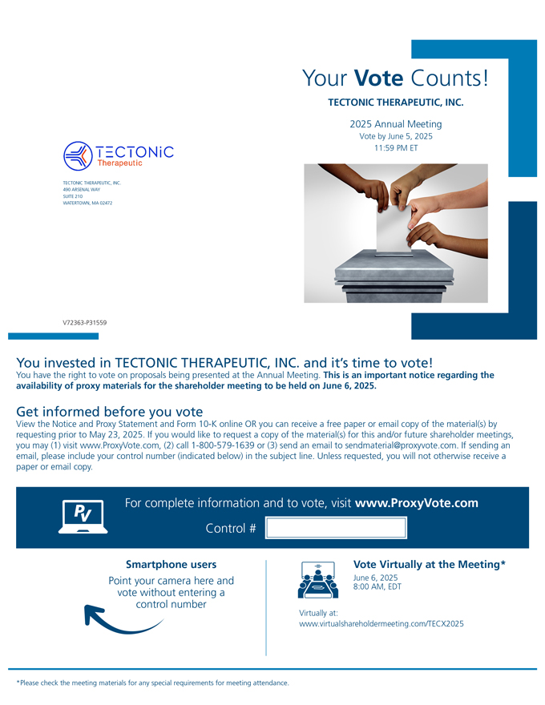
TECTONIC THERAPEUTIC, INC. 490 ARSENAL WAY SUITE 210 WATERTOWN, MA 02472 Your Vote Counts! TECTONIC THERAPEUTIC, INC. 2025 Annual Meeting Vote by June 5, 2025 11:59 PM ET V72363-P31559 You invested in TECTONIC THERAPEUTIC, INC. and its time to vote! You have the right to vote on proposals being presented at the Annual Meeting. This is an important notice regarding the availability of proxy materials for the shareholder meeting to be held on June 6, 2025. Get informed before you vote View the Notice and Proxy Statement and Form 10-K online OR you can receive a free paper or email copy of the material(s) by requesting prior to May 23, 2025. If you would like to request a copy of the material(s) for this and/or future shareholder meetings, you may (1) visit www.ProxyVote.com, (2) call 1-800-579-1639 or (3) send an email to sendmaterial@proxyvote.com. If sending an email, please include your control number (indicated below) in the subject line. Unless requested, you will not otherwise receive a paper or email copy. For complete information and to vote, visit www.ProxyVote.com Control # Smartphone users Point your camera here and vote without entering a control number Virtually at: Vote Virtually at the Meeting* June 6, 2025 8:00 AM, EDT www.virtualshareholdermeeting.com/TECX2025 *Please check the meeting materials for any special requirements for meeting attendance.

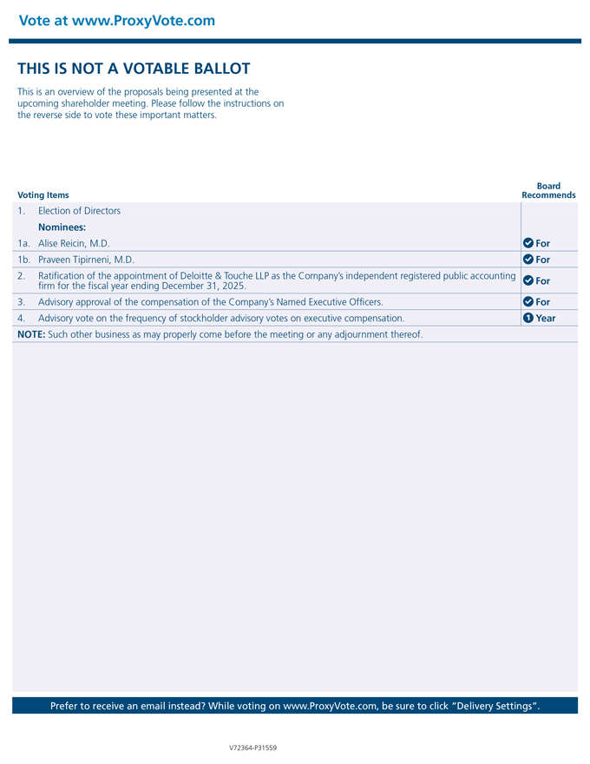
1. Election of Directors Nominees: 1a. Alise Reicin, M.D. For 1b. Praveen Tipirneni, M.D. For 2. Ratification of the appointment of Deloitte & Touche LLP as the Companys independent registered public accounting firm for the fiscal year ending December 31, 2025. For 3.Advisory approval of the compensation of the Companys Named Executive Officers. For 4.Advisory vote on the frequency of stockholder advisory votes on executive compensation. 1 Year NOTE: Such other business as may properly come before the meeting or any adjournment thereof. Prefer to receive an email instead? While voting on www.ProxyVote.com, be sure to click Delivery Settings. V72364-P31559

