UNITED STATES

SECURITIES AND EXCHANGE COMMISSION
Washington, D.C. 20549

FORM 8-K

CURRENT REPORT

Pursuant to Section 13 or 15(d)
of the Securities Exchange Act of 1934

Date of Report (Date of earliest event reported): January 30, 2025

Tectonic Therapeutic, Inc.

(Exact name of registrant as specified in its charter)

Delaware | 001-38537 | 81-0710585
(state or other jurisdiction | (Commission | (I.R.S. Employer
of incorporation) | File Number) | Identification No.)

490 Arsenal Way, Suite 210
Watertown, Massachusetts | 02472
(Address of principal executive offices) | (Zip Code)

Registrant’s telephone number, including area code: (339) 666-3320

Not applicable

(Former name or former address, if changed since last report.)

Check the appropriate box below if the Form 8-K filing is intended to simultaneously satisfy the filing obligation of the registrant under any of the following provisions:

- Written communications pursuant to Rule 425 under the Securities Act (17 CFR 230.425)

- Soliciting material pursuant to Rule 14a-12 under the Exchange Act (17 CFR 240.14a-12)

- Pre-commencement communications pursuant to Rule 14d-2(b) under the Exchange Act (17 CFR 240.14d-2(b))

- Pre-commencement communications pursuant to Rule 13e-4(c) under the Exchange Act (17 CFR 240.13e-4(c)) Securities registered pursuant to Section 12(b) of the Act:
Title of each class |  | Trading |  | Name of each exchange
 |  | Symbol |  | on which registered
Common Stock, $0.0001 par value per share |  | TECX |  | The Nasdaq Stock Market LLC

Indicate by check mark whether the registrant is an emerging growth company as defined in Rule 405 of the Securities Act of 1933 (§230.405 of this chapter) or Rule 12b-2 of the Securities Exchange Act of 1934 (§240.12b-2 of this chapter).

Emerging growth company ☐

If an emerging growth company, indicate by check mark if the registrant has elected not to use the extended transition period for complying with any new or revised financial accounting standards provided pursuant to Section 13(a) of the Exchange Act. ☐

Item 7.01 Regulation FD Disclosure.

On January 30, 2025, Tectonic Therapeutic, Inc. (the “Company”) posted a presentation titled “TX45 Phase 1b PH-HFpEF Interim Data Release for Single Dose Hemodynamic Trial” on its website, a copy of which is attached as Exhibit 99.1 to this Current Report on Form 8-K.

The information under Item 7.01 in this Current Report on Form 8-K, including Exhibit 99.1 attached hereto, is being furnished and shall not be deemed “filed” for purposes of Section 18 of the Securities Exchange Act of 1934, as amended (the “Exchange Act”), or otherwise subject to the liabilities of that section. Such information and the accompanying Exhibit 99.1 are not incorporated by reference in any filing of the Company under the Securities Act of 1933, as amended, or the Exchange Act, whether made before or after the date hereof, regardless of any general incorporation language in such filing, except as shall be expressly set forth by specific reference in such filing.

Item 8.01 Other Events.

On January 30, 2025, the Company issued a press release titled “Tectonic Therapeutic Announces Positive Interim Data from Phase 1b Trial for TX45 in Patients with Group 2 Pulmonary Hypertension in HFpEF.” A copy of the press release is attached as Exhibit 99.2 to this Current Report on Form 8-K and, other than the quotes contained therein, is incorporated herein by reference.

Item 9.01 Financial Statements and Exhibits.

(d) Exhibits

Exhibit
No. Description

99.1 Presentation dated January 2025.

99.2 Press Release dated January 30, 2025.

104 Cover Page Interactive Data File (the cover page XBRL tags are embedded within the Inline XBRL document)

SIGNATURES

Pursuant to the requirements of the Securities Exchange Act of 1934, the registrant has duly caused this report to be signed on its behalf by the undersigned hereunto duly authorized.

TECTONIC THERAPEUTIC, INC.

By: /s/ Daniel Lochner

Daniel Lochner

Chief Financial Officer

Dated: January 30, 2025

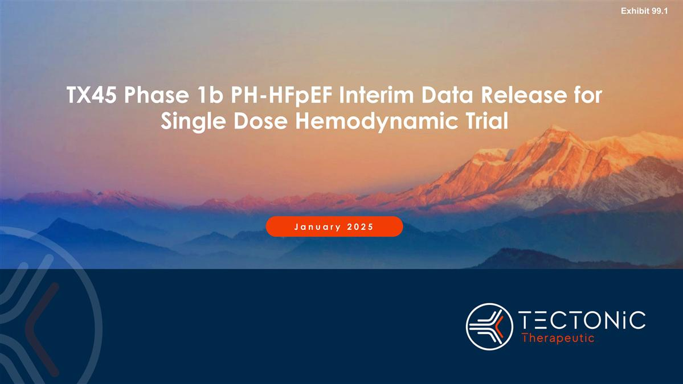

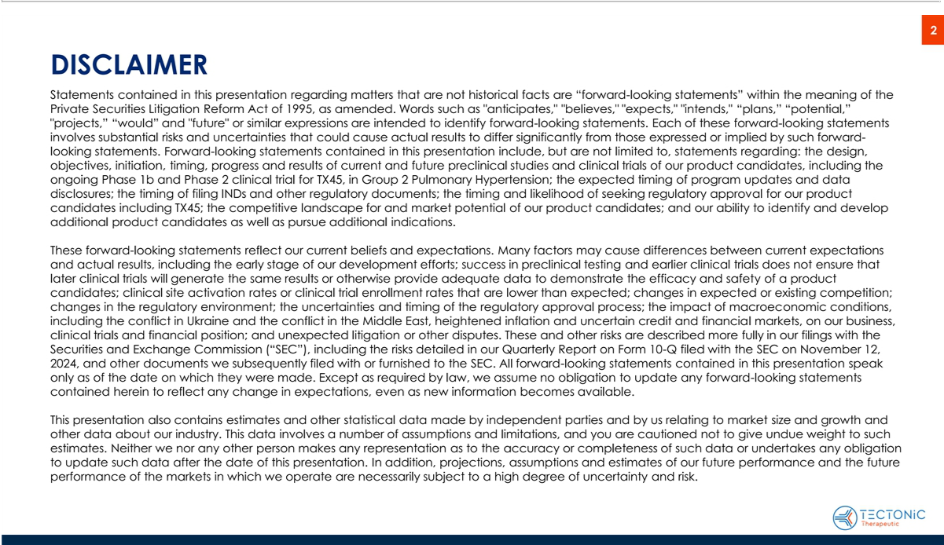

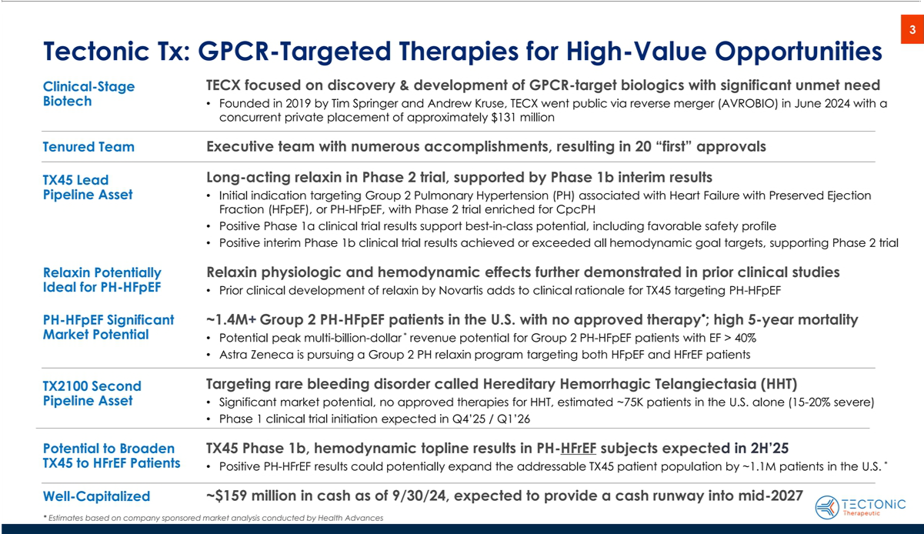

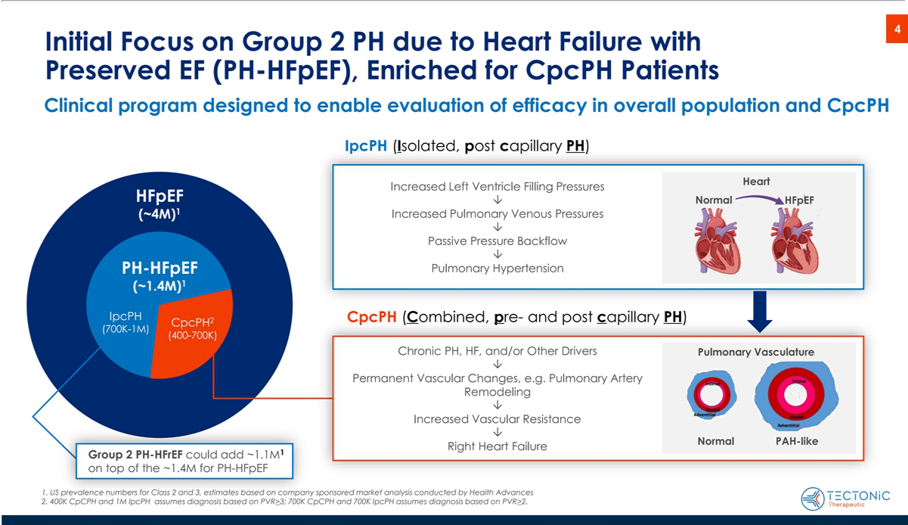

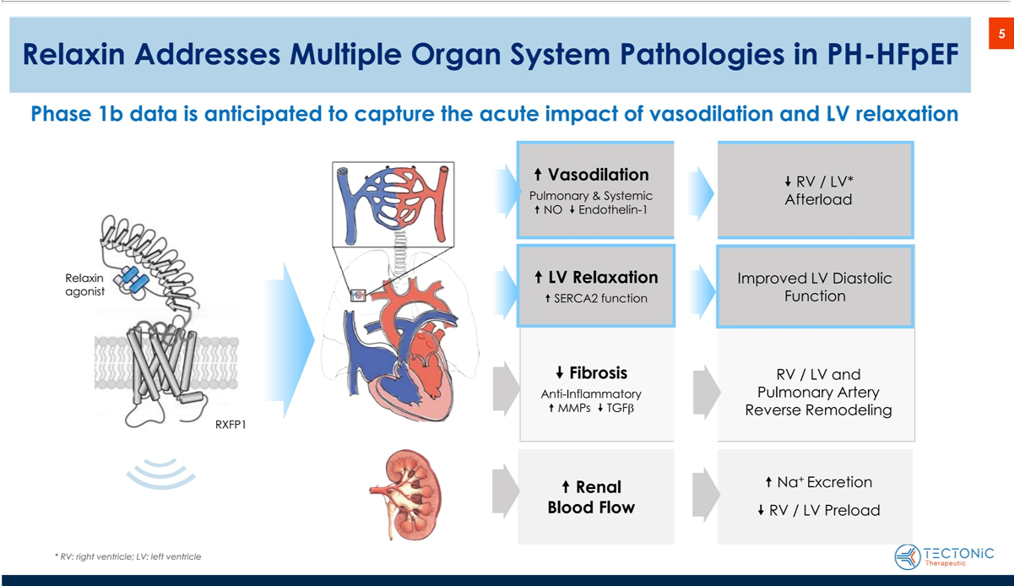

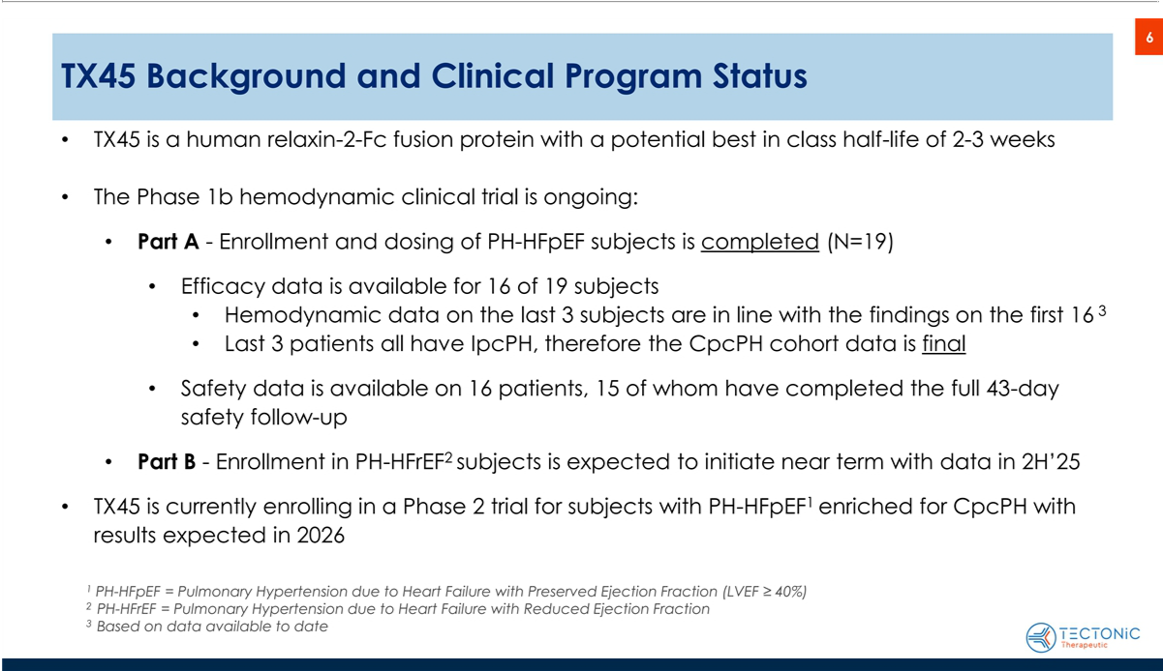

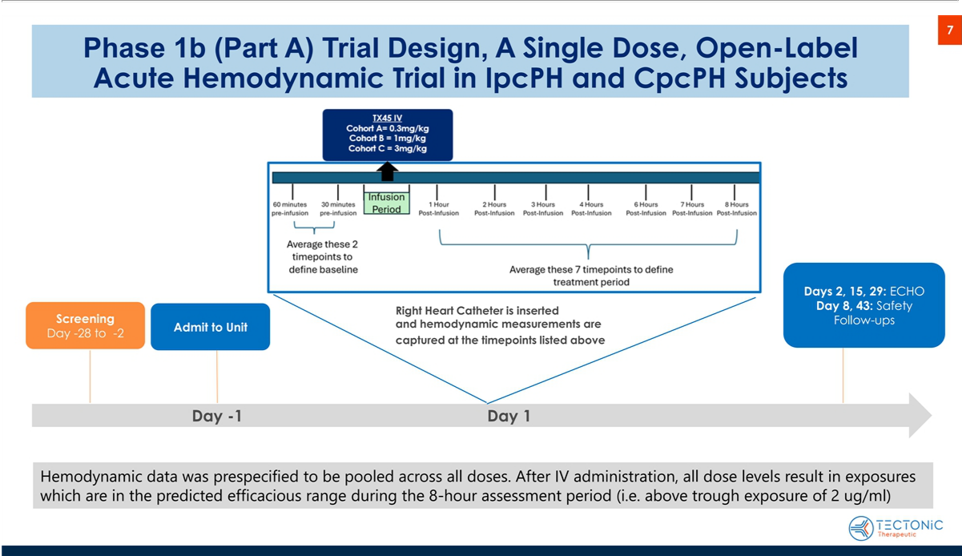

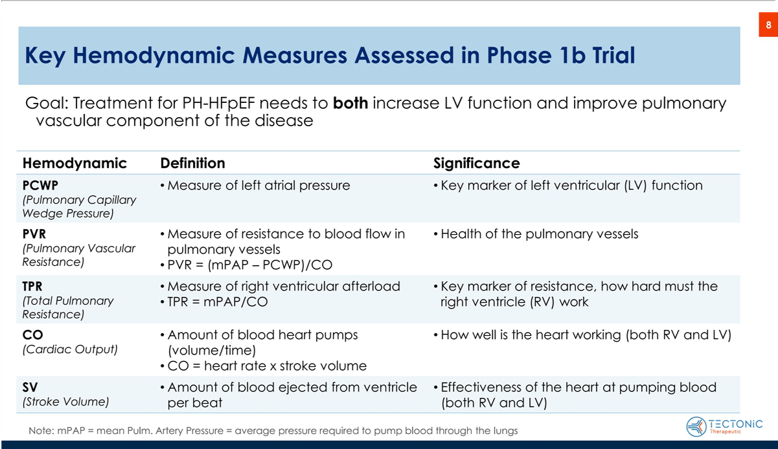

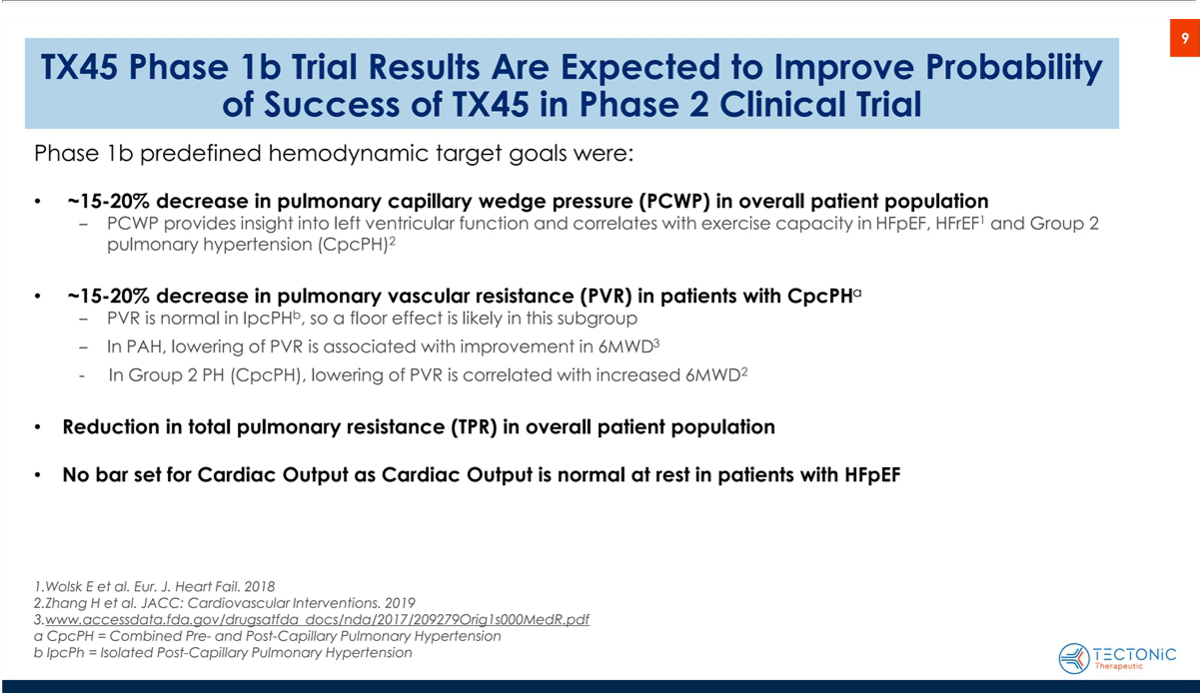

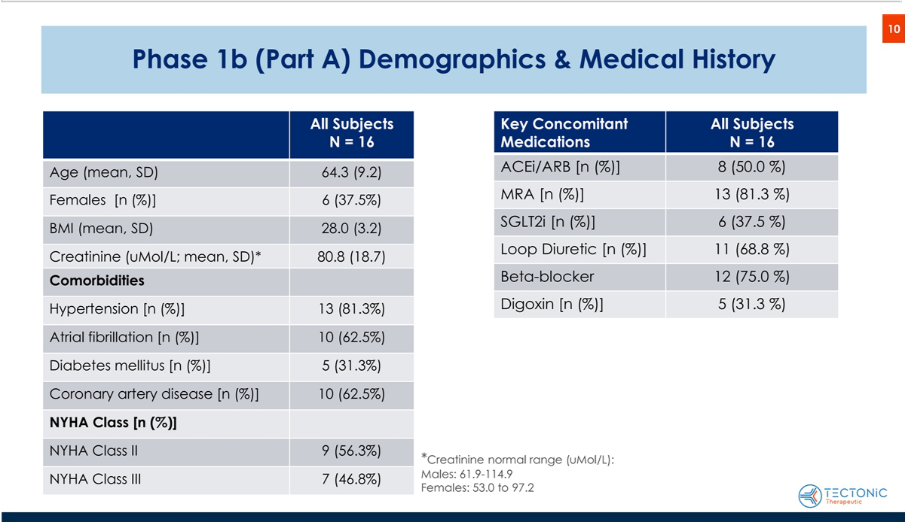

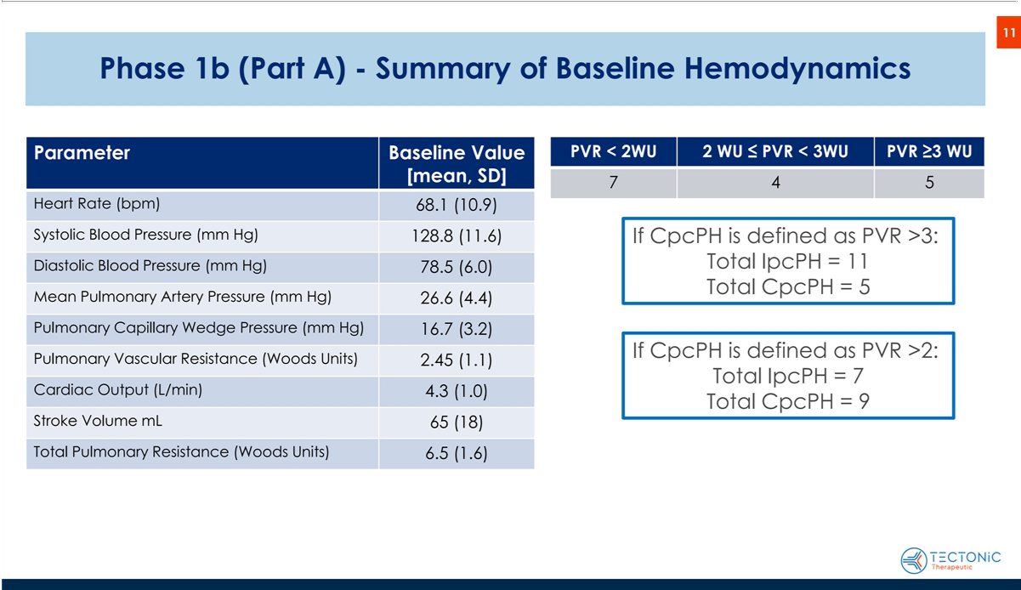

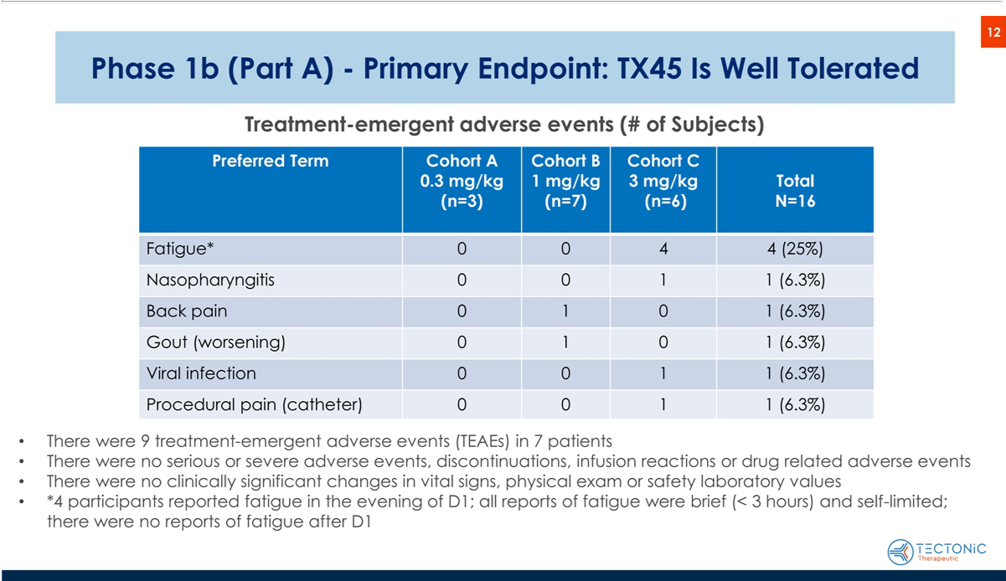

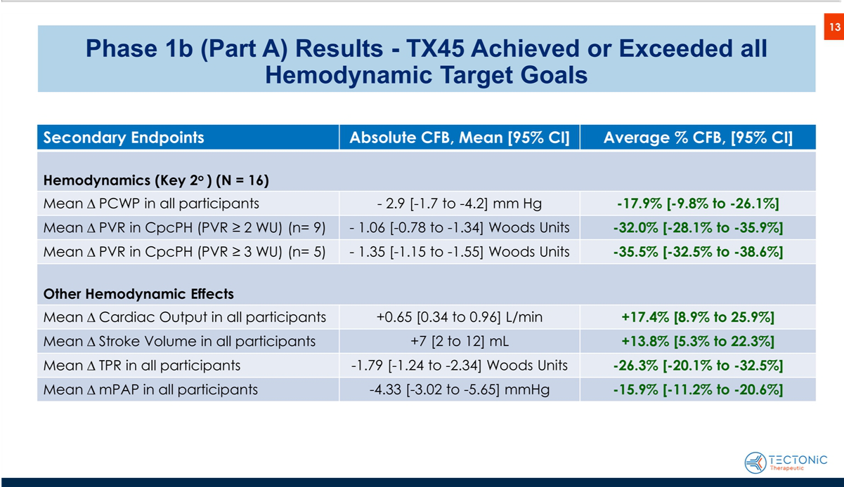

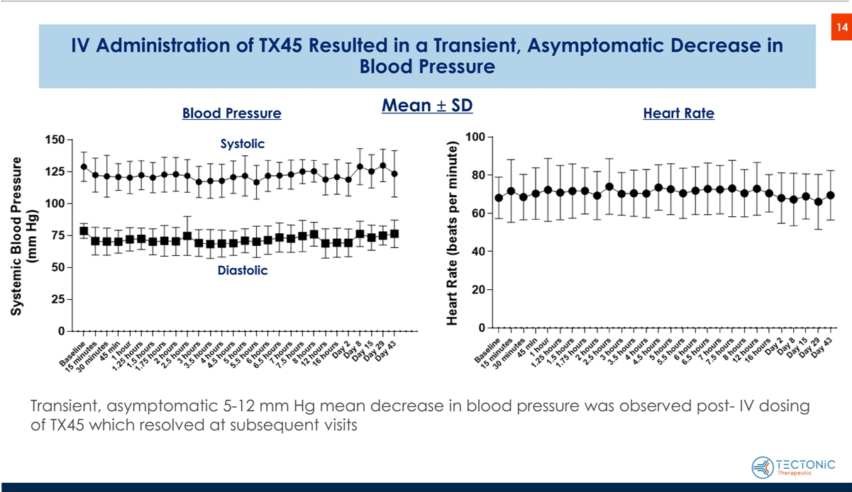

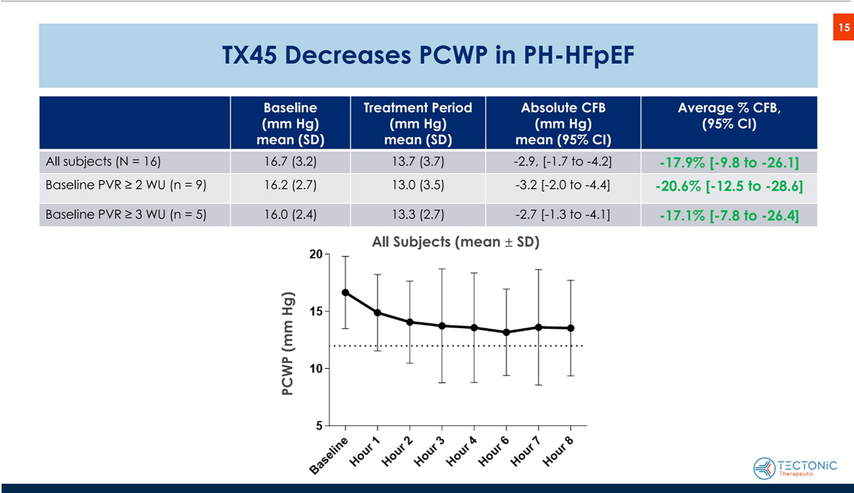

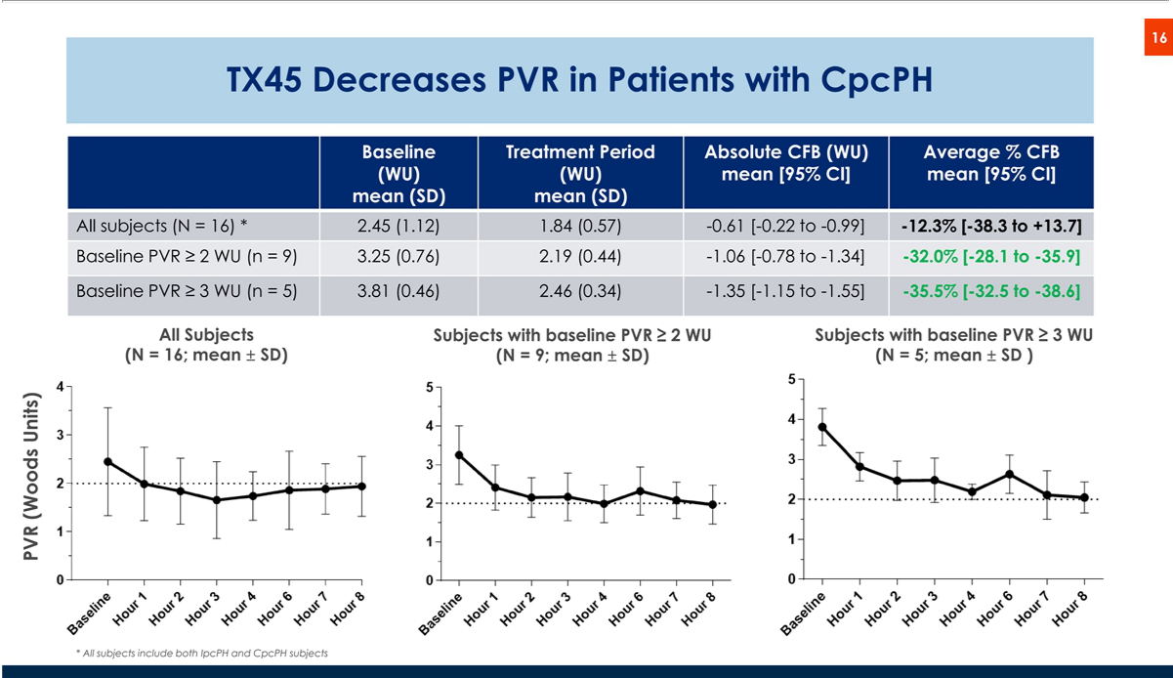

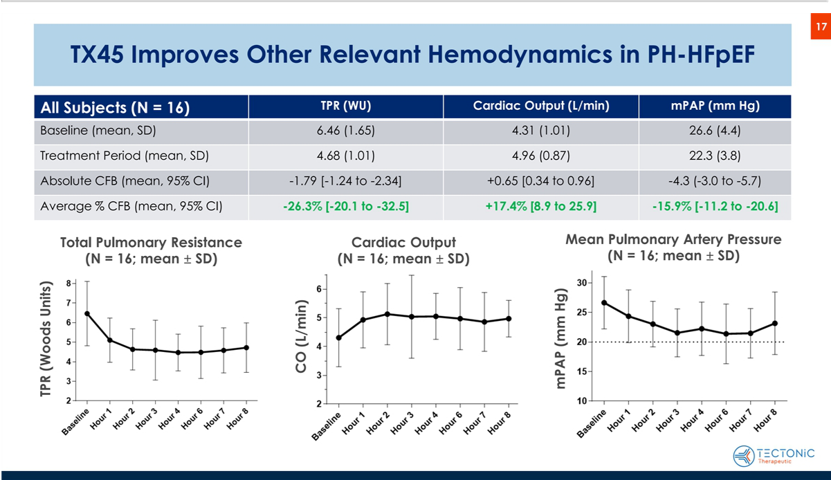

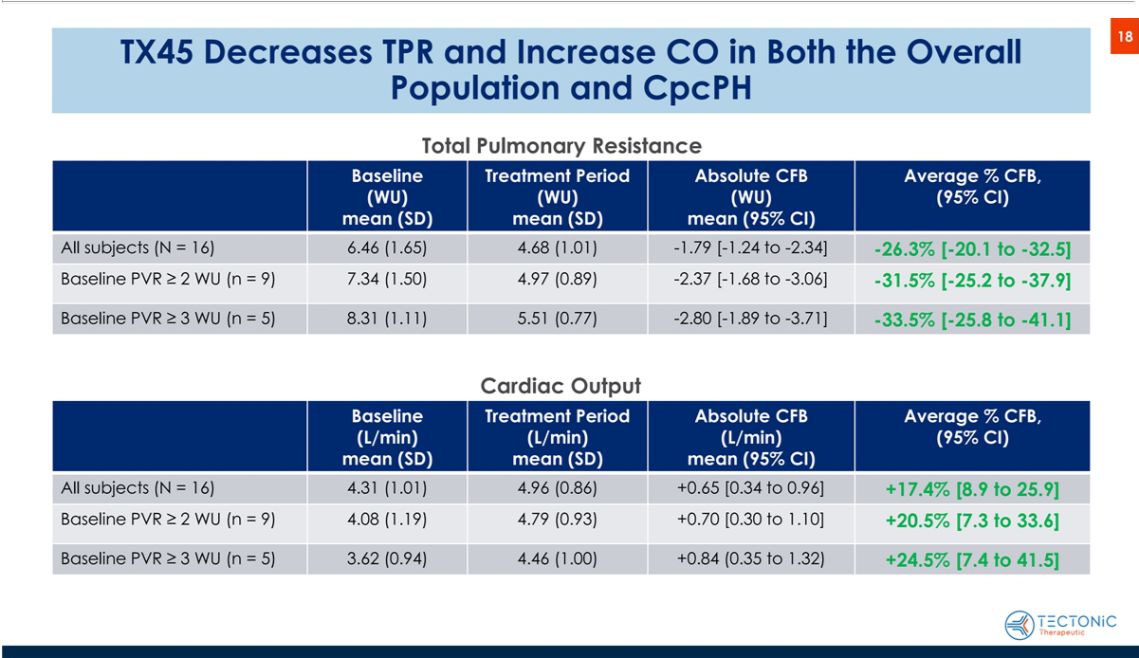

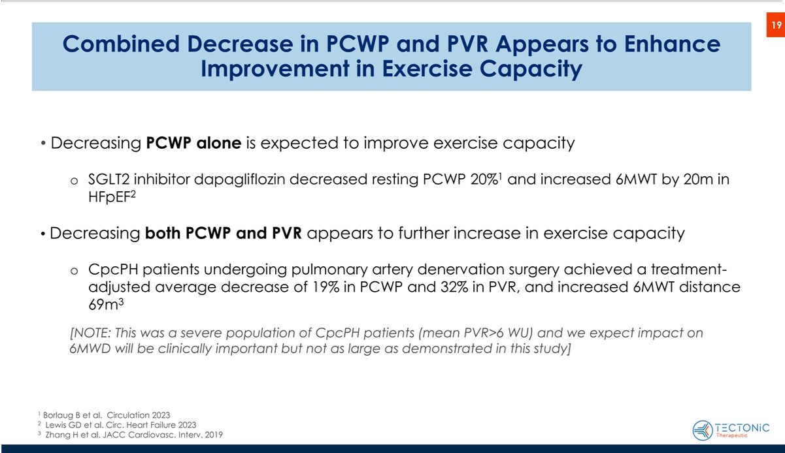

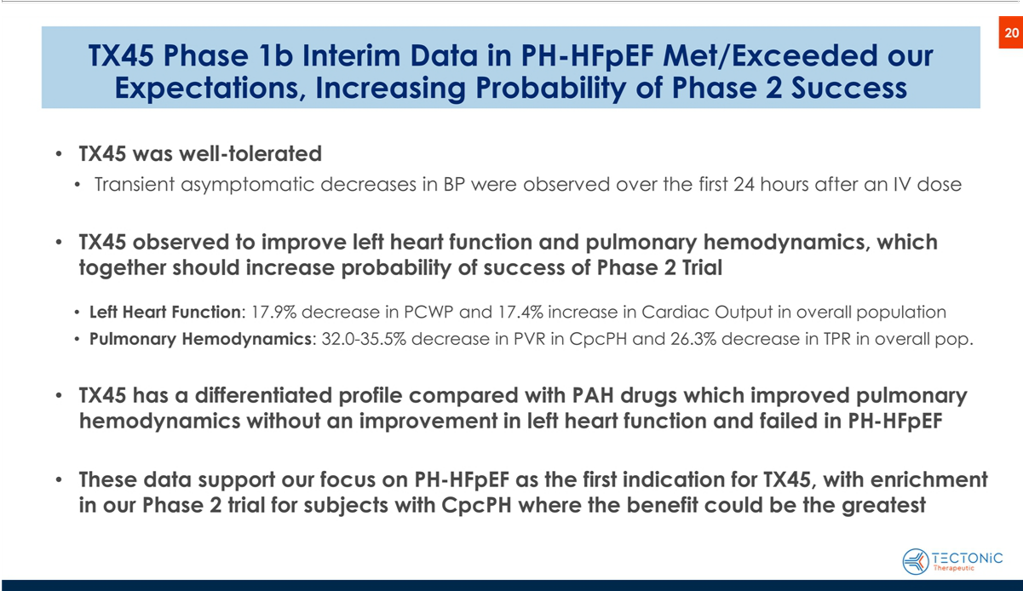

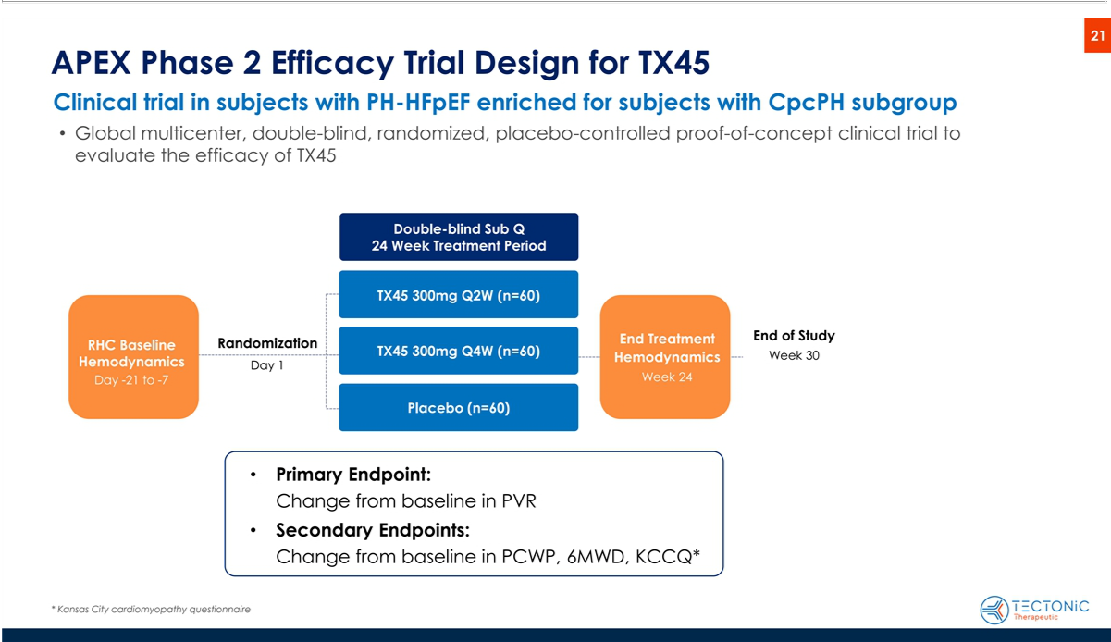

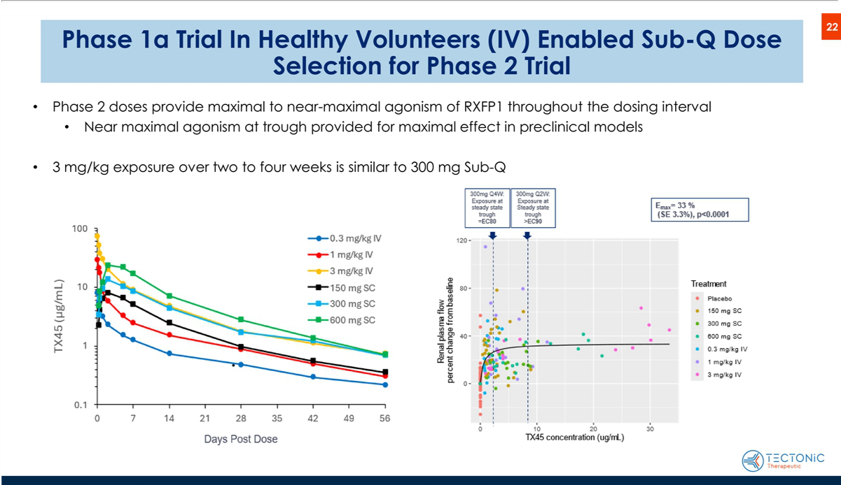

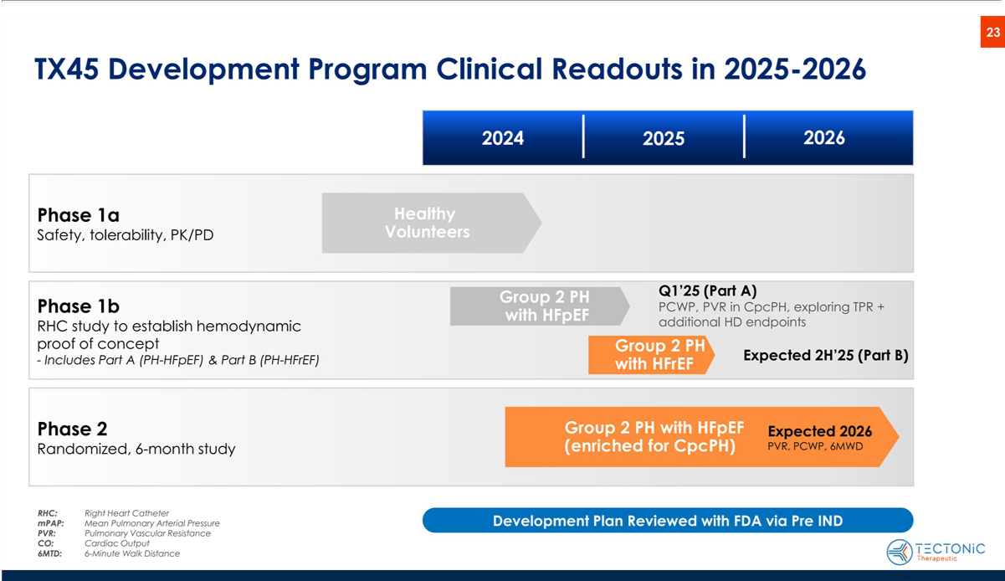

Exhibit 99.2

Tectonic Therapeutic Announces Positive Interim Data from Phase 1b Trial for

TX45 in Patients with Group 2 Pulmonary Hypertension in HFpEF

- TX45 improved both left ventricular function and pulmonary hemodynamics in patients with Group 2 Pulmonary Hypertension in Heart Failure with preserved Ejection Fraction (“PH-HFpEF”), supporting endpoints and patient populations in ongoing APEX Phase 2 clinical trial

- Interim analysis demonstrated that TX45 achieved 17.9% reduction in Pulmonary Capillary Wedge Pressure (“PCWP”) in the total study population of PH-HFpEF and >30% reduction in Pulmonary Vascular Resistance (“PVR”) in Combined pre- and post-capillary PH (“CpcPH”), a subpopulation with more severe disease

- TX45 was well tolerated in patients with PH-HFpEF with no serious or severe adverse events, significant hypotension, or immune related reactions

- Company to host conference call and webcast today at 8:00 a.m. ET

WATERTOWN, Mass., January 30, 2025 (GLOBE NEWSWIRE) — Tectonic Therapeutic, Inc. (NASDAQ: TECX) (“Tectonic”), today announced positive interim data from the Phase 1b acute hemodynamic clinical trial of its lead product candidate, TX45, a long-acting, Fc-relaxin fusion protein. The interim data showed that a single intravenous dose of TX45 resulted in meaningful improvements in both left ventricular function and pulmonary hemodynamics in patients with Group 2 Pulmonary Hypertension in Heart Failure with Preserved Ejection Fraction (“PH-HFpEF”). In the trial, TX45 was well tolerated in patients with PH-HFpEF with no serious or severe adverse events.

In the overall study population, TX45 achieved a 17.9% reduction in pulmonary capillary wedge pressure (“PCWP”), an endpoint known to correlate with exercise capacity, morbidity and mortality in patients with heart failure. In the subpopulation with combined pre- and post-capillary pulmonary hypertension (“CpcPH”) who have an elevated Pulmonary Vascular Resistance (“PVR”) and more severe disease, TX45 demonstrated >30% reduction in PVR, which along with PCWP is correlated to exercise capacity and mortality in these patients. The Phase 1b trial enrolled a patient population and evaluated hemodynamic endpoints which are similar to our ongoing APEX Phase 2 clinical trial (ClinicalTrials.gov NCT06616974). APEX is a 24-week clinical trial in PH-HFpEF with topline results expected in 2026.

“These interim results show that TX45 achieved improvements in hemodynamics which met and exceeded our prespecified objectives. We are highly encouraged that TX45 improved left ventricular function and pulmonary hemodynamics, because we believe improving both parameters is necessary to improve exercise capacity and outcomes in patients with pulmonary hypertension with HFpEF,” said Alise Reicin, M.D., President and Chief Executive Officer of Tectonic. “We believe these Phase 1b interim data accelerate momentum of our TX45 clinical program as our ongoing Phase 2 APEX trial is designed to enroll a similar patient population and evaluate the same endpoints. These data strengthen our confidence in advancing TX45 for the many patients with PH-HFpEF who face high mortality and have no currently approved treatments.”

“These therapeutic results show remarkably consistent and meaningful improvement across multiple clinically important hemodynamic measures in this patient population,” said John Teerlink, MD, Professor of Medicine, University of California, San Francisco. “I am excited about the prospects ahead for the continued development of TX45 which appears to address the underlying pathologies of PH-HFpEF that lead to impairment of exercise capacity, poor outcomes and increased mortality. This patient population is in desperate need of treatment options.”

Highlights from interim Phase 1b results and overview of the Phase 1b trial

The interim results from the Phase 1b open label clinical trial are based on 16 of 19 enrolled patients with PH-HFpEF, with the remaining 3 patients currently completing Part A of the protocol. Within the 16 patients in the interim analysis, 9 patients had CpcPH, as measured by PVR>2 Wood units. Hemodynamic measures evaluating left ventricular function included PCWP, Cardiac Output (“CO”) and Stroke Volume (“SV”). Hemodynamic measures evaluating the pulmonary vasculature included PVR, Total Pulmonary Resistance (“TPR”) and mean Pulmonary Artery Pressure (“mPAP”).

Safety Results: TX45 was well tolerated with no serious or severe adverse events, discontinuations, infusion reactions or drug-related adverse events.

- There were no clinically significant changes in vital signs, physical exam or safety laboratory values.

- Transient asymptomatic decreases in blood pressure were observed over the first 24 hours after TX45 dosing.

Hemodynamic Results: TX45 administration resulted in meaningful improvement in both left ventricular function and pulmonary hemodynamics, representing a differentiated profile for TX45 compared to other PAH drugs that are pulmonary vasodilators but have not shown improvement in left ventricular function and have not shown efficacy in PH-HFpEF.

- Improvement in left ventricular function: In the overall population, TX45 achieved 17.9% [95% CI, -9.8% to -26.1%] reduction in PCWP and 17.4% [95% CI, 8.9% to 25.9%] increase in CO.

- Improvement in pulmonary hemodynamics: TX45 achieved 32.0% [95% CI, -28.1% to -35.9%] reduction in PVR in the subgroup of patients with CpcPH who have elevated PVR at baseline, a 26.3% [95% CI, -20.1% to -32.5%] reduction in TPR and a 15.9% [95% CI, -11.2% to -20.6%] reduction in mean pulmonary artery pressure in the overall population.

- As a relaxin therapeutic, the unique mechanism of TX45 improves both left ventricular function and pulmonary hemodynamics, which most strongly matches the more severe pathophysiology of patients with CpcPH.

“We are excited about these interim Phase 1b results in demonstrating promising hemodynamic improvements and tolerability in a broad patient population with PH-HFpEF”, said Marcella K. Ruddy, M.D., Chief Medical Officer of Tectonic. “We are particularly encouraged by the striking results in CpcPH patients who saw improvements in both PCWP and PVR. This finding suggests that these patients, who have more severe disease, may have the greatest benefit from a relaxin therapeutic. These data support our planned enrichment of CpcPH patients in our Phase 2 APEX trial.

The Phase 1b open label clinical trial is designed to evaluate the safety and hemodynamic effect of single doses of TX45 in patients with Group 2 pulmonary hypertension. Part A is examining the effect of TX45 in PH-HFpEF and Part B will evaluate effects of TX45 in Pulmonary Hypertension in Heart Failure with reduced Ejection Fraction (“PH-HFrEF”). The design of the clinical trial is as follows: after obtaining informed consent, a right heart catheter, which is the gold standard for the measurement of cardiopulmonary hemodynamics, is inserted and baseline measurements are obtained, an intravenous dose of TX45 is administered, and hemodynamic effects are evaluated over 8 hours post dose. Participants are then followed for 45 days post dose for safety and exploratory biomarker

endpoints. Part A enrollment has completed. Part B enrollment will start in February with topline data expected in the second half of 2025. The complete Phase 1b clinical trial results in PH-HFpEF and PH-HFrEF patient populations are planned to be presented at future medical meetings.

Conference Call

Tectonic will host a conference call and webcast today, January 30, 2025, at 8:00 a.m. ET. To access the conference call via phone, please dial 1-877-423-9813 or 1-201-689-8573 (International) and ask to join the Tectonic Therapeutic call. A live webcast of the event will be available here and under Events and Presentations in the Investors section of the Company’s website at www.tectonictx.com. A replay of the webcast will also be available on the Company’s website after the call’s conclusion.

About Group 2 Pulmonary Hypertension in HFpEF

The World Health Organization has defined 5 groups of pulmonary hypertension (“PH”). Tectonic is focused on the Group 2 subtype, a condition that develops due to left-sided heart disease, specifically Pulmonary Hypertension in Heart Failure with preserved Ejection Fraction (“PH-HFpEF”). In patients with PH-HFpEF, chronic heart failure leads to increased blood pressure in the pulmonary arteries, exerting severe strain on the right side of the heart, which adapts poorly to the increased pressure. This increased pulmonary pressure gradually causes worsening exercise capacity, shortness of breath and right-sided heart failure which can lead to death. PH-HFpEF is further segmented based on pulmonary hemodynamics into Isolated, post-capillary PH (“IpcPH”) and Combined pre- and post-capillary PH (“CpcPH”). CpcPH is more severe, accounts for about one third to one half of the

1.4 million PH-HFpEF patients in the U.S. and is characterized by additional, abnormal changes to the pulmonary vasculature, leading to an increase in Pulmonary Vascular Resistance (“PVR”). Although several Group 1 PH (Pulmonary Arterial Hypertension, “PAH”) medications have been explored in Group 2 PH, to date, no medications have been approved for its treatment.

About TX45, a long-acting Fc-relaxin fusion protein

TX45 is an Fc-relaxin fusion protein with optimized pharmacokinetics and biophysical properties that activates the RXFP1 receptor, the G-protein coupled receptor target of the hormone relaxin. Relaxin is an endogenous protein, expressed at low levels in both men and women that is a pulmonary and systemic vasodilator with lusitropic, anti-fibrotic and anti-inflammatory activity. In normal human physiology, relaxin is upregulated during pregnancy where it exerts vasodilative effects, reduces systemic and pulmonary vascular resistance and increases cardiac output to accommodate the increased demand for oxygen and nutrients from the developing fetus. Relaxin also exerts anti-fibrotic effects on pelvic ligaments to facilitate delivery of the baby.

About Tectonic

Tectonic is a biotechnology company focused on the discovery and development of therapeutic proteins and antibodies that modulate the activity of G-protein coupled receptors (“GPCRs”). Leveraging its proprietary technology platform called GEODe™ (GPCRs Engineered for Optimal Discovery), Tectonic is focused on developing biologic medicines that overcome the existing challenges of GPCR-targeted drug discovery and harness the human body to modify the course of disease. Tectonic focuses on areas of significant unmet medical need, often where therapeutic options are poor or nonexistent, as these are areas where new medicines have the potential to improve patient quality of life. Tectonic is headquartered in Watertown, Massachusetts. For more information, please visit www.tectonictx.com and follow on LinkedIn.

Forward-Looking Statements

This press release contains “forward-looking statements” within the meaning of the “safe harbor” provisions of the Private Securities Litigation Reform Act of 1995. All statements in this press release other than statements of historical facts are “forward-looking statements. These statements may be identified by words such as “aims,” “anticipates,” “believes,” “could,” “estimates,” “expects,” “forecasts,” “goal,” “intends,” “may,” “plans,” “possible,” “potential,” “seeks,” “will” and variations of these words or similar expressions that are intended to identify forward-looking statements, although not all forward-looking statements contain these words. Forward-looking statements in this press release include statements regarding: the design, objectives, timing, progress and results of clinical trials of Tectonic’s product candidates, including the ongoing Part B of Phase 1b and Phase 2 (APEX) clinical trials for TX45 in Group 2 PH-HFpEF; and the potential properties and benefits of TX45. These forward-looking statements are based on Tectonic’s expectations and assumptions as of the date of this press release. Each of these forward-looking statements involves risks and uncertainties that could cause Tectonic’s clinical development programs, future results or performance to differ materially from those expressed or implied by the forward-looking statements. Many factors may cause differences between current expectations and actual results, including: the potential that success in preclinical testing and earlier clinical trials does not ensure that later clinical trials will generate the same results or otherwise provide adequate data to demonstrate the efficacy and safety of a product candidate; the impacts of macroeconomic conditions, heightened inflation and uncertain credit and financial markets, on Tectonic’s business, clinical trials and financial position; unexpected safety or efficacy data observed during preclinical studies or clinical trials; clinical trial site activation or enrollment rates that are lower than expected; Tectonic’s ability to realize the benefits of its collaborations and license agreements; changes in expected or existing competition; changes in the regulatory environment; the uncertainties and timing of the regulatory approval process; and unexpected litigation or other disputes. Other factors that may cause Tectonic’s actual results to differ from those expressed or implied in the forward-looking statements in this press release are identified under the heading “Risk Factors” in Tectonic’s quarterly report on Form 10-Q filed with the SEC on November 12, 2024, and in other filings that Tectonic makes and will make with the SEC in the future. Tectonic expressly disclaims any obligation to update any forward-looking statements contained herein, whether as a result of any new information, future events, changed circumstances or otherwise, except as otherwise required by law.

Contacts:

Investors:

Dan Ferry

LifeSci Advisors

daniel@lifesciadvisors.com

(617) 430-7576

Media:

Kathryn Morris

The Yates Network

kathryn@theyatesnetwork.com

(914) 204-6412

