UNITED STATES

SECURITIES AND EXCHANGE COMMISSION

Washington, D.C. 20549

FORM 8-K

CURRENT REPORT

Pursuant to Section 13 or 15(d)

of the Securities Exchange Act of 1934

Date of Report (Date of earliest event reported): May 14, 2020

AVROBIO, INC.

(Exact name of registrant as specified in its charter)

Delaware

001-38537

81-0710585

(State or other jurisdiction

of incorporation)

(Commission

File Number)

(I.R.S. Employer

Identification No.)

One Kendall Square

Building 300, Suite 201

Cambridge, MA 02139

(Address of principal executive offices, including zip code)

(617) 914-8420

(Registrant’s telephone number, including area code)

Not Applicable

(Former Name or Former Address, if Changed Since Last Report)

Check the appropriate box below if the Form 8-K filing is intended to simultaneously satisfy the filing obligation of the registrant under any of the following provisions:

- Written communications pursuant to Rule 425 under the Securities Act (17 CFR 230.425)

- Soliciting material pursuant to Rule 14a-12 under the Exchange Act (17 CFR 240.14a-12)

- Pre-commencement communications pursuant to Rule 14d-2(b) under the Exchange Act (17 CFR 240.14d-2(b))

- Pre-commencement communications pursuant to Rule 13e-4(c) under the Exchange Act (17 CFR 240.13e-4(c))

Securities registered pursuant to Section 12(b) of the Act:

 |  | Trading |  | Name of each exchange
Title of each class |  | symbol(s) |  | on which registered
Common Stock, $0.0001 par value per share |  | AVRO |  | Nasdaq Global Select Market

Indicate by check mark whether the registrant is an emerging growth company as defined in Rule 405 of the Securities Act of 1933 (§ 230.405 of this chapter) or Rule 12b-2 of the Securities Exchange Act of 1934 (§ 240.12b-2 of this chapter).

Emerging growth company ☒

If an emerging growth company, indicate by check mark if the registrant has elected not to use the extended transition period for complying with any new or revised financial accounting standards provided pursuant to Section 13(a) of the Exchange Act. ☐

Item 7.01 Regulation FD Disclosure.

On May 14, 2020, AVROBIO, Inc. (the “Company”) presented a scientific presentation titled “Hematopoietic Stem Cell Gene Therapy Corrects Neuromuscular Manifestations in Preclinical Study of Pompe Mice” at the 23rd Annual Meeting of the American Society of Gene & Cell Therapy. A copy of the slide presentation is furnished as Exhibit 99.1 to this Current Report on Form 8-K.

The information in this Item 7.01 and Exhibit 99.1 attached hereto shall not be deemed “filed” for purposes of the Securities Exchange Act of 1934, as amended (the “Exchange Act”), or otherwise subject to the liabilities of that section, nor shall it be deemed incorporated by reference in any filing under the Securities Act of 1933, as amended, or the Exchange Act, except as expressly set forth by specific reference in such a filing.

Item 8.01 Other Events.

On May 14, 2020, the Company issued a press release titled “AVROBIO Presents New Preclinical Data on Lentiviral Gene Therapy Program for Pompe Disease at ASGCT 2020.” A copy of the press release is filed as Exhibit 99.2 to this Current Report on Form 8-K and incorporated into this Item 8.01 by reference.

Item 9.01. Financial Statements and Exhibits.

(d) Exhibits

99.1 AVROBIO, Inc. slide presentation, dated May 14, 2020.

99.2 Press release issued by AVROBIO, Inc., dated May 14, 2020.

SIGNATURES

Pursuant to the requirements of the Securities Exchange Act of 1934, the registrant has duly caused this report to be signed on its behalf by the undersigned hereunto duly authorized.

AVROBIO, INC.

Date: May 14, 2020 By: /s/ Geoff MacKay

Geoff MacKay

President and Chief Executive Officer



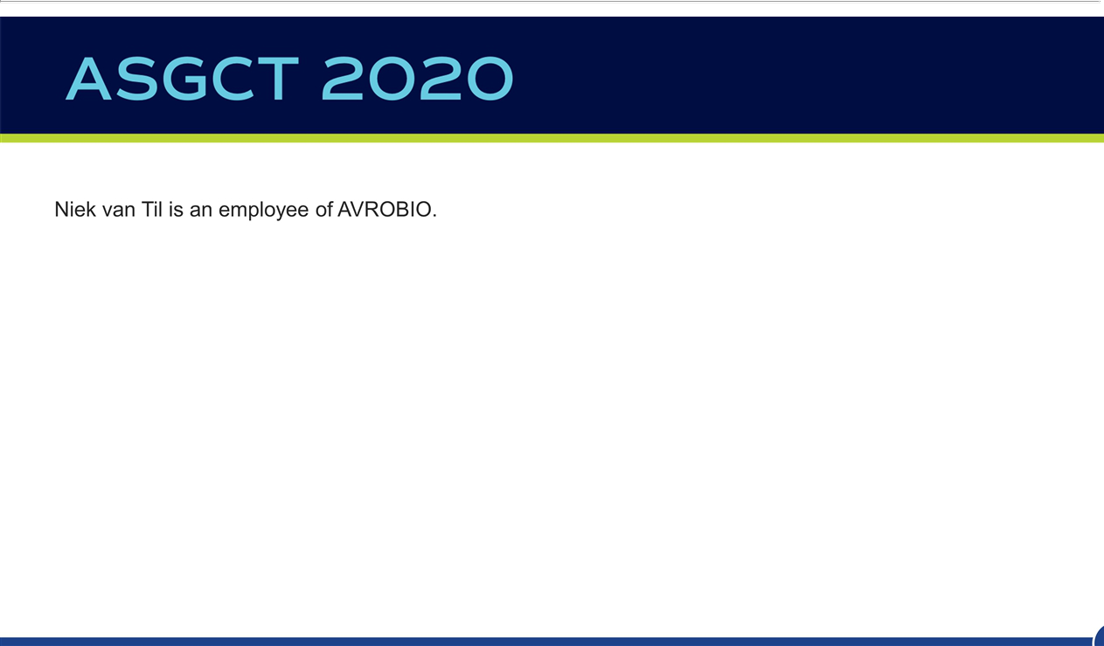

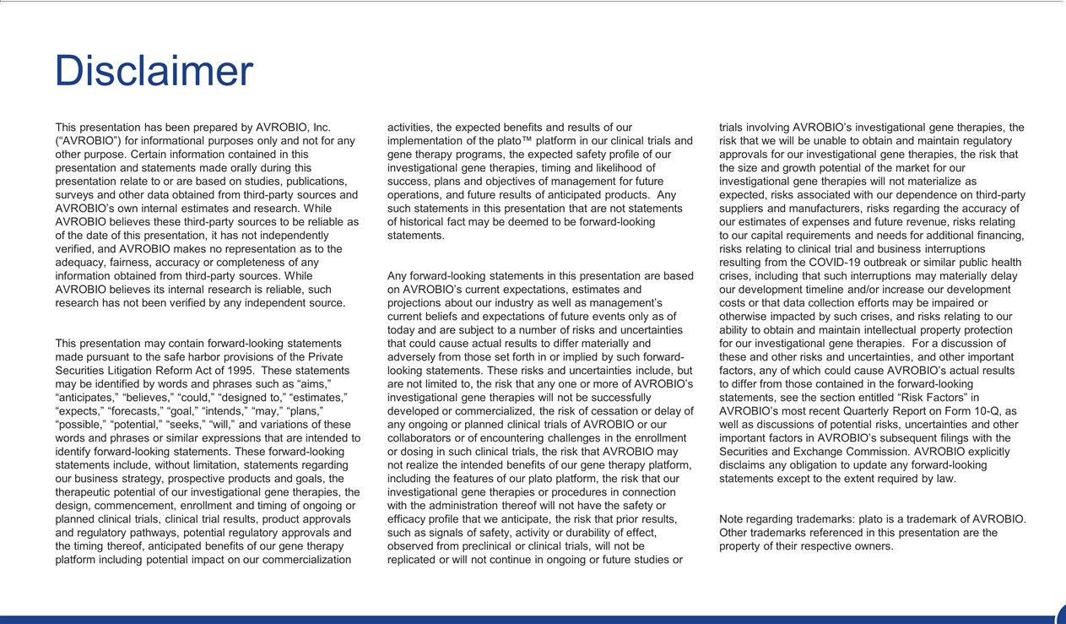

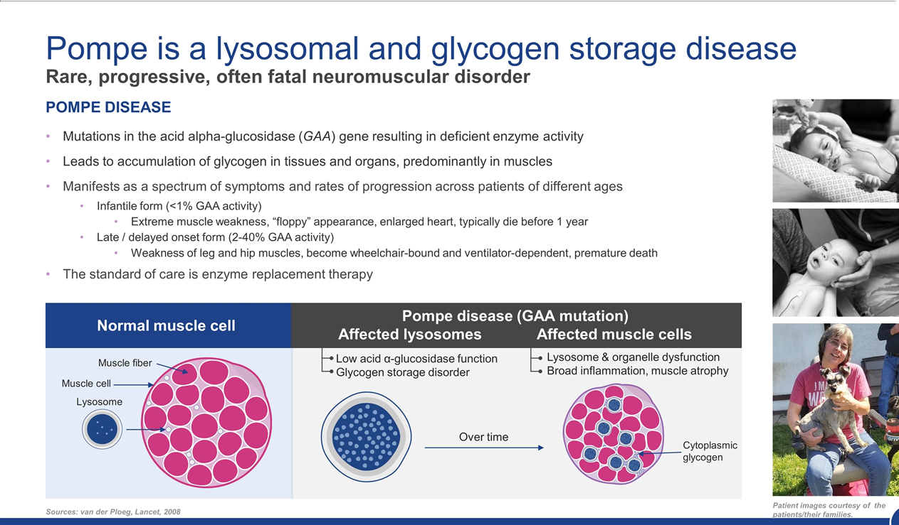

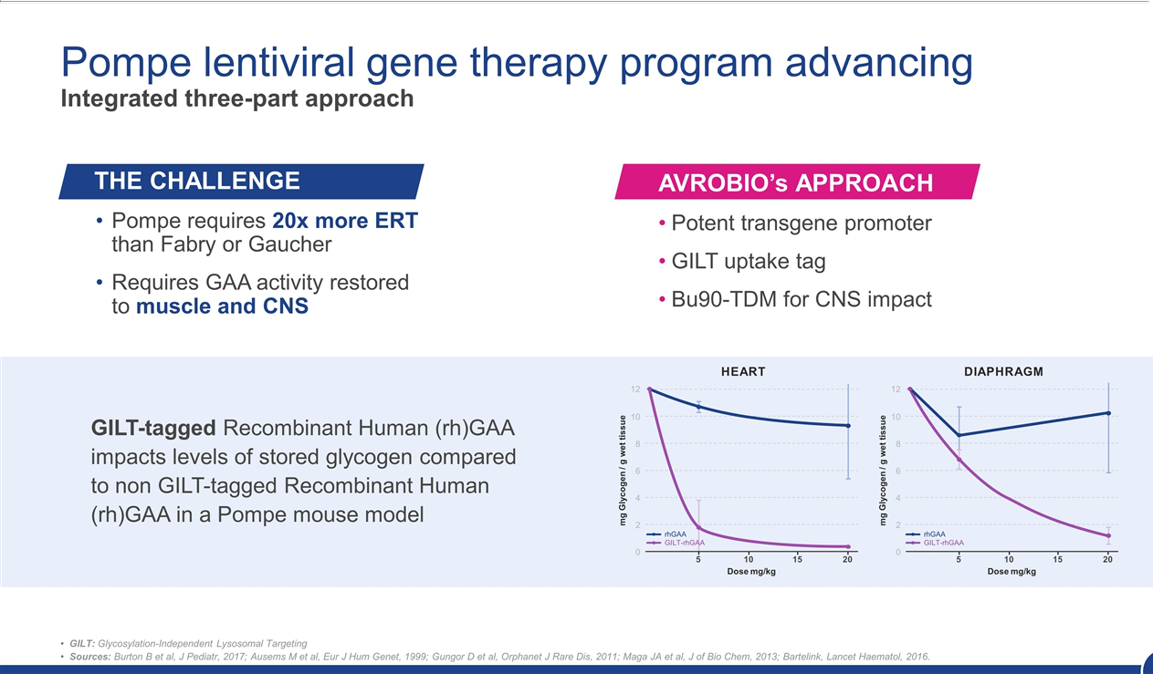

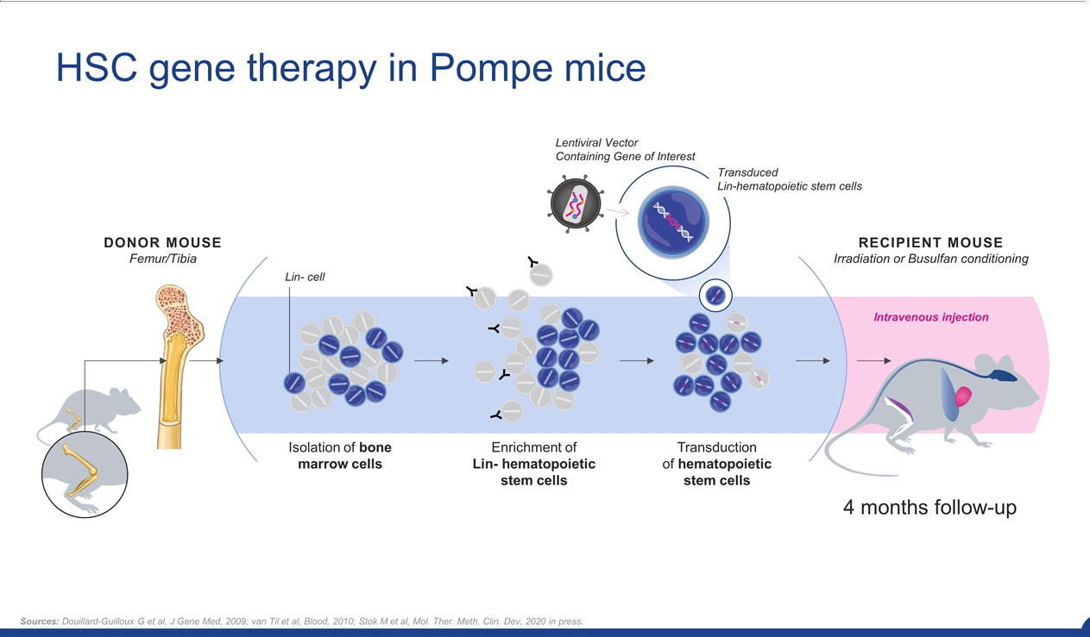

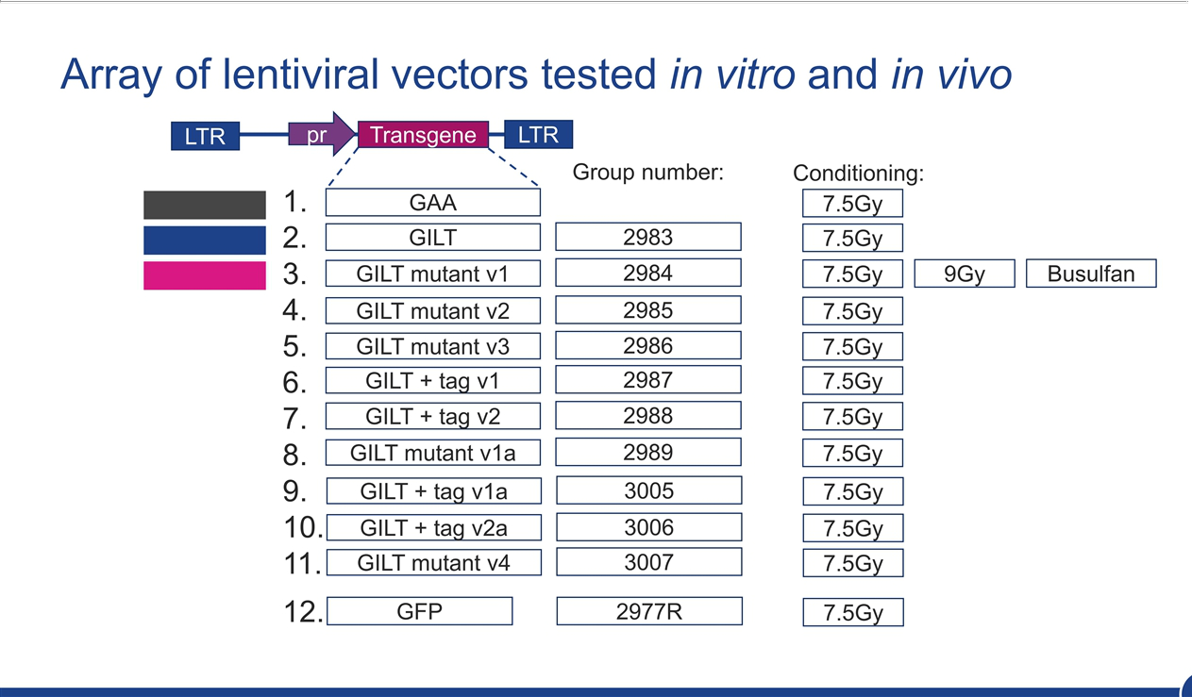

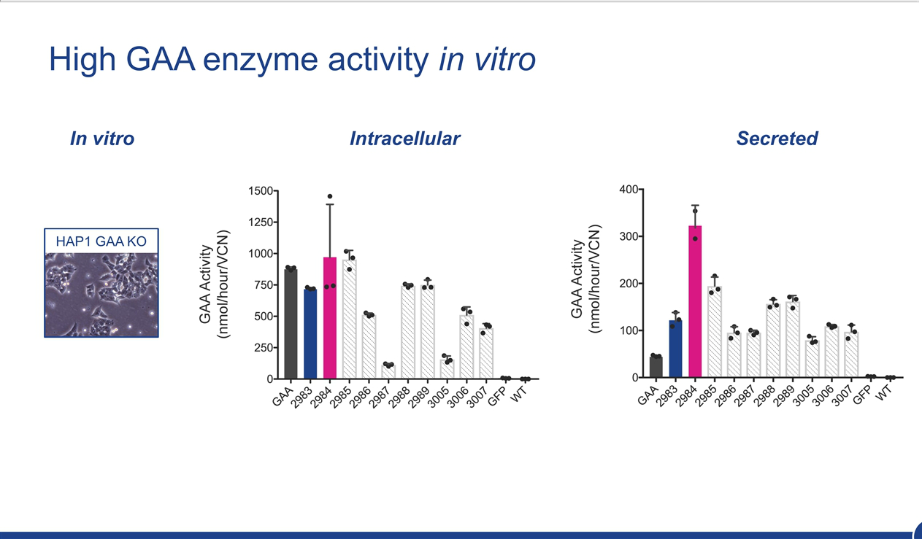

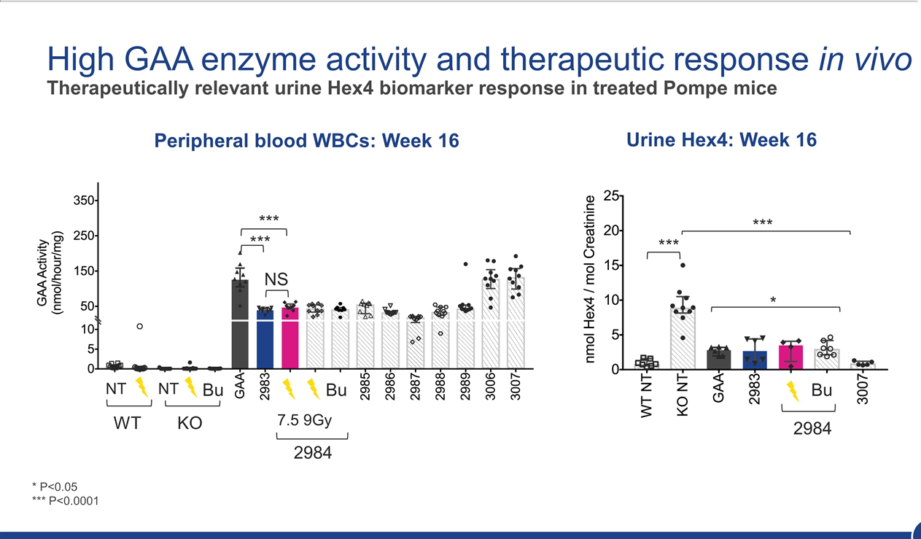

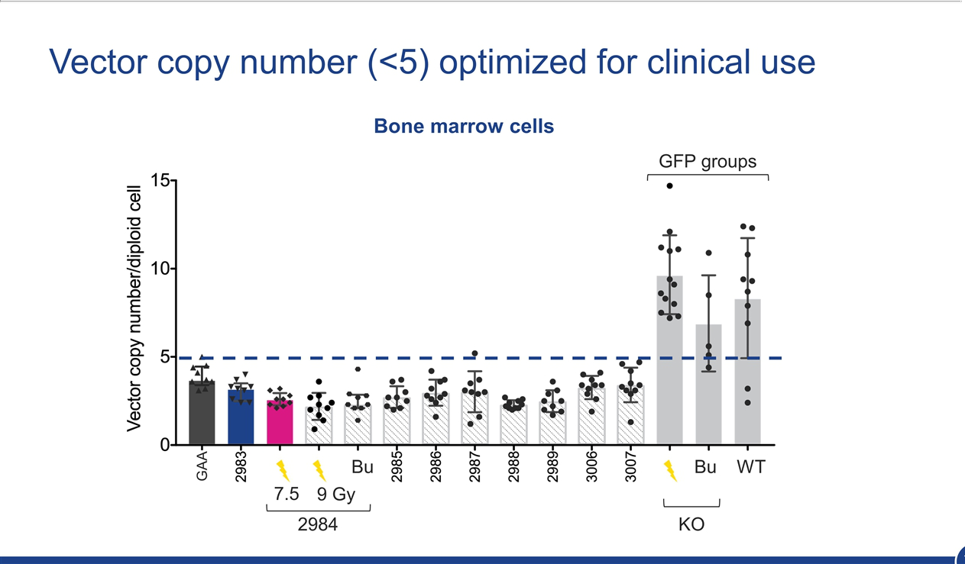

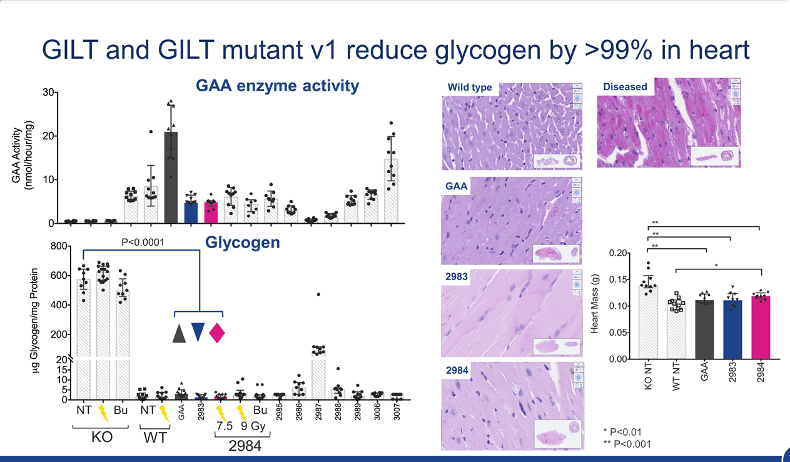

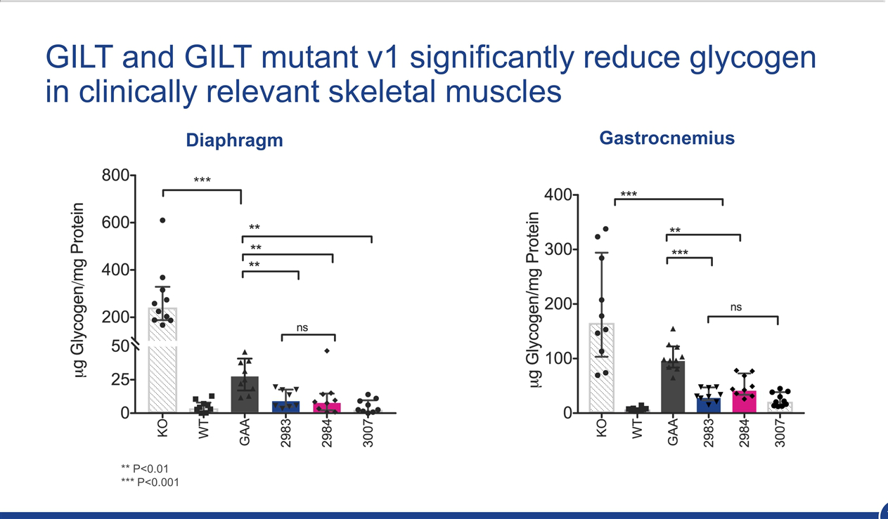

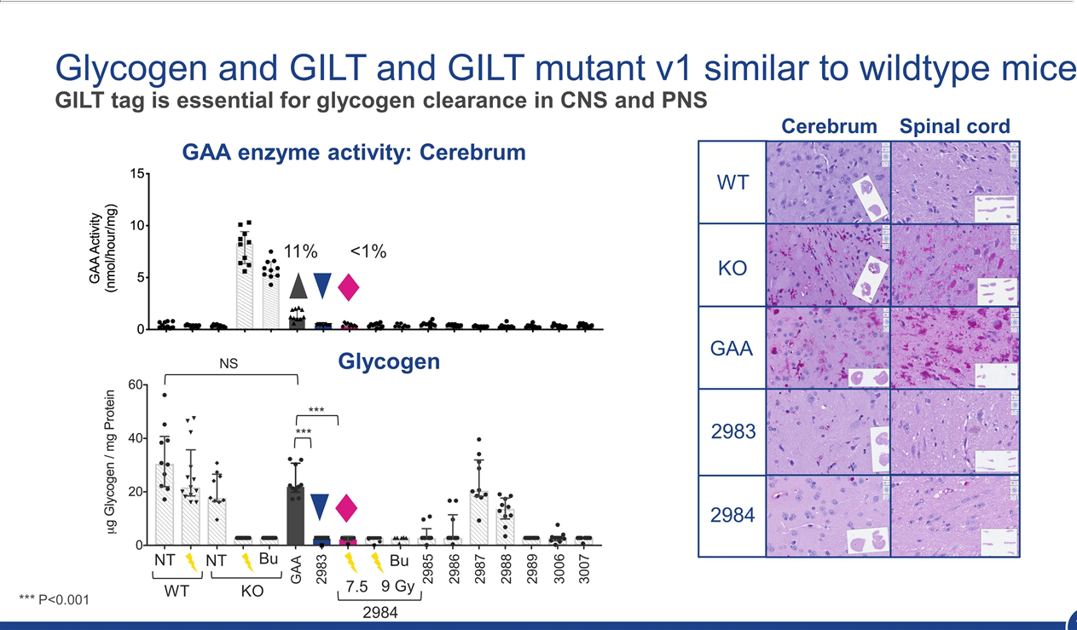

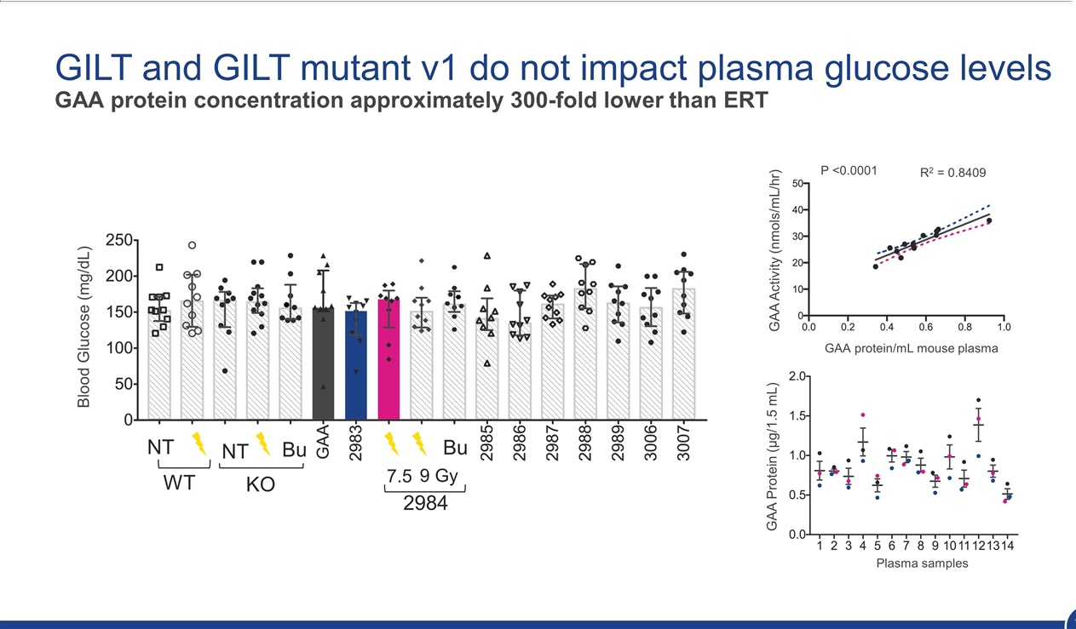

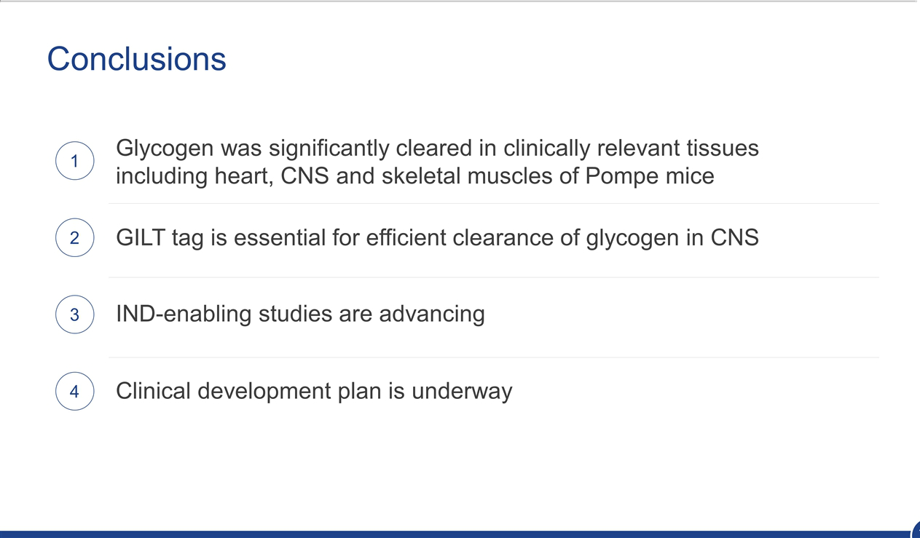

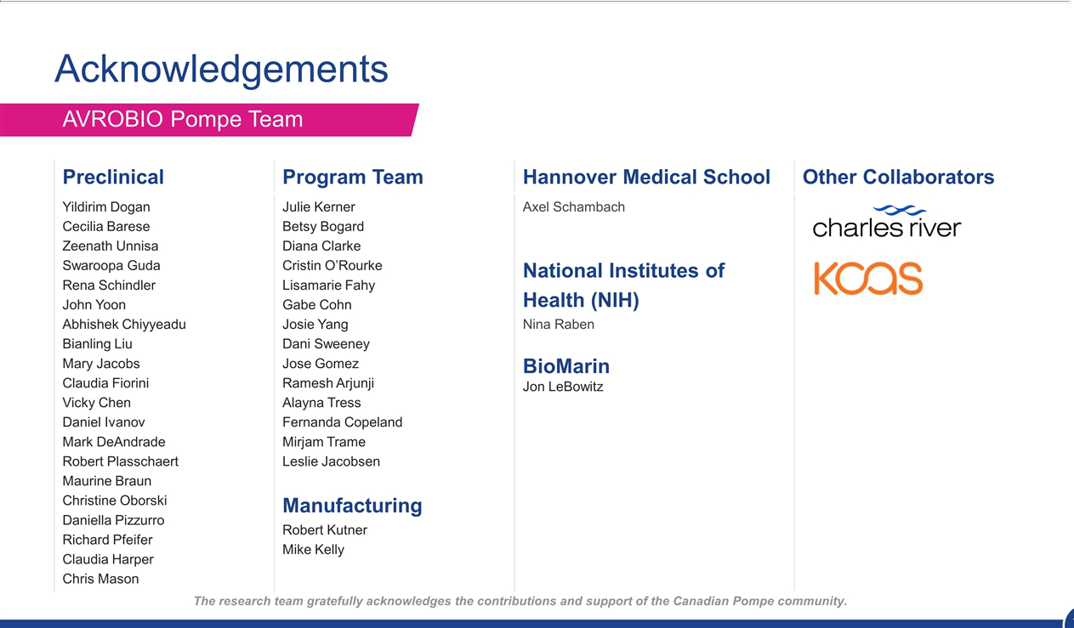

Exhibit 99.2

AVROBIO Presents New Preclinical Data on Lentiviral Gene Therapy Program for

Pompe Disease at ASGCT 2020

AVROBIO’s optimized lentiviral vectors demonstrate significant glycogen reduction in the muscle

and central nervous system of Pompe disease mouse model

Investigational New Drug (IND)-enabling proof-of-concept study for AVR-RD-03 for Pompe

disease currently underway

CAMBRIDGE, Mass., May 14, 2020 — AVROBIO, Inc. (Nasdaq: AVRO), a leading clinical-stage gene therapy company with a mission to free people from a lifetime of genetic disease, today announced new preclinical data for AVR-RD-03 for Pompe disease showcasing how its lentiviral gene therapy approach may potentially correct Pompe disease manifestations in the muscle and central nervous system (CNS). The data will be presented today at the American Society of Gene & Cell Therapy (ASGCT) 23rd Annual Meeting.

AVROBIO’s optimized lentiviral vectors for Pompe disease include a proprietary Glycosylation-Independent Lysosomal Targeting (GILT)-tag technology, which consists of a short peptide sequence linked to the therapeutic protein and is designed to enhance uptake in key tissues, and a potent transgene promoter to boost protein production. Data to be presented today demonstrate that AVROBIO-designed lentiviral vectors for Pompe disease incorporating GILT-tag technology significantly reduce toxic accumulation of glycogen in a mouse model of Pompe disease, including in cardiac and skeletal muscle, and the CNS. The toxic buildup of glycogen is caused by a mutation in the GAA gene and leads to a broad range of symptoms for people with Pompe disease, including progressive weakness, loss of motor function and trouble breathing. GAA encodes acid alpha-glucosidase, the enzyme that is functionally deficient in people living with Pompe disease.

“Our preclinical data strongly support the potential of our optimized lentiviral vector for Pompe disease with proprietary GILT-tag technology as a novel mechanism in the ‘head-to-toe’ treatment of Pompe disease, including symptoms that originate in the CNS,” said Chris Mason, M.D., Ph.D. AVROBIO’s chief scientific officer. “We feel a tremendous urgency to advance this therapy for people living with Pompe disease and look forward to completing the IND-enabling studies that could pave our path to the clinic.“

The study assessed 10 different lentiviral vectors with therapeutic transgenes in a mouse model of Pompe disease. Each vector was capable of producing expression of the GAA gene and included different versions of the GILT tag. Control vectors without a GILT tag were also tested. The presence of GILT tags substantially improved clearance of glycogen in the brain and spinal cord. The leading vector reduced glycogen in the cardiac muscle, the cerebrum and the spinal cord to levels that closely resembled those seen in wild-type mice. Glycogen content was also significantly reduced in heart, diaphragm and skeletal muscle tissue. Average vector copy number (VCN) in bone marrow was below five and there were no adverse effects seen on the hematopoietic compartment in treated mice. The mice were followed for four months after transplantation.

Based on these data, AVROBIO selected a candidate vector for progression into an Investigational New Drug-enabling proof-of-concept study, which is expected to conclude in 2020.

About Pompe disease

Pompe disease is a lysosomal disorder caused by a mutation in the GAA gene. The lack of the enzyme encoded by GAA results in a toxic buildup of glycogen throughout the body and central nervous system, causing a wide range of symptoms including progressive weakness and loss of motor function. Pompe disease affects about 1 in 58,000 Americans and is treated with enzyme replacement therapy, or ERT, which is typically given as a biweekly infusion for life. ERT slows but does not halt the overall progression of disease and does not cross the blood-brain barrier to address neurological pathologies. Even with ERT treatment, people with Pompe disease experience debilitating symptoms that reduce their quality of life.

About lentiviral gene therapy

Lentiviral vectors are differentiated from other delivery mechanisms because of their large cargo capacity and their ability to integrate the therapeutic gene directly into the patient’s chromosomes. This integration is designed to maintain the therapeutic gene’s presence as the patient’s cells divide, which potentially enables dosing of pediatric patients, whose cells divide rapidly as they grow. Because the therapeutic gene is integrated using the vector into patients’ stem cells ex vivo, patients are not excluded from receiving the investigational therapy due to pre-existing antibodies to the viral vector.

About AVROBIO

Our mission is to free people from a lifetime of genetic disease with a single dose of gene therapy. We aim to halt or reverse disease throughout the body by driving durable expression of functional protein, even in hard-to-reach tissues and organs including the brain, muscle and bone. Our clinical-stage programs include Fabry disease, Gaucher disease and cystinosis and we also are advancing a program in Pompe disease. AVROBIO is powered by the plato™ gene therapy platform, our foundation designed to scale gene therapy worldwide. We are headquartered in Cambridge, Mass., with an office in Toronto, Ontario. For additional information, visit avrobio.com, and follow us on Twitter and LinkedIn.

Forward-Looking Statement

This press release contains forward-looking statements, including statements made pursuant to the safe harbor provisions of the Private Securities Litigation Reform Act of 1995. These statements may be identified by words and phrases such as “aims,” “anticipates,” “believes,” “could,” “designed to,” “estimates,” “expects,” “forecasts,” “goal,” “intends,” “may,” “plans,” “possible,” “potential,” “seeks,” “will,” and variations of these words and phrases or similar expressions that are intended to identify forward-looking statements. These forward-looking statements include, without limitation, statements regarding our business strategy for and the potential therapeutic benefits of our prospective product candidates, preclinical trial results and the potential therapeutic benefits of our optimized lentiviral vector with proprietary GILT-tag technology for the treatment of Pompe disease, including the potential for treatment of symptoms originating in the brain and CNS, the design, commencement and timing of ongoing or planned preclinical trials and regulatory pathways, including the timing of completion of our IND-enabling preclinical study for the treatment of Pompe disease, and the anticipated benefits of our lentiviral gene therapy approach. Any such statements in this press release that are not statements of historical fact may be deemed to be forward-looking statements. Results in preclinical or early-stage clinical trials may not be indicative of results from later stage or larger scale clinical trials and do not ensure regulatory approval. You should not place undue reliance on these statements, or the scientific data presented.

Any forward-looking statements in this press release are based on AVROBIO’s current expectations, estimates and projections about our industry as well as management’s current beliefs and expectations of future events only as of today and are subject to a number of risks and uncertainties that could cause actual results to differ materially and adversely from those set forth in or implied by such forward-looking statements. These risks and uncertainties include, but are not limited to, the risk that any one or more of AVROBIO’s product candidates will not be successfully developed or commercialized, the risk of cessation or delay of any ongoing or planned preclinical or clinical trials of AVROBIO or our collaborators, the risk

that AVROBIO may not successfully recruit or enroll a sufficient number of patients for our clinical trials, the risk that AVROBIO may not realize the intended benefits of our gene therapy platform, including our GILT-tag technology and the features of our plato platform, the risk that our product candidates or procedures in connection with the administration thereof will not have the safety or efficacy profile that we anticipate, the risk that prior results, such as signals of safety, activity or durability of effect, observed from preclinical or clinical trials, will not be replicated or will not continue in ongoing or future studies or trials involving AVROBIO’s product candidates, the risk that we will be unable to obtain and maintain regulatory approval for our product candidates, the risk that the size and growth potential of the market for our product candidates will not materialize as expected, risks associated with our dependence on third-party suppliers and manufacturers, risks regarding the accuracy of our estimates of expenses and future revenue, risks relating to our capital requirements and needs for additional financing, risks relating to clinical trial and business interruptions resulting from the COVID-19 outbreak or similar public health crises, including that such interruptions may materially delay our development timeline and/or increase our development costs or that data collection efforts may be impaired or otherwise impacted by such crises, and risks relating to our ability to obtain and maintain intellectual property protection for our product candidates. For a discussion of these and other risks and uncertainties, and other important factors, any of which could cause AVROBIO’s actual results to differ materially and adversely from those contained in the forward-looking statements, see the section entitled “Risk Factors” in AVROBIO’s most recent Quarterly Report, as well as discussions of potential risks, uncertainties and other important factors in AVROBIO’s subsequent filings with the Securities and Exchange Commission. AVROBIO explicitly disclaims any obligation to update any forward-looking statements except to the extent required by law.

Investor Contact:

Christopher F. Brinzey

Westwicke, an ICR Company

339-970-2843

chris.brinzey@westwicke.com

Media Contact:

Tom Donovan

Ten Bridge Communications

857-559-3397

tom@tenbridgecommunications.com

